Test Issue Log |  |  |  |  |  | SCP ID# :
Project Name: | AGROBANK BUSINESS INTERNET BANKING
Test Stage: | Unit Functionality Integration System Interface  Performance Regression Acceptance Pilot
Test Case Number: | Support #7159 |  |  | Test Started Date: |  |  | 20/02/2017
Test Title:
Test Description: | To ensure error message pop up displayed: Invalid Total Amount for entered alphabets on ‘Total Amount’ field.
Test Functionality: | BIB  - Payroll > Statutory Bodies > EPF
Test Procedure: | - On excel upload file, enter alphabets on ‘Total Amount’ field.  - Perform to upload file on BIB.
Test Result: | Pass: Fail: | Tested by: |  |  | Erni Suhaireen binti Zulkifli
Reason for Failure: | Error message should display: Invalid Total Amount for entered alphabets on ‘Total Amount’ field.
TEST DESCRIPTION
Screenshot:
Set empty/alphabets on ‘Employer Contribution’ at upload excel file
- Set empty/alphabets on ‘Employer Contribution’ field
- Empty
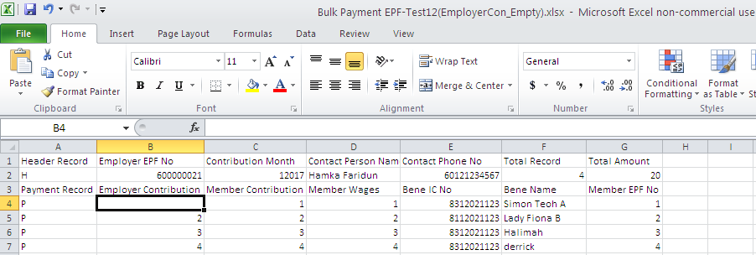

- Alphabets
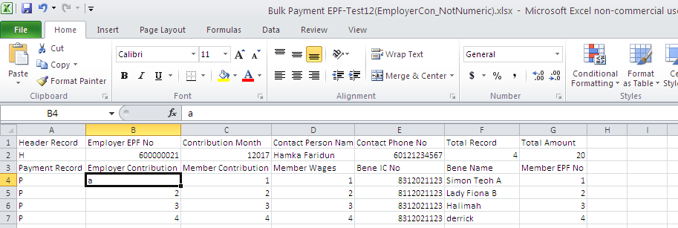
Perform Upload File
- On Statutory Body – EPF page:
  - Select “From Account” from the dropdown List
  - Click “Browse” button and attached the Form A file
  - Enter the “Remarks”
- Click on ‘Next’ button.
- Empty
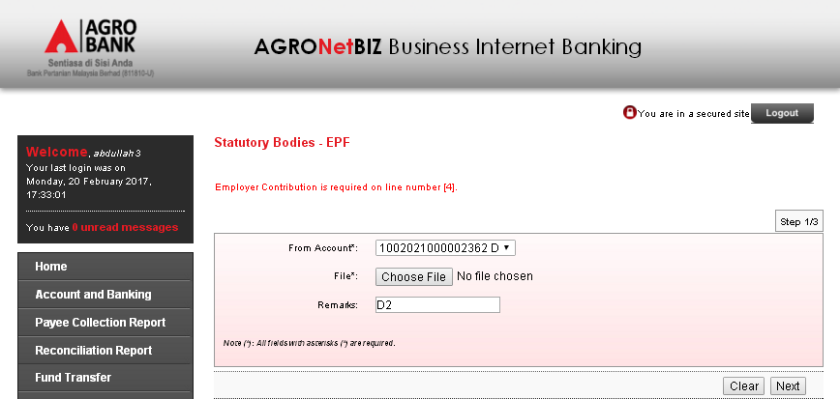
Current error Message Displayed: Employer Contribution is required on line number [4].
Expected Error Message Displayed: Employer Contribution Amount is required on line number [4].

- Numeric
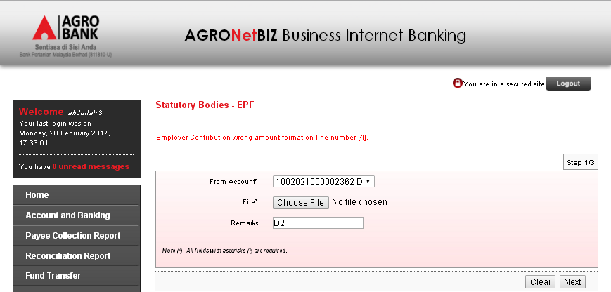
Current error Message Displayed: Employer Contribution wrong amount format on line number [4].
Expected Error Message Displayed: Employer Contribution Amount should be numeric on line number [4]
Reviewed By: (PMO)
 |  |  | Name/Position : Norhaidah Binti Md Dasuki / Senior Manager, Quality Assurance and Support  Date :

