Test Issue Log |  |  |  |  |  | SCP ID# : 3674
Project Name: | AGROBANK BUSINESS INTERNET BANKING
Test Stage: | Unit Functionality Integration System Interface  Performance Regression Acceptance Pilot
Test Case Number: | Support #7162 |  |  | Test Started Date: |  |  | 20/02/2017
Test Title: | KADA Approver - SMS Notification.
Test Description: | To ensure approver received SMS notification to approved transaction.  Based on record, last SMS send to this customer is 2017-01-11 16:22:11.193, after that no SMS generated.
Test Functionality: | BIB - Initiator  - Bulk Payment > File Upload  BIB - Approver  - Authentication
Test Procedure: | - Login to BIB as Initiator and perform Bulk Payment File Upload.  - Check on the status changes  - Login to BIB as Approver and approve the transaction made.  - Check log on the sms received.
Test Result: | Pass: Fail: | Tested by: |  |  | Erni Suhaireen binti Zulkifli
Reason for Failure:
TEST DESCRIPTION
- Login to BIB as Initiator and perform Bulk Payment File Upload.
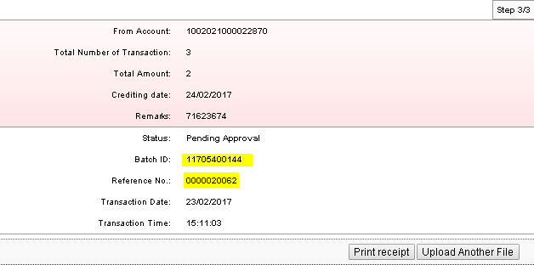
  - Check on the status changes
    - BPS Status
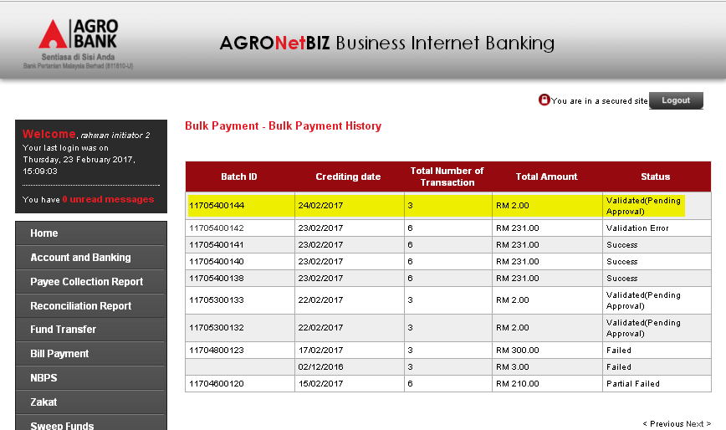

    - AgronetBiz Transaction Status
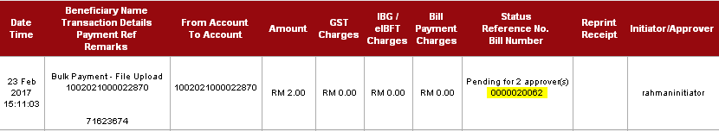

- Login to BIB as Approver and approve the transaction made.
  - 1st Approver
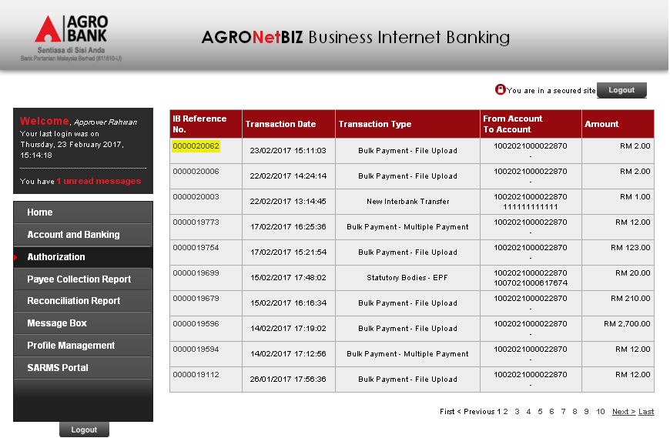
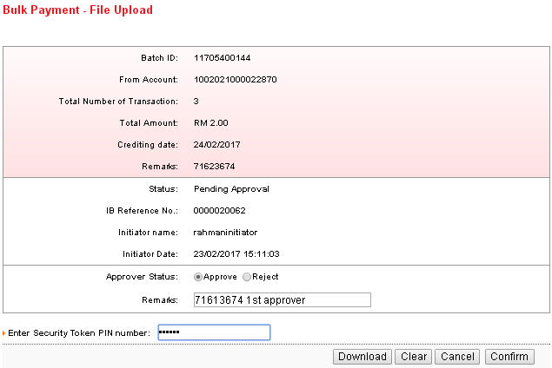
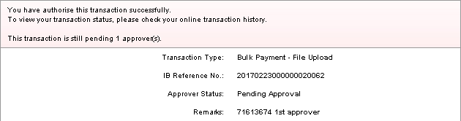
AgronetBiz Transaction History after 1st Approver approved.
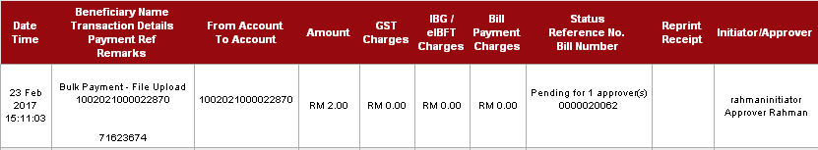
  - 2nd Approver
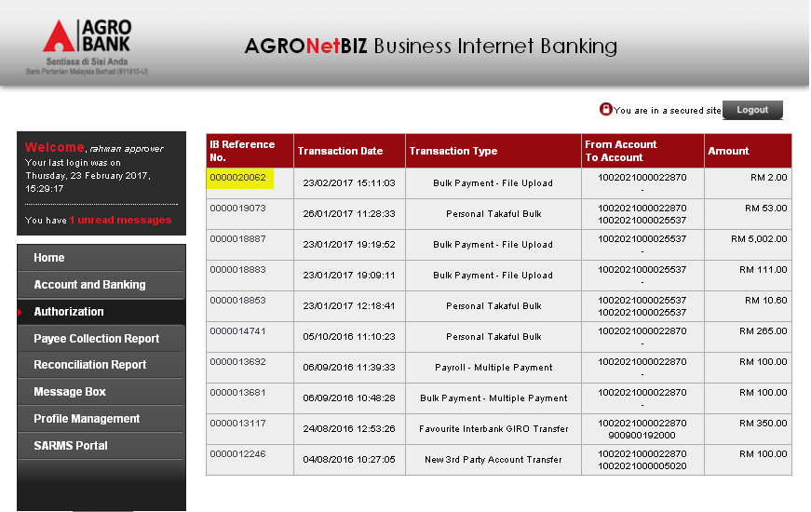
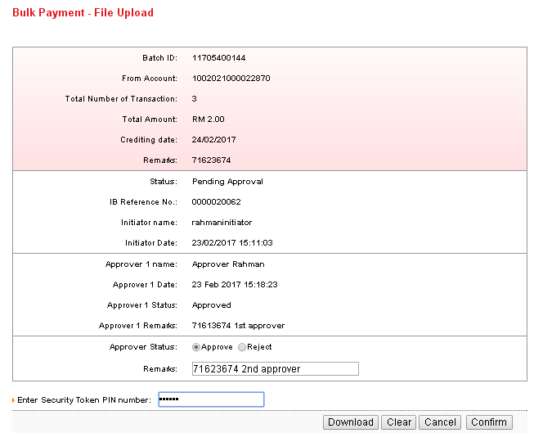
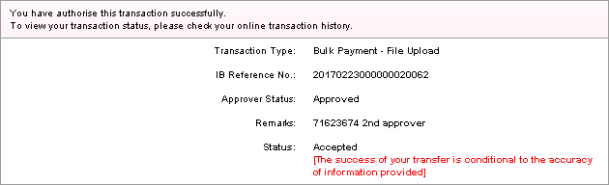
AgronetBiz Transaction History after 2nd Approver approved.
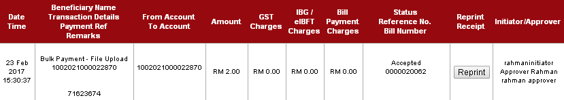
Bulk Payment History after 2nd Approver approved.
- Check log on the sms received.
[Refer attached filename: Task #7162 - SCP #3674 -SMS Notification.txt
Reviewed By: (PMO)
 |  |  | Name/Position : Norhaidah Binti Md Dasuki / Senior Manager, Quality Assurance and Support  Date :

