Test Issue Log |  |  |  |  |  | SCP ID# : TPMS CR201702
Project Name: | Trade Promotion Management System (TPMS)
Test Stage: | Unit Functionality Integration System Interface  Performance Regression Acceptance Pilot
Test Case Number: | Task #7182 |  |  | Test Started Date: |  |  | 27/02/2017
Test Title: | Trade Fair Change Request : Feedback form functional test
Test Description: | To update feedback form for Trade Fair
Test Functionality: | TPMS  - Post Event > Programmes > Feedback > List by Company > View/Edit Feedback Form
Test Procedure: | - In feedback form, in Part A: Outcome of Participation, Potential Sales is divided in three (3).  - Add text ‘unit’ at the end of No. Of trades and No. Of business.  - Update feedback form footer with form id.
Test Result: | Pass: Fail: | Tested by: |  |  | Siti Norahayu Binti Mohd Desa
Reason for Failure:
TEST DESCRIPTION
Screenshot:
- In feedback form, in Part A: Outcome of Participation, Potential Sales is divided in three (3). There are:
  - Short term
  - Midterm
  - Long term
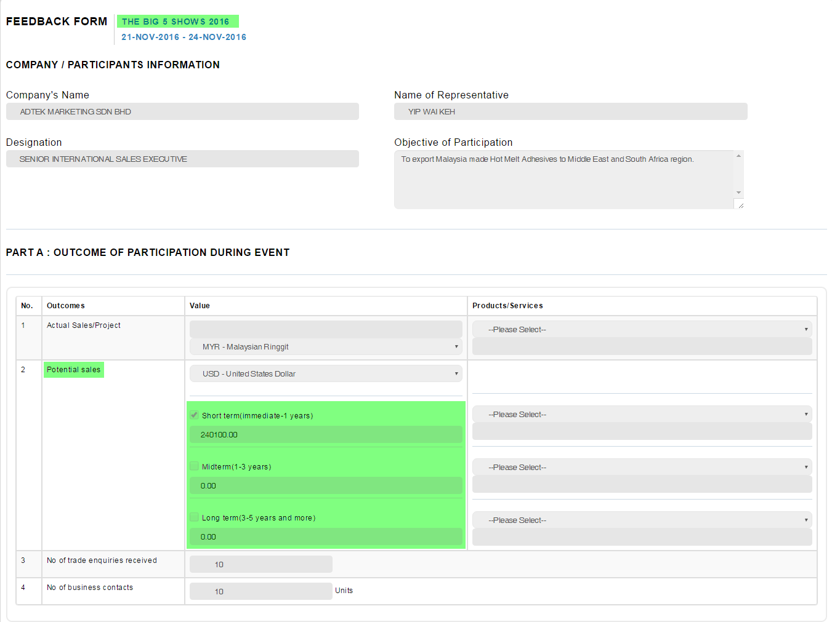
- Add text ‘unit’ at the end of No. Of trades and No. Of business.
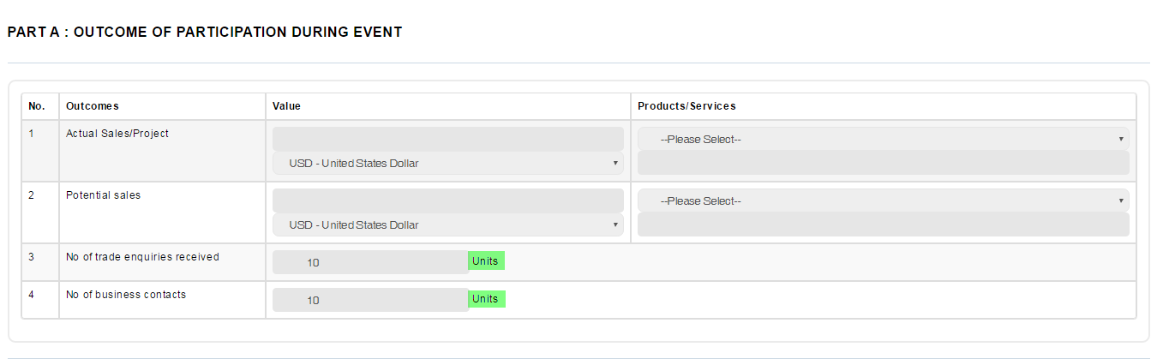

- Update feedback form footer with form id.
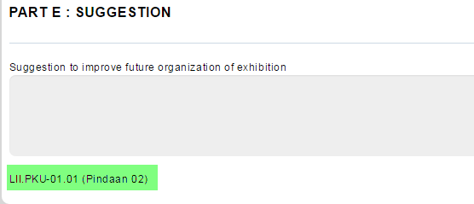

Reviewed By: (PMO)
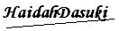 |  |  | Name/Position : Norhaidah Binti Md Dasuki / Senior Manager, Quality Assurance and Support  Date : 27/02/2017

