**Deskmate > Directory**

**OLD**

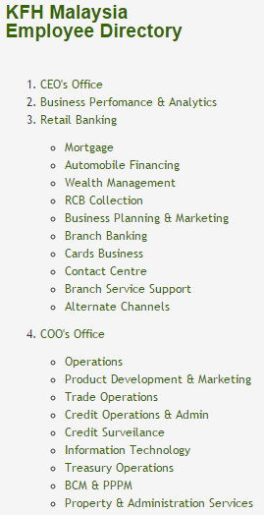

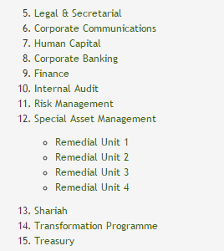

**NEW**

1. ** (change to capital letters)**

**to remove the following staff:**

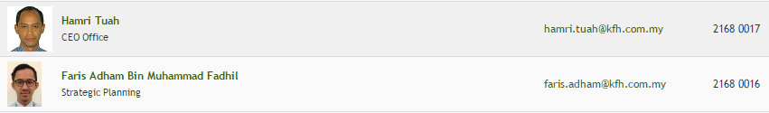

1. **COMPANY SECRETARY (rename, previously )**

**to remove the following staff:**

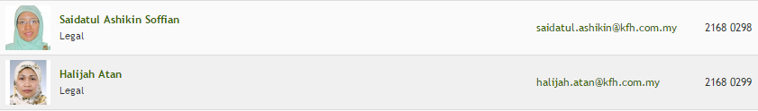

1. **LEGAL (new tab)**

**to add the following staff:**



1. **STRATEGY, PMO & COMMUNICATION (new tab)**

**to add the following staff:**

**from**

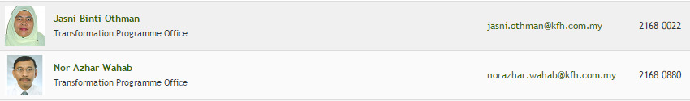

**to rename from Transformation Programme Office to Project Management Office**



**to rename from Transformation Programme Office to Project Management Office**



**to rename from Retail & Consumer Banking / Branch Operation Support to Project Management Office**

**from**



**from **



**to rename from CEO Office to Strategic Planning**



1. ** (change to capital letters)**

**to remove the following staff:**



1. ** (change to capital letters)**

**to make this staff No 1 in list:**



1. ** (change to capital letters)**
2. ** (change to capital letters)**
3. **BUSINESS PROCESS REENGINEERING & INNOVATION (new tab)**
4. **HUMAN RESOURCES (previously )**
5. ** (change to capital letters)**

**to add the following staff:**



**to rename from Credit operations & Administration / Payment & Fund Mgmt Support to Finance**

1. ** (change to capital letters)**
2. ** (change to capital letters)**
3. ** (change to capital letters)**

**to add the following departments:**





1. **RECOVERY (previously )**

**to add the following units:**

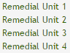

1. ** (change to capital letters)**
2. **OPERATIONS (new tab, capital letters)**

**to remove the following staff:**



**to add the following departments:**

**Alternate Services Operations (new sub-tab) and add the following staff:**

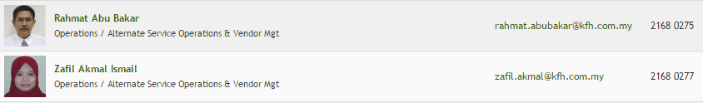

**to rename from Operations / Alternate Service Operations & Vendor Mgt to Alternate Services Operations**



**to rename from Operations / Alternate Service Operations & Vendor Mgt to Alternate Services Operations**

**Remittance & Clearing (rename, previously )**

**to rename from Operations / Clearing & Payment Operations to Remittance & Clearing**



**to add Trade Opertions to title**

**Credit Operations & Administration (rename, previously )**

**to remove Credit Operations & Administration from all staff’s title**

**to remove the following staff:**











**to add Treasury Operations to title**





**to remove Property & Administration Services from all staff’s title**