Test Issue Log |  |  |  |  |  | SCP ID# :
Project Name: | AGROBANK BUSINESS INTERNET BANKING
Test Stage: | Unit Functionality Integration System Interface  Performance Regression Acceptance Pilot
Test Case Number: | Support #7131 |  |  | Test Started Date: |  |  | 03/03/2017
Test Title: | SIT_007 : EPF Payment - Other Payment
Test Description: | To put notes beside the "Sequence No" field as per below  "Mandatory based on selection of payment type.
Test Functionality: | BIB  - Payroll > Statutory Bodies > EPF Other Payment
Test Procedure: | - On Statutory Body – EPF Other Payment Submission page:  - Select “From Account” from Dropdown List  - Select on ‘Late Charges’, ‘Dividend Loss’ or ‘Other Charges’ on “Payment Type” dropdown list  - Enter “Contribution Month”/ Input “Contribution Month” with wrong format  - Enter “Employer EPF No”/ Input with other than numeric  - Enter “Payment Amount”/ Input “Payment Amount” with other than numeric character  - Leave blank on “Penalty Sequence No”  - Enter “Form F Reference Number’.
Test Result: | Pass: Fail: | Tested by: |  |  | Erni Suhaireen binti Zulkifli
Reason for Failure:
TEST DESCRIPTION
Screenshot:
Perform to access EPF Other Payment Submission Page
- Click on “Payroll” navigation.
- On ‘Statutory Bodies’ sub navigation, click on ‘EPF Other Payment Submission’ sub navigation hyperlink.
Perform Upload File
- On Statutory Body – EPF Other Payment Submission page:
  - Select “From Account” from Dropdown List
  - Select on ‘Late Charges’, ‘Dividend Loss’ or ‘Other Charges’ on “Payment Type” dropdown list
  - Enter “Contribution Month”/ Input “Contribution Month” with wrong format
  - Enter “Employer EPF No”/ Input with other than numeric
  - Enter “Payment Amount”/ Input “Payment Amount” with other than numeric character
  - Leave blank on “Penalty Sequence No”
  - Enter “Form F Reference Number’.
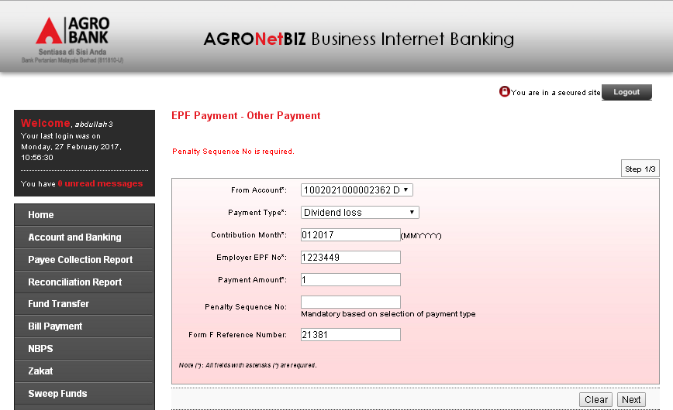
Reviewed By: (PMO)
 |  |  | Name/Position : Norhaidah Binti Md Dasuki / Senior Manager, Quality Assurance and Support  Date :

