Test Issue Log |  |  |  |  |  | SCP ID# :
Project Name: | AGROBANK BUSINESS INTERNET BANKING
Test Stage: | Unit Functionality Integration System Interface  Performance Regression Acceptance Pilot
Test Case Number: | Support #7115 |  |  | Test Started Date: |  |  | 03/03/2017
Test Title: | SIT_006 : EPF Payment - Other Payment
Test Description: | Unsuccessful EPF transaction captured as successful at Statutory Bodies History - EPF
Test Functionality: | BIB  - Payroll > Statutory Bodies > EPF  - Payroll > Statutory Bodies > EPF Transfer History
Test Procedure: | - Perform EPF File Upload Submission with Unsuccessful status.  - View EPF Transfer History status.
Test Result: | Pass: Fail: | Tested by: |  |  | Erni Suhaireen binti Zulkifli
Reason for Failure:
TEST DESCRIPTION
Screenshot:
- Perform an Unsuccessful transaction for EPF.
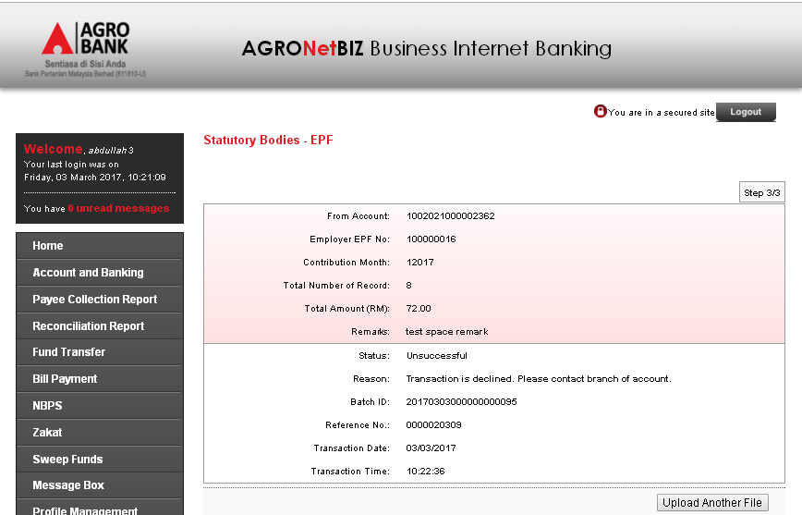

- View the EPF transfer History status.
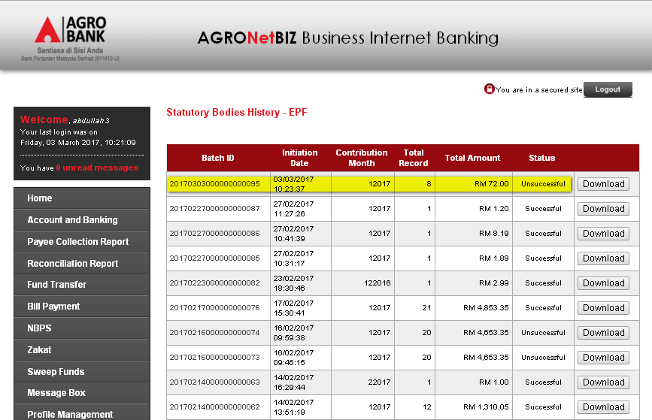
Reviewed By: (PMO)
 |  |  | Name/Position : Norhaidah Binti Md Dasuki / Senior Manager, Quality Assurance and Support  Date :

