Test Issue Log |  |  |  |  | SCP ID# : SIT_011
Project Name: | AGROBANK BUSINESS INTERNET BANKING
Test Stage: | Unit Functionality Integration System Interface  Performance Regression Acceptance Pilot
Test Case Number: | Support #7118 |  | Test Started Date: |  |  | 03/03/2017
Test Title: | SIT_011
Test Description: | To fix this issue:  Form A testing file for 1st time contribution is blank, no data generated.
Test Functionality:
Test Procedure:
Test Result: | Pass: Fail: | Tested by: |  | Erni Suhaireen binti Zulkifli
Reason for Failure:
TEST DESCRIPTION

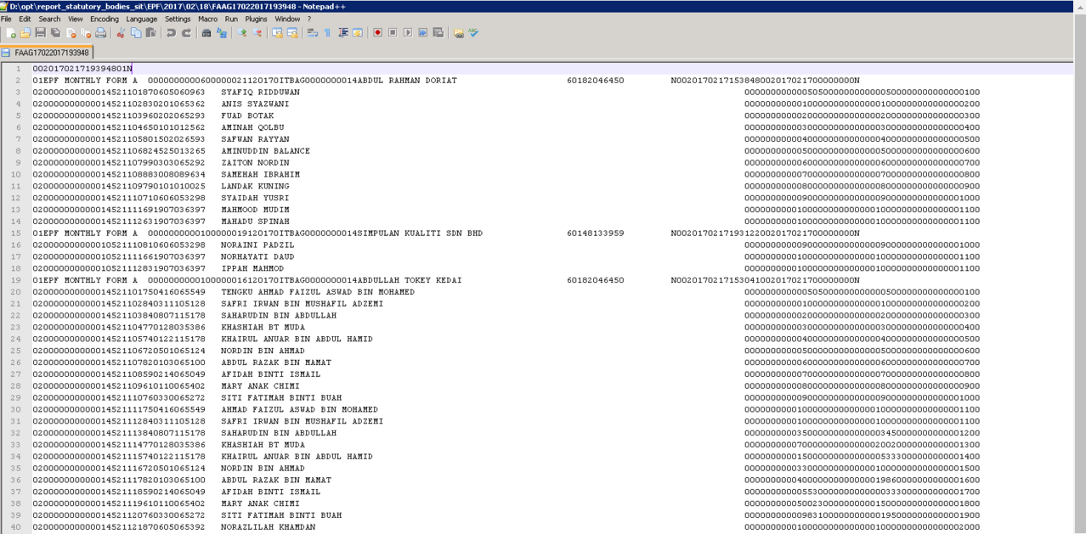

Reviewed By: (PMO)
 | Name/Position : Norhaidah Binti Md Dasuki / Senior Manager, Quality Assurance and Support  Date :

