Test Issue Log |  |  |  |  |  | SCP ID# :
Project Name: | AGROBANK BUSINESS INTERNET BANKING
Test Stage: | Unit Functionality Integration System Interface  Performance Regression Acceptance Pilot
Test Case Number: | Support #7034 |  |  | Test Started Date: |  |  | 03/02/2017
Test Title: | IBAM Report
Test Description: | To ensure that Remarks display even when the transaction status is Unsuccessful
Test Functionality: | IBAM  - IBAM > BIB Report > File Type: PDF/XLS
Test Procedure:
Test Result: | Pass: Fail: | Tested by: |  |  | Erni Suhaireen binti Zulkifli
Reason for Failure:
TEST DESCRIPTION
Current Result
- Perform EPF File Upload with Remarks and the status for this transaction is Unsuccessful.
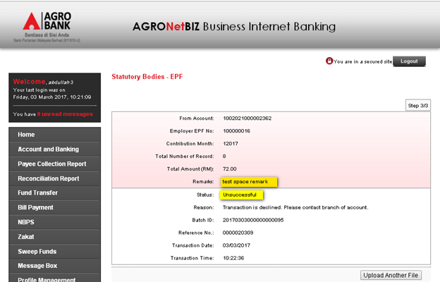

- IBAM Report (.pdf format)
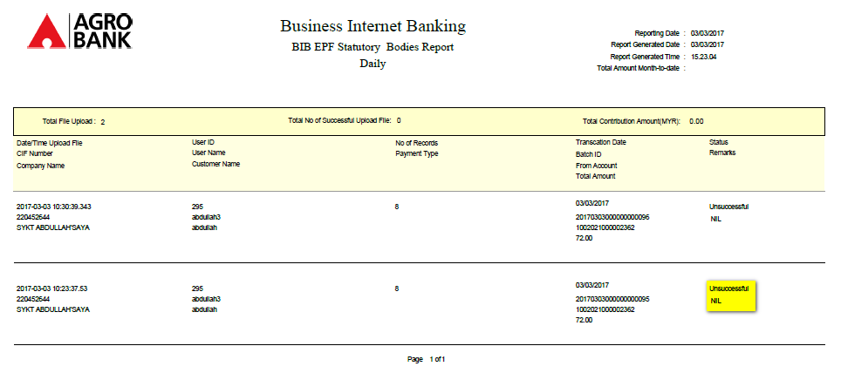
- IBAM Report (.xls format)
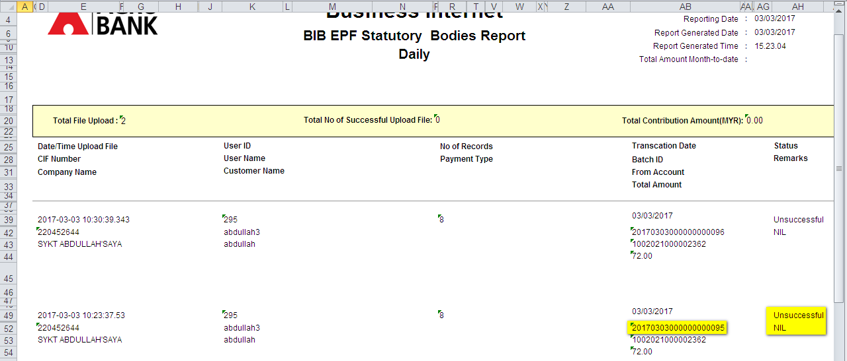
Expected Result
- To display result for all status including Unsuccessful.
Reviewed By: (PMO)
 |  |  | Name/Position : Norhaidah Binti Md Dasuki / Senior Manager, Quality Assurance and Support  Date :

