Test Issue Log |  |  |  |  |  | SCP ID# :
Project Name: | AGROBANK BUSINESS INTERNET BANKING
Test Stage: | Unit Functionality Integration System Interface  Performance Regression Acceptance Pilot
Test Case Number: | Support #7034 |  |  | Test Started Date: |  |  | 09/03/2017
Test Title: | IBAM Report
Test Description: | To ensure all these bug reported fixed:  - Remove spacing for Company Name. Should have no space in front of Company Name.  - Remarks should have space.  - The value for 'Total Month-to-Date' is not parallel.  - The value for 'Total Contribution Amount (MYR)' is not parallel.
Test Functionality: | IBAM  - IBAM > BIB Report > File Type: PDF/XLS
Test Procedure:
Test Result: | Pass: Fail: | Tested by: |  |  | Erni Suhaireen binti Zulkifli
Reason for Failure:
TEST DESCRIPTION
To ensure all these bug reported fixed:
- Remove spacing for Company Name. Should have no space in front of Company Name.
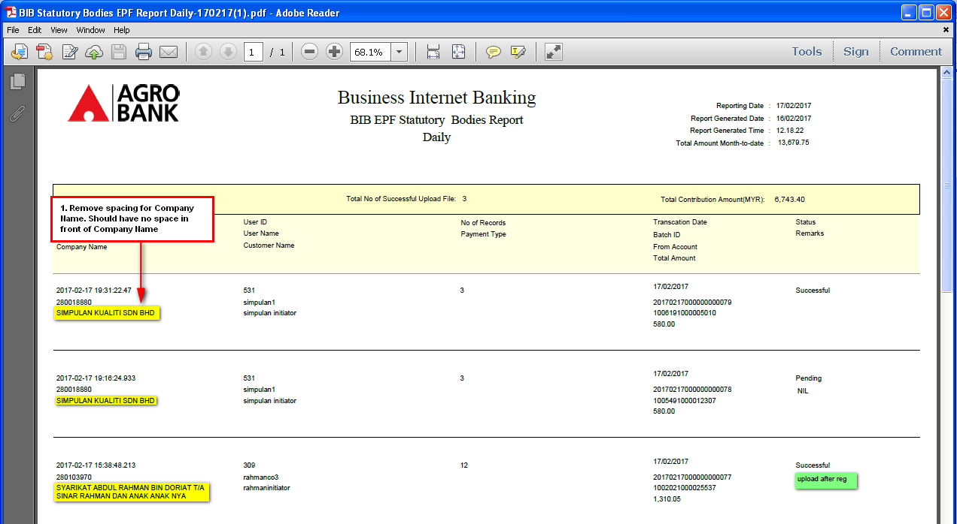

- Remarks should have space.
  - .pdf
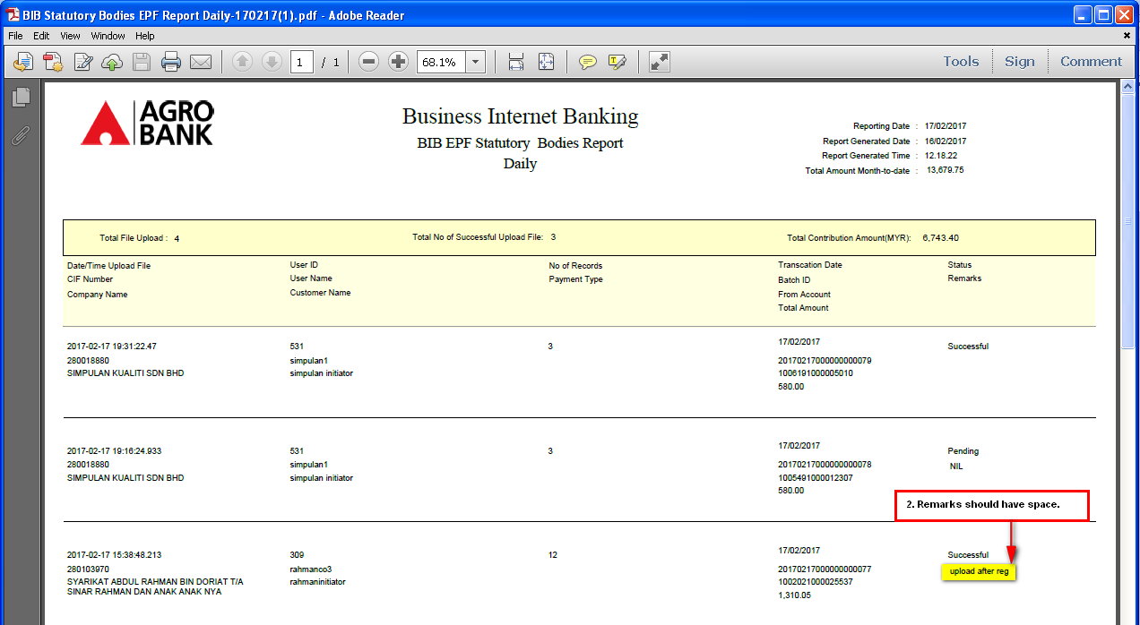
  - .xls
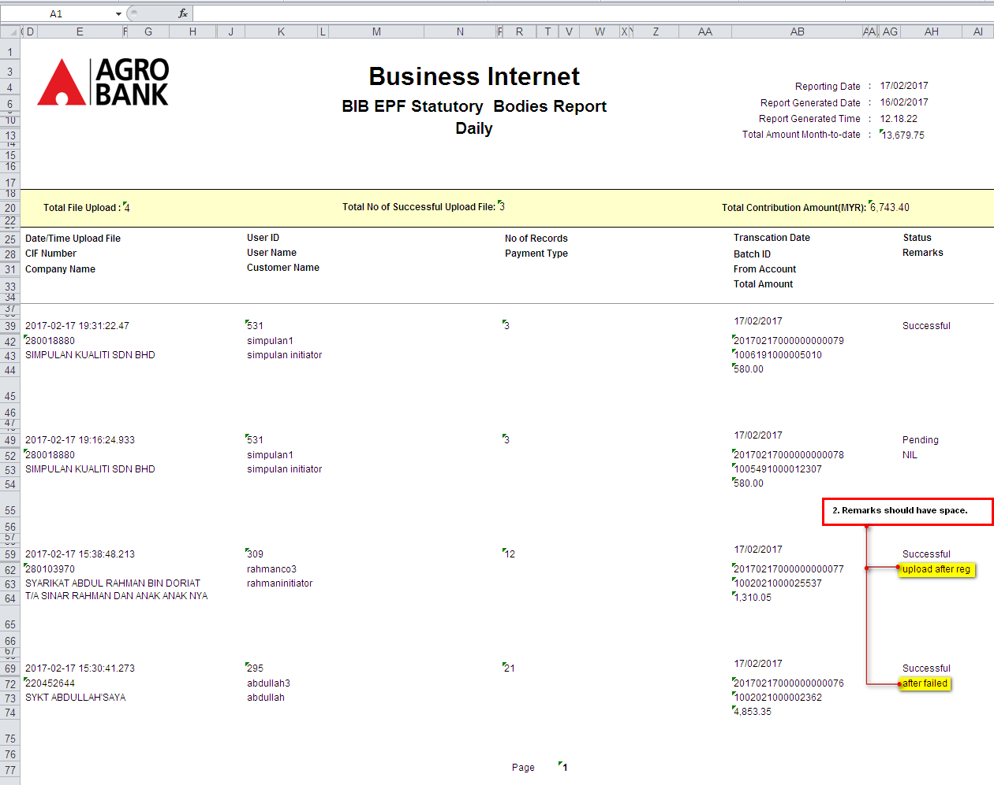
- The value for 'Total Month-to-Date' is not parallel.
  - .pdf
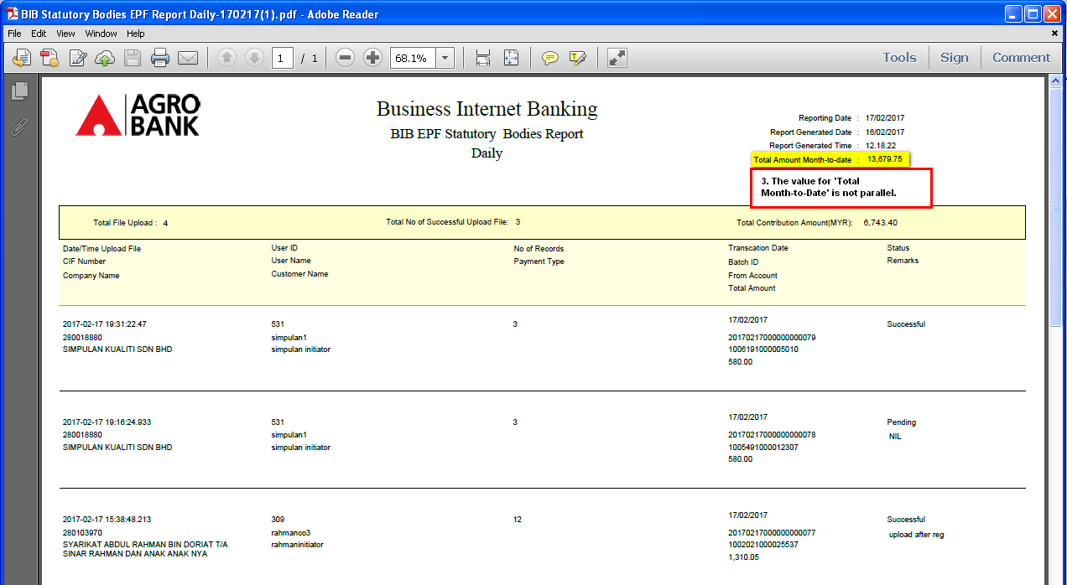
  - .xls
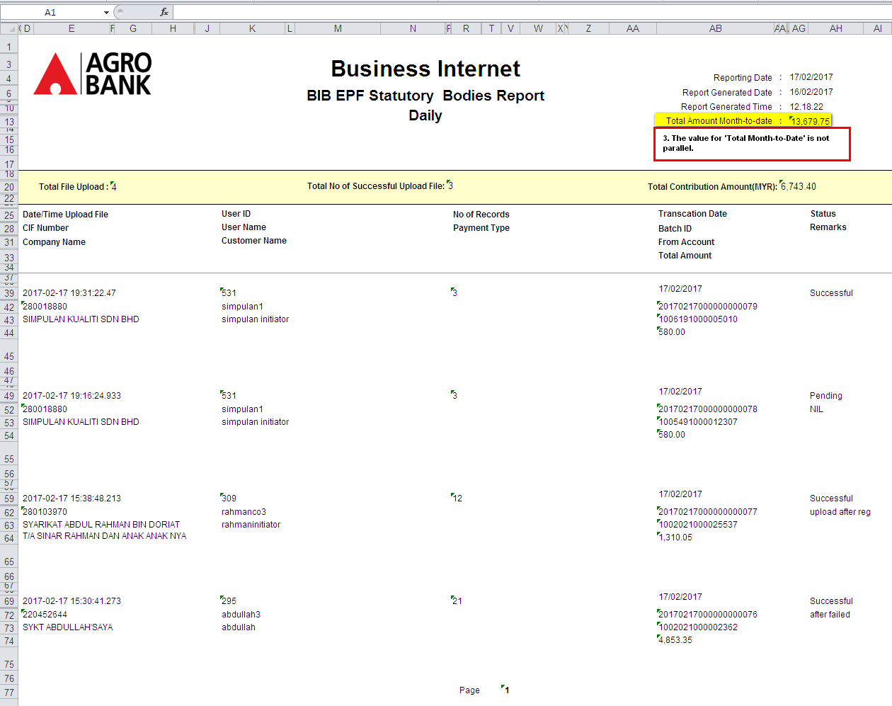
- The value for 'Total Contribution Amount (MYR)' is not parallel.
  - .pdf
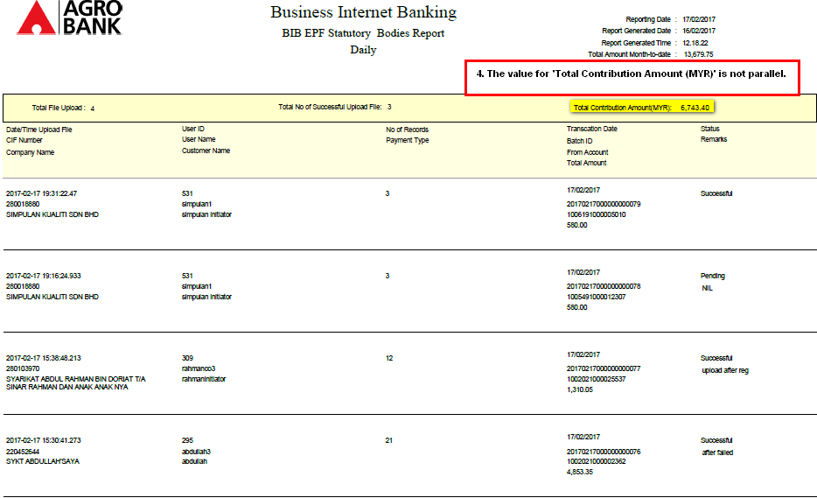
  - .xls
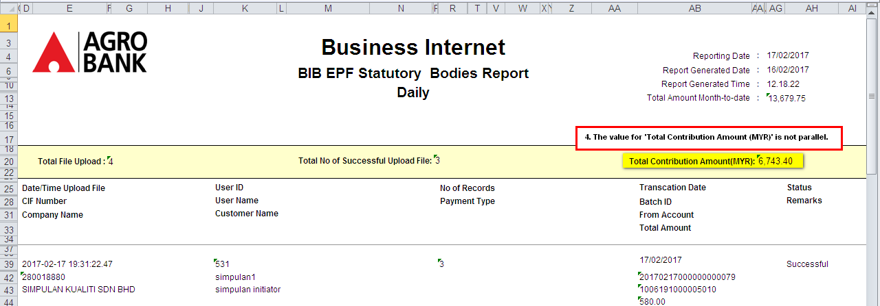
Reviewed By: (PMO)
 |  |  | Name/Position : Norhaidah Binti Md Dasuki / Senior Manager, Quality Assurance and Support  Date :

