Test Issue Log |  |  |  |  |  | SCP ID# :SITB_004
Project Name: | AGROBANK BUSINESS INTERNET BANKING
Test Stage: | Unit Functionality Integration System Interface  Performance Regression Acceptance Pilot
Test Case Number: | Support #7186 |  |  | Test Started Date: |  |  | 08/03/2017
Test Title: | [SITB_004] : BIB - Takaful Transaction Enquiry
Test Description: | To add status column and details in takaful trnx enquiry.  1. pending  2. pending approval (multiple user)  3. successful  4. rejected/unsuccessful
Test Functionality: | BIB  - BIB Takaful Enquiry
Test Procedure: | - View BIB Takaful Enquiry
Test Result: | Pass: Fail: | Tested by: |  |  | Erni Suhaireen binti Zulkifli
Reason for Failure:
TEST DESCRIPTION
Screenshot:
- Single User
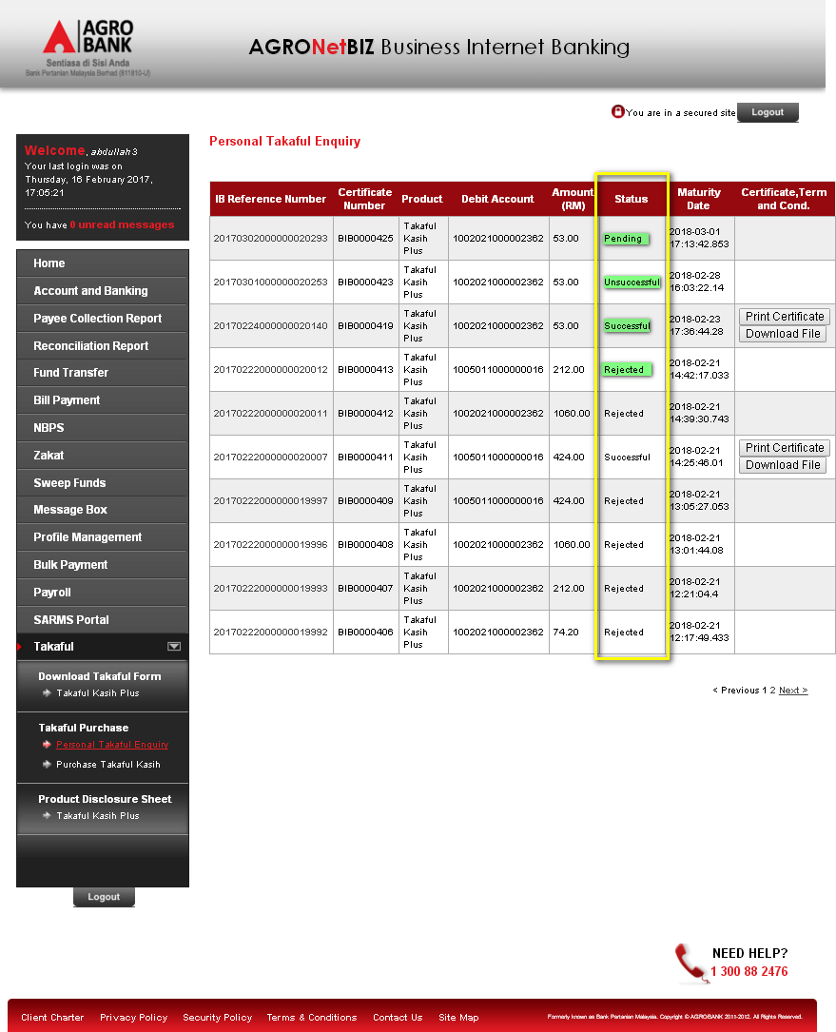

  - Details screen for Pending status.
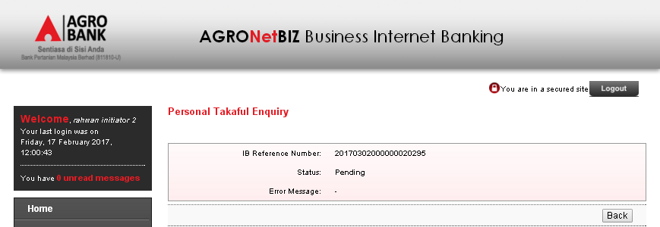`
  - Details screen for Successful status.
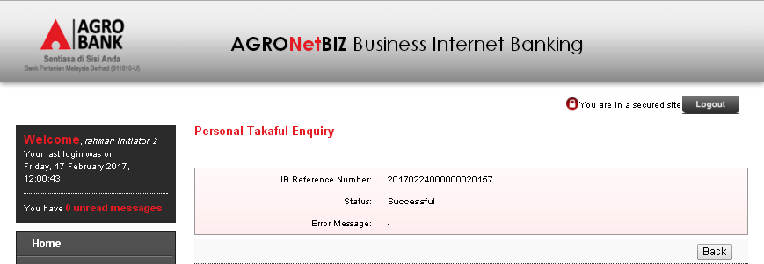
  - Details screen for Rejected status.
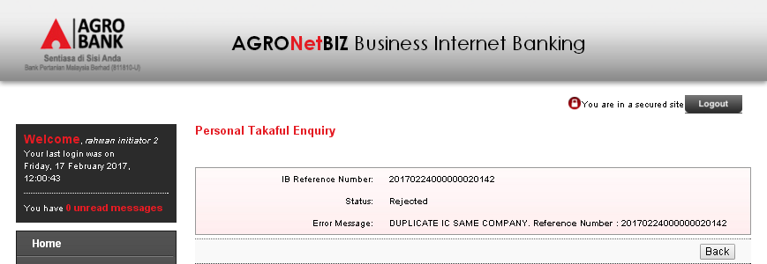

  - Details screen for Pending Approval status.
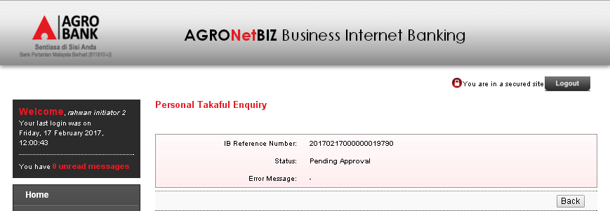

- Multiple User
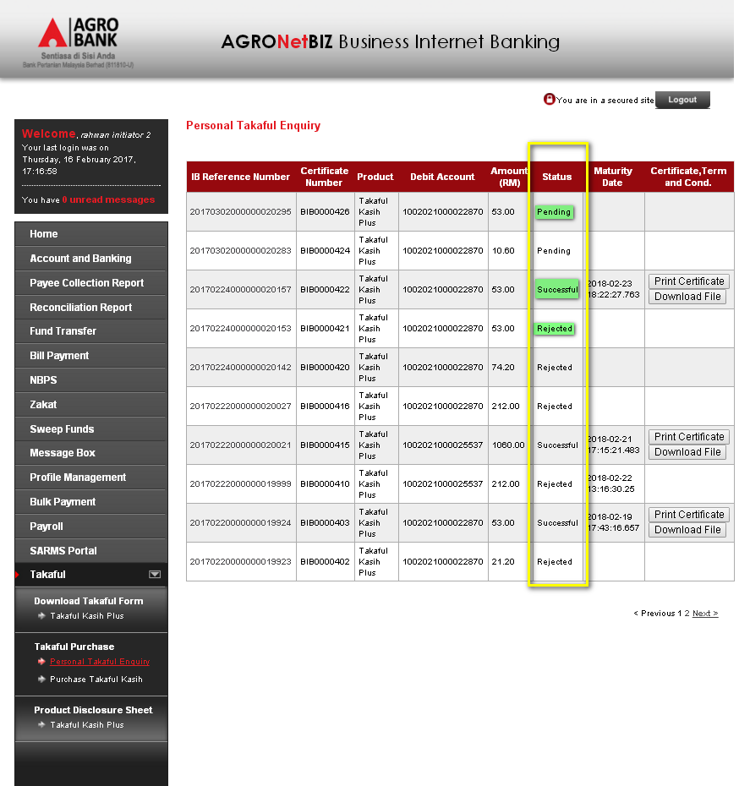
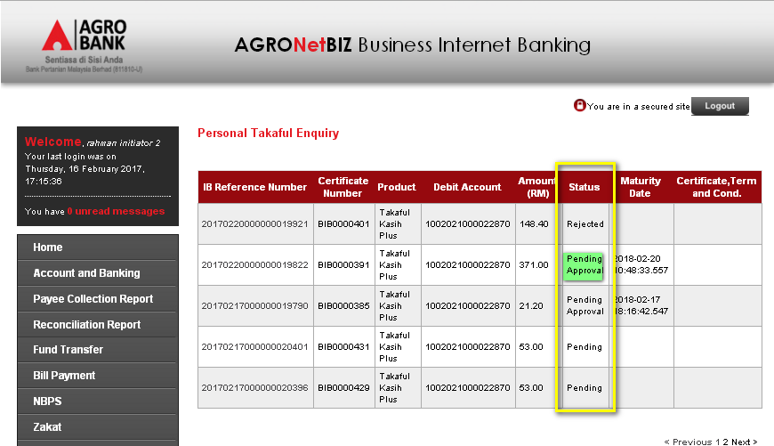
  - Details screen for Pending status.
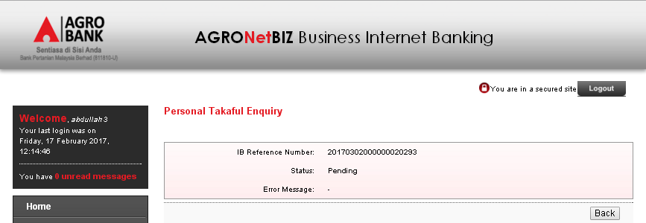
  - Details screen for Successful status.
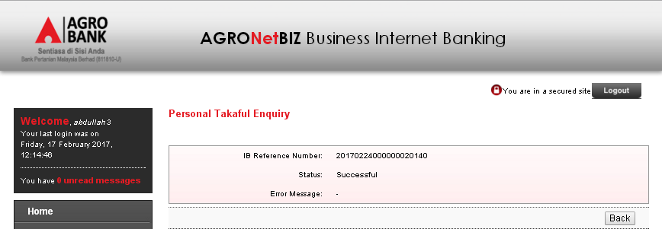
  - Details screen for Unsuccessful status.
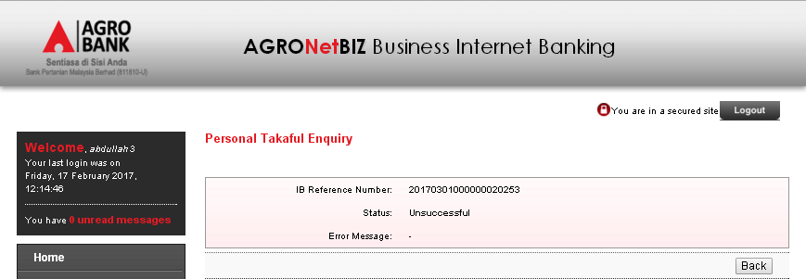
  - Details screen for Rejected status.
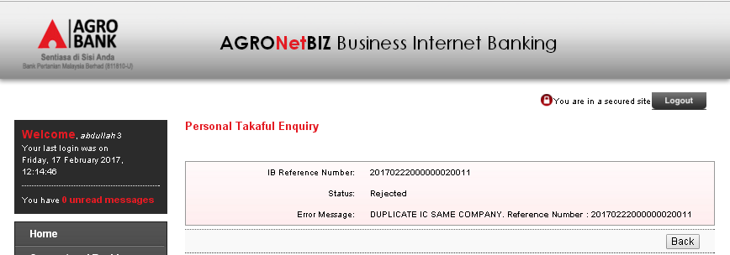

Reviewed By: (PMO)
 |  |  | Name/Position : Norhaidah Binti Md Dasuki / Senior Manager, Quality Assurance and Support  Date :

