Test Issue Log |  |  |  |  |  | SCP ID# :SITB_006
Project Name: | AGROBANK BUSINESS INTERNET BANKING
Test Stage: | Unit Functionality Integration System Interface  Performance Regression Acceptance Pilot
Test Case Number: | Support #7188 |  |  | Test Started Date: |  |  | 10/03/2017
Test Title: | [SITB_006] : IBAM – BIB Transaction Enquiry
Test Description: | To display meaningful error message.  Eg:  invalid ic no format --> Error "IC Number in Line 7 must be numeric"  invalid date of birth --> Error "DOB in Line 4 cannot be future date"
Test Functionality: | IBAM  - BIB Takaful Enquiry
Test Procedure: | Display Error Message: IC Number is not numeric  - Perform Takaful purchase with scenario: enter alphabets on I/C Number  - Set Takaful upload file to be alphabets in I/C Number column.  - View Test Result page.  - View Takaful Enquiry page before run engine.  - View IBAM> BIB Transaction Enquiry page before run engine.  - View Takaful Enquiry after run engine  - View IBAM> BIB Transaction Enquiry after run engine.
Test Result: | Pass: Fail: | Tested by: |  |  | Erni Suhaireen binti Zulkifli
Reason for Failure:
TEST DESCRIPTION
Screenshot:
Display Error Message: IC Number is not numeric
- Perform Takaful purchase with scenario: enter alphabets on I/C Number
  - Set Takaful upload file to be alphabets in I/C Number column.
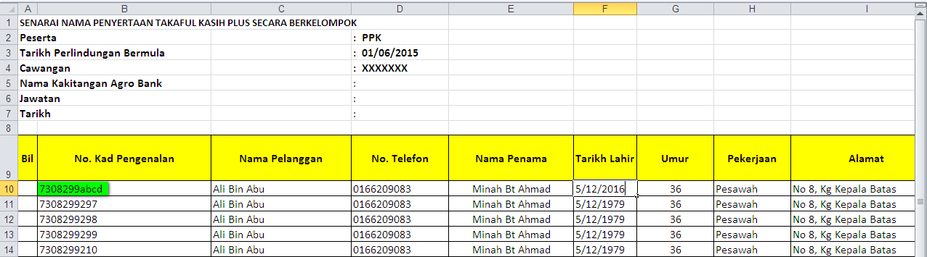
  - View Test Result page.
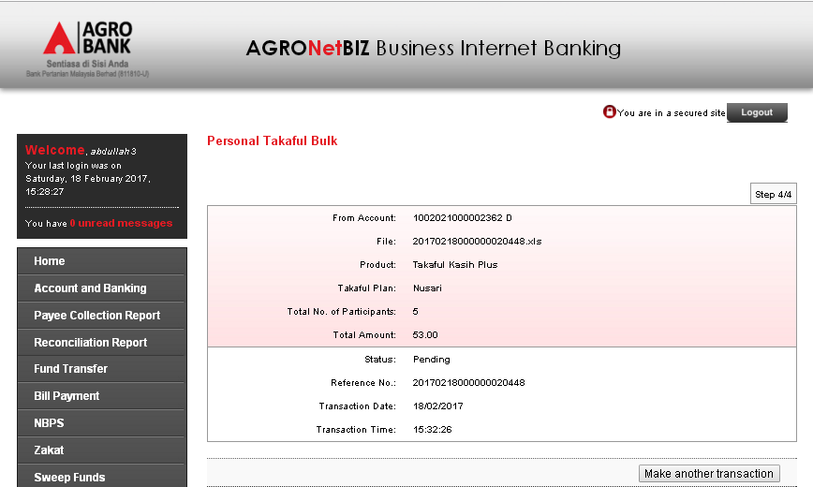
  - View Takaful Enquiry page before run engine.
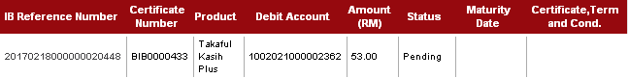

  - View IBAM > BIB Transaction Enquiry page before run engine.
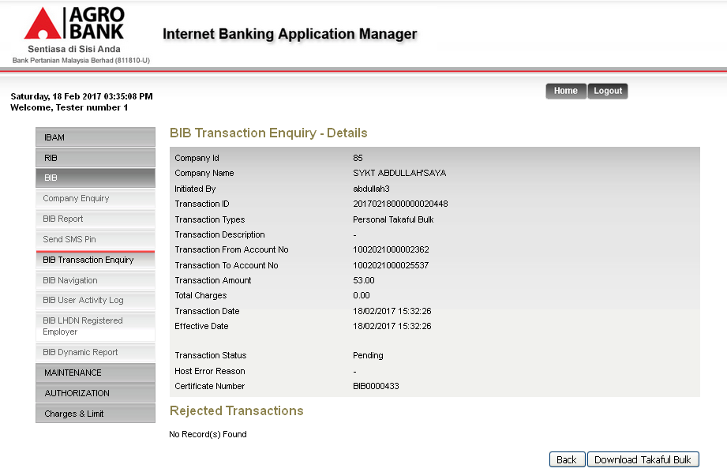
  - View Takaful Enquiry after run engine
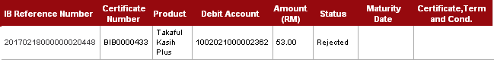
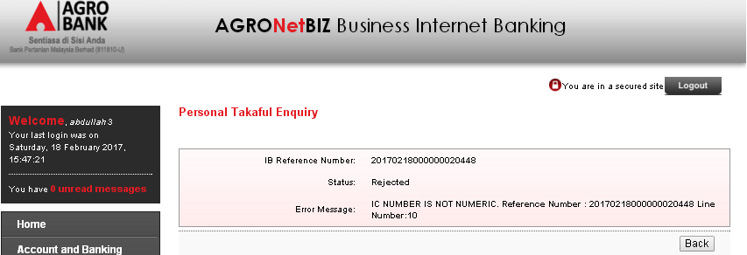

  - View IBAM> BIB Transaction Enquiry after run engine.
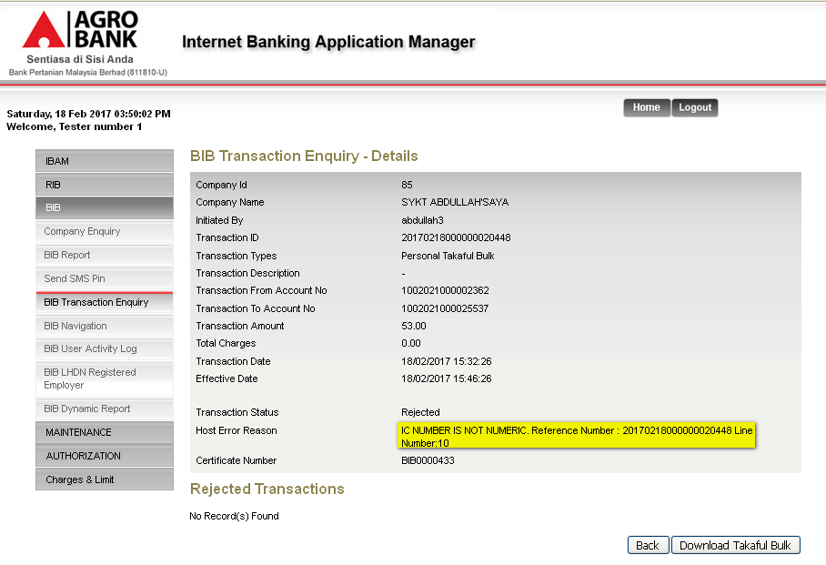

Reviewed By: (PMO)
 |  |  | Name/Position : Norhaidah Binti Md Dasuki / Senior Manager, Quality Assurance and Support  Date :

