Test Issue Log |  |  |  |  |  | SCP ID# : 3705
Project Name: | AGROBANK BUSINESS INTERNET BANKING
Test Stage: | Unit Functionality Integration System Interface  Performance Regression Acceptance Pilot
Test Case Number: | Support #7258 |  |  | Test Started Date: |  |  | 13/03/2017
Test Title: | LHDN & SOCSO REPORT GENERATION ISSUE
Test Description: | To ensure LHDN and SOCSO REPORT GENERATION is generate based on uploaded file date.
Test Functionality: | - LHDN  - SOCSO  - EPF
Test Procedure: | - LHDN  - Perform LHDN payment on 14/03/2017  - Approve the transaction on 15/03/2017  - Display the Report Generation on 16/03/2017  - SOCSO  - Perform SOCSO payment on 14/03/2017  - Approve the transaction on 15/03/2017  - Display the Report Generation on 16/03/2017  - EPF  - Perform SOCSO payment on 14/03/2017  - Approve the transaction on 15/03/2017  - Display the Report Generation on 16/03/2017
Test Result: | Pass: Fail: | Tested by: |  |  | Erni Suhaireen binti Zulkifli
Reason for Failure:
TEST DESCRIPTION
- LHDN
- Perform LHDN payment on 14/03/2017
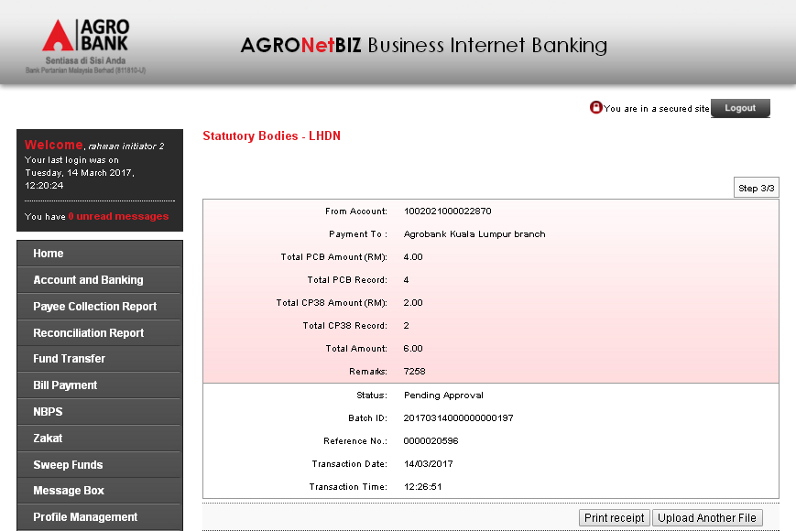
- Approve the transaction on 15/03/2017
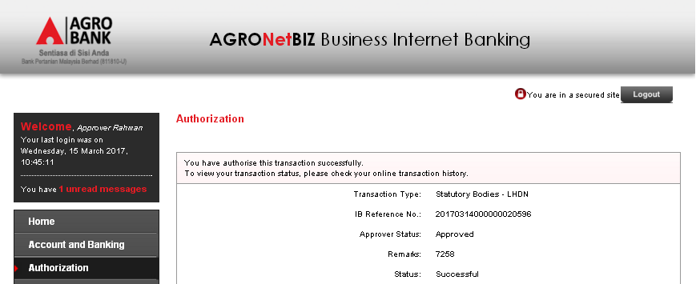

- Display the Report Generation on 15/03/2017
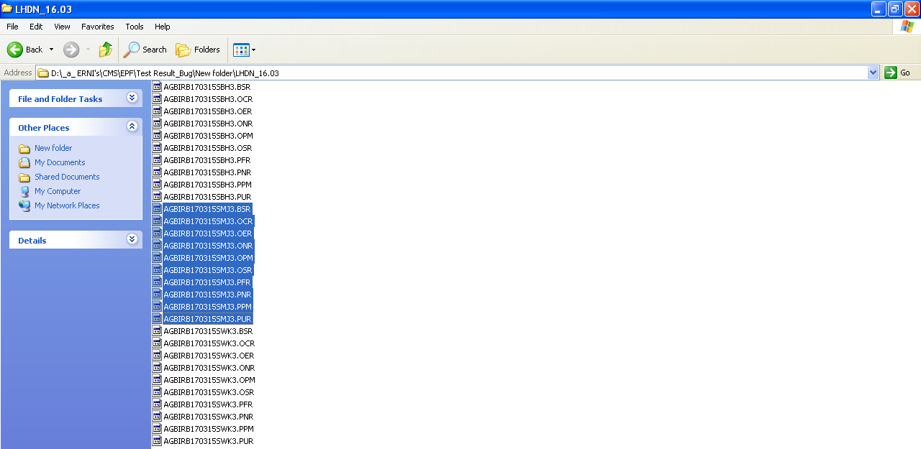

- SOCSO
- Perform SOCSO payment on 14/03/2017
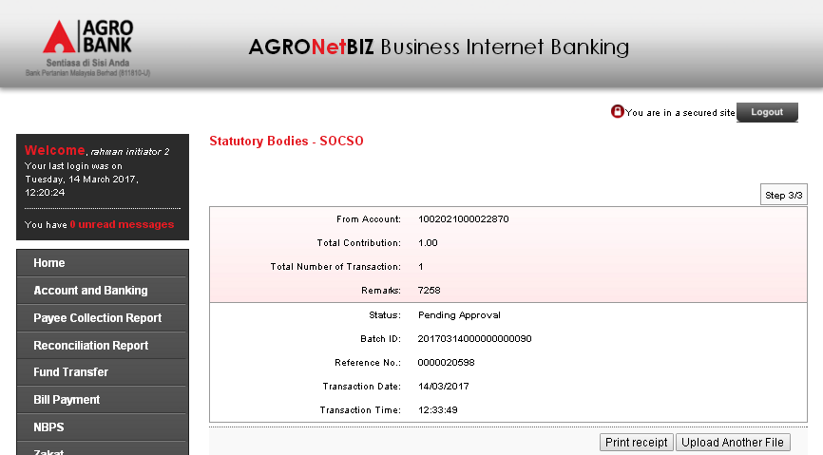
- Approve the transaction on 15/03/2017
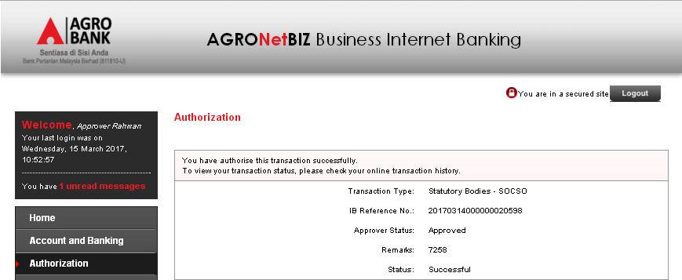

- Display the Report Generation on 15/03/2017
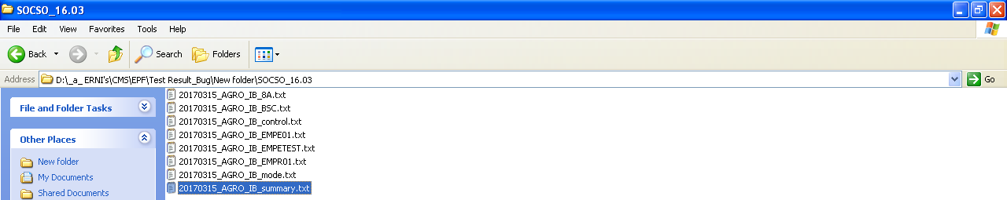
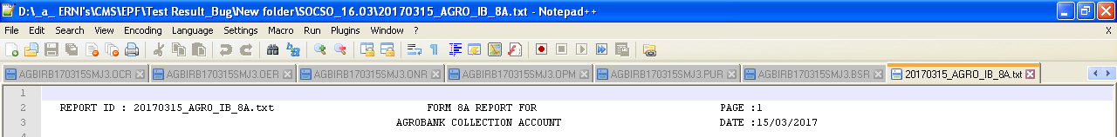
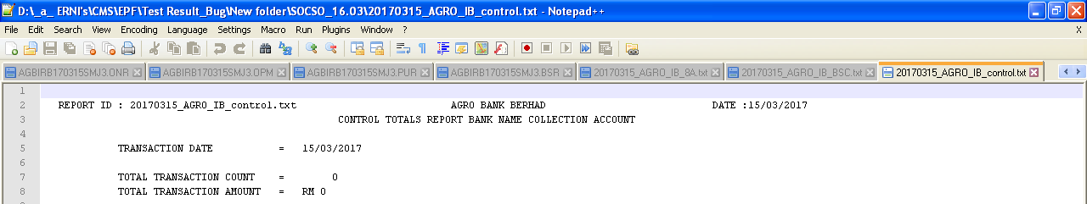
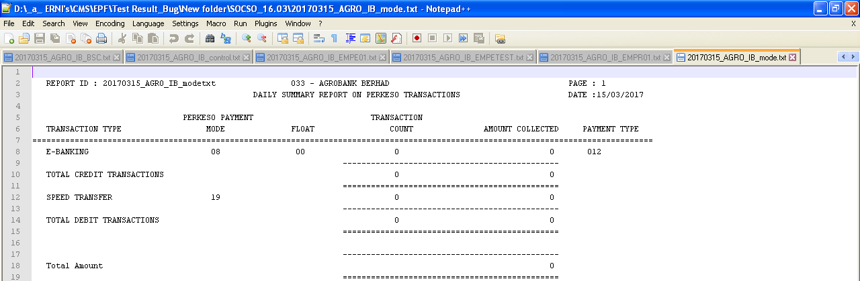
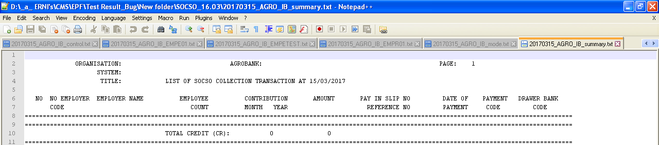

Reviewed By: (PMO)
 |  |  | Name/Position : Norhaidah Binti Md Dasuki / Senior Manager, Quality Assurance and Support  Date :

