Test Issue Log |  |  |  |  |  | SCP ID# : 3712
Project Name: | [Internal Testing] TEKUN NASIONAL - Approver not able approve bulk transaction, error “ Exceed Transaction Limit”
Test Stage: | Unit Functionality Integration System Interface  Performance Regression Acceptance Pilot
Test Case Number: | 7265 |  |  | Test Started Date: |  |  | 22/03/2017
Test Title: | [Internal Testing] Bank Admin suspend token but token not auto unassigned from user
Test Description: | - To ensure token has been automatically unassigned to the selected user when the token has been suspended.  https://172.16.51.35:9452/ibam.preprod.sit/common/Login.do
Test Functionality: | - IBAM – Administrator  - IBAM – Maker/Checker
Test Procedure: | - IBAM – Login as Super Admin  - Performed to assigned token to user (Approvererni).  - View Token Management page to ensure token has been assigned to user (Approvererni).  - Performed to suspend token.  - View Token Management page to ensure token has automatically been unassigned from previous user (Approvererni)
Test Result: | Pass: Fail: | Tested by: |  |  | Erni Suhaireen binti Zulkifli
Reason for Failure:
TEST DESCRIPTION
- IBAM – Login as Super Admin
  - Performed to assigned token to user (Approvererni).
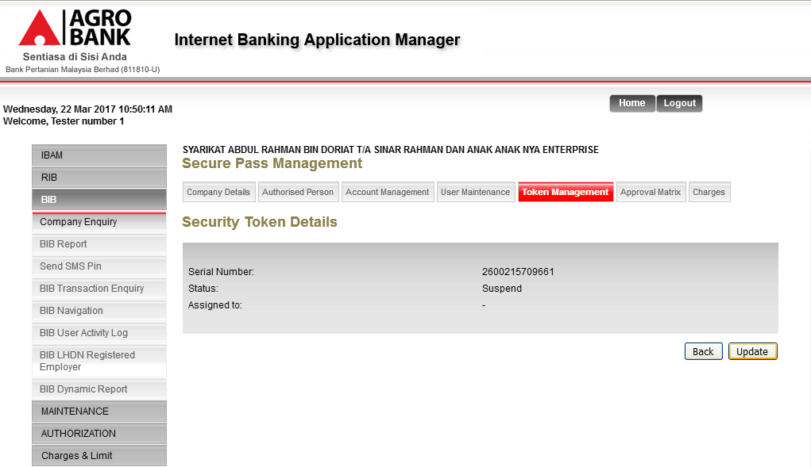
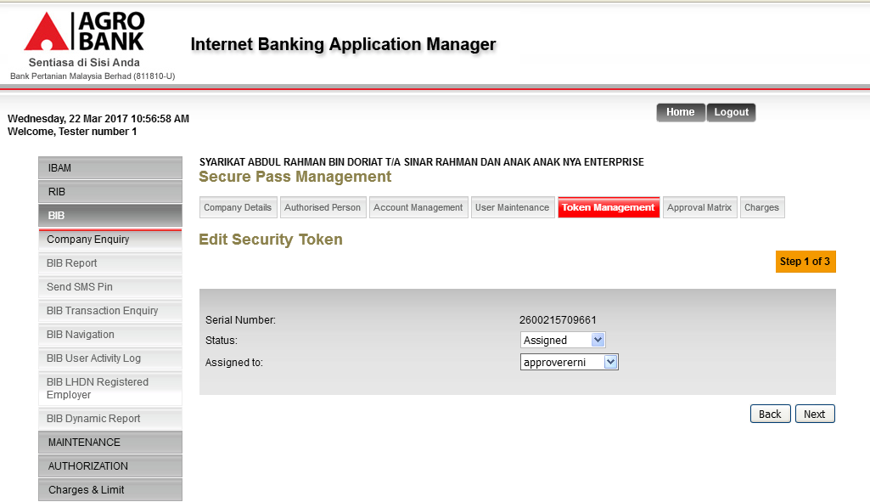
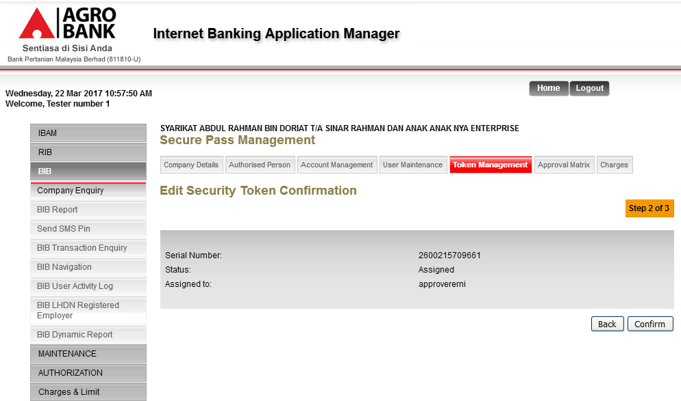
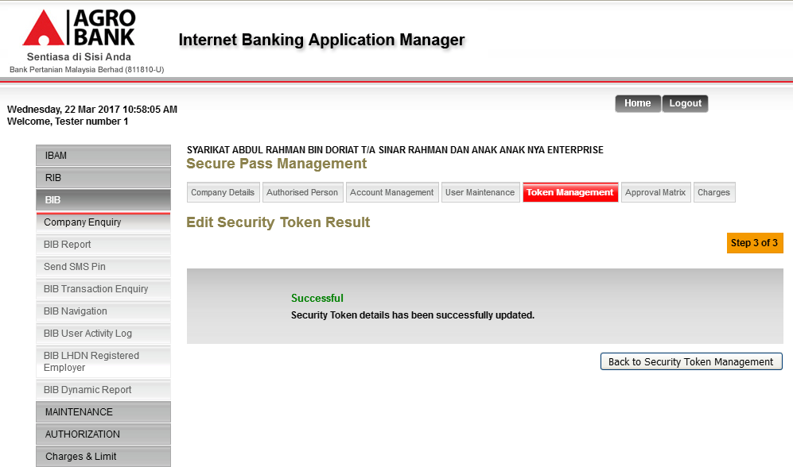
  - View Token Management page to ensure token has been assigned to user (Approvererni).
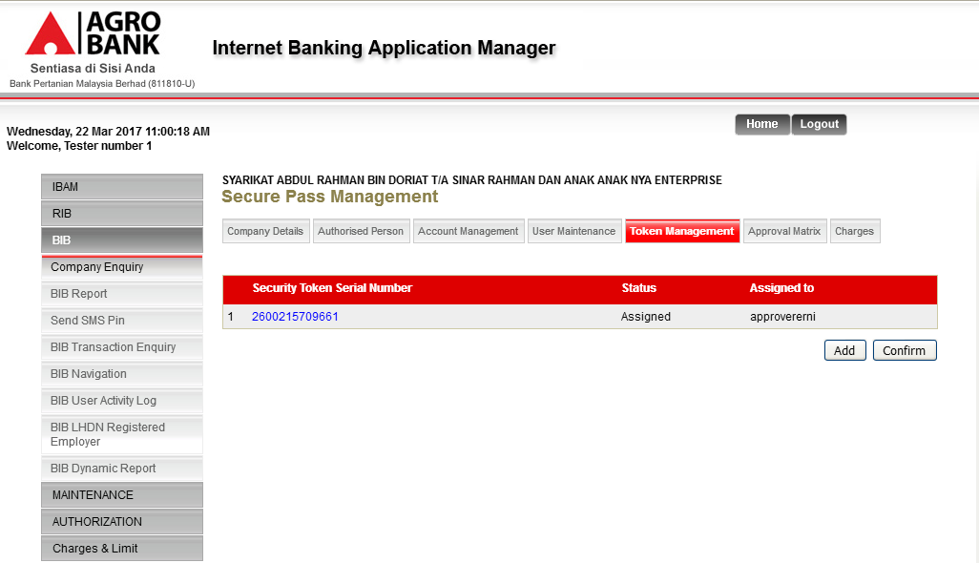
  - Performed to suspend token.
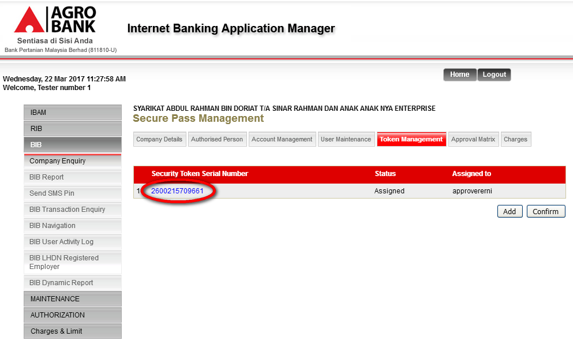
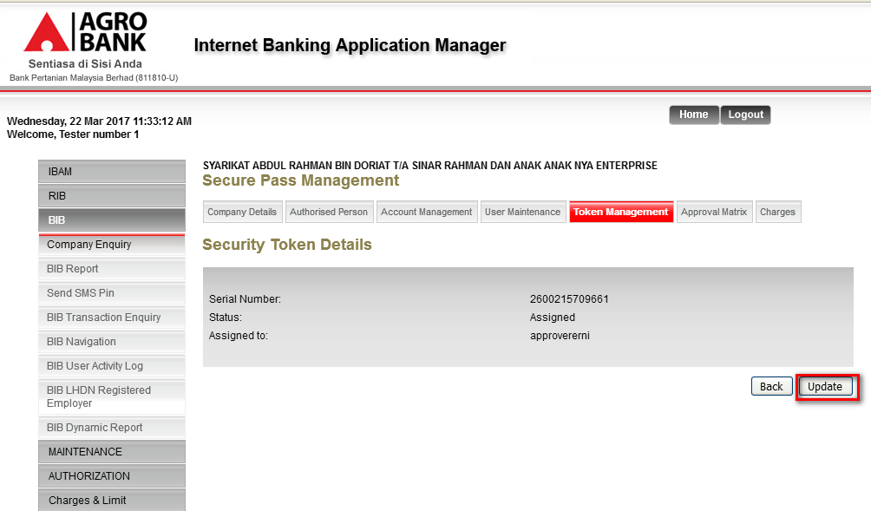
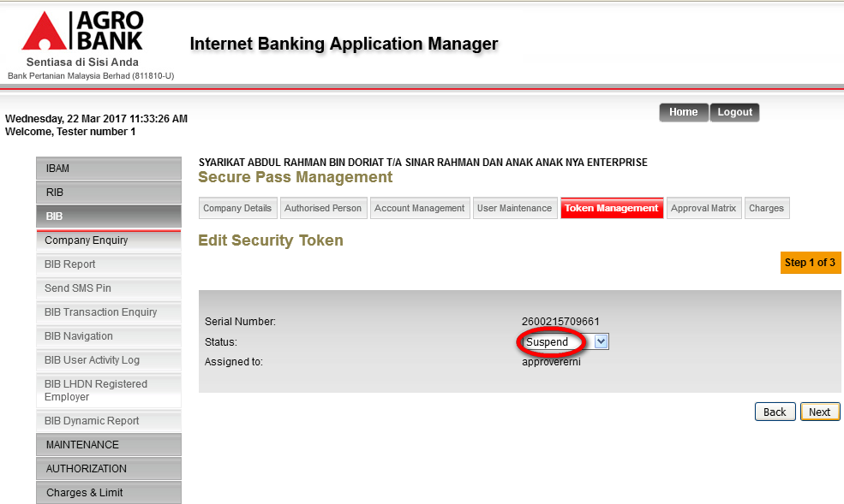
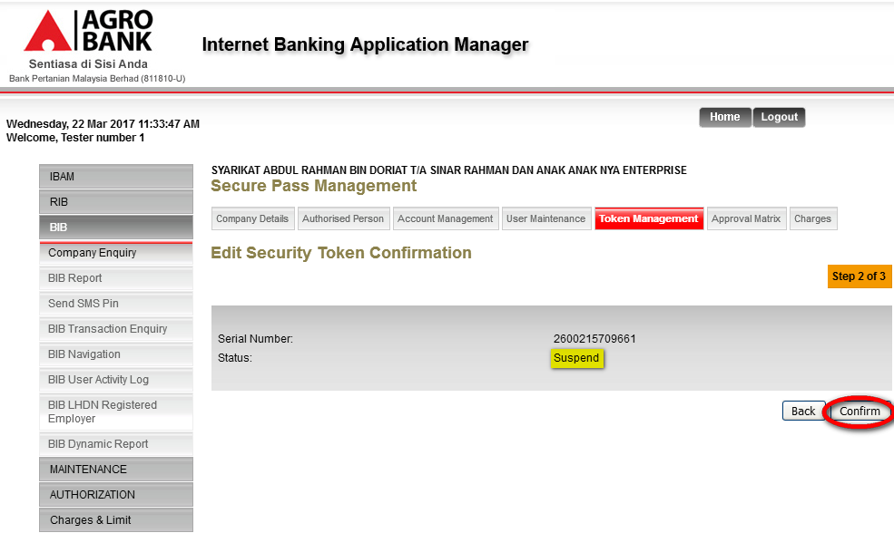
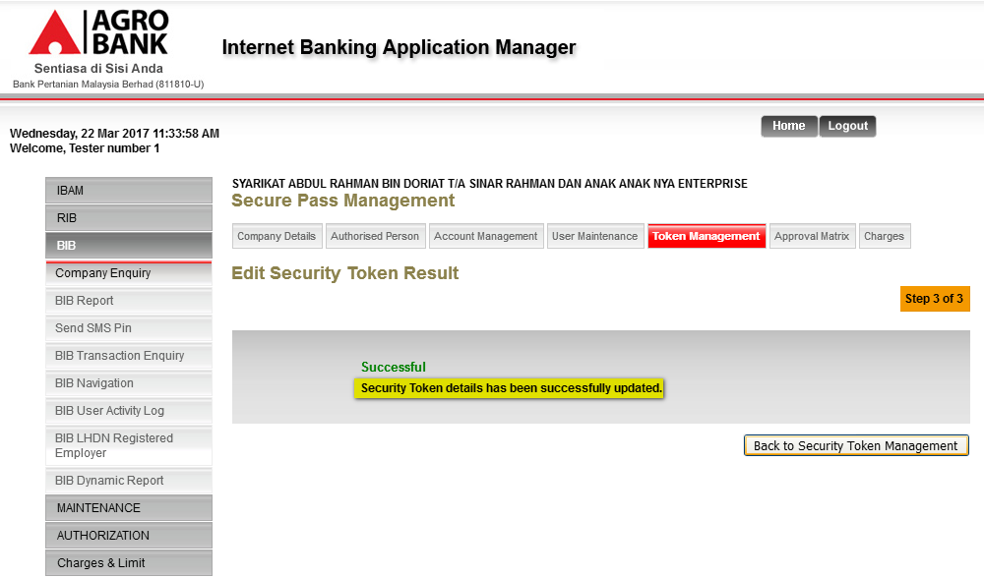
  - View Token Management page to ensure token has automatically been unassigned from previous user (Approvererni)
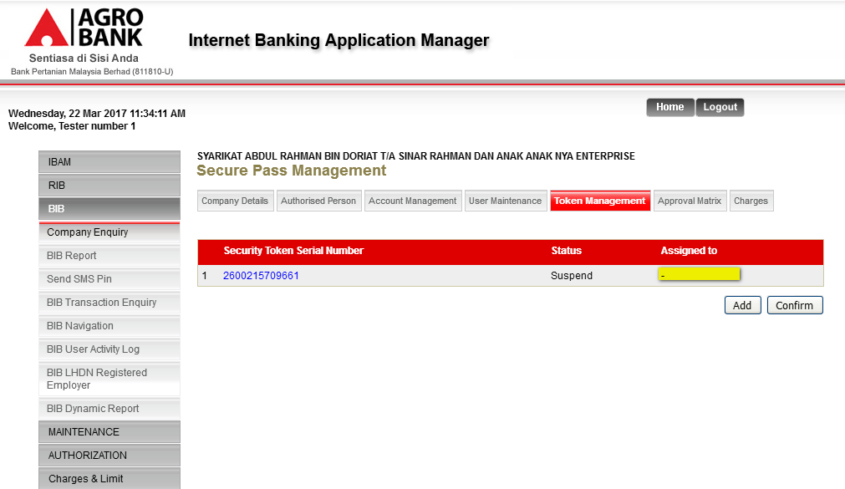
Reviewed By: (PMO)
Lizahwati |  |  | Name/Position : Lizahwati binti Basirun  Date :

