Test Issue Log |  |  |  |  |  | SCP ID# : CR064_1
Project Name: | AGROBANK BUSINESS INTERNET BANKING
Test Stage: | Unit Functionality Integration System Interface  Performance Regression Acceptance Pilot
Test Case Number: | Support #7188 |  |  | Test Started Date: |  |  | 23/03/2017
Test Title: | Unable to displays User Maintenance Edit Page
Test Description: | System displays ‘System is currently unavailable. Please try again later’ when click on Edit button
Test Functionality: | IBAM  - Company Enquiry > User Maintenance
Test Procedure: | To test whether Sweep Funds services is list down on User Maintenance Edit Page when click on Edit button  - Perform to edit selected user (rahmanco3)  - Click on selected user (rahmanco30  - On User Maintenance Details page, click on Edit button.  - System display the User Maintenance Edit Page  Current Result: System displays ‘System is currently unavailable. Please try again later’  Expected Result: System should displays the User Maintenance Edit Page
Test Result: | Pass: Fail: | Tested by: |  |  | Erni Suhaireen binti Zulkifli
Reason for Failure: | System displays ‘System is currently unavailable. Please try again later’ when click on Edit button
TEST DESCRIPTION
To test whether Sweep Funds services is list down on User Maintenance Edit Page when click on Edit button
- Perform to edit selected user (rahmanco3)
  - Click on selected user (rahmanco30
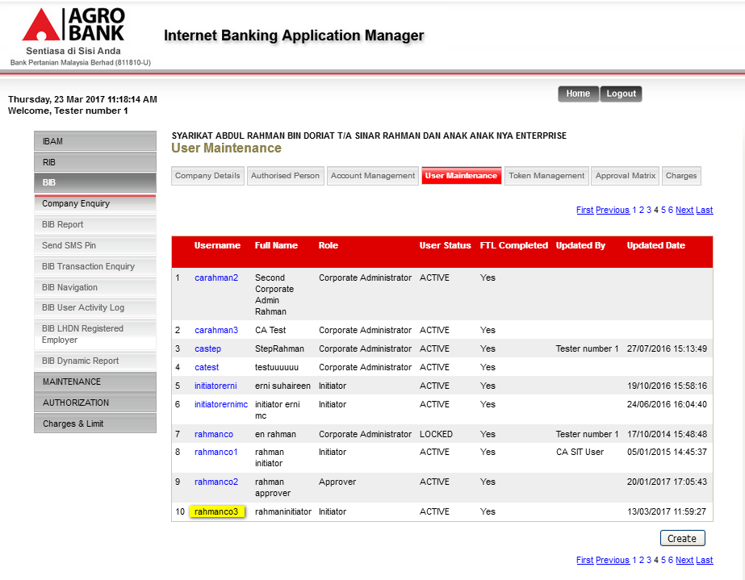

  - On User Maintenance Details page, click on Edit button.
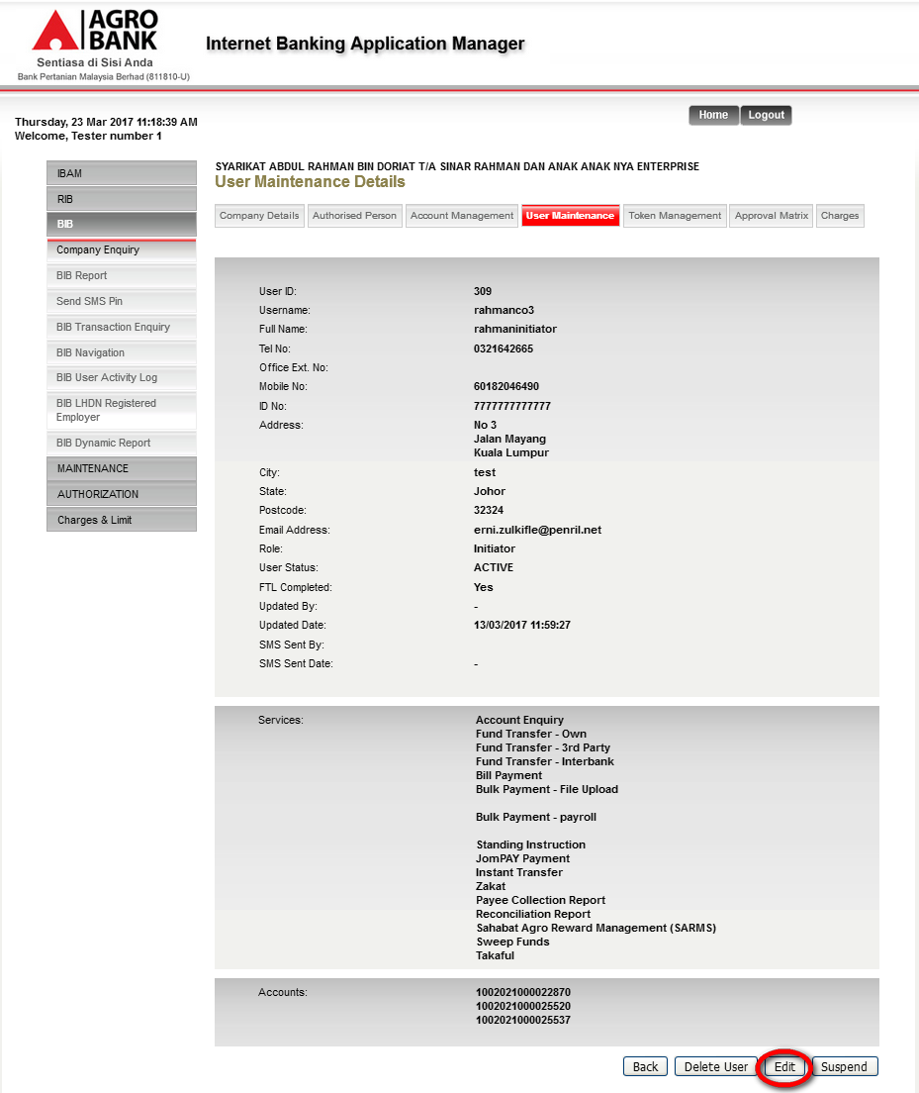\

  - System display the User Maintenance Edit Page
Current Result: System displays ‘System is currently unavailable. Please try again later’
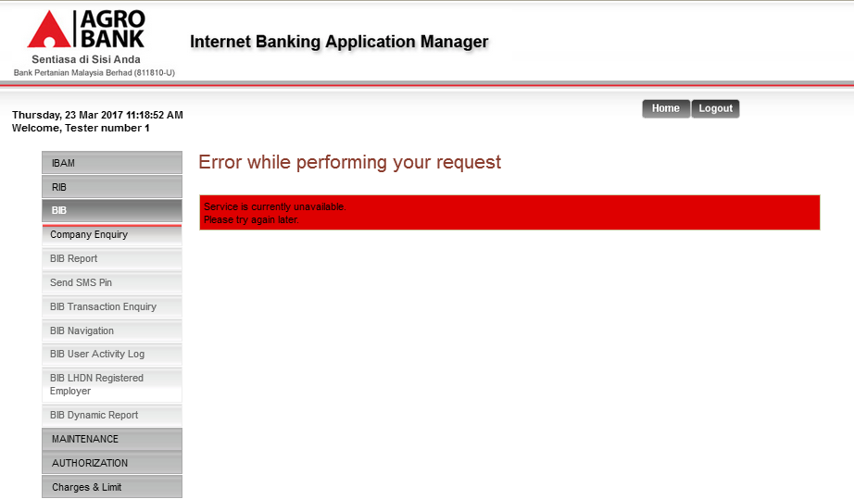
Expected Result: System should displays the User Maintenance Edit Page

Reviewed By: (PMO)
 |  |  | Name/Position : Norhaidah Binti Md Dasuki / Senior Manager, Quality Assurance and Support  Date :

