Test Issue Log |  |  |  |  |  | SCP ID# : CR064_1
Project Name: | AGROBANK BUSINESS INTERNET BANKING
Test Stage: | Unit Functionality Integration System Interface  Performance Regression Acceptance Pilot
Test Case Number: | Support #7188 |  |  | Test Started Date: |  |  | 23/03/2017
Test Title: | Unable to create new user under User Maintenance Page
Test Description: | System displays ‘System is currently unavailable. Please try again later’ when click on Confirm button at User Maintenance Confirm Page  Scenario: Create New User under User Maintenance
Test Functionality: | IBAM  - Company Enquiry > User Maintenance
Test Procedure: | To test whether Sweep Funds services is list down when attempt to create New User under User Maintenance  - Perform to create new user  - Click on Create button.  - On User Maintenance Details page, fill on all blanks space, and then click on Next button.  - On User Maintenance Confirm Page, click on Confirm button. System will displays the Result page.  Current Result: System displays ‘System is currently unavailable. Please try again later’  Expected Result: System should displays the Result Page
Test Result: | Pass: Fail: | Tested by: |  |  | Erni Suhaireen binti Zulkifli
Reason for Failure: | System displays ‘System is currently unavailable. Please try again later’ when click on Confirm button at User Maintenance Confirm Page
TEST DESCRIPTION
To test whether Sweep Funds services is list down when attempt to create New User under User Maintenance
- Perform to create new user
  - Click on Create button.
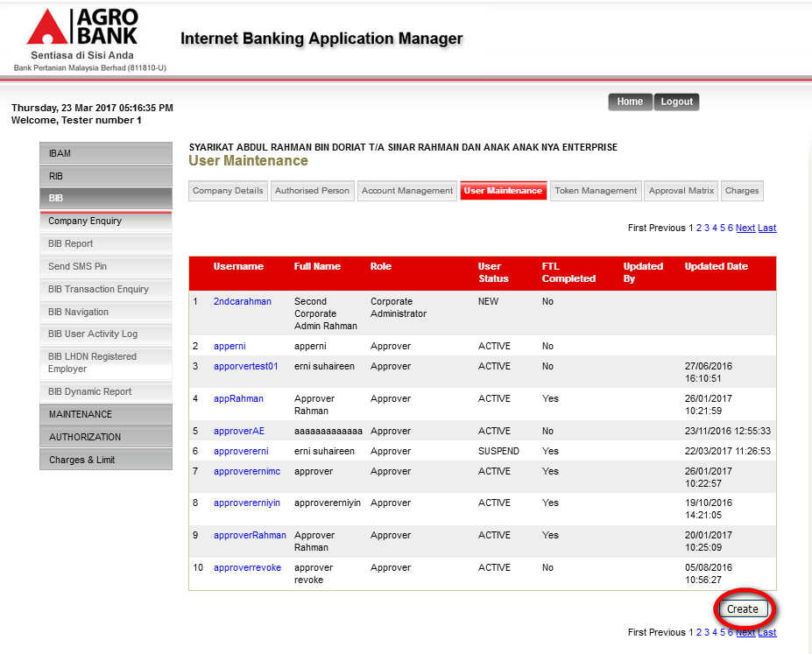

  - On User Maintenance Details page, fill on all blanks space, and then click on Next button.
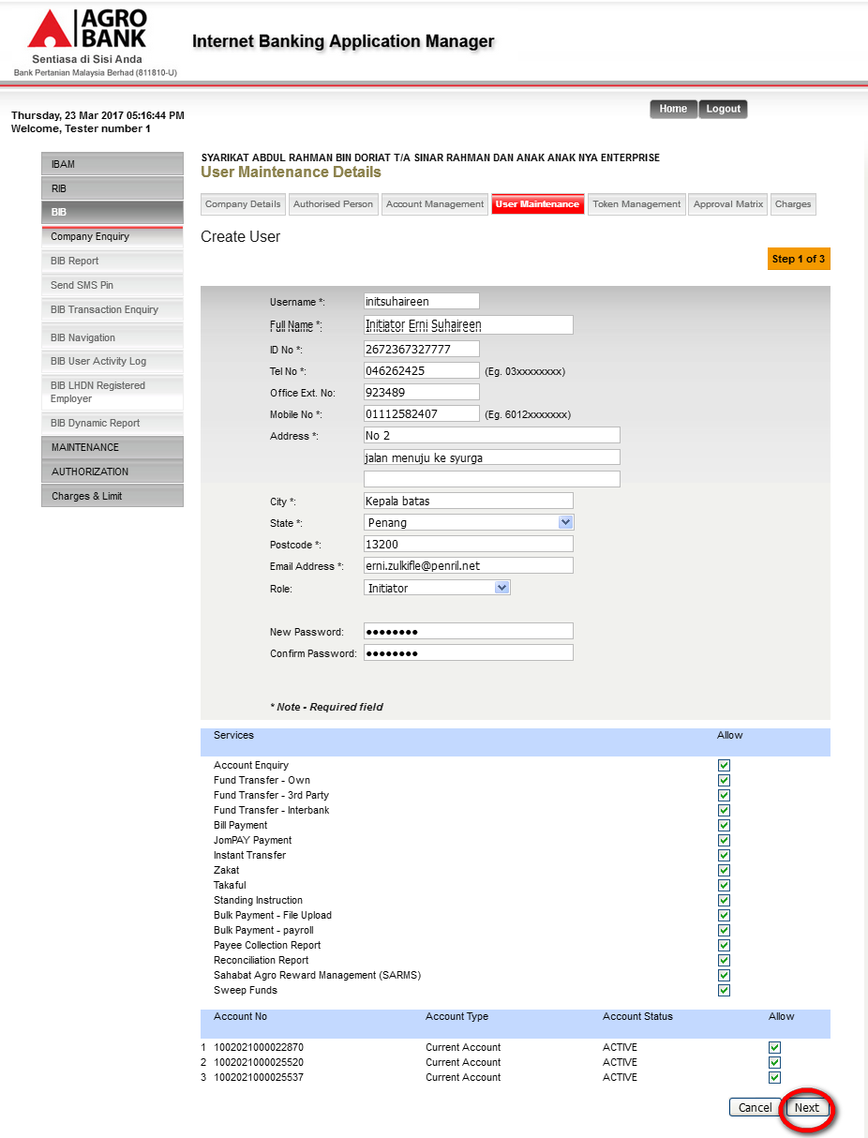
  - On User Maintenance Confirm Page, click on Confirm button. System will display the Result page.
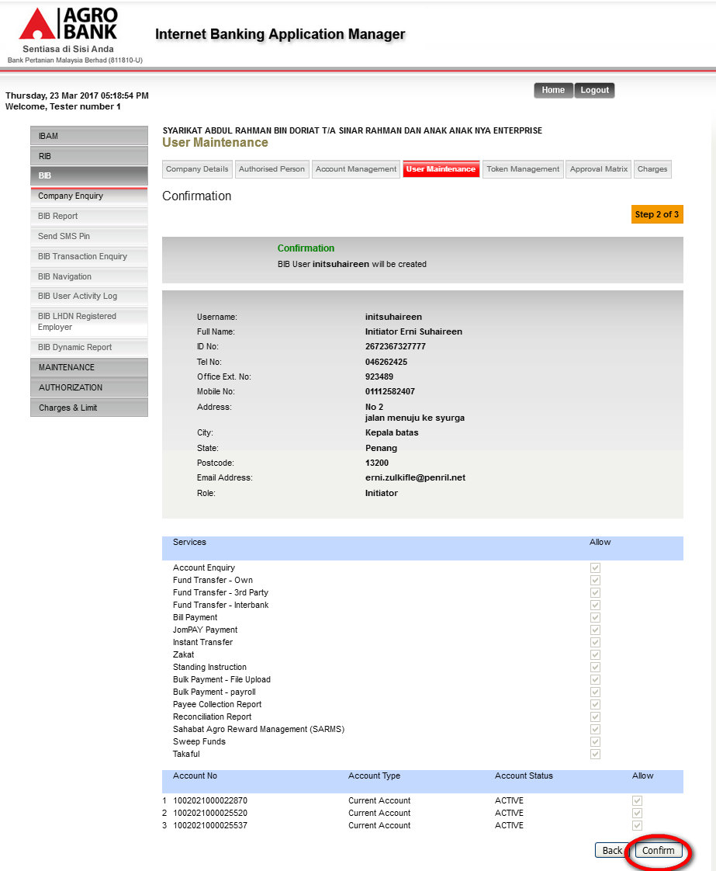

Current Result: System displays ‘System is currently unavailable. Please try again later’
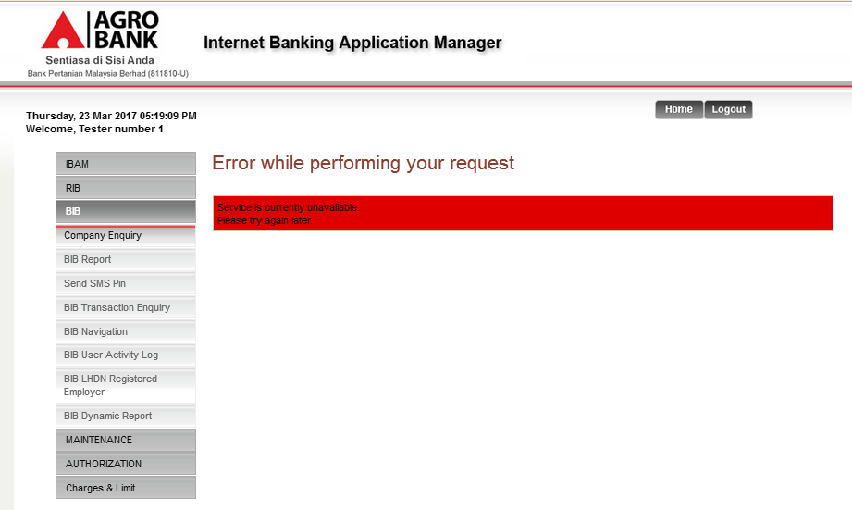
Expected Result: System should displays the Result Page

Reviewed By: (PMO)
 |  |  | Name/Position : Norhaidah Binti Md Dasuki / Senior Manager, Quality Assurance and Support  Date :

