Test Issue Log |  |  |  |  |  | SCP ID# : UAT_RIB013
Project Name: | AGROBANK BUSINESS INTERNET BANKING
Test Stage: | Unit Functionality Integration System Interface  Performance Regression Acceptance Pilot
Test Case Number: | Support #7305 |  |  | Test Started Date: |  |  | 27/03/2017
Test Title: | [UAT_RIB012] - RIB - RIB Takaful - Personal Takaful Purchase
Test Description: | - To ensure Agronet Transaction History displayed RIB Certificate Number in Beneficiary Name/Transaction Details/Payment Ref/Remarks column  https://172.16.50.27/rib.sit.takaful/common/Login.do
Test Functionality: | RIB  - Account and Banking > Agronet Transaction History
Test Procedure: | RIB  - Display Agronet Transaction History.
Test Result: | Pass: Fail: | Tested by: |  |  | Erni Suhaireen binti Zulkifli
Reason for Failure:
TEST DESCRIPTION
- Display Agronet Transaction History.
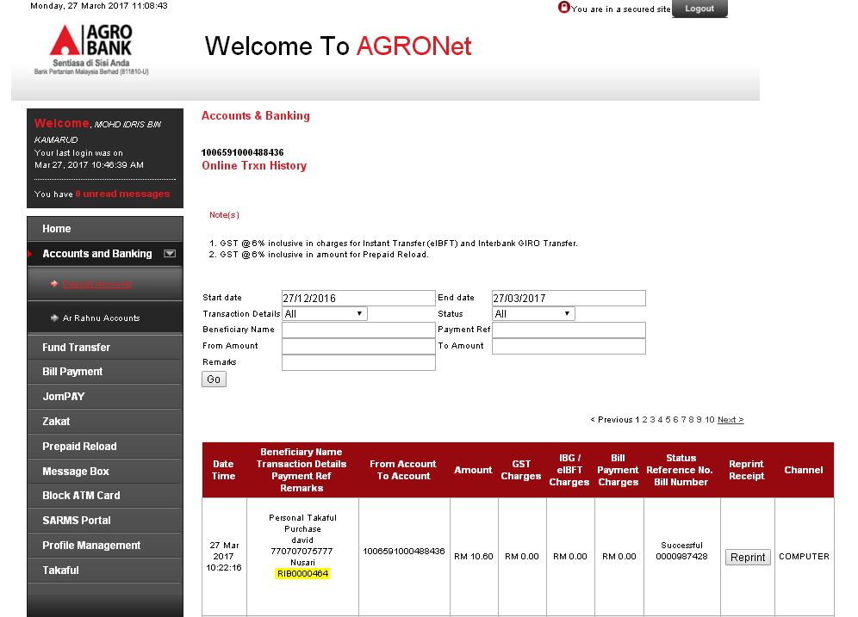
Reviewed By: (PMO)
 |  |  | Name/Position : Norhaidah Binti Md Dasuki / Senior Manager, Quality Assurance and Support  Date :

