**Agrobank**

|  |
| --- |
| **Enhancement for KADA Requirements**  Enable Audit Trail of User Activities  For The Company’s |
| Business Requirement and System Specification |

**(PENRIL/AGRO-BRS/CR00063/05)**

**Version 1.0**

**18th January 2017**

Prepared By:



**Penril Datability (SEA) Sdn Bhd (384556-U)**

Suite A-07-07 Plaza Mon’t Kiara

No. 2, Jalan Kiara, Mon’t Kiara

50480 Kuala Lumpur, Malaysia

Tel: (603) 6201 2622Fax: (603) 6201 7622

# Document Amendment Log

| **Rev. No** | **Date Update** | **Description of Change** | **Update By**  **<Name, Dept>** | **Review By**  **<Name, dept>** | **Approved By**  **<Name, Dept>** |
| --- | --- | --- | --- | --- | --- |
| 1.0 | 06/03/2017 | Initial Release | Stephanie Sufrapto,  Software Engineer |  |  |
|  |  |  |  |  |  |
|  |  |  |  |  |  |
|  |  |  |  |  |  |
|  |  |  |  |  |  |

# Table of Contents

Document Amendment Log 2

Table of Contents 3

Business Requirement Acceptance 4

Section A: Introduction 5

1 Objective 5

2 Scope 6

Section B: Internet Banking 7

2. Cash Management Solution 7

2.1 Audit Trail 7

2.1.1 Process Flow 7

2.1.2 Screen Flow 8

2.2 User Maintenance – Edit User 11

2.2.1 Screen Flow 11

2.3 User Maintenance – Create User 17

2.2.1 Screen Flow 18

3. Internet Banking Administration Module (IBAM) 23

3.1 Create Company 23

3.1.1 Screen Flow 23

3.2 Edit Company Details 31

3.1.1 Screen Flow 31

3.3 Create User 40

3.3.1 Screen Flow 40

3.4 Edit User 50

3.4.1 Screen Flow 50

3.4 BIB Navigation 58

3.5 IBAM Audit Trail 58

Section C: Appendix 61

A1: Impact Module 61

# Business Requirement Acceptance

I/We hereby verify that this Business Requirement consist of all the requirements requested by AGROBANK. The implemented system will fulfill ONLY this requirement.

I/We also hereby AGREE that this satisfies our entire requirement for **CR BIB Project**

Any future changes to this agreed scope will be treated as an enhancement to the system. Any future changes to the project timeline will be subjected to the final approval of the project steering committee.

**AGROBANK:**

|  |  |  |  |
| --- | --- | --- | --- |
| **Approved by** | **Role** | **Signature** | **Date** |
|  |  |  |  |
|  |  |  |  |
|  |  |  |  |
|  |  |  |  |
|  |  |  |  |
|  |  |  |  |
|  |  |  |  |

**Penril Datability (M) Sdn. Bhd.:**

|  |  |  |  |
| --- | --- | --- | --- |
| **Approved by** | **Role** | **Signature** | **Date** |
|  |  |  |  |
|  |  |  |  |

# Section A: Introduction

This document served as the business requirement and system specification of adding/creating new function/module for display transaction details at Authorization Screen for Business Internet Banking.

This document shall explain all the features and functionalities, which is elaborating with screen captures, process flow, descriptions, input fields specifications and error messages. All screen designs provided in this document are samples and only illustration purpose for easy understanding. The screen designs are not final

# Objective

The objective of this document is to capture user requirements of adding/create new function/module by display transaction details at Authorization Screen for Bulk Payment, Payroll, and Statutory Bodies modules. This document will facilitate development and implementation of the mentioned modules of Internet Banking System for Agro bank.

The base line features description and screen designs will become a reference blueprint for the development team to develop the transactional and administration module. Hence, it is crucial that all stakeholders need to ensure the correctness and adequacy of the requirements captured in this document.

All stakeholders involved are expected to review and sign off this document before the development start. By signing off the document, the stakeholder has endorsed the correctness and accuracy and adequacy of the requirements documented in this document.

# Scope

The scope is inclusive all services as follows:

| **System** | **Feature/Functionality** | **Description** |
| --- | --- | --- |
| **CMS** | * User Activity Log (new navigation)   Roles: Corporate Admin, Initiator, Single User & Approver | * To enable audit trail to view the Company’s User Activity (Monetary and Non-Monetary Activity) * To add search criteria   + User Name   + Date From/To   + Activity Type   + Status * To add search result screen   + Including Activity ID, UserName, Activity Date, Activity Type |
| IBAM | * Company Enquiry | * Company Enquiry-Company Details   + Functionality to enable/disable the Company to access to User Activity Log * Company Enquiry-User Maintenance   + Functionality to enable/disable the Company’s User to access to User Activity Log |
|  | * BIB Navigation | * Add Audit Trail to navigation |

# Section B: Internet Banking

# Cash Management Solution

## Audit Trail

To enable audit trail to view the Company’s User Activity (Monetary and Non-Monetary Activity)

### 2.1.1 Process Flow



### 2.1.2 Screen Flow

***Step 1:***

1. User login to BIB.
2. Access Audit Trail Navigation
3. CMS will display the Audit Trail Type, User need to select Monetary or Non–Monetary.

(Note: Monetary equal to BIB Transaction Enquiry and Non-Monetary equal to BIB User Activity)

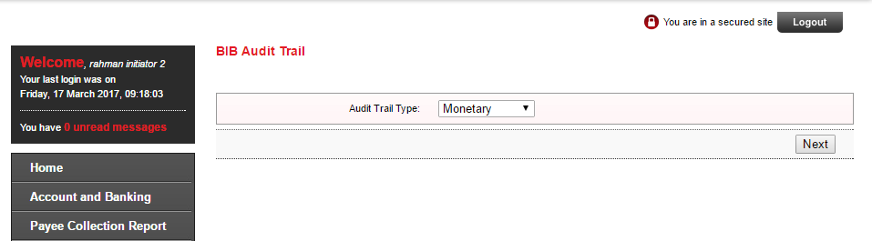

Figure 1 : Audit Trail Type page

**Input Specification:**

|  |  |  |  |  |  |
| --- | --- | --- | --- | --- | --- |
| **No** | **Field** | **Field Type** | **Validation Rule** | **Description** | **Compulsory** |
|  | Audit Trail Type | Drop Down | - | Unique identifier for audit trail type.  -Monetary  -Non Monetary | Default the option to monetary |

Table 1: Audit Trail Type Input Specification

**Action:**

| **No** | **Action** | **Type** | **Description** |
| --- | --- | --- | --- |
|  | Next | Button | Contain action to go to search page |

Table 2: Audit Trail Type Action Specification

**Step 2:**

1. CMS will display the search page for audit Trail

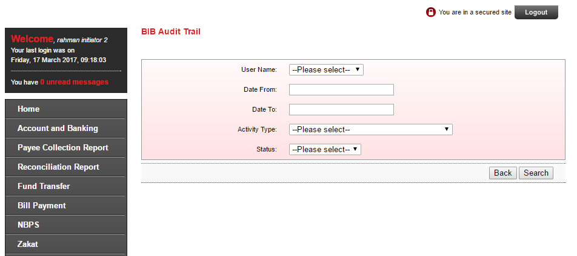

Figure 2 :

**Input Specification:**

|  |  |  |  |  |  |
| --- | --- | --- | --- | --- | --- |
| **No** | **Field** | **Field Type** | **Validation Rule** | **Description** | **Compulsory** |
|  | User Name | Drop Down | - | Unique identifier for each user.  Dropdown list consist of user from same company as the user login to CMS | No |
|  | Date from | Calendar, Date Picker | Date format: dd/MM/yyyy | Search any transaction that occurred from the date defined. | No |
|  | Date to | Calendar, Date Picker | Date format: dd/MM/yyyy | Search any transaction that occurred until to the date defined. | No |
|  | Activity Type | Drop down list | - | Search any activity based on the activity type | No |
|  | Status | Drop down list | - | Search any activity based on the status | No |
|  | Transaction Type | Drop down list | - | Search any activity based on the transaction type  Drop down consists of:  - Monetary  - Non-Monetary | No |

Table 2: Audit Trail Input Specification

**Action:**

| **No** | **Action** | **Type** | **Description** |
| --- | --- | --- | --- |
|  | Search | Button | Contain action to search the Audit Log based on criteria input by user |
|  | Back | Button | Contain action to back to Main page |

Table 3: Audit Trail Action

***Step 2:***

1. User input the criteria of search
2. Click Search

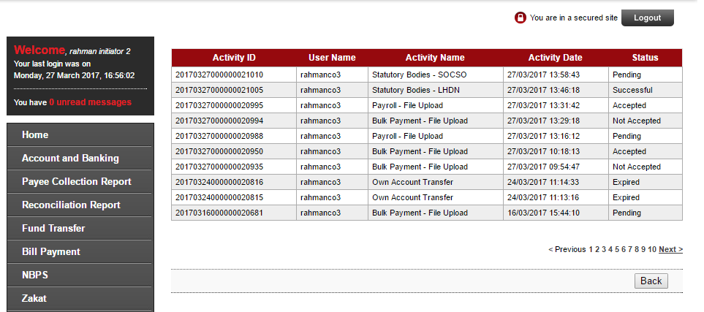

Display Specification:

| **No** | **Field** | **Format** | **Description** |
| --- | --- | --- | --- |
|  | Activity ID | Numeric, Hyperlink | Unique ID for Activity |
|  | Username | Text | Username for user for activity |
|  | Activity Name | Text | Name of activity |
|  | Activity date | Text | Date with format dd/MM/yyyy |
|  | Status | Text | Status of the Activity |

Table 4: Audit Trail Search display Specification

**Action:**

| **No** | **Action** | **Type** | **Description** |
| --- | --- | --- | --- |
|  | Back | Button | Back to audit trail search page |

Table 5: Audit Trail Search Action

## User Maintenance – Edit User

In this CR, Audit Trail will be added in list of Services. Corporate Admin will able to add/remove service Audit Trail in User Maintenance.

### 2.2.1 Screen Flow

Step 1:

1. User login to BIB as CA

2. CA access IB service Administration > User Maintenance

3. CA click specific user to be edit

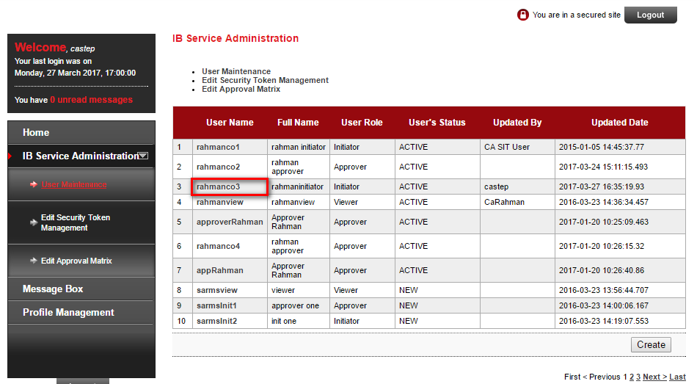

Figure 3 : User Maintenance Result page

Step 2:

1. CMS will display the details of user

2. Click edit

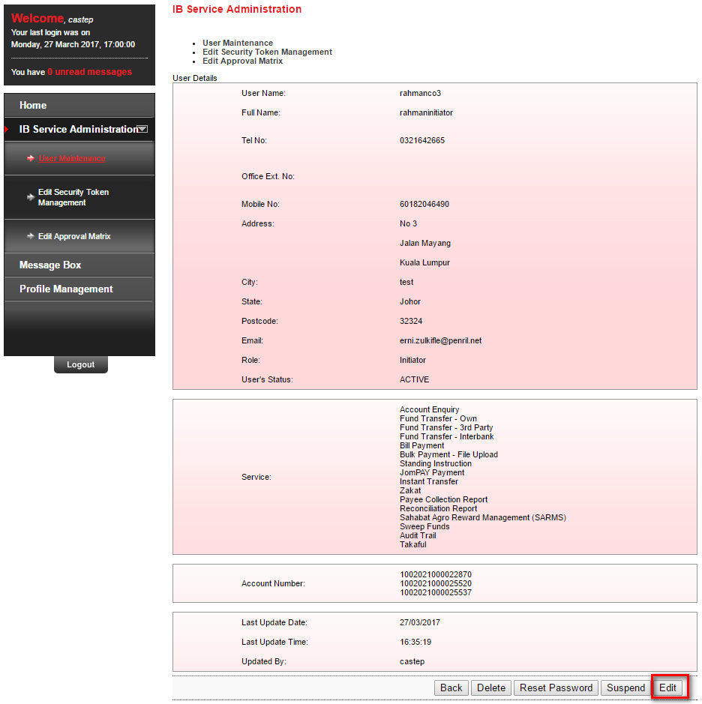

Figure 4 : User Maintenance Details page

Step 3:

1. This CR consist of adding Audit Trail in service, CA will able to tick or un tick the Audit Trail in service

2. Click update

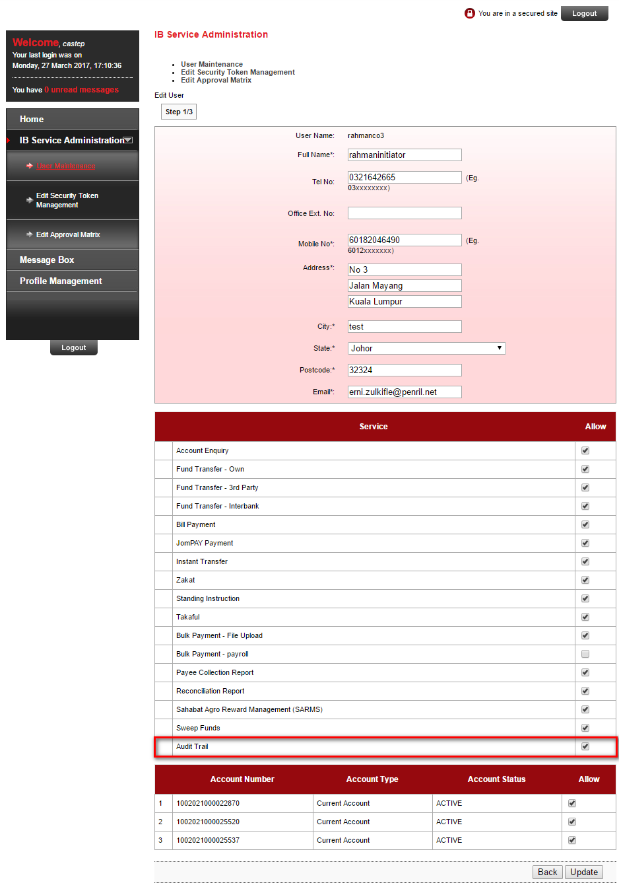

Figure 5 : User Maintenance Edit page

**Input Specification:**

|  |  |  |  |  |  |
| --- | --- | --- | --- | --- | --- |
| **No** | **Field** | **Field Type** | **Validation Rule** | **Description** | **Compulsory** |
| 1. | Audit Trail | Check box | - | Determine whether the user able to navigate it or not | - |

Table 6: Audit Trail Type Input Specification

**Action:**

| **No** | **Action** | **Type** | **Description** |
| --- | --- | --- | --- |
| 1 | Update | Button | Contain action to go to confirm the changes |

Table 7: Audit Trail Edit Action

Step 4:

1. Confirm the page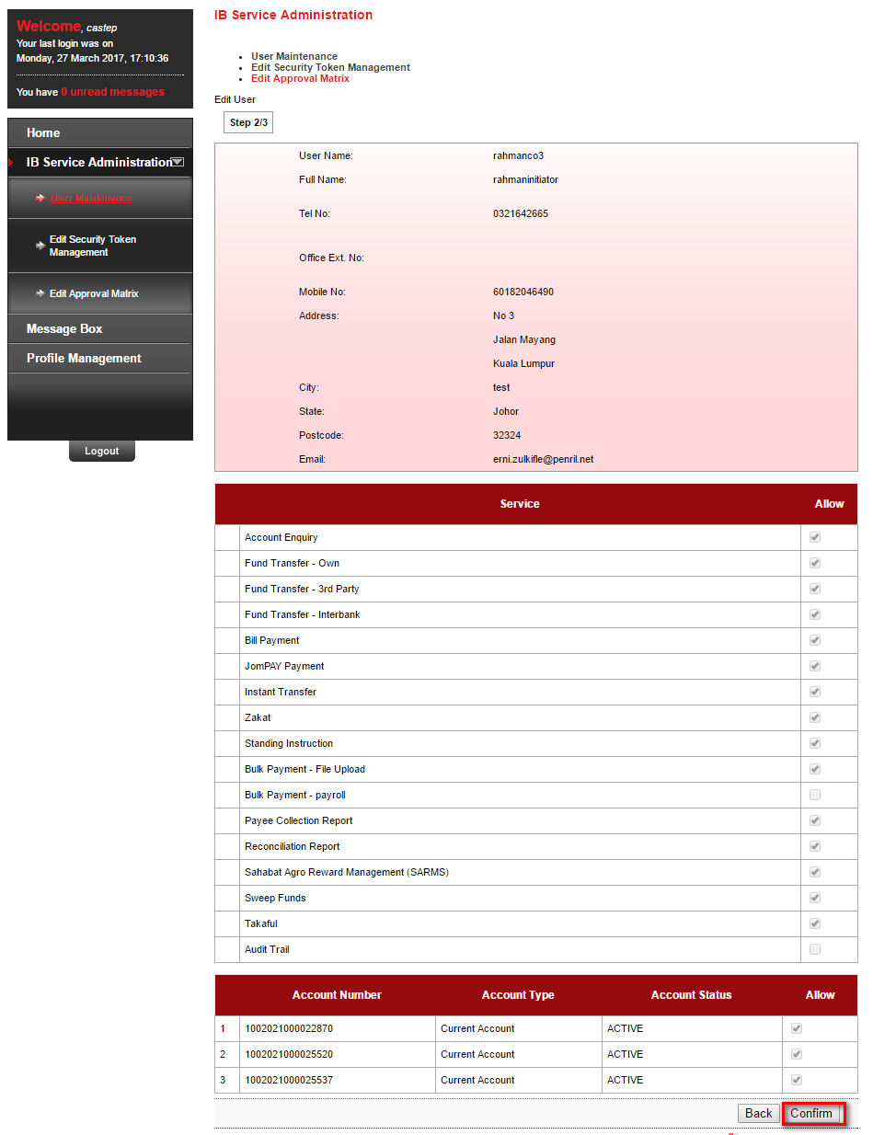

Figure 6 : User Maintenance Edit Confirm page

Step 5:

1. CMS will show result page

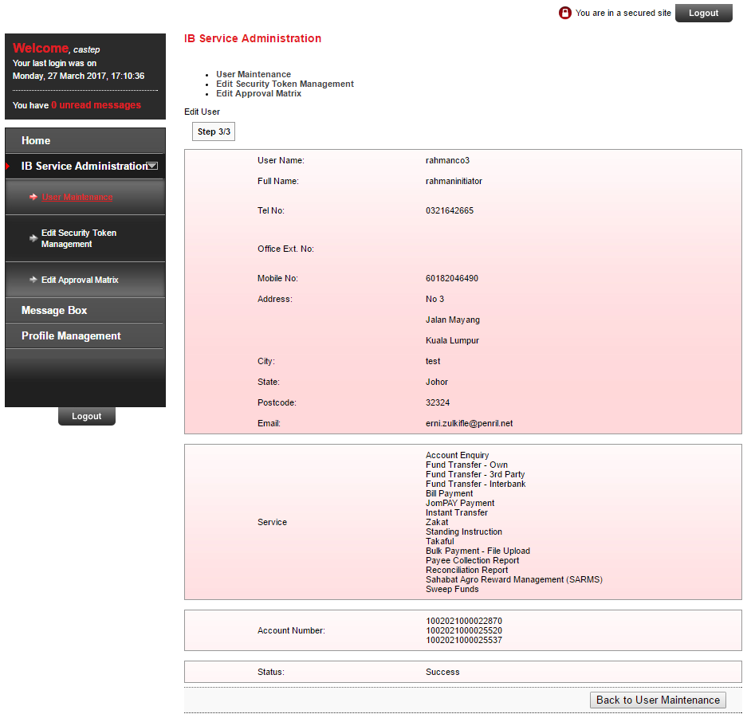

Figure 7 : User Maintenance Edit Result page

## User Maintenance – Create User

### 2.2.1 Screen Flow

Step 1:

1. User login to BIB as CA

2. CA access IB service Administration > User Maintenance

3. CA click Create

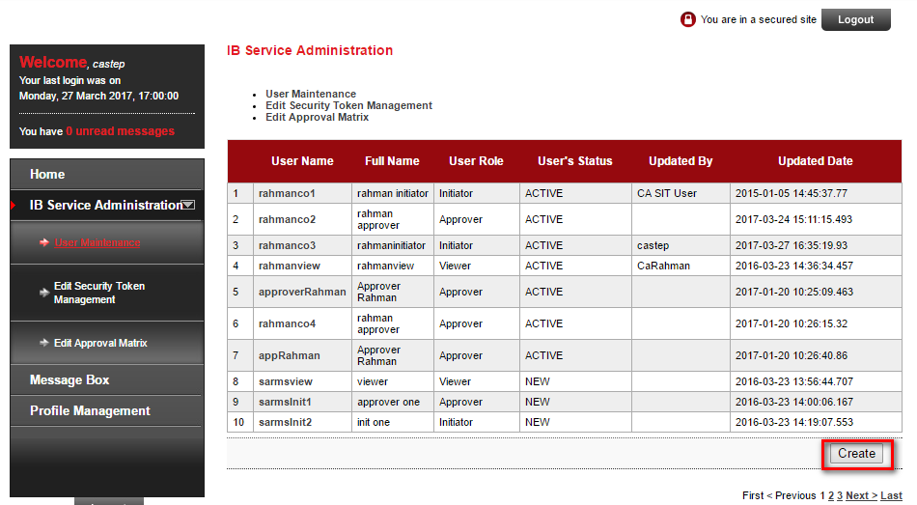

Figure 8 : User Maintenance Result page

Step 2:

1. CA needs to select the type of user to be created

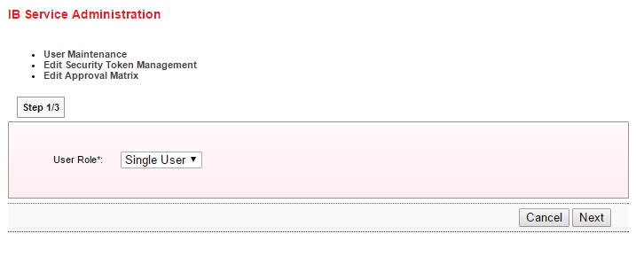

Figure 9 : User Maintenance Create page

Step 3:

1. CMS will display the input for user

2. Click Confirm

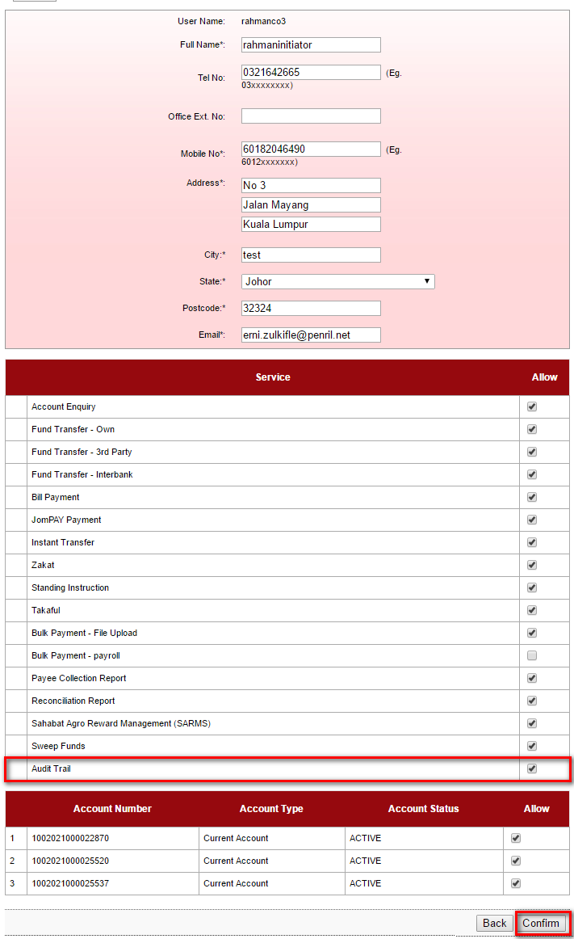

Figure 10 : User Maintenance Create confirm page

**Input Specification:**

|  |  |  |  |  |  |
| --- | --- | --- | --- | --- | --- |
| **No** | **Field** | **Field Type** | **Validation Rule** | **Description** | **Compulsory** |
| 1. | Audit Trail | Check box | - | Determine whether the user able to navigate it or not | - |

Table 8: Audit Trail Type Input Specification

**Action:**

| **No** | **Action** | **Type** | **Description** |
| --- | --- | --- | --- |
| 1 | Confirm | Button | Contain action to go to confirm the changes |

Table 9: Audit Trail Edit Action

Step 4:

1. CMS will display confirm Page

2. Click confirm



Figure 11 : User Maintenance Edit Confirm page

Step 5:

1. CMS will show result page

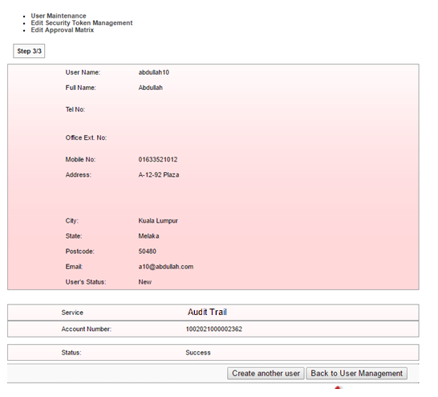

Figure 12 : User Maintenance Create Result page

# Internet Banking Administration Module (IBAM)

## Create Company

### 3.1.1 Screen Flow

Step 1:

1. Login to IBAM

2. Access Company Enquiry

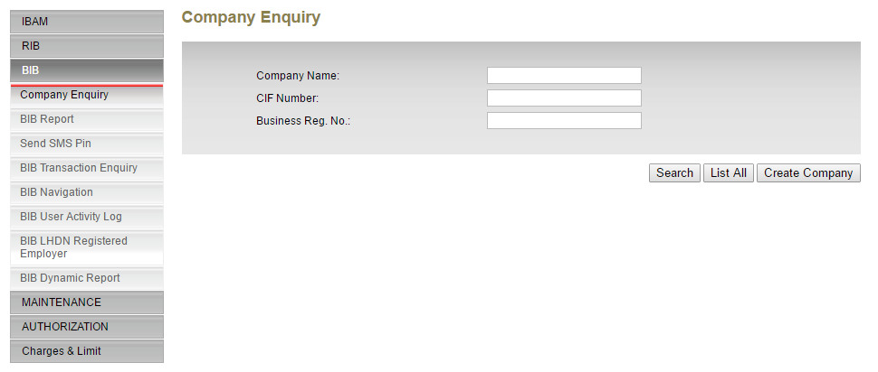

Figure 13 : Company Enquiry Search page

Step 2:

1. Insert search CIF number or business registration no for company

2. Click Search, the Company details will be populated

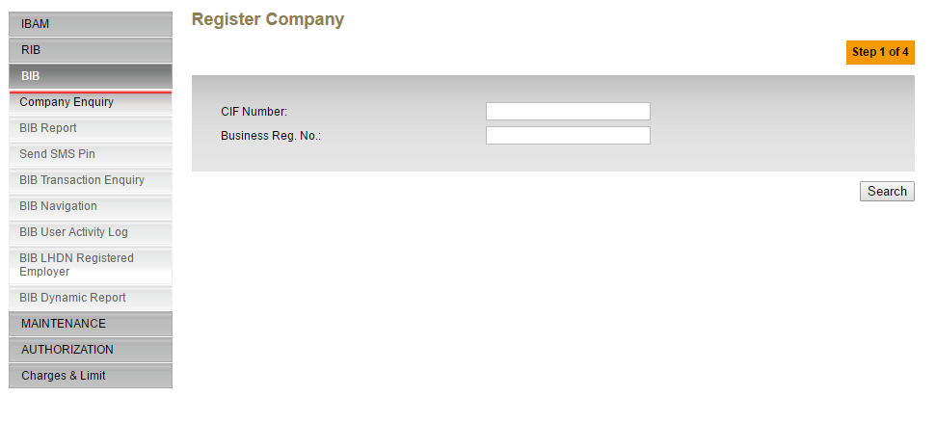

Figure 14 : Register Company page

Step 3:

1. User will able to offsite and online the audit trail flag

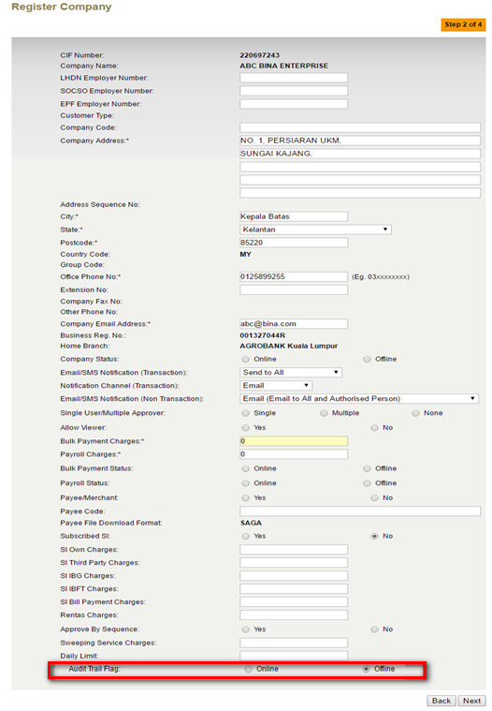

Figure 15 : Register Company Detail page

**Action:**

| **No** | **Action** | **Type** | **Description** |
| --- | --- | --- | --- |
| 1 | Confirm | Button | Redirect to confirm page |
| 2 | Back | Button | Redirect to Previous page |

Table 10: Register Company Details Action

Input Specification:

| **No** | **Field** | **Database** | **Field Type** | **Validation Rule** | **Description** | **M/O** |
| --- | --- | --- | --- | --- | --- | --- |
| 1. | Audit Trail |  | Radio Button |  |  |  |

Table 11: Register Company Details Input Spec

Step 4:

1. IBAM will show confirm page

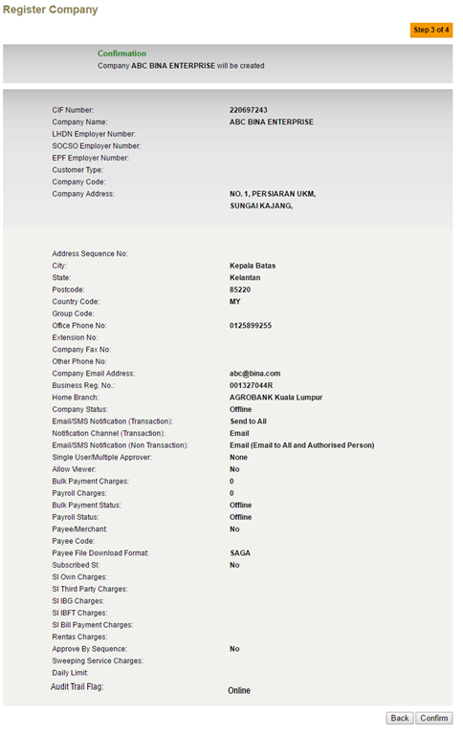

**Action:**

| **No** | **Action** | **Type** | **Description** |
| --- | --- | --- | --- |
| 1 | Confirm | Button | Redirect to confirm page |
| 2 | Back | Button | Redirect to Previous page |

Table 12: Register Company Confirm Action

***Step 5****: Display Result Page*

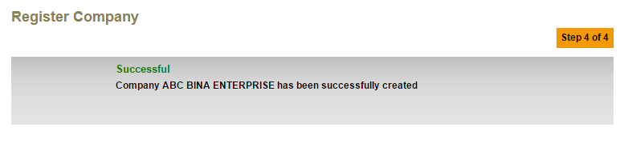

Figure 16: Register Company Result Screen (Super Admin)

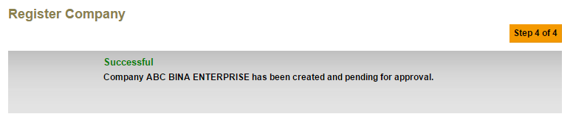

Figure 17: Register Company Result Screen (Maker)

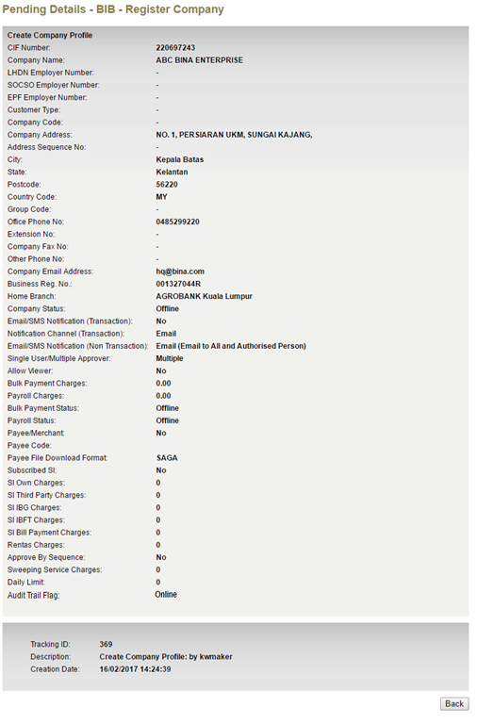

Figure 18: Register Company Maker Screen

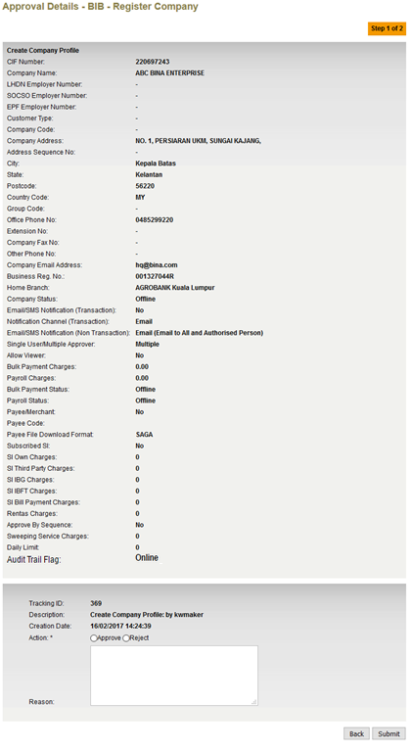

Figure 19: Register Company Checker Screen

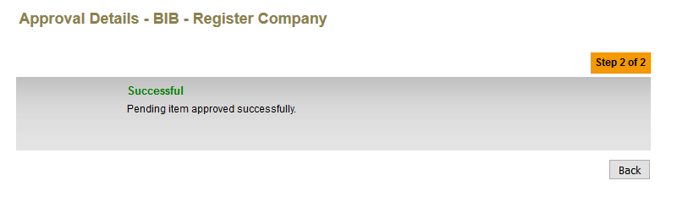

Figure 20: Register Company Checker Result Screen

## Edit Company Details

To allow Bank Admin to enable/disable the Company to access to User Activity Log.

When Audit trail flag is disabled, audit trail service from the entire user in that particular company will be removed.

### 3.1.1 Screen Flow

Step 1:

1. Login to IBAM

2. Access BIB> Company Enquiry

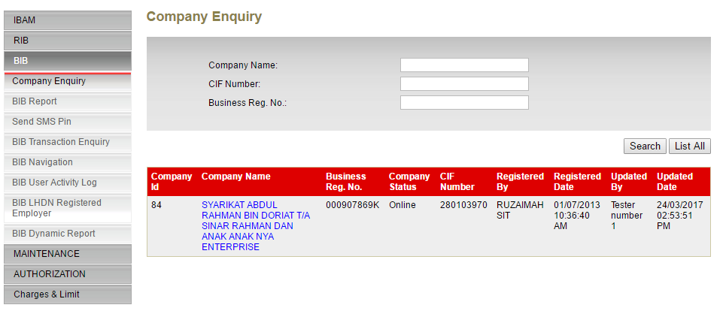

Figure 21 : Company Enquiry Search page

Step 2:

1. Click Edit

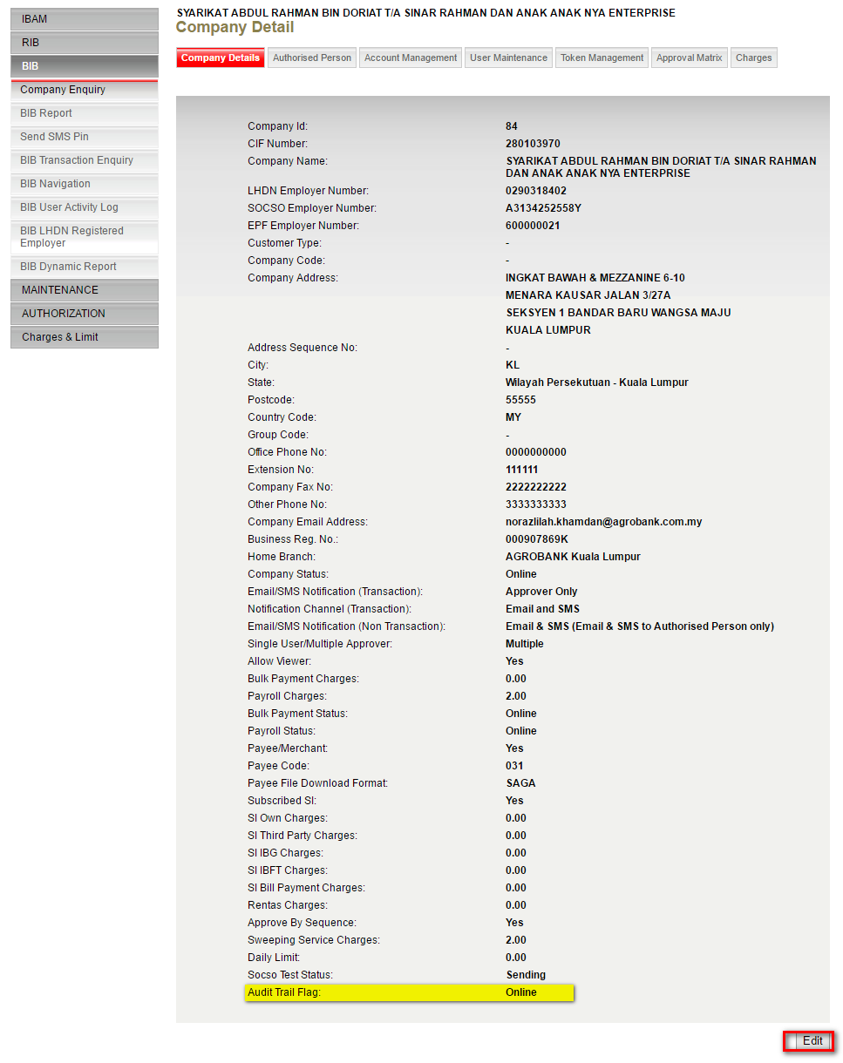

Figure 22 : Company Details page

Step 3:

1. User able to enable and disable the Audit Trail flag

2. After that, click Next

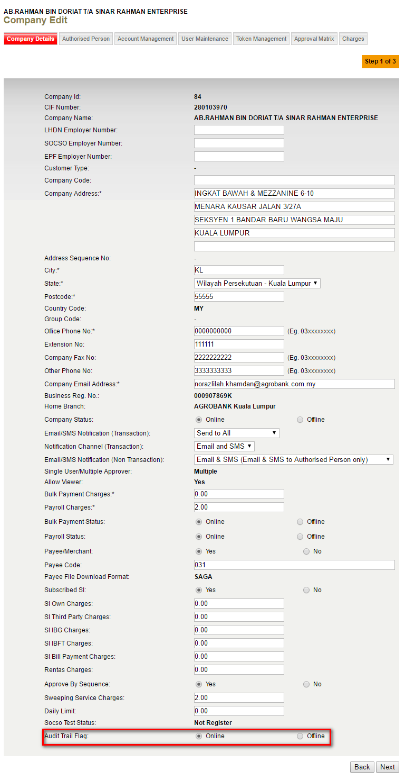

Figure 23 : Company Edit page

**Action:**

| **No** | **Action** | **Type** | **Description** |
| --- | --- | --- | --- |
| 1 | Next | Button | Redirect to confirm page |
| 2 | Back | Button | Redirect to Previous page |

Table 13: Register Company Details Action

Input Specification:

| **No** | **Field** | **Database** | **Field Type** | **Validation Rule** | **Description** | **M/O** |
| --- | --- | --- | --- | --- | --- | --- |
| 1. | Audit Trail |  | Radio Button |  |  |  |

Table 14: Register Company Details Input Spec

Step 4:

1. IBAM will display the confirm page of changes

2. Click confirm

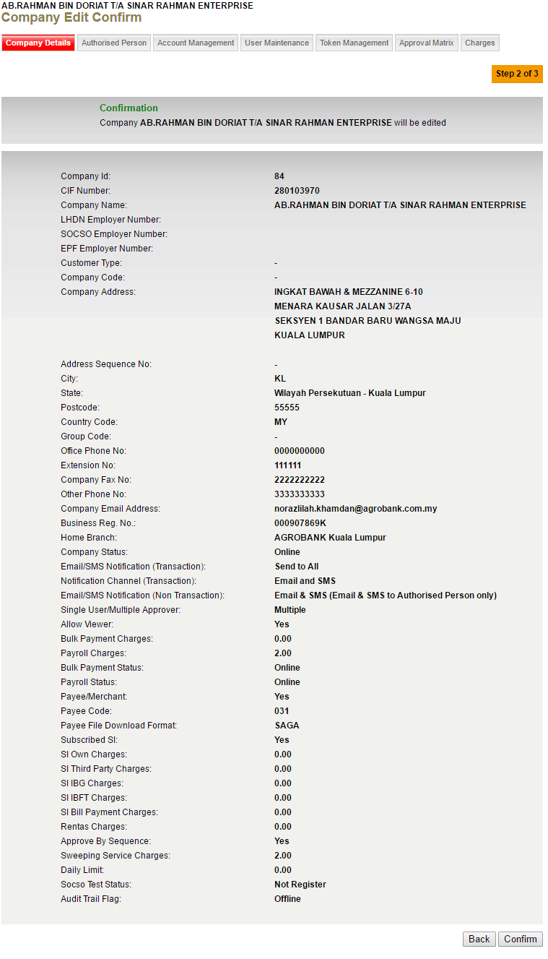

Figure 24 : Company Edit Confirm page

Step 5:

1. IBAM will show result page

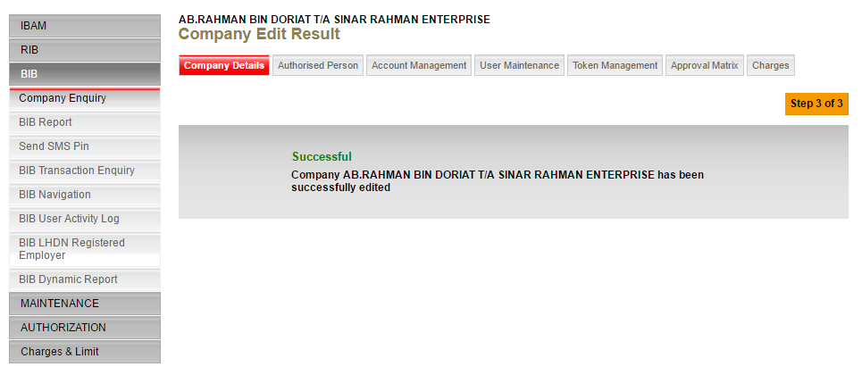

Figure 25 : Company Edit Result page

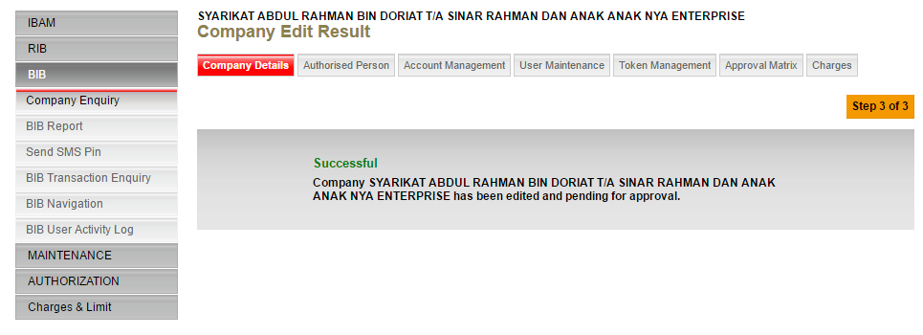

Figure 26 : Company Edit Result (initiator) page

Initiator can see the pending for approval activity at Authorization>Pending

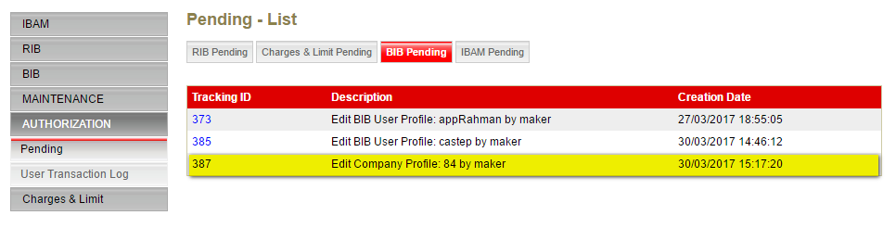

Figure 27 : BIB Pending List page

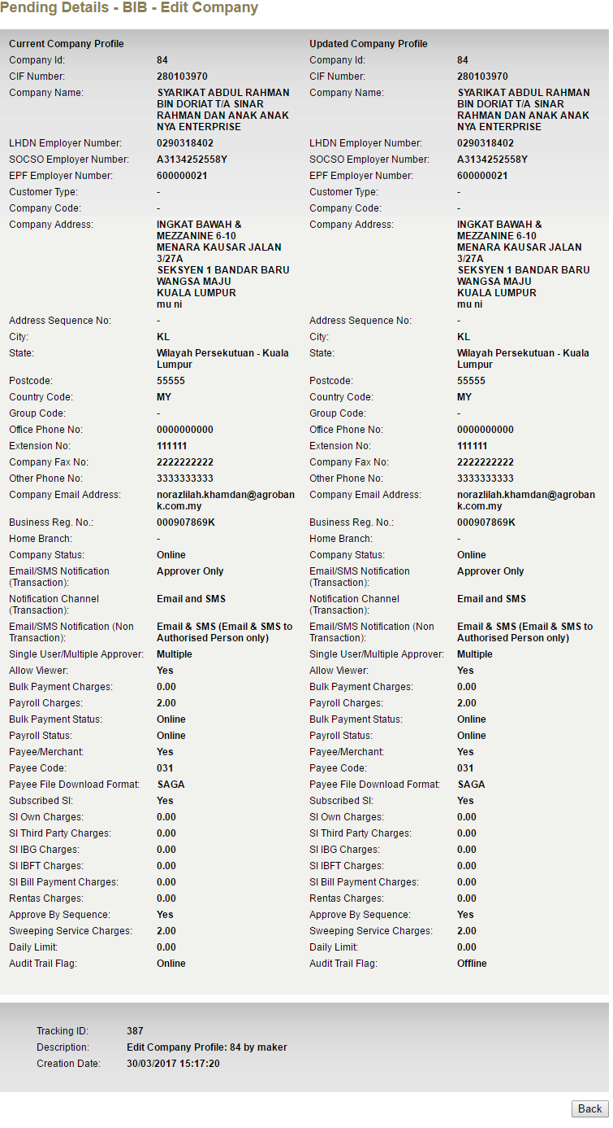

Figure 28 : BIB Pending Detail page

Step 6:

1. Checker need to approve this activity

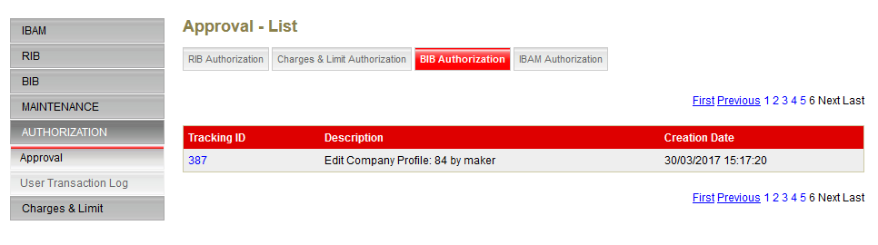

Figure 29 : BIB Approval List page

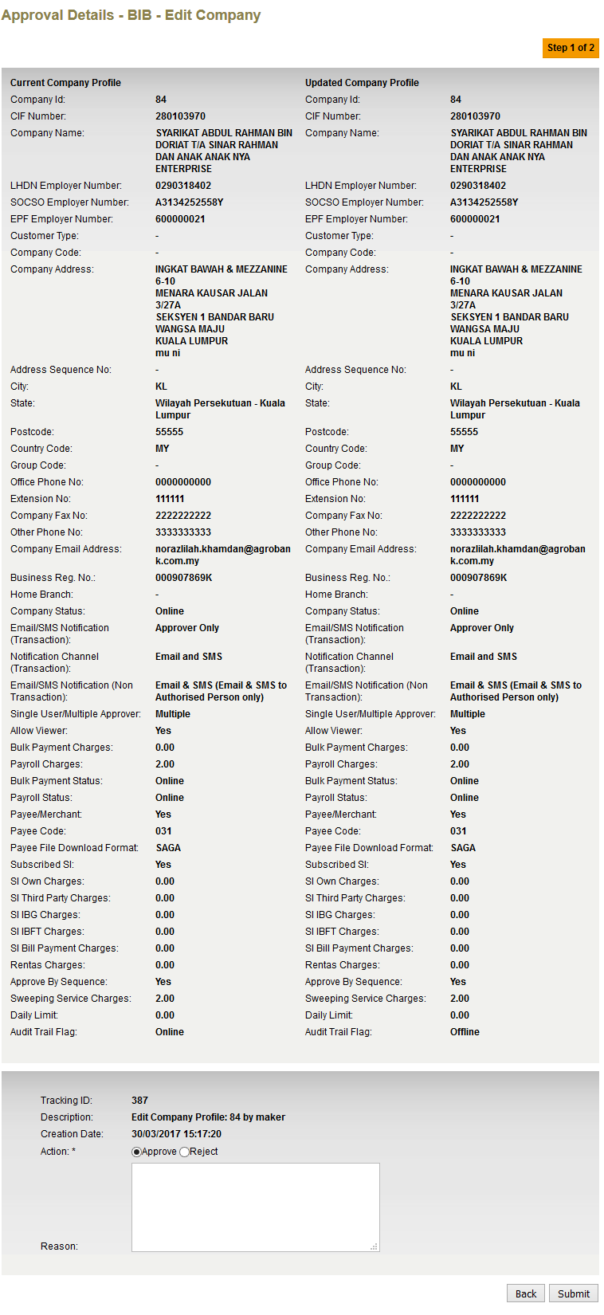

Figure 30 : BIB Approval Details page

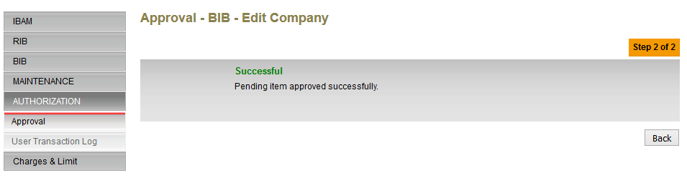

Figure 31 : BIB Approval Result page

## Create User

To allow Bank Admin to enable/disable the Company’s User to access to User Activity Log

### 3.3.1 Screen Flow

Step 1:

1. User login to IBAM

2. Create user by access BIB> Company Enquiry> User Maintenance

3. Click Create button

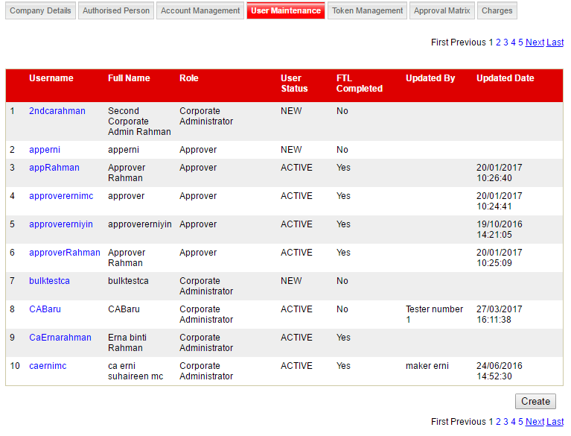

Figure 32 : Company User maintenance page

Step 2:

1. Input the details required for user

2. Click Next

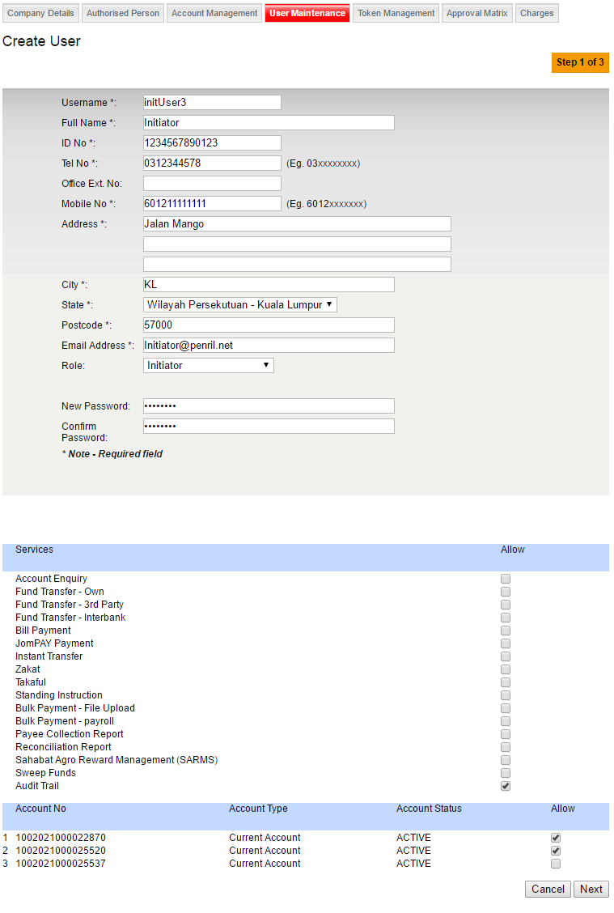

Figure 33 : Company User Create page

**Action:**

| **No** | **Action** | **Type** | **Description** |
| --- | --- | --- | --- |
| 1 | Next | Button | Redirect to confirm page |
| 2 | Back | Button | Redirect to Previous page |

Table 15: Register Company Details Action

Input Specification:

| **No** | **Field** | **Database** | **Field Type** | **Validation Rule** | **Description** | **M/O** |
| --- | --- | --- | --- | --- | --- | --- |
| 1. | Audit Trail |  | Checkbox |  |  |  |

Table 16: Register Company Details Input Spec

Step 3:

1. IBAM will display confirmation page

2. Click confirm

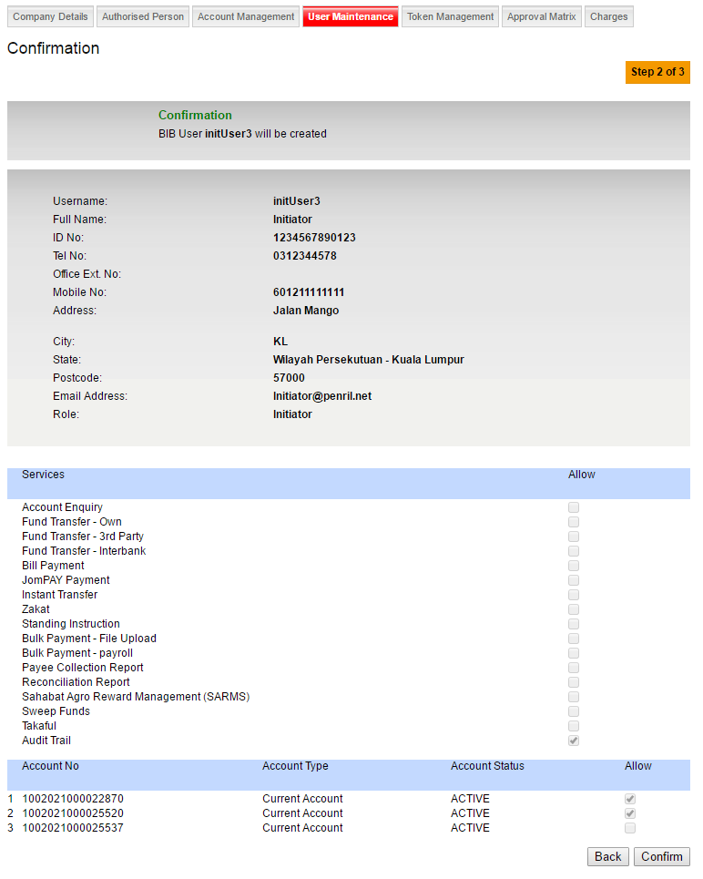

Figure 34 : Company Create Confirm page

Step 4:

1. IBAM will display result page

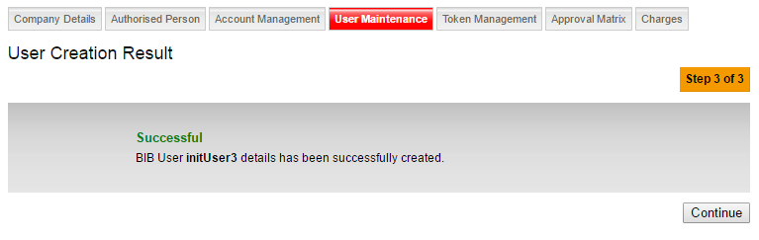

Figure 35 : Company Create result page

Initiator will able to see the pending activity in Authorization>Pending

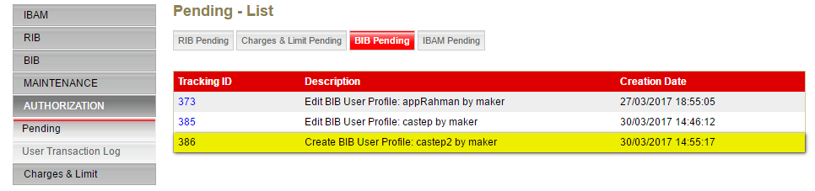

Figure 36 : Authorization BIB Pending page

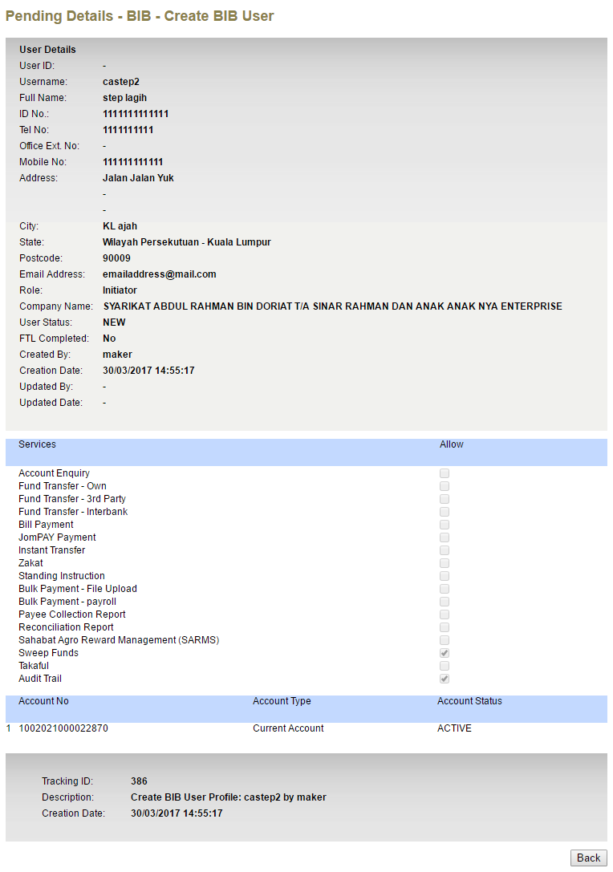

Figure 37 : Authorization BIB Pending details page

Step 5:

1. Checker will approve this activity by Autorization>Approval

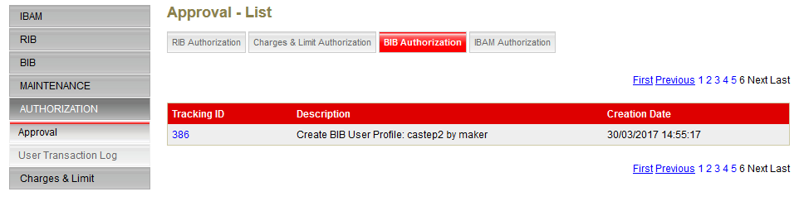

Figure 38 BIB Authorization list page

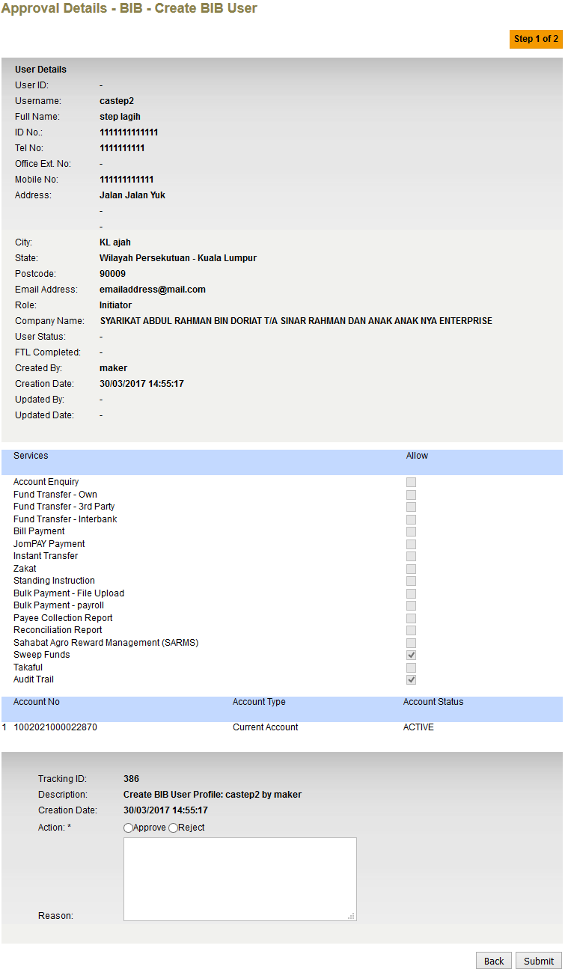

Figure 39 BIB Authorization detail page

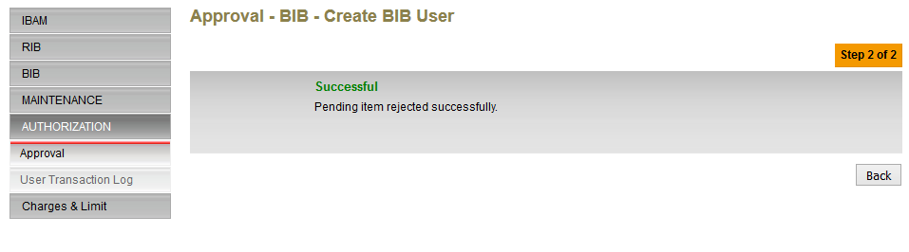

Figure 40 BIB Authorization Result page

## 3.4 Edit User

### 3.4.1 Screen Flow

Step 1:

1. Login to IBAM

2. Access BIB> Company Enquiry> User Maintenance



Figure 41 : User Maintenance page

Step 2:

1. Select one of the users from the list to open the details

2. Click Edit

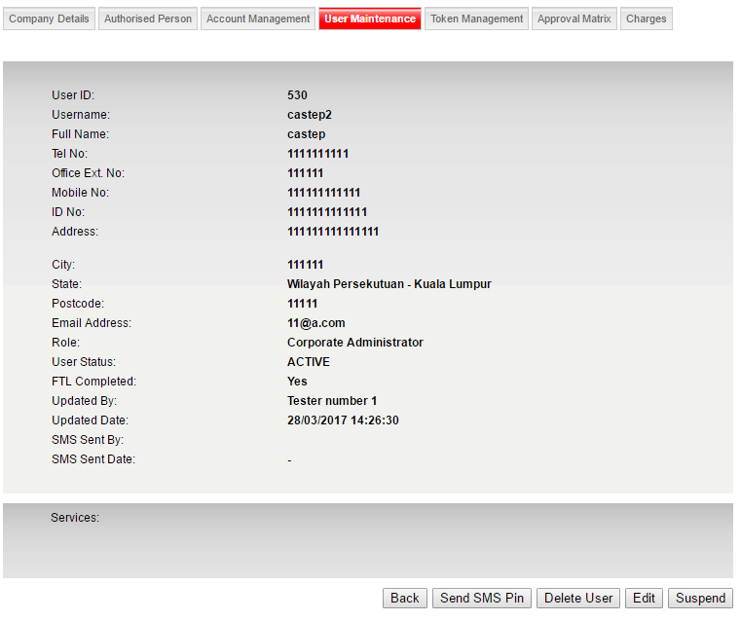

Figure 42 : BIB User Details page

Step 3:

1. User able to check or uncheck the Audit Trail service

2. Click Next

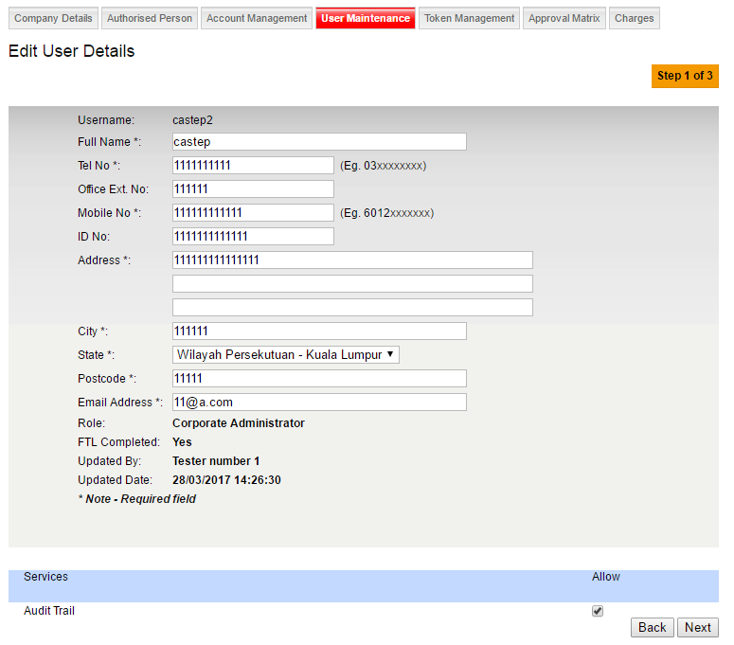

Figure 43 : User Edit page

**Action:**

| **No** | **Action** | **Type** | **Description** |
| --- | --- | --- | --- |
| 1 | Next | Button | Redirect to confirm page |
| 2 | Back | Button | Redirect to Previous page |

Table 17: Register Company Details Action

Input Specification:

| **No** | **Field** | **Database** | **Field Type** | **Validation Rule** | **Description** | **M/O** |
| --- | --- | --- | --- | --- | --- | --- |
| 1. | Audit Trail |  | Checkbox |  |  |  |

Table 18: Register Company Details Input Spec

Step 4:

1. IBAM will show confirmation page

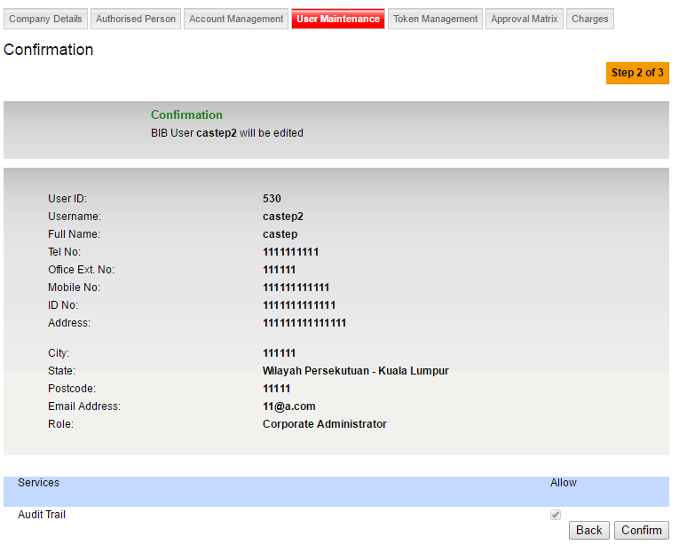

Figure 44 : User Edit Confirm page

Step 5:

1. If it’s successful, IBAM will display successful page

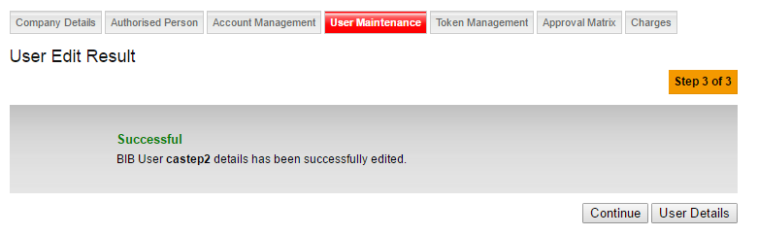

Figure 45 : User Edit Result page

2. For initiator will display pending for approval page

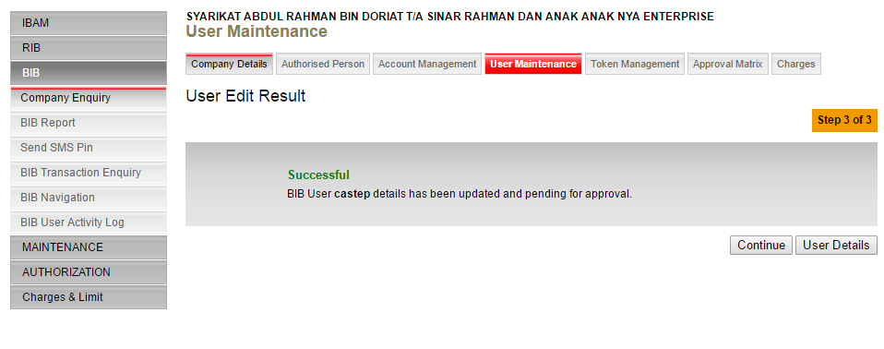

Figure 46 : User Edit Result page

Initiator can check the pending activity in Authorization > pending

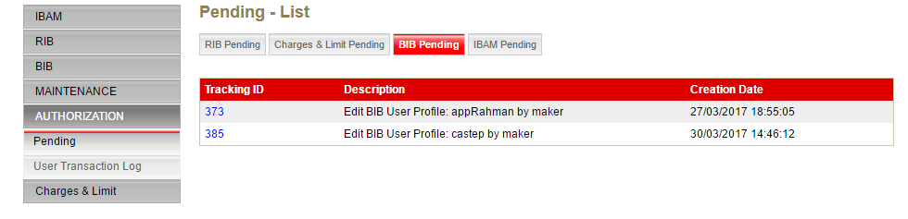

Figure 47 : BIB Pending page

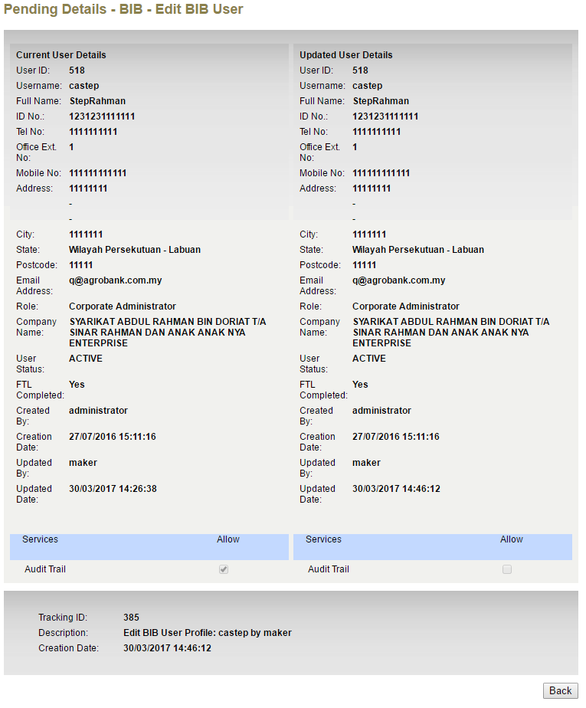

Figure 48 : BIB Pending Detials page

Step 6:

Authorization will be show

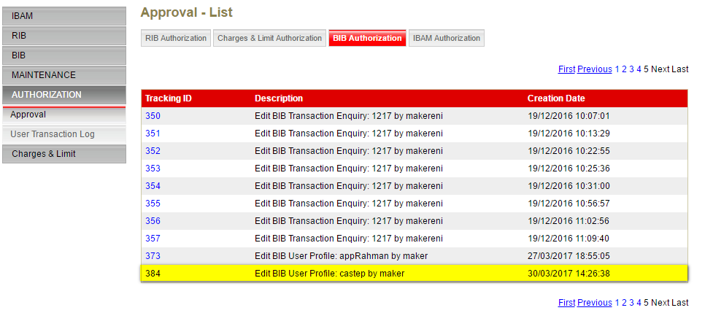

Figure 49 : User BIB authorization page

Step 7: Checker will need to approve the edit

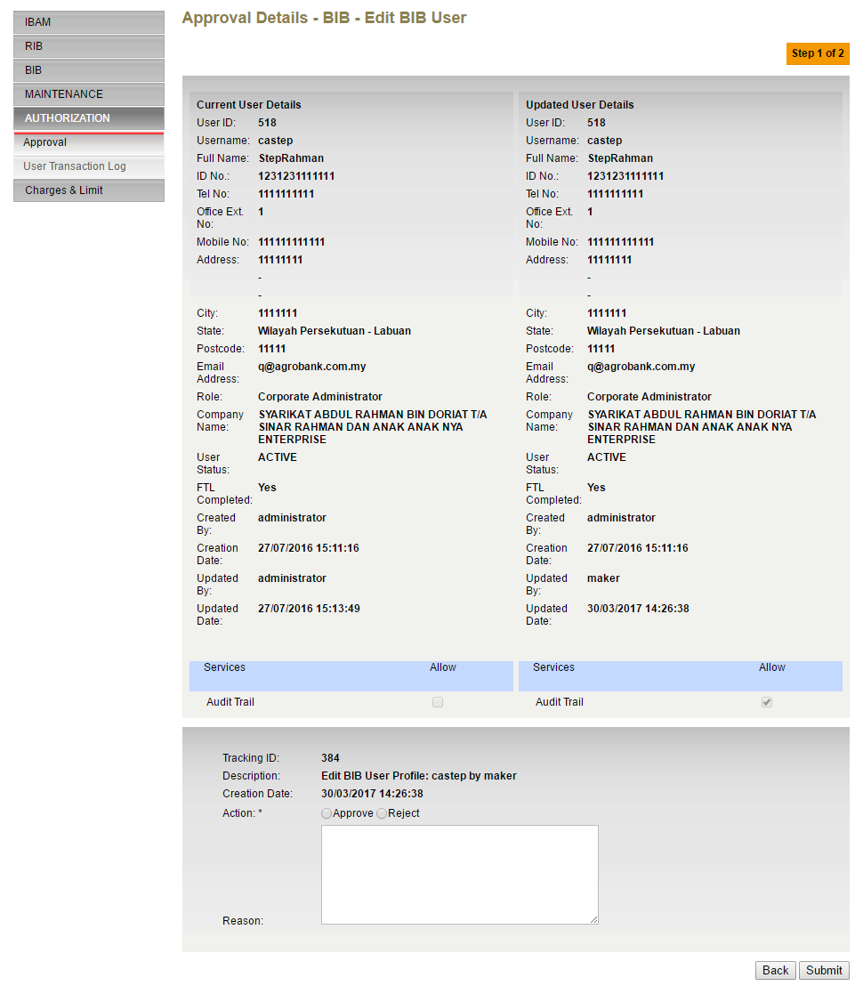

Figure 50 : User BIB authorization Details page

Step 8: Authorization result page

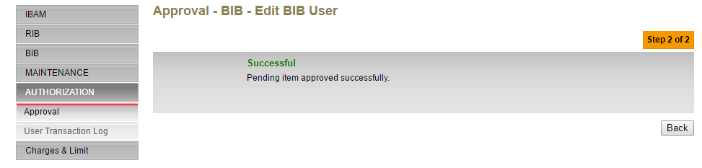

Figure 51 : User BIB authorization Result page

## BIB Navigation

In this Enhancement, Audit Trail will added in new Navigation

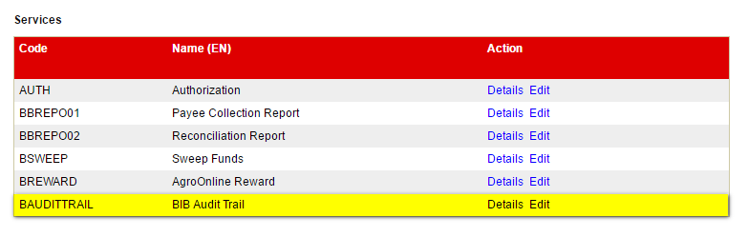

Figure 52 : BIB Navigation page

## IBAM Audit Trail

Step 1: All the Edit and create for user and company will be able display in audit trail

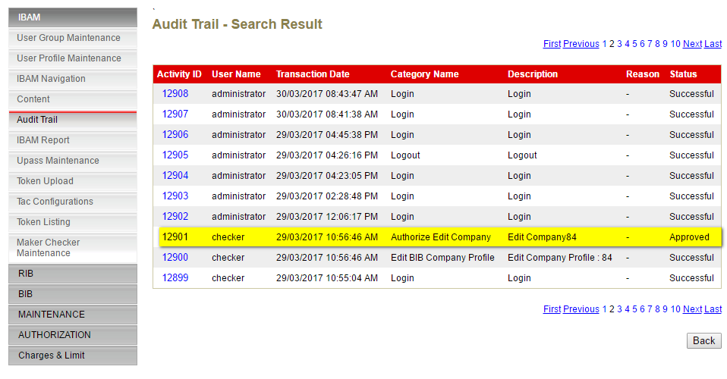

Figure 53 : IBAM Audit Trail page

Step 2: Click the Activity ID to show the details of the Audit Trail

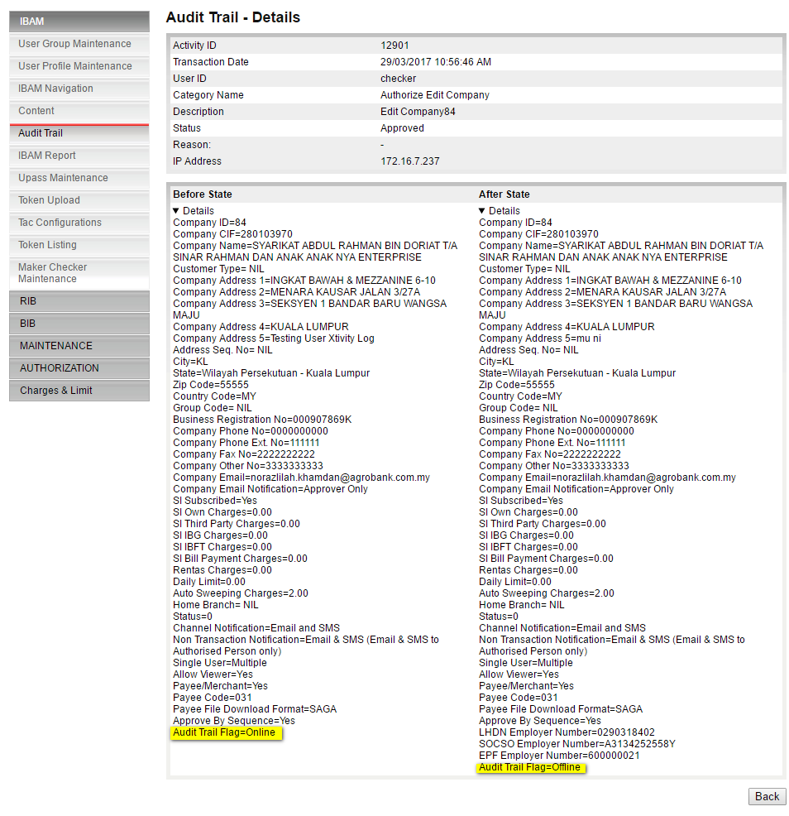

Figure 54 : IBAM Audit Trail Details for Edit Company page

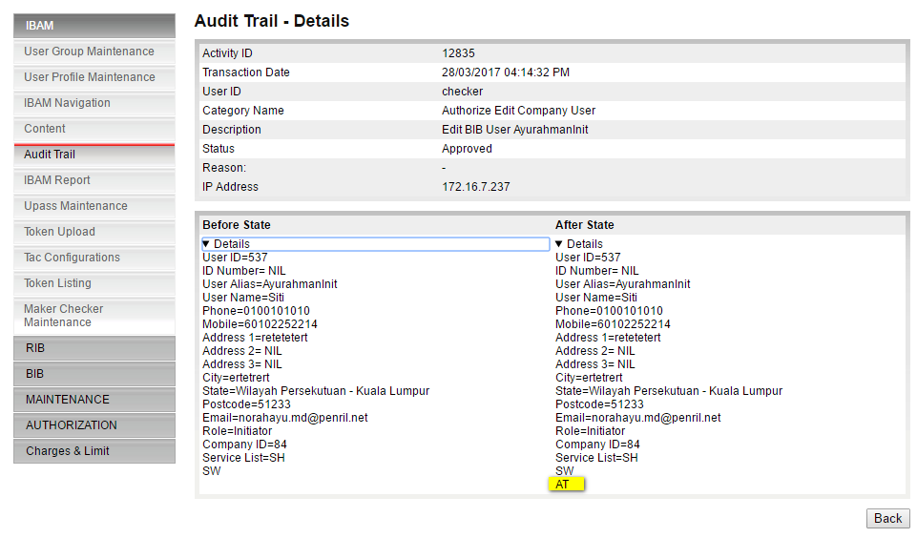

Figure 55 : IBAM Audit Trail Details for Edit Company User page

# Section C: Appendix

## A1: Impact Module

| **No** | **System** | **Modules** |
| --- | --- | --- |
|  | Cash Management System (CMS) | * IB Administration   + User Maintenance * Audit Trail (New Module) |
|  | IBAM | * Company Enquiry   + Company Details   + User Maintenance * BIB Navigation * Maker Checker Maintenance * Authorization |

Notes: Include also any related document/sample related to the changes.