Test Issue Log |  |  |  |  |  | SCP ID# :
Project Name: | AGROBANK BUSINESS INTERNET BANKING
Test Stage: | Unit Functionality Integration System Interface  Performance Regression Acceptance Pilot
Test Case Number: | Task #5990 |  |  | Test Started Date: |  |  | 13/02/2017
Test Title: | Online Payment Gateway functional test
Test Description: | To ensure system develop as per requirement
Test Functionality: | RIB  - Online Payment  - Agronet Transaction History  - Transaction History
Test Procedure: | RIB  - Go to https://172.16.50.27/dp.sit.test  - Click on Test Online Payment  - Enter Merchant ID, User ID, Transaction ID and amount  - Click on Confirm button  - Login to RIB  - Select “From Account”, enter “Remarks” and click on “Next” button  - Click on “Request TAC Number” and enter TAC. Click on “Confirm” button.  - View result page and click on “Print Receipt” button  - Click on Account and Banking and select Agronet Transaction History  - Click on Account and Banking and select Transaction
Test Result: | Pass: Fail: | Tested by: |  |  | Siti Norahayu Binti Mohd Desa
Reason for Failure:
TEST DESCRIPTION
Screenshot:

- Go to https://172.16.50.27/dp.sit.test
- Click on Test Online Payment
- Enter Merchant ID, User ID, Transaction ID and amount
- Click on Confirm button

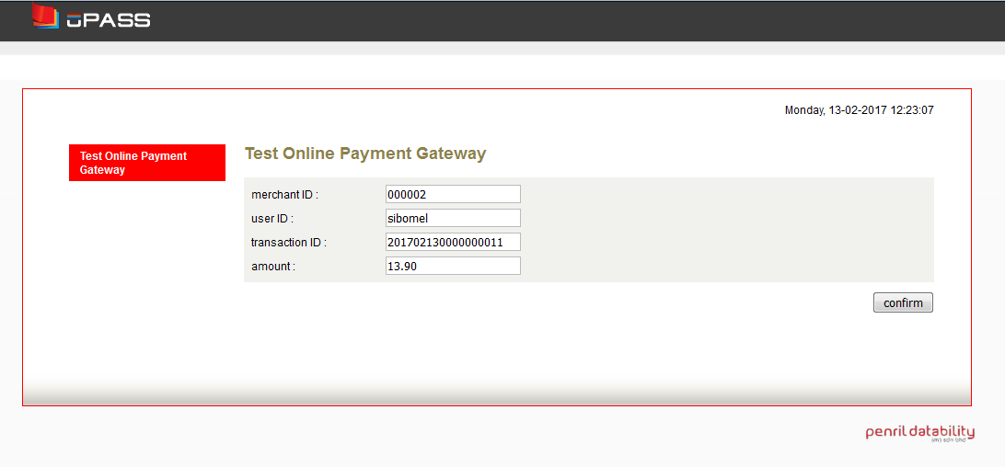
- Login to RIB

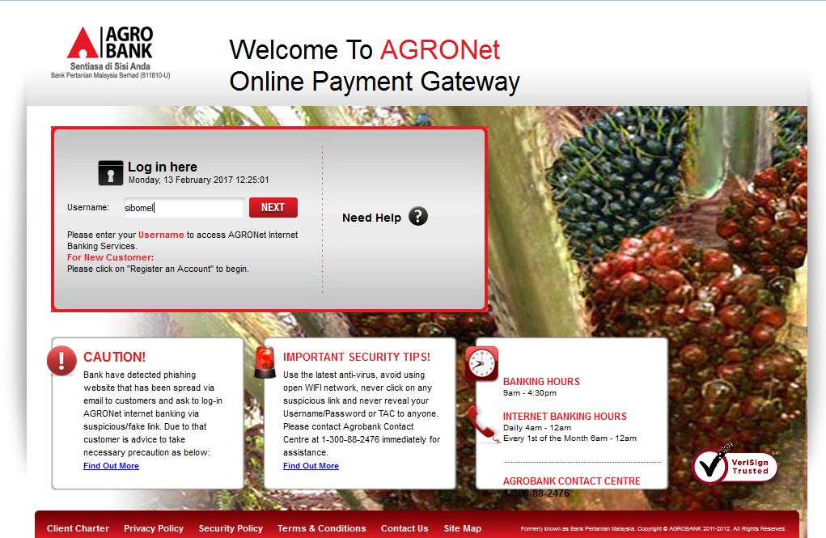

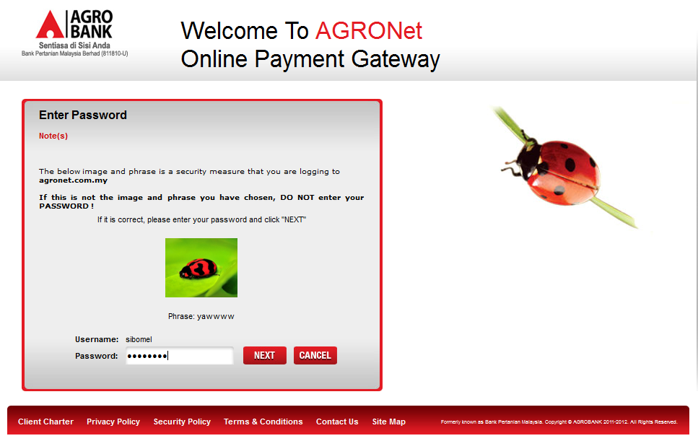
- Select “From Account”, enter “Remarks” and click on “Next” button

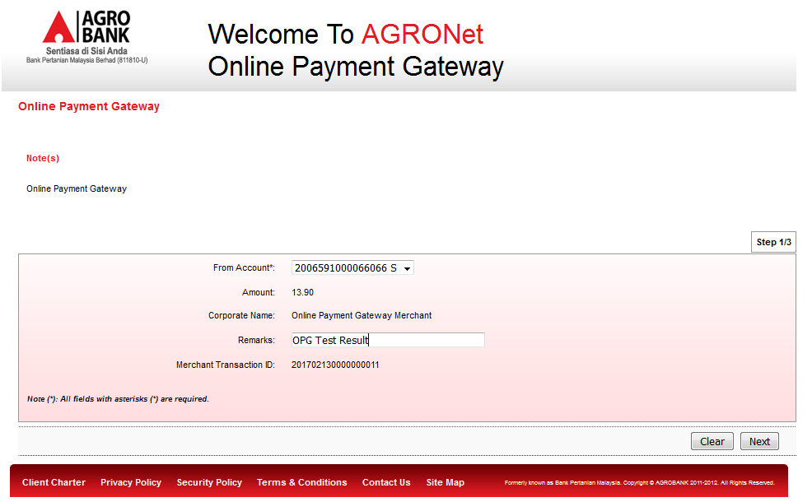

- Click on “Request TAC Number” and enter TAC. Click on “Confirm” button.
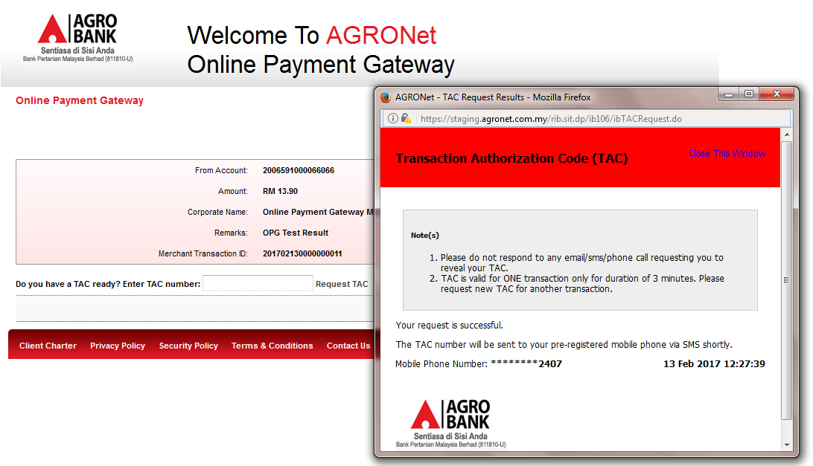
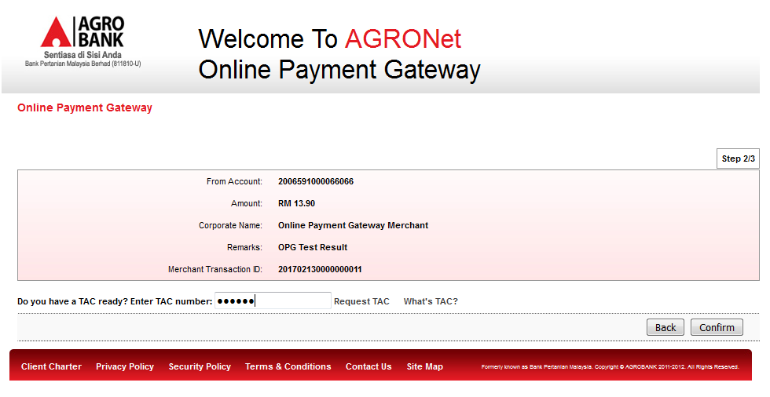

- View result page and click on “Print Receipt” button
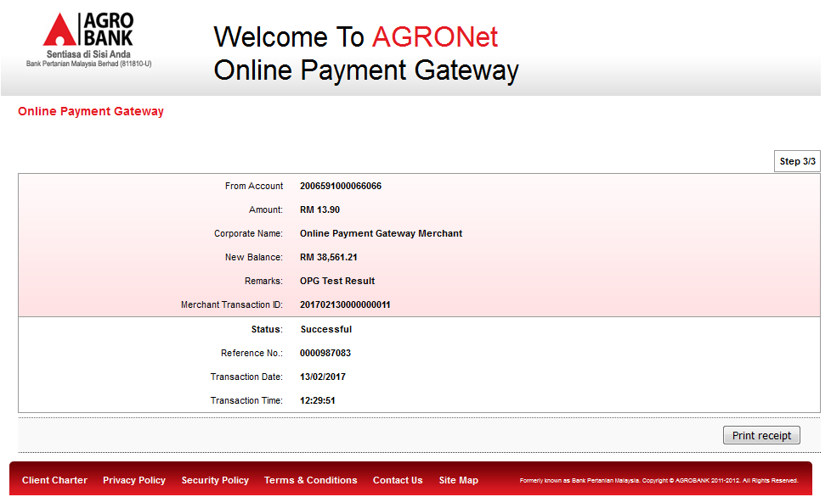

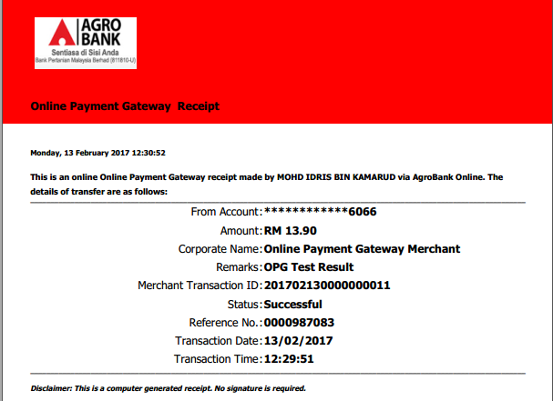
- Click on Account and Banking and select Agronet Transaction History
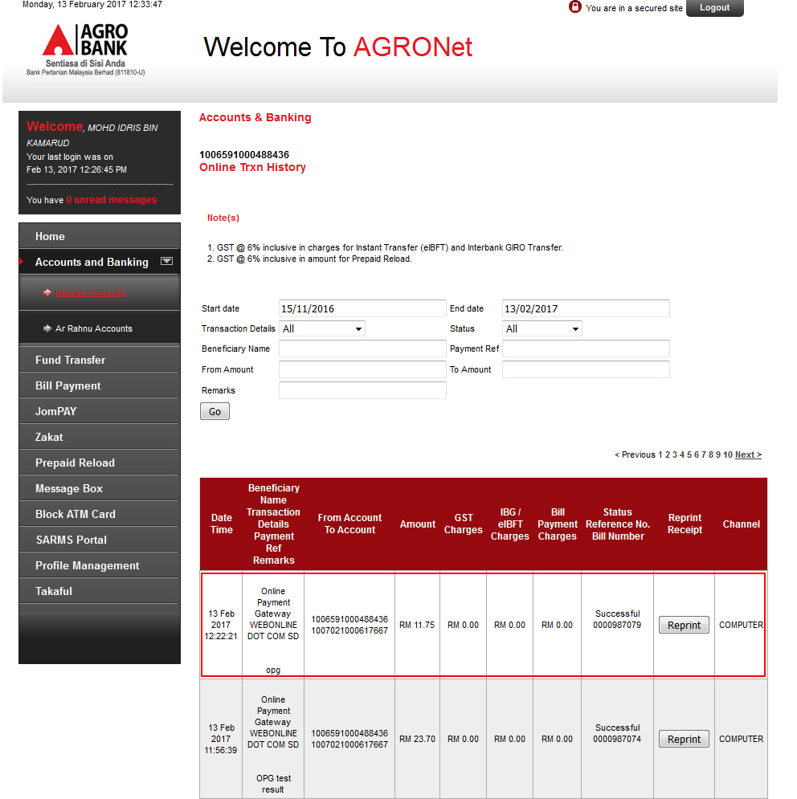

- Click on Account and Banking and select Transaction
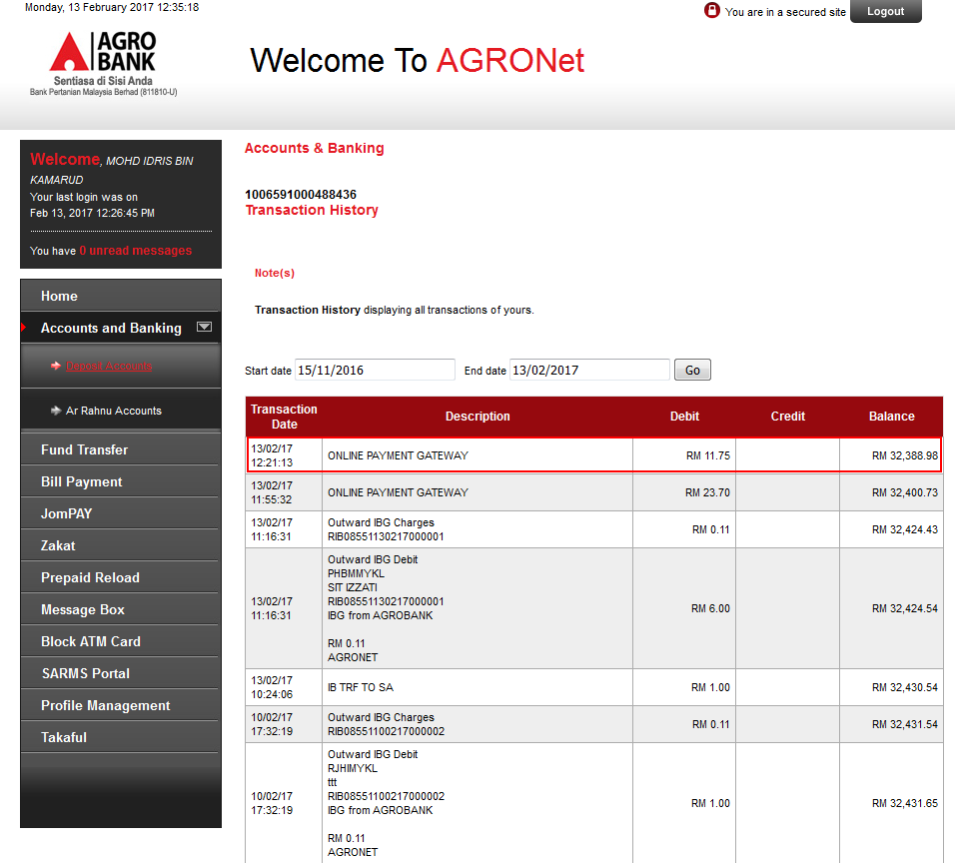

Reviewed By: (PMO)
 |  |  | Name/Position : Norhaidah Binti Md Dasuki / Senior Manager, Quality Assurance and Support  Date :

