Test Issue Log |  |  |  |  |  | SCP ID# :
Project Name: | AGROBANK BUSINESS INTERNET BANKING
Test Stage: | Unit Functionality Integration System Interface  Performance Regression Acceptance Pilot
Test Case Number: | Task #7137 |  |  | Test Started Date: |  |  | 17/03/2017
Test Title: | Online Payment Gateway functional test
Test Description: | To ensure system develop as per requirement
Test Functionality: | IBAM  - RIB > RIB Report > OPG Report Daily  - RIB > RIB Report > Consolidated Transaction IB Report Monthly
Test Procedure: | - Login into IBAM  - Click on RIB Report  - Select OPG Report Daily  - Consolidated Transaction IB Report Monthly
Test Result: | Pass: Fail: | Tested by: |  |  | Siti Norahayu Binti Mohd Desa
Reason for Failure:
TEST DESCRIPTION
Screenshot:

- Click on RIB Report and select OPG Report Daily

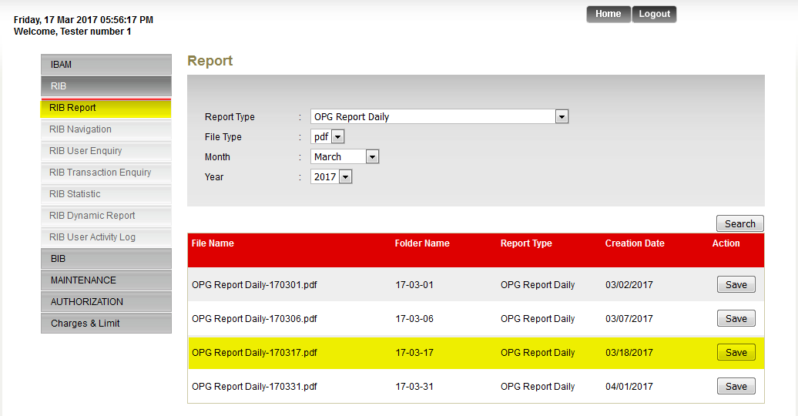

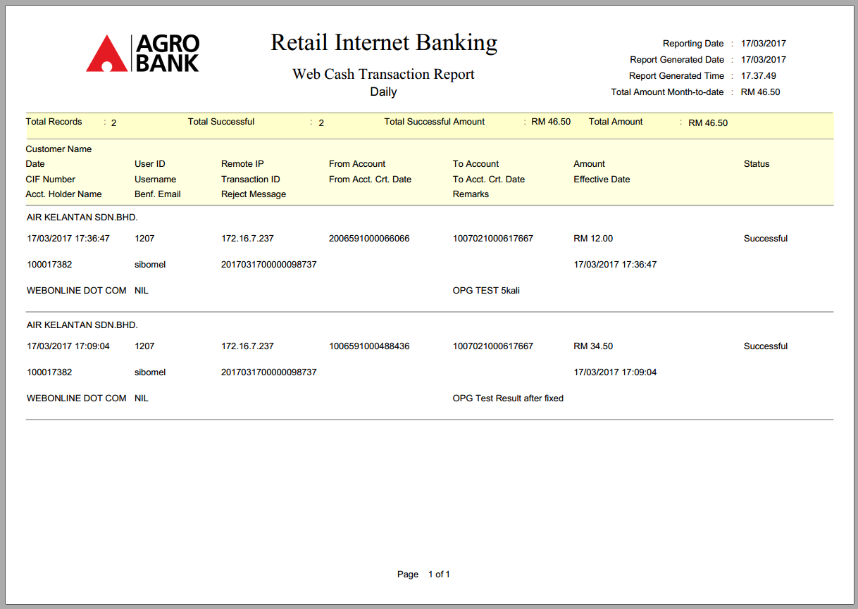
Generated Report Daily

- Click on RIB Report and select OPG Report Monthly
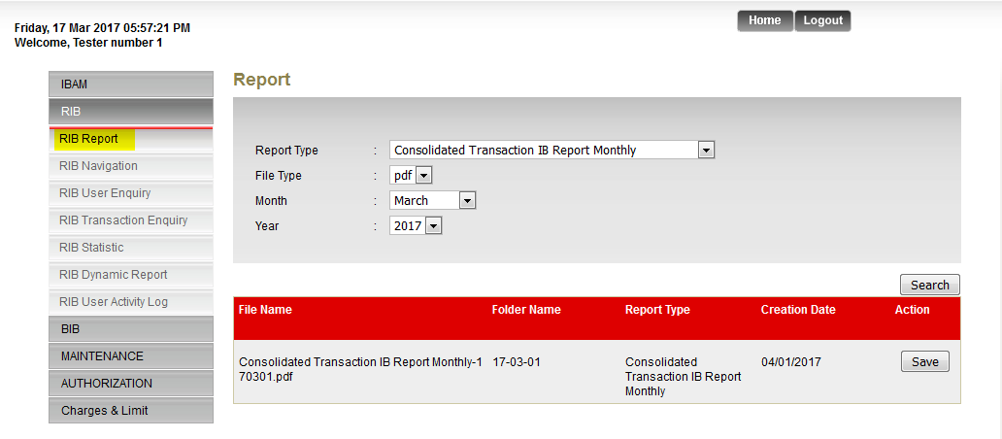

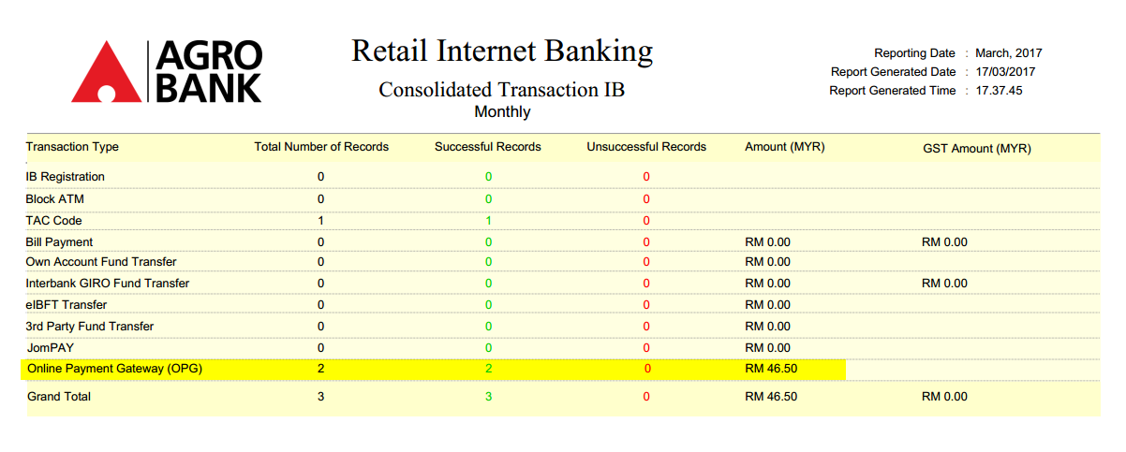
Generated Report Monthly

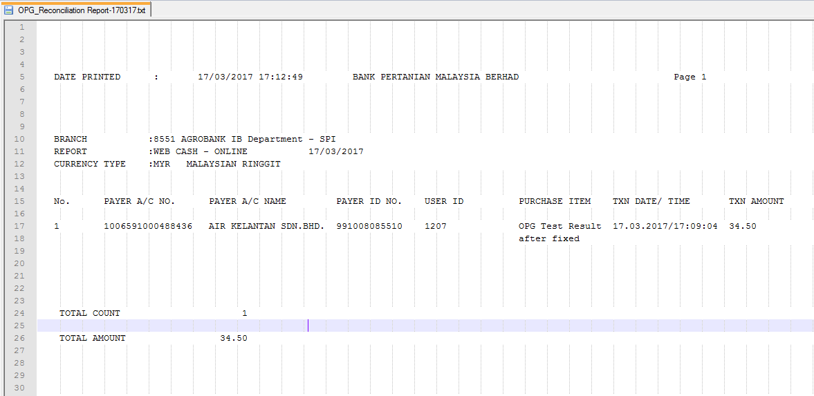
Reconciliation Report from server

Reviewed By: (PMO)
 |  |  | Name/Position : Norhaidah Binti Md Dasuki / Senior Manager, Quality Assurance and Support  Date :

