Test Issue Log |  |  |  |  |  | SCP ID# : 3804
Project Name: | USER ACTIVITY LOG
Test Stage: | Unit Functionality Integration System Interface  Performance Regression Acceptance Pilot
Test Case Number: | #7401 |  |  | Test Started Date: |  |  | 18/04/2017
Test Title: | RIB User Activity Error
Test Description: | Error when request information unsuccessful RIB Registration via IBAM.  1. Select activity = Registration  2. Select status = Unsuccessful  3. Click confirm  4. Error prompt "Error While Performing Your Request"
Test Functionality: | - IBAM > RIB > RIB User Activity Log
Test Procedure: | - Login to IBAM and go to RIB > RIB User Activity  - On Activity dropdown navigation, choose on “Registration”.  - On Status dropdown navigation, choose on “Unsuccessful”.  - Then click on “Search” button.
Test Result: | Pass: Fail: | Tested by: |  |  | Erni Suhaireen binti Zulkifli
Reason for Failure:
TEST DESCRIPTION
Screenshot:

- Login to IBAM and go to RIB > RIB User Activity
- On Activity dropdown navigation, choose on “Registration”.
- On Status dropdown navigation, choose on “Unsuccessful”.
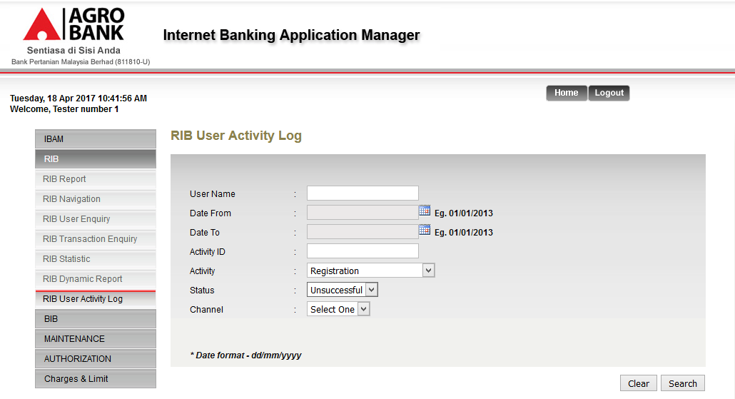
- Then click on “Search” button
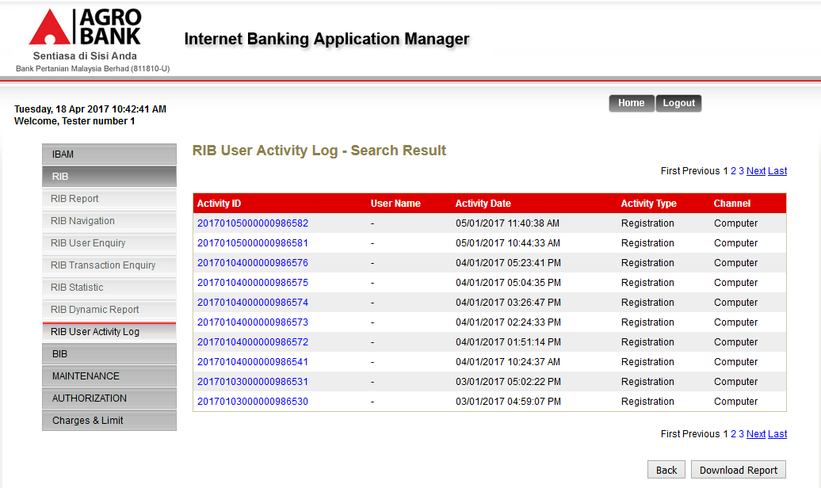
Reviewed By: (PMO)
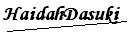 |  |  | Name/Position : Norhaidah Binti Md Dasuki / Senior Manager, Quality Assurance and Support  Date :

