**Agrobank**

|  |
| --- |
| **SI HOLIDAY MAINTAINENCE** |
| Business Requirement and System Specification |

**(PENRIL/AGRO-BRS/PCF/20160316)**

**Version 1.0**

**9 MAY 2017**

Prepared By:



**Penril Datability (SEA) Sdn Bhd (384556-U)**

Suite A-07-07 Plaza Mon’t Kiara

No. 2, Jalan Kiara, Mon’t Kiara

50480 Kuala Lumpur, Malaysia

Tel: (603) 6201 2622Fax: (603) 6201 7622

Document Amendment Log

| **Rev. No** | **Date Update** | **Description of Change** | **Update By**  **<Name, Dept>** | **Review By**  **<Name, dept>** | **Approved By**  **<Name, Dept>** |
| --- | --- | --- | --- | --- | --- |
| 1 | 9/5/2017 | Initial release | Siew Kar Chun |  |  |
|  |  |  |  |  |  |
|  |  |  |  |  |  |
|  |  |  |  |  |  |

Contents

Document Amendment Log 2

Section A: Introduction 5

1 Objective 5

Section B: Internet Banking Application Manager 6

2 Enhancement at IBAM -> SI holiday Maintainence 6

2.1 SI holiday maintenance – main page 7

2.1.1 Screen Flow: 7

2.2 SI holiday maintenance – Enquiry 9

2.2.1 Screen Flow: 9

2.3 SI holiday Maintenance – Edit 12

2.3.1 Screen Flow: 12

2.5 SI Holiday Maintenance- Delete 16

2.3.2 Screen Flow: 16

2.2 SI Holiday Maintenance – Create 19

3 Database Design 23

3.2 Entity Relationship Diagram (ERD) 23

3.3 Data Dictionary 23

Business Requirement Acceptance

I/We hereby verify that this Business Requirement consist of all the requirements requested by AGROBANK. The implemented system will fulfill ONLY this requirement.

I/We also hereby AGREE that this satisfies our entire requirement for **SI holiday**

Any future changes to this agreed scope will be treated as an enhancement to the system. Any future changes to the project timeline will be subjected to the final approval of the project steering committee.

**AGROBANK:**

|  |  |  |  |
| --- | --- | --- | --- |
| **Approved by** | **Role** | **Signature** | **Date** |
|  |  |  |  |
|  |  |  |  |
|  |  |  |  |
|  |  |  |  |
|  |  |  |  |
|  |  |  |  |
|  |  |  |  |

**Penril Datability (SEA) Sdn. Bhd.:**

|  |  |  |  |
| --- | --- | --- | --- |
| **Approved by** | **Role** | **Signature** | **Date** |
|  |  |  |  |
|  |  |  |  |

Section A: Introduction

This document served as the business requirement and system specification of adding/creating new function/module for SI holiday for Internet Banking Application Manager.

This document shall explain all the features and functionalities, which is elaborating with screen captures, process flow, descriptions, input fields specifications and error messages. All screen designs provided in this document are samples and only illustration purpose for easy understanding. The screen designs are not final

# Objective

The objective of this document is to capture user requirements of the ability to create/edit/delete holiday date as well as view and search for existing entry within the system of Internet Banking Application Manager. This document will facilitate development and implementation of the mentioned modules of Internet Banking System for Agrobank.

The base line features description and screen designs will become a reference blueprint for the development team to develop the SI holiday module. Hence, it is crucial that all stakeholders need to ensure the correctness and adequacy of the requirements captured in this document.

All stakeholders involved are expected to review and sign off this document before the development start. By signing off the document, the stakeholder has endorsed the correctness and accuracy and adequacy of the requirements documented in this document.



Section B: Internet Banking Application Manager

# Enhancement at IBAM -> SI holiday Maintainence

This module allows Administrator to manage SI holidays in the internet banking application manager. Below is the page navigation: -

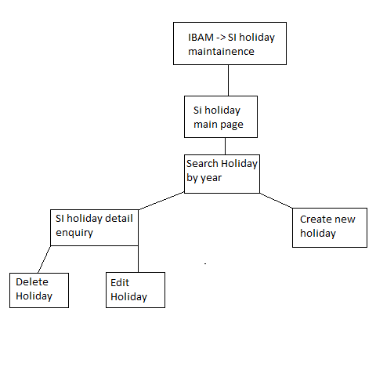

## 2.1 SI holiday maintenance – main page

Si holiday maintenance allows user to choose between different year depending on the server setting.

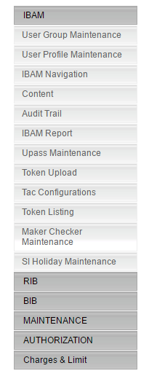

### Screen Flow:

1)Click on the tab SI Holiday Maintenance under IBAM.

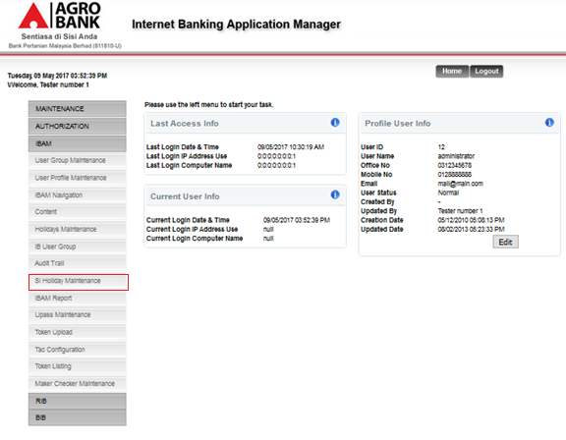

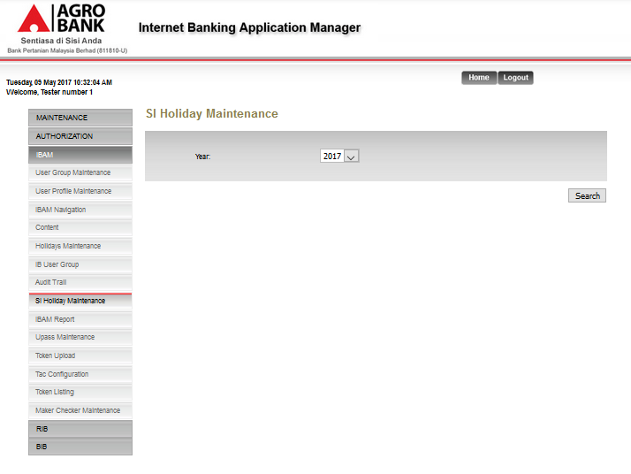

**Action:**

| **No** | **Action** |  | **Type** | **Description** |
| --- | --- | --- | --- | --- |
|  | Search |  | Button | Allow use to search for year based on the selected year. |

## SI holiday maintenance – Enquiry

### Screen Flow:

1. Click on the Search button to search.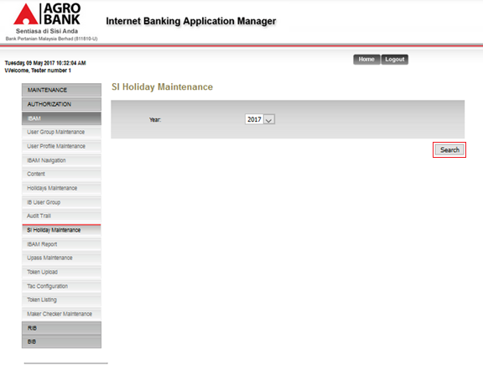

2) Click on one of the ID number to view the selected entry’s detail.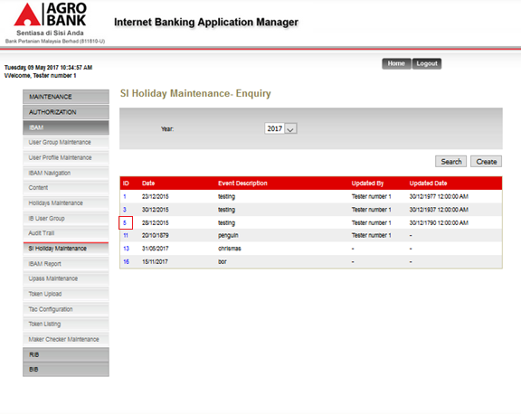

Action:

| **No** | **Action** | **Type** | **Description** |
| --- | --- | --- | --- |
|  | View Holiday Detail | Button | Clicking the ID of every entry allows user to view detail of the particular entry. |
|  | Search | Button | Allow use to search for year based on the selected year. |
|  | Create | Button | Allow user to create more holiday entry. |

**Display:**

| No | Field | Database | Description |
| --- | --- | --- | --- |
| 1. | ID | IB.HOLIDAY.ID | Unique identification for holiday |
| 2. | Date | IB.HOLIDAY.Holiday | Date of holiday |
| 3. | Event description | IB.HOLIDAY.Description | Description of holiday |
| 4. | Updated by | IB.HOLIDAY.Update_by | Holiday updated by |
| 5. | Updated date | IB.HOLIDAY.Update_date | Holiday date updated |

3) Arrived at detail page.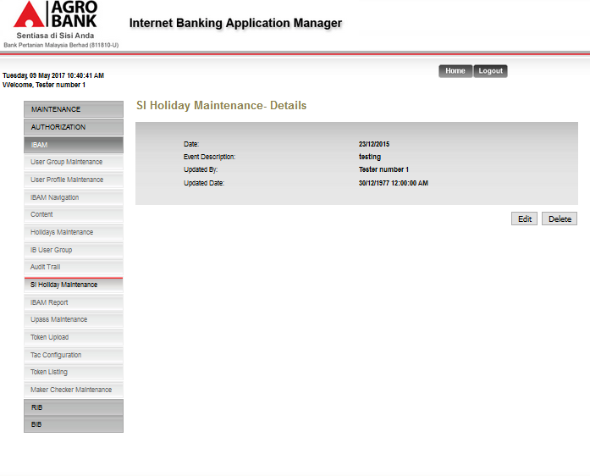

Action:

| **No** | **Action** | **Type** | **Description** |
| --- | --- | --- | --- |
|  | Edit | Button | Allow user to edit current holiday. |
|  | Delete | Button | Allow user to delete current holiday |

**Display:**

| No | Field | Database | Description |
| --- | --- | --- | --- |
| 1. | ID | IB.HOLIDAY.ID | Unique identification for holiday |
| 2. | Date | IB.HOLIDAY.Holiday | Date of holiday |
| 3. | Event description | IB.HOLIDAY.Description | Description of holiday |
| 4. | Updated by | IB.HOLIDAY.Update_by | Holiday updated by |
| 5. | Updated date | IB.HOLIDAY.Update_date | Holiday date updated |

## SI holiday Maintenance – Edit

### Screen Flow:

1. Click on the edit button.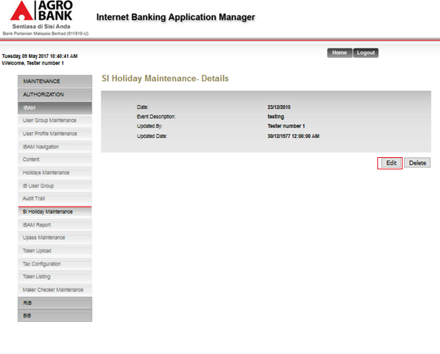
2. Click Next.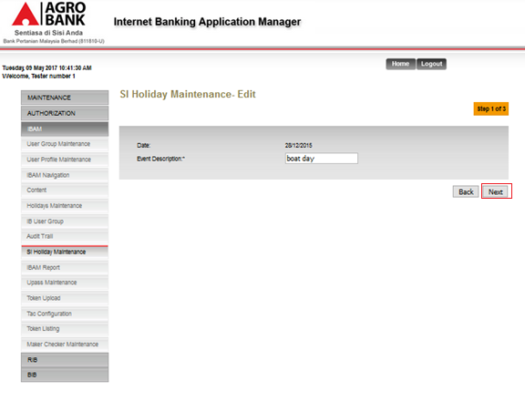

Input specification:

| **No** | **Field** | **Database** | **Validation Rule** | **Description** | **M/O** |
| --- | --- | --- | --- | --- | --- |
| 1. | Event Description | IB_holiday.Description |  | Enter new description to update | M |

Action:

| **No** | **Action** | **Type** | **Description** |
| --- | --- | --- | --- |
|  | Back | Button | Allow user to return to the previous page |
|  | Next | Button | Allow user to proceed to the next page |

**Display:**

| No | Field | Database | Description |
| --- | --- | --- | --- |
| 1. | Date | IB.HOLIDAY.Holiday | Date of holiday |

1. Click confirm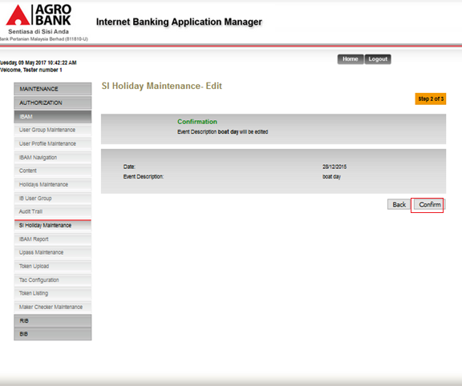

Actions:

| **No** | **Action** | **Type** | **Description** |
| --- | --- | --- | --- |
|  | Back | Button | Allow user to return to the previous page |
|  | Confirm | Button | Allow user to proceed with the edit. |

**Display:**

| No | Field | Database | Description |
| --- | --- | --- | --- |
| 1. | Date | IB.HOLIDAY.Holiday | Date of holiday |
| 2. | Event description | IB.HOLIDAY.Description | Description of holiday |

4) Result page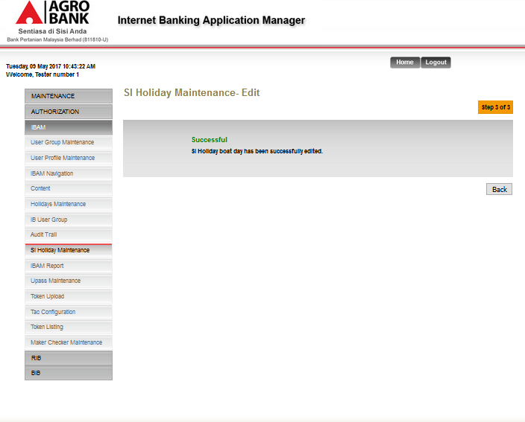

Actions:

| **No** | **Action** | **Type** | **Description** |
| --- | --- | --- | --- |
|  | Back | Button | Allow user to return to the details page. |

## SI Holiday Maintenance- Delete

### Screen Flow:

1. Select the delete button.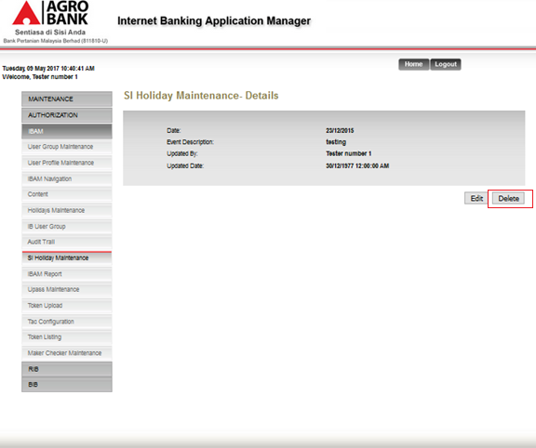
2. Select confirm.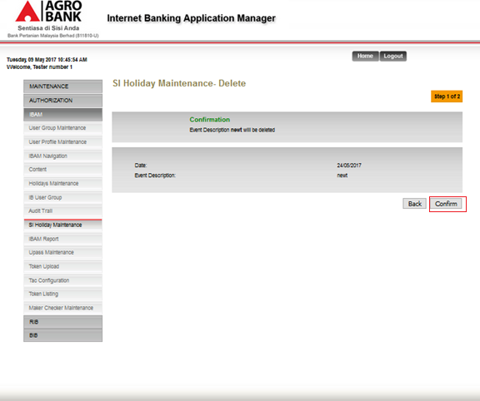

Actions:

| **No** | **Action** | **Type** | **Description** |
| --- | --- | --- | --- |
|  | Back | Button | Allow user to return to the previous page |
|  | Confirm | Button | Allow user to proceed with the delete. |

**Display:**

| No | Field | Database | Description |
| --- | --- | --- | --- |
| 1. | Date | IB.HOLIDAY.Holiday | Date of holiday |
| 2. | Event description | IB.HOLIDAY.Description | Description of holiday |

1. Result page.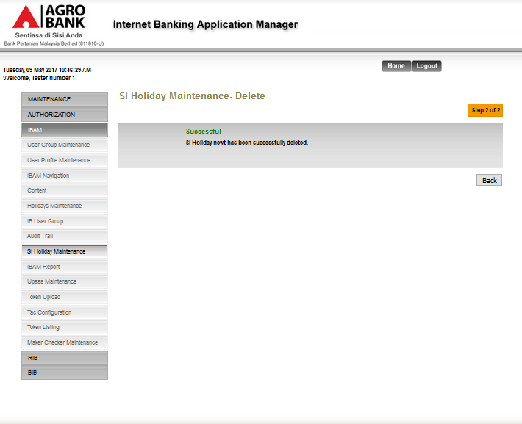

Actions:

| **No** | **Action** | **Type** | **Description** |
| --- | --- | --- | --- |
|  | Back | Button | Allow user to return to the main page |

## SI Holiday Maintenance – Create

1. Click Create.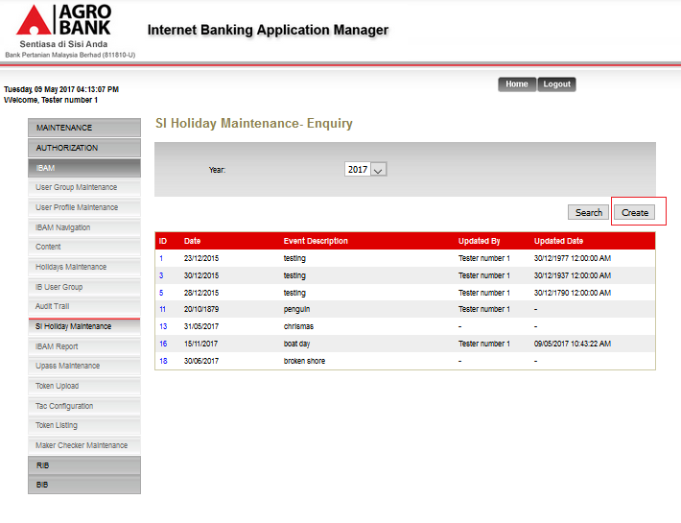
2. Enter value and click Next.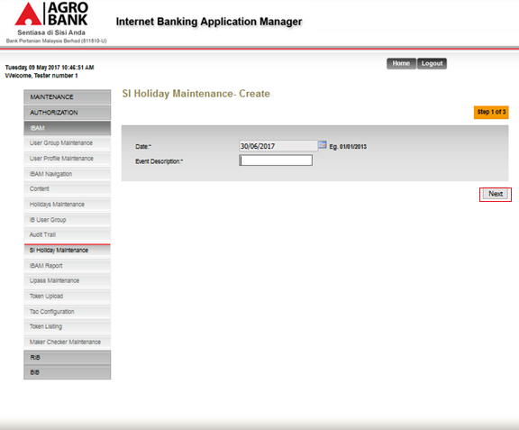

Input specification:

| **No** | **Field** | **Database** | **Validation Rule** | **Description** | **M/O** |
| --- | --- | --- | --- | --- | --- |
| 1. | Event Description | IB_holiday.Description |  | Enter new description | M |
| 2 | Date | IB_holiday.HOLIDAY |  | Enter new date | m |

Actions:

| **No** | **Action** | **Type** | **Description** |
| --- | --- | --- | --- |
|  | Next | Button | Allow user to proceed to the next stage. |

**Display:**

| No | Field | Database | Description |
| --- | --- | --- | --- |
| 2. | Date | IB.HOLIDAY.Holiday | Date of holiday |

1. Click Confirm.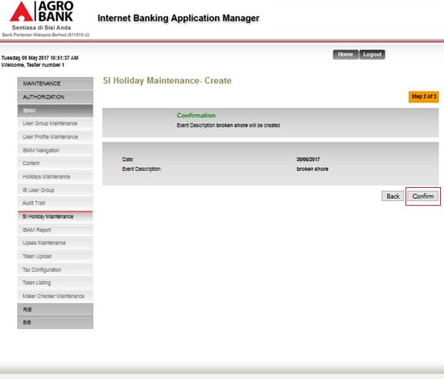

Actions:

| **No** | **Action** | **Type** | **Description** |
| --- | --- | --- | --- |
|  | Back | Button | Allow user to return to the previous page |
|  | Confirm | Button | Allow user to proceed with the creation. |

**Display:**

| No | Field | Database | Description |
| --- | --- | --- | --- |
| 1. | Date | IB.HOLIDAY.Holiday | Date of holiday |
| 2. | Event description | IB.HOLIDAY.Description | Description of holiday |

1. Result Page.

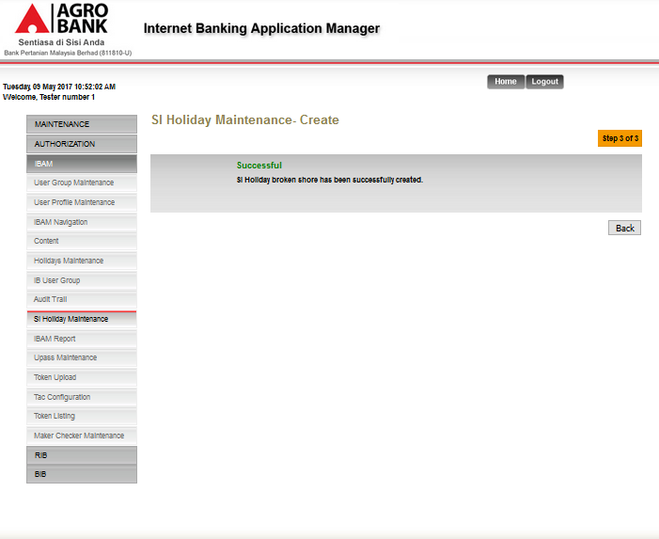

| **No** | **Action** | **Type** | **Description** |
| --- | --- | --- | --- |
|  | Back | Button | Allow user to return to the main page |

# Database Design

# Entity Relationship Diagram (ERD)

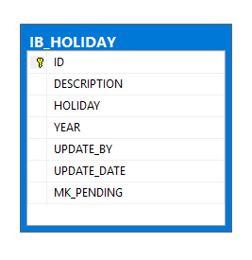

# Data Dictionary

**IB_HOLIDAY**

**This table stores record for Ib holiday**

|  |  |  |  |  |  |  |
| --- | --- | --- | --- | --- | --- | --- |
| **Field Name** | **Data Type** | **Size** | **Nullable** | **Primary Key** | **Foreign Key** | **Description** |
| ID | numeric | 18 | no | √ |  | Unique identifier for ID |
| DESCRIPTION | varchar | 128 | yes |  |  | Description for holiday |
| HOLIDAY | varchar | 8 | yes |  |  | Date for holiday |
| YEAR | numeric | 4 | yes |  |  | Year of holiday |
| UPDATE_BY | varchar | 32 | yes |  |  | Record updated by |
| UPDATE_DATE | date | 3 | yes |  |  | Record update date |
| MK_PENDING | numeric | 1,0 | yes |  |  | Mk pending |