Test Issue Log |  |  |  |  |  | SCP ID# : RIB_CR_001
Project Name: | AGROBANK BUSINESS INTERNET BANKING
Test Stage: | Unit Functionality Integration System Interface  Performance Regression Acceptance Pilot
Test Case Number: | Support #7748 |  |  | Test Started Date: |  |  | 27/03/2017
Test Title: | [RIB_CR_001] Limit Nominee IC Number to 12 Character
Test Description: | To ensure limit New NRIC no field to 12 character for both Nominee 1 & Nominee  https://172.16.50.27/rib.sit.takaful.cr/common/Login.do
Test Functionality: | RIB  - Personal Takaful Purchase
Test Procedure: | RIB  - Login to an perform Personal Takaful Purchase  - Test to unselect on New NRIC Number on Nominee 1  - Test to unselect on New NRIC Number on Nominee 1
Test Result: | Pass: Fail: | Tested by: |  |  | Erni Suhaireen binti Zulkifli
Reason for Failure:
TEST DESCRIPTION
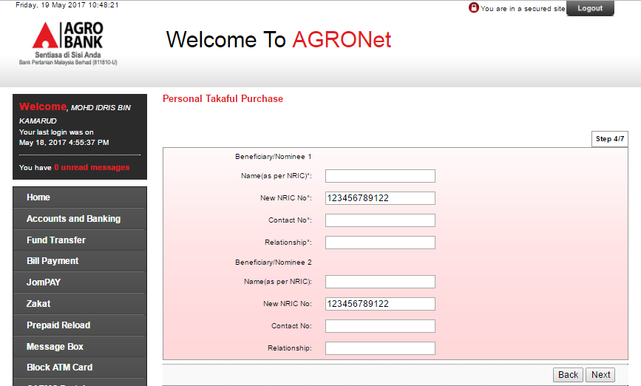
Reviewed By: (PMO)
 |  |  | Name/Position : Norhaidah Binti Md Dasuki / Senior Manager, Quality Assurance and Support  Date :

