Test Issue Log |  |  |  |  | SCP ID#: CR00074
Project Name: | Agrobank Retail Internet Banking
Test Stage: | Unit Functionality Integration System Interface  Performance Regression Acceptance Pilot
Test Case Number: | Change #7463 |  | Test Started Date: |  |  | 26/10/2016
Test Title: | CR-00074 - Setup Self-Service IBAM Access
Test Description: | - To ensure Branch only can access on BIB Company Enquiry and BIB Transaction Enquiry.  https://hub.penril.net/share/s/IY4d71jZRHymeyX6rWmj6w
Test Functionality: | - BIB Company Enquiry  - BIB Transaction Enquiry
Test Procedure: | - Create New User Group Maintenance  - Create New User Profile Maintenance and assign it to the created Group.  - Login as Branch  - Display access service for branch.
Test Result: | Pass: Fail: | Tested by: |  | Erni Suhaireen binti Zulkifli
Reason for Failure:
TEST DESCRIPTION

- Create New User Group Maintenance
  - Click on ‘Create’ button to create new user group.
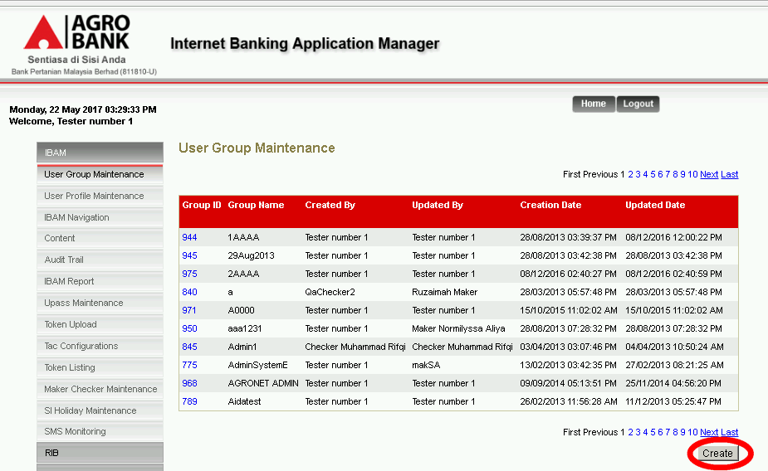
  - Set on ‘View’ Mode and only allow access on BIB Company Enquiry and BIB Transaction Enquiry.
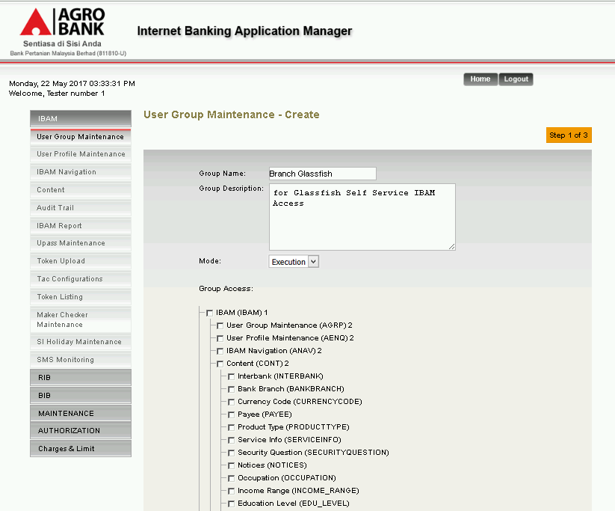
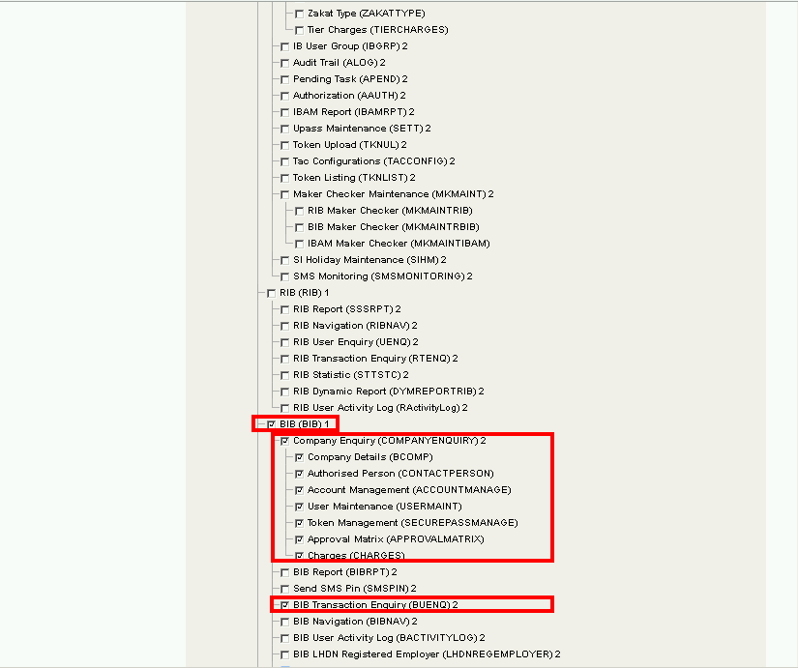
  - Proceed to Confirm Page and Result Page.
Branch Glassfish group has been created.
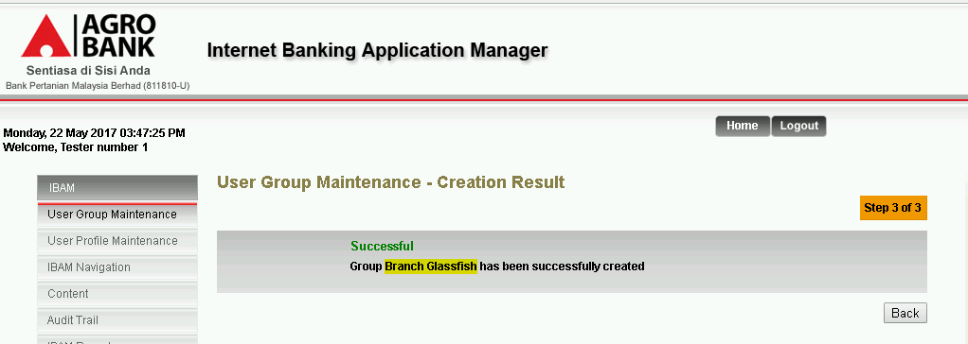

- Create New User Profile Maintenance and assign it to the created Group.
  - Click on ‘Create’ button to create on new user.
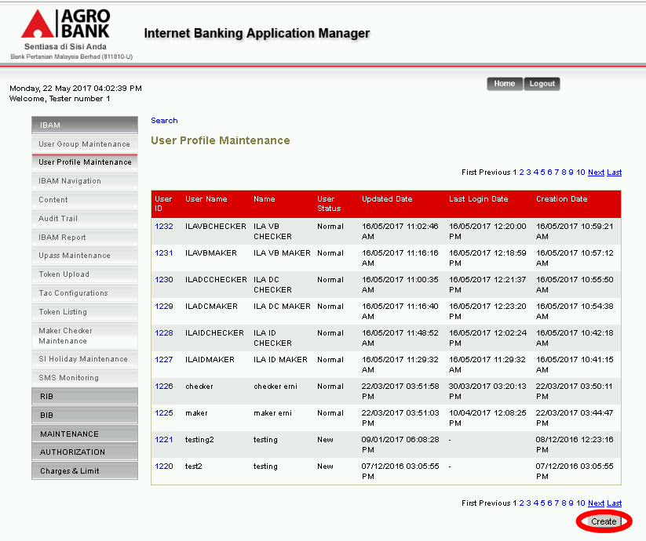
  - Set on ‘Branch Glassfish’ (created group) at Group dropdown navigation. Ensure that the service allow is only on Company Enquiry and BIB Transaction Enquiry.
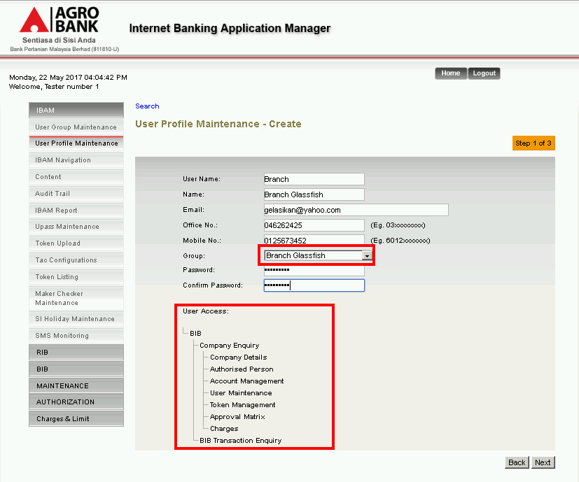
  - Proceed to Confirm Page and Result Page.
User Branch has successfully been creted.
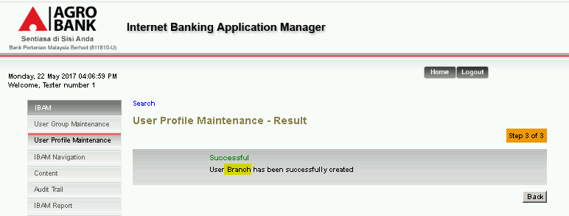
- Login as Branch
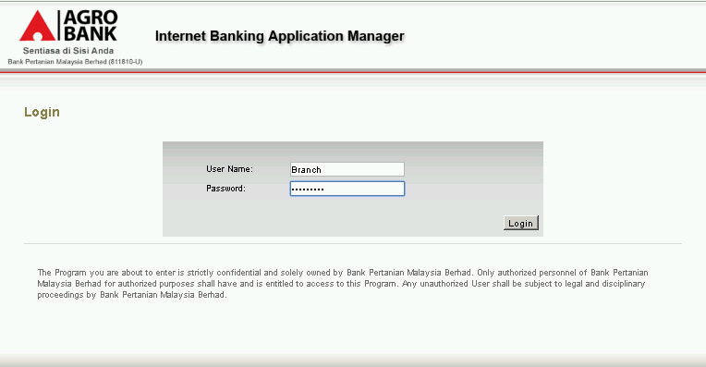
  - Perform FTL.
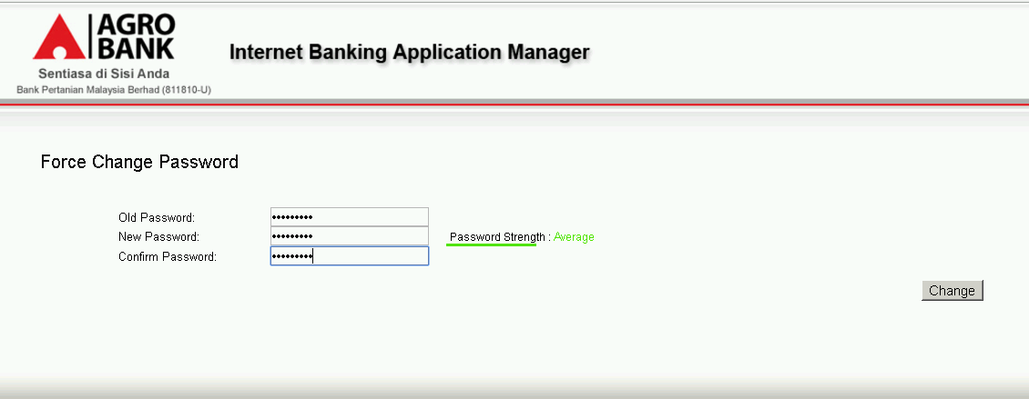
- Display access service for branch.
  - Home Page
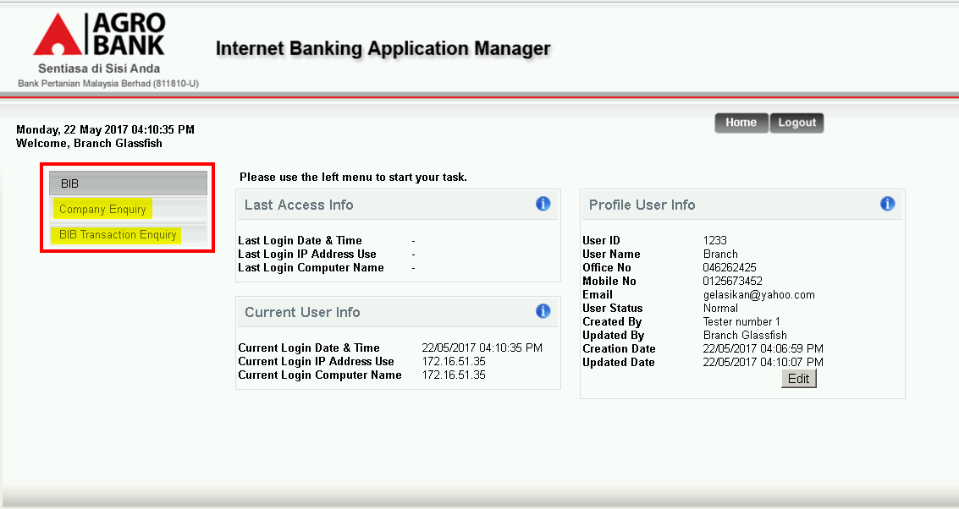
  - Company Enquiry Page
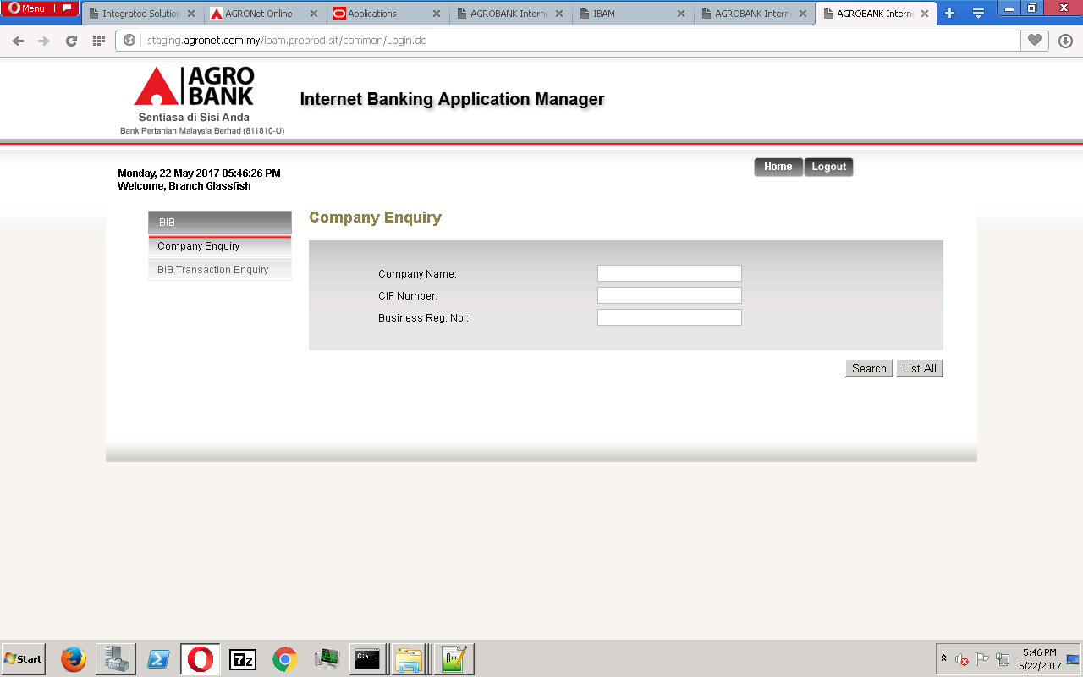
    - Company Details
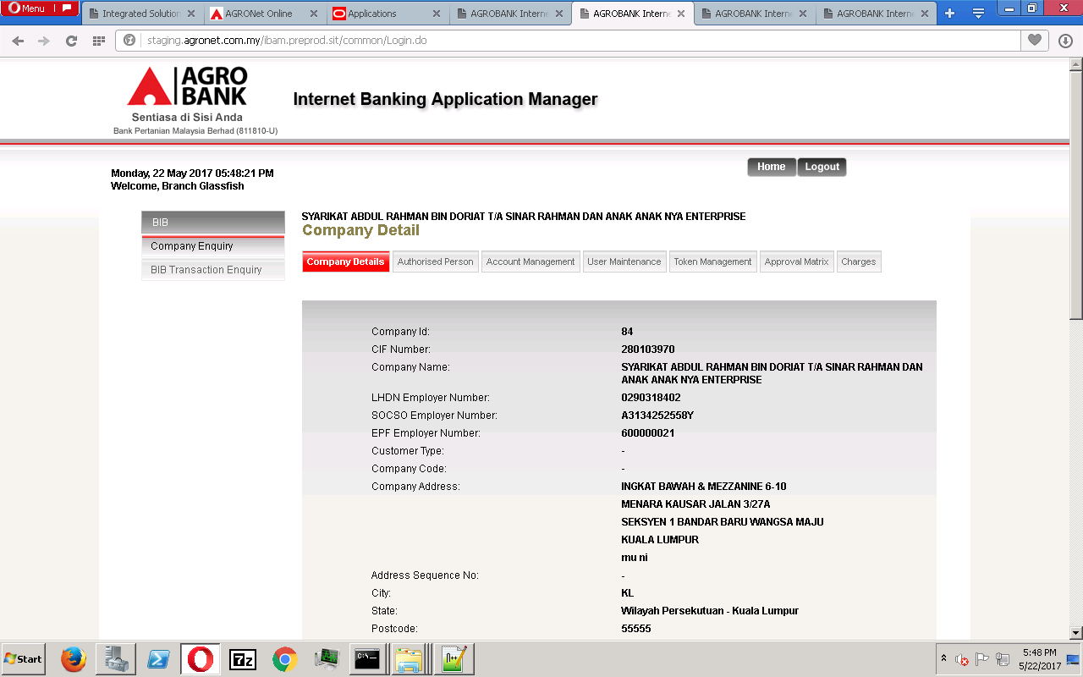
    - Authorized Person
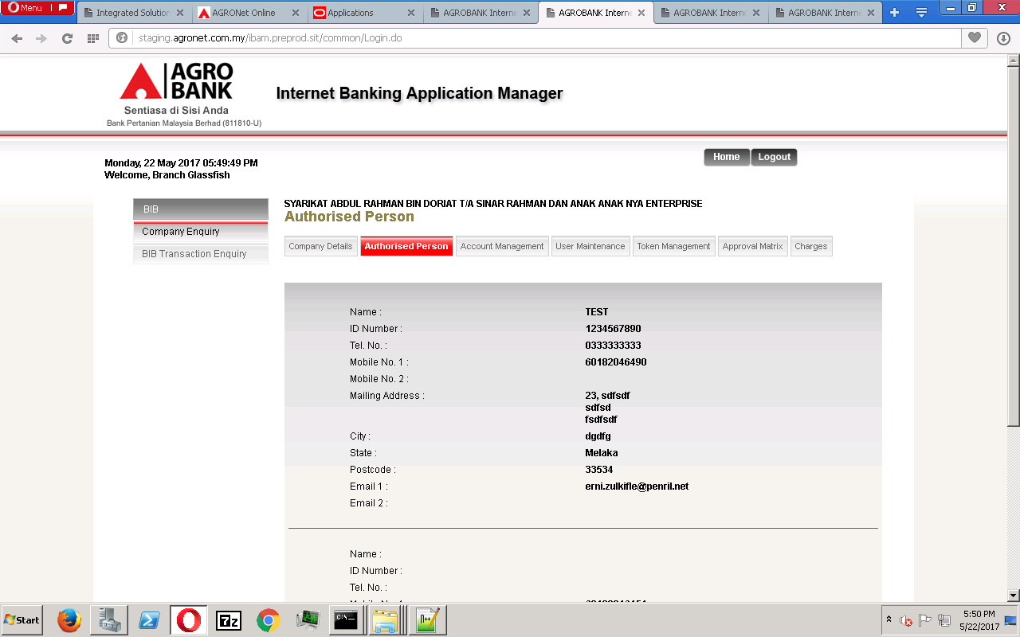
    - Account Management
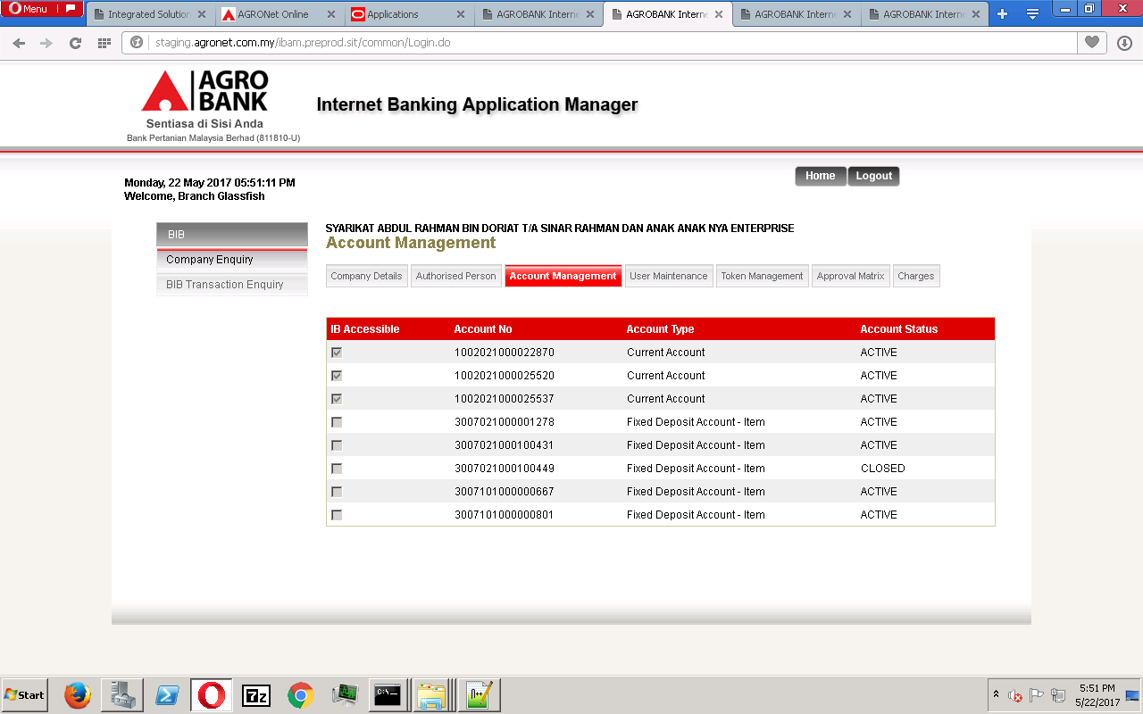

    - User Maintenance
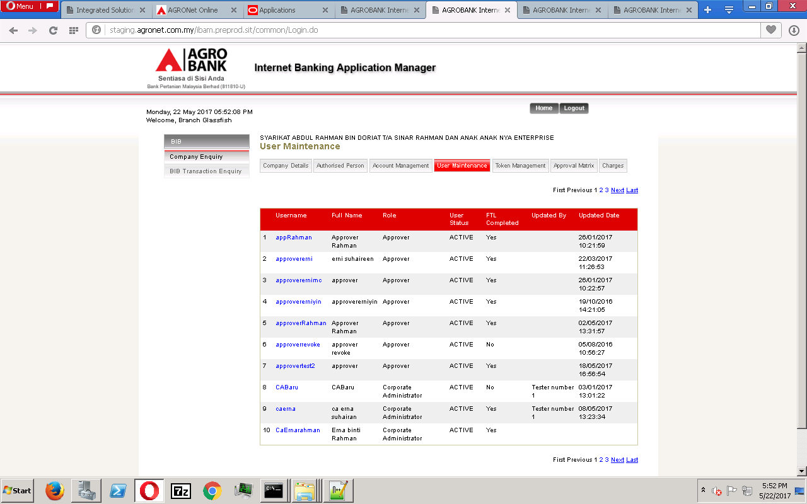
    - Token Management
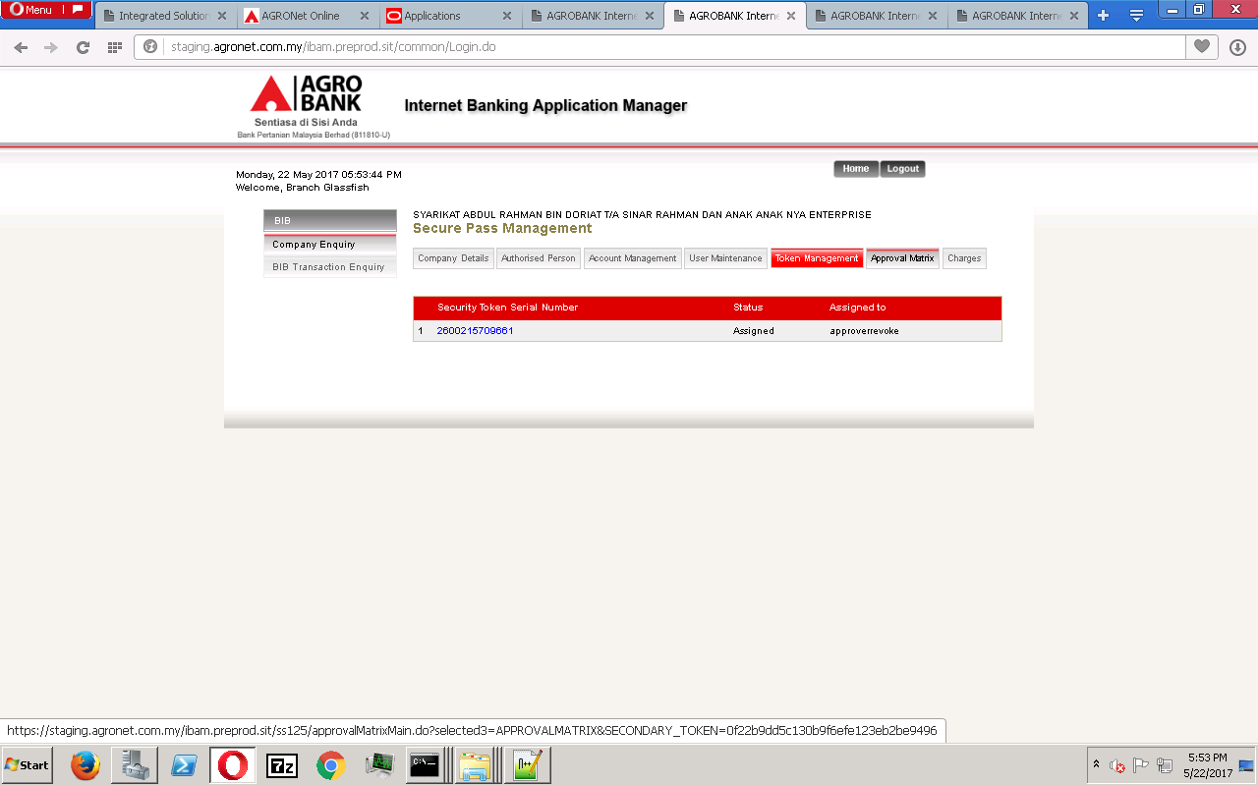
    - Approval Matrix
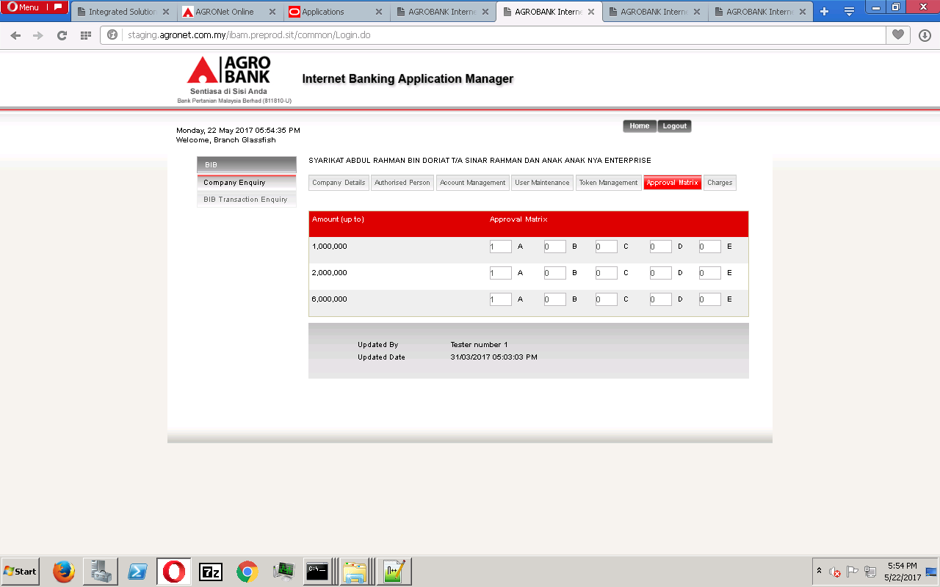

    - Charges
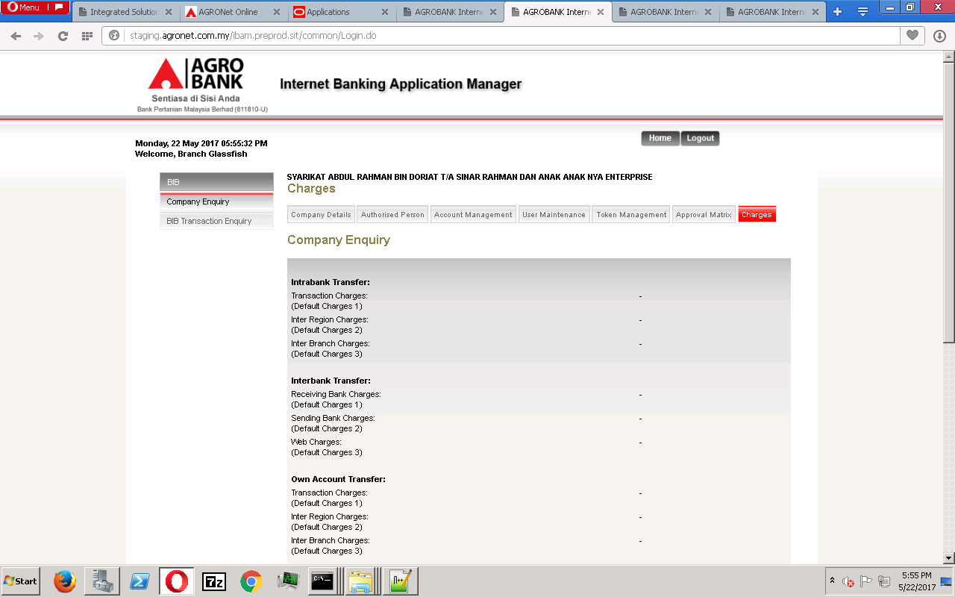
  - BIB Transaction Enquiry
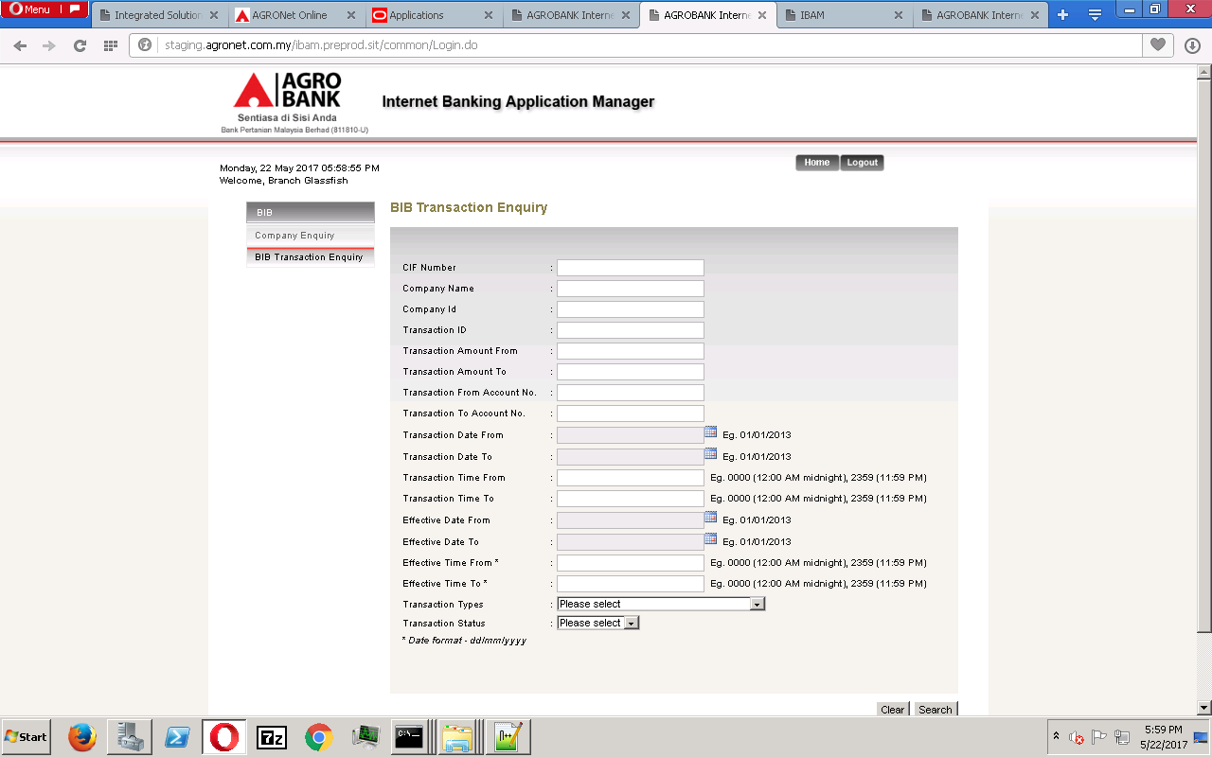

Reviewed By: (PMO)
 | Name/Position : Norhaidah Binti Md Dasuki / Senior Manager, Quality Assurance and Support  Date :

