Test Issue Log |  |  |  |  |  | SCP ID# : CR00072
Project Name: | AGROBANK BUSINESS INTERNET BANKING
Test Stage: | Unit Functionality Integration System Interface  Performance Regression Acceptance Pilot
Test Case Number: | Change #7464 |  |  | Test Started Date: |  |  | 23/05/2017
Test Title: | OPG Reconciliation Report
Test Description: | To ensure current report include above changes:  - To add Transaction Status column  - To show all Transaction for status Successful and Unsuccessful  - Total Count and Total Amount only for Successful Transaction OPG Reconciliation Report
Test Functionality: | - OPG Reconciliation Report
Test Procedure: | - Login Remote Desktop to check the OPG Reconciliation Report.  - Display the OPG Reconciliation Report.  - Ensure current report include above changes:  - To add Transaction Status column  - To show all Transaction for status Successful and Unsuccessful  - Total Count and Total Amount only for Successful Transaction OPG Reconciliation Report
Test Result: | Pass: Fail: | Tested by: |  |  | Erni Suhaireen binti Zulkifli
Reason for Failure:
TEST DESCRIPTION
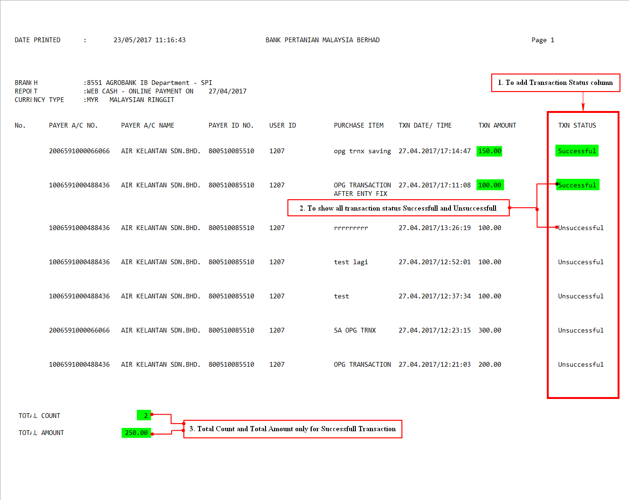
Reviewed By: (PMO)
 |  |  | Name/Position : Norhaidah Binti Md Dasuki / Senior Manager, Quality Assurance and Support  Date :

