Test Issue Log |  |  |  |  |  | SCP ID# : 3888
Project Name: | AGROBANK BUSINESS INTERNET BANKING
Test Stage: | Unit Functionality Integration System Interface  Performance Regression Acceptance Pilot
Test Case Number: | Support #7530 |  |  | Test Started Date: |  |  | 14/06/2017
Test Title: | BULK PAYMENT - Failed to approve, crediting date expired but successful go through to BPS for processing
Test Description: | To ensure current system works; transaction should not go through to BPS if the crediting date expired.
Test Functionality: | BIB  Bulk Payment File Upload
Test Procedure: | - Perform to Bulk Payment File Upload, set crediting date to current date (14/06/2017).  - Approve the transaction after the crediting date (15/06/2017)  - Reject the transaction after the crediting date (15/06/2017)
Test Result: | Pass: Fail: | Tested by: |  |  | Erni Suhaireen binti Zulkifli
Reason for Failure:
TEST DESCRIPTION
- Perform to Bulk Payment File Upload, set crediting date to current date (15/06/2017).
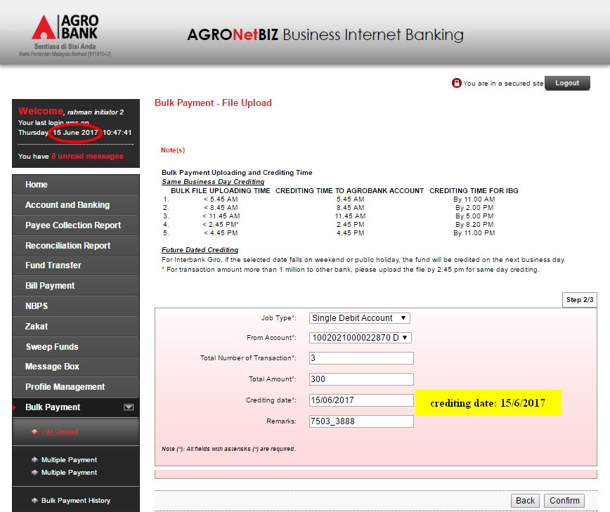

  - Display Result Page
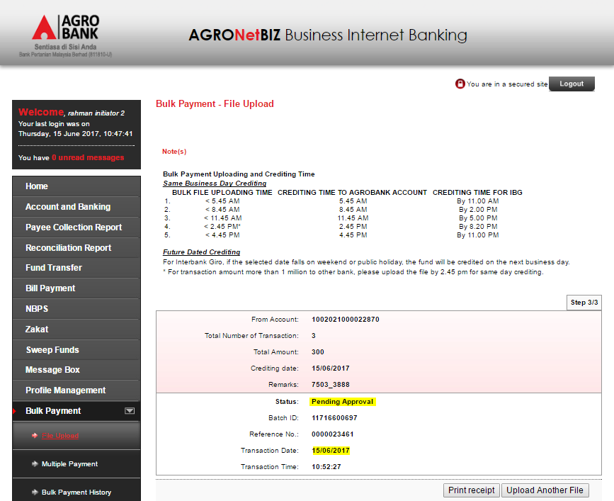

  - Display Bulk Payment History page (after run cronjob)
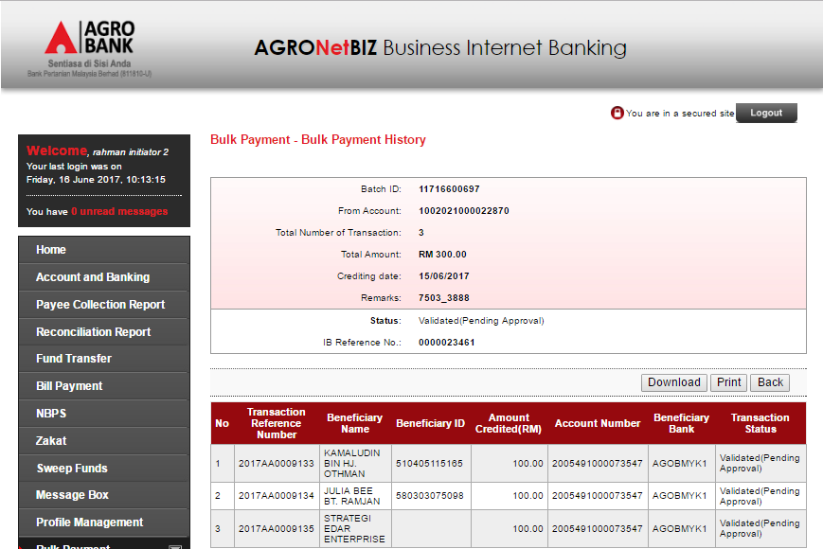

- Approve the transaction after the crediting date (15/06/2017)
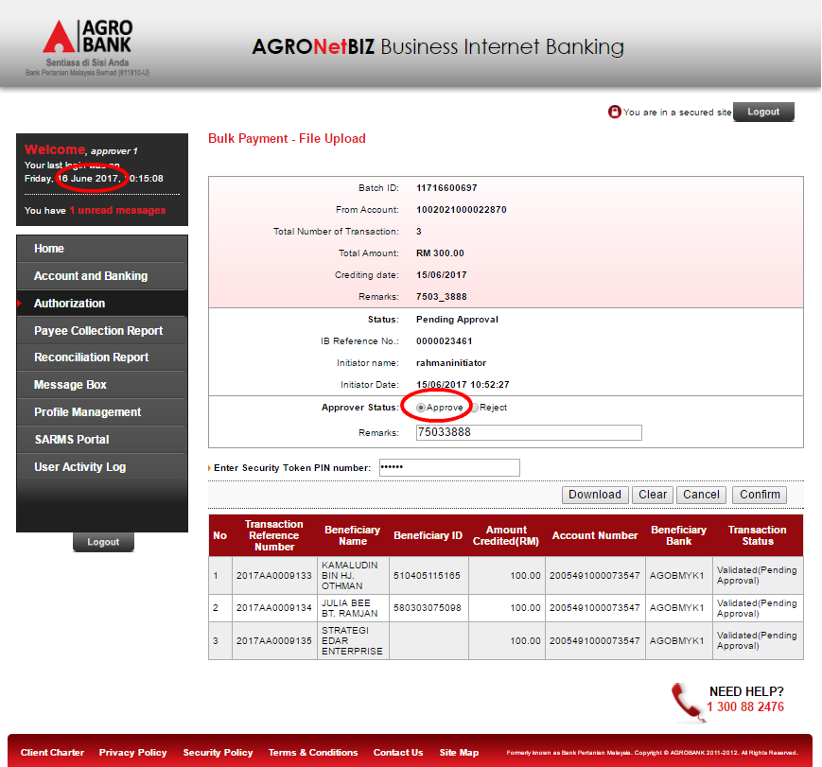

  - Approver Result Page.
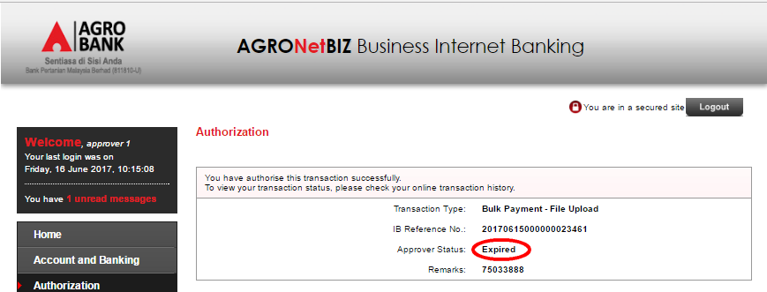

- Reject the transaction after the crediting date (15/06/2017)
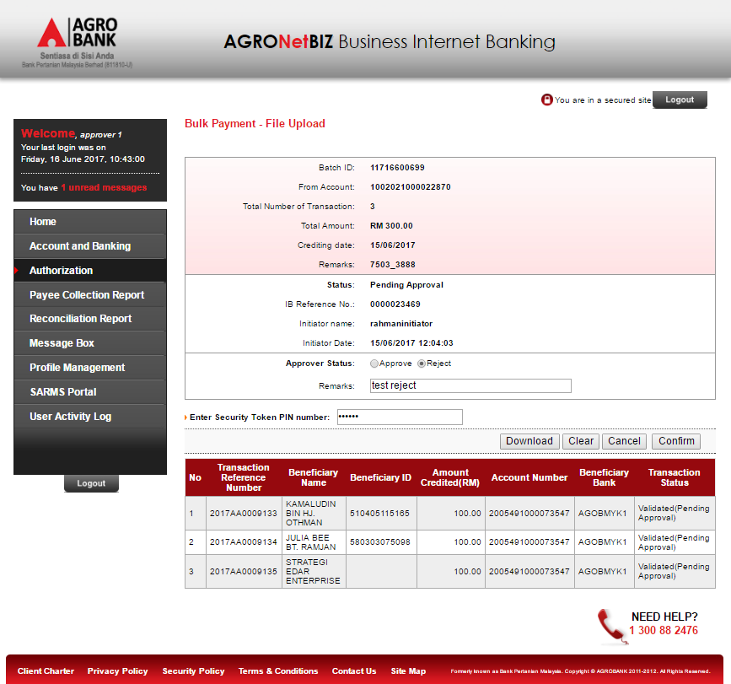

  - Approver Result Page.
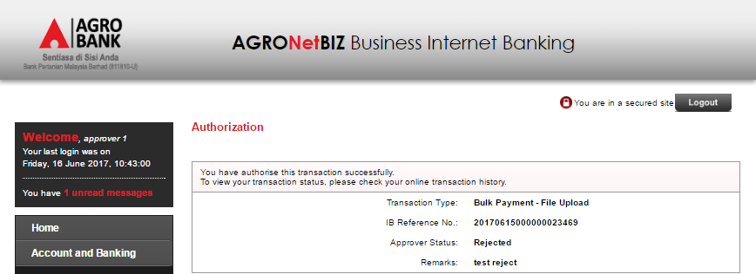
Reviewed By: (PMO)
 |  |  | Name/Position : Norhaidah Binti Md Dasuki / Senior Manager, Quality Assurance and Support  Date :

