Test Issue Log |  |  |  |  |  | SCP ID# : 3889
Project Name: | AGROBANK BUSINESS INTERNET BANKING
Test Stage: | Unit Functionality Integration System Interface  Performance Regression Acceptance Pilot
Test Case Number: | Support #7504 |  |  | Test Started Date: |  |  | 16/06/2017
Test Title: | System unavailable when click fund transfer menu
Test Description: | To ensure initiator successfully perform on Own Account Transfer without loading and System Unavailable issue.
Test Functionality: | BIB  Fund Transfer > Own Account
Test Procedure: | - Perform to Own Account Transfer  - Display result page
Test Result: | Pass: Fail:  Conditional Pass: | Tested by: |  |  | Erni Suhaireen binti Zulkifli
Reason for Failure: | This issue is Conditional Pass because we do not have any companies that have more than 50 current account to replicate this issue.
TEST DESCRIPTION
- Perform to Own Account Transfer
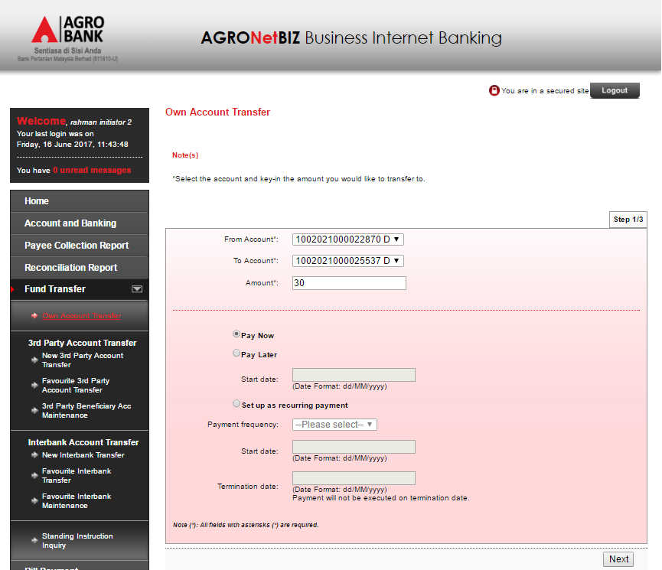
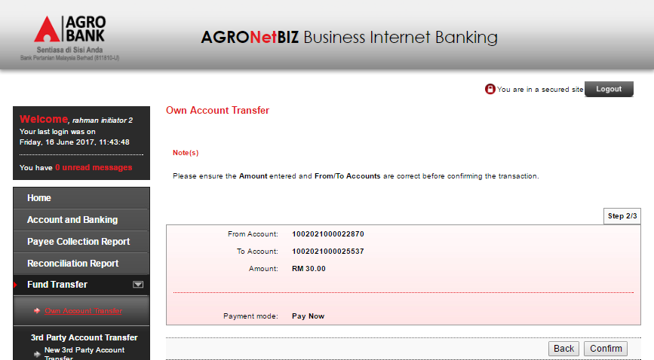
  - Display result page
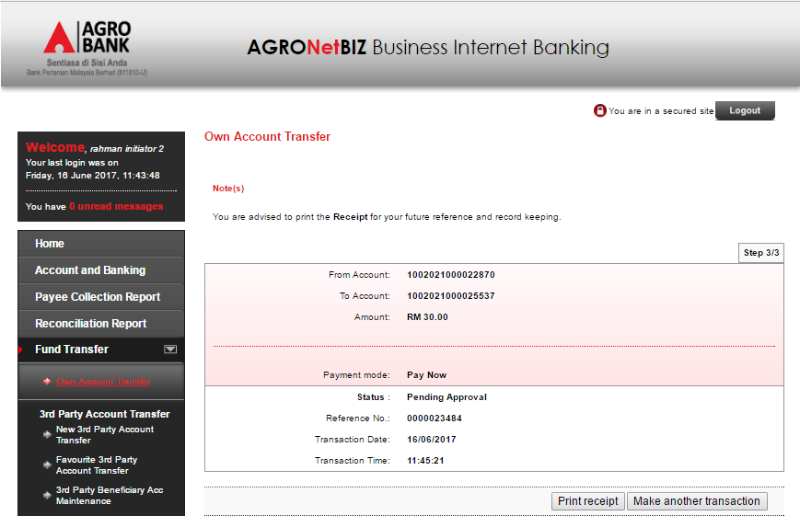
Reviewed By: (PMO)
 |  |  | Name/Position : Norhaidah Binti Md Dasuki / Senior Manager, Quality Assurance and Support  Date :

