Test Issue Log |  |  |  |  |  | SCP ID# : 3892
Project Name: | AGROBANK BUSINESS INTERNET BANKING
Test Stage: | Unit Functionality Integration System Interface  Performance Regression Acceptance Pilot
Test Case Number: | Support #7507 |  |  | Test Started Date: |  |  | 16/06/2017
Test Title: | Charges eibft not correct
Test Description: | To ensure charges for EIBF display RM 0.53 instead of RM 53.
Test Functionality: | BIB  Fund Transfer > New Interbank transfer > Instant Transfer  Fund Transfer > Favorite Interbank transfer > Instant Transfer
Test Procedure: | - Perform New EIBFT transfer.  - Perform favorite EIBFT transfer.
Test Result: | Pass: Fail:  Conditional Pass: | Tested by: |  |  | Erni Suhaireen binti Zulkifli
Reason for Failure: | This issue is Conditional Pass due to limitation in order to test EIBFT transaction.
TEST DESCRIPTION
- Perform New EIBFT transfer.
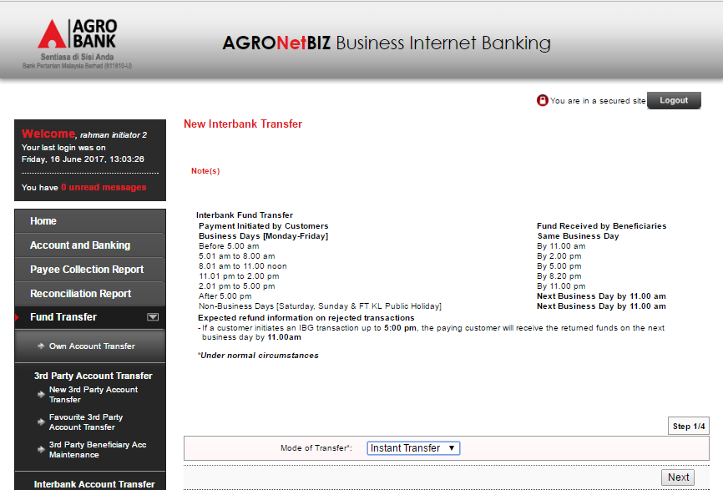

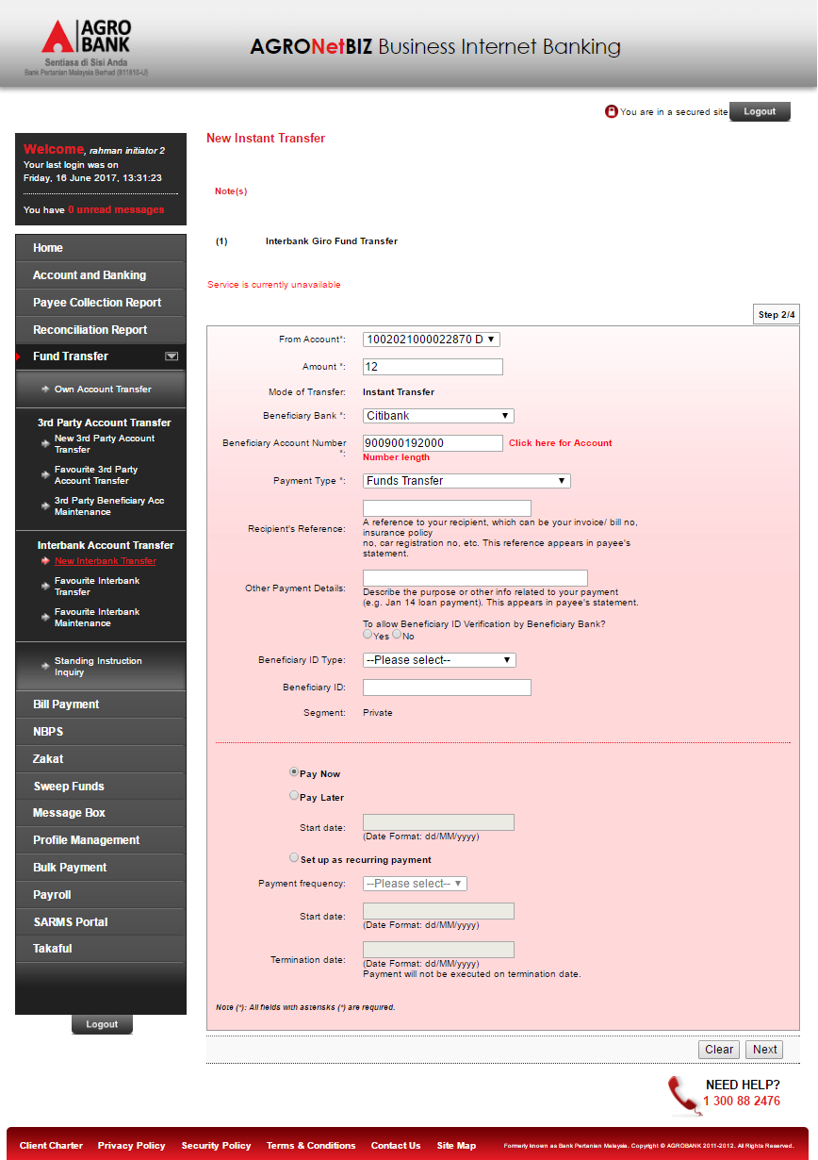
Result: System display “Service is currently unavailable”

- Perform favorite EIBFT transfer
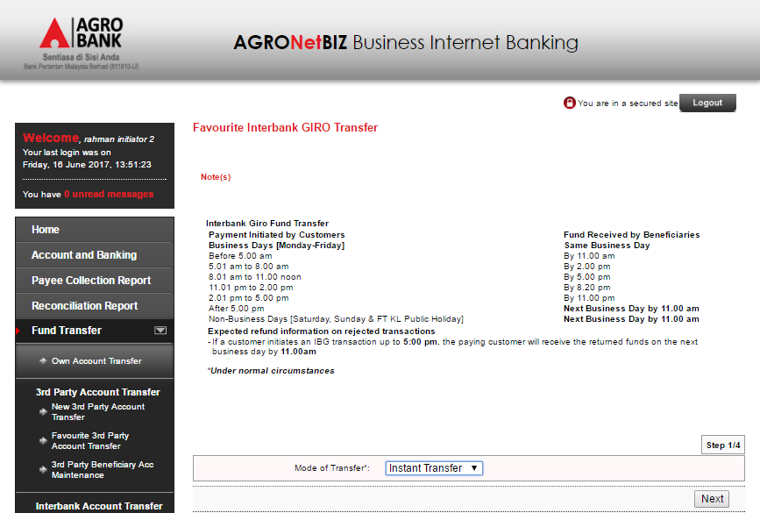
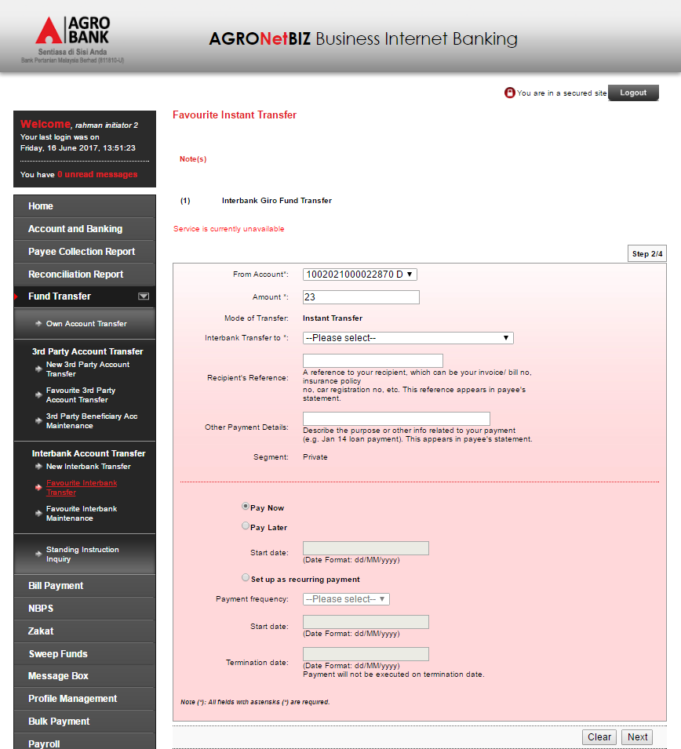
Result: System display “Service is currently unavailable”
Reviewed By: (PMO)
 |  |  | Name/Position : Norhaidah Binti Md Dasuki / Senior Manager, Quality Assurance and Support  Date :

