Test Issue Log |  |  |  |  |  | SCP ID# : SIT_006
Project Name: | AGROBANK BUSINESS INTERNET BANKING
Test Stage: | Unit Functionality Integration System Interface  Performance Regression Acceptance Pilot
Test Case Number: | Support #7536 |  |  | Test Started Date: |  |  | 21/06/2017
Test Title: | [EPF_006] Allow Special Character in Bene Name
Test Description: | To ensure Bene Name field allow special character
Test Functionality: | BIB  - Payroll > Statutory Bodies > EPF
Test Procedure: | - Test upload EPF file with special character
Test Result: | Pass: Fail: | Tested by: |  |  | Erni Suhaireen binti Zulkifli
Reason for Failure:
TEST DESCRIPTION
- Test upload EPF file with special character
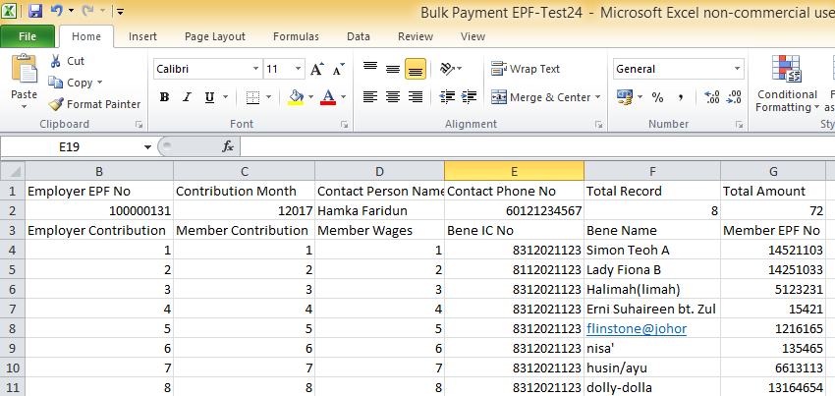

- Upload the edited file. Then click on Next Button.
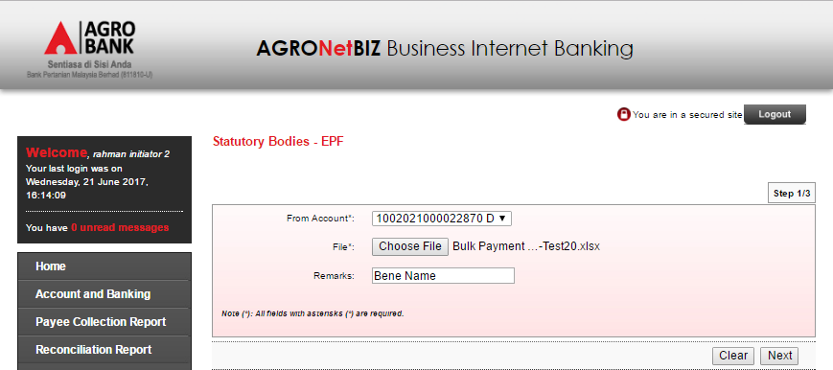
- System successfully proceeds on the Next Page. No validation occur on Bene Name special character.
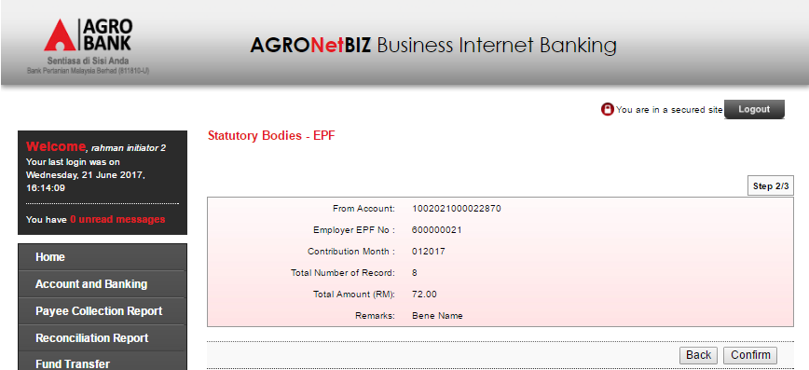
Reviewed By: (PMO)
 |  |  | Name/Position : Norhaidah Binti Md Dasuki / Senior Manager, Quality Assurance and Support  Date :

