Test Issue Log |  |  |  |  |  | SCP ID# : SIT_008
Project Name: | AGROBANK BUSINESS INTERNET BANKING
Test Stage: | Unit Functionality Integration System Interface  Performance Regression Acceptance Pilot
Test Case Number: | Support #7537 |  |  | Test Started Date: |  |  | 04/07/2017
Test Title: | [EPF_008] Payment Reference
Test Description: | To ensure Remarks that entered during transaction displayed on Agronet Transaction History.  To ensure From Account Number displayed on Agronet Transaction History.
Test Functionality: | BIB  - Payroll > Statutory Bodies > EPF
Test Procedure: | - Test upload EPF file with special character
Test Result: | Pass: Fail: | Tested by: |  |  | Erni Suhaireen binti Zulkifli
Reason for Failure:
TEST DESCRIPTION
- Test upload EPF file and enter the Remarks
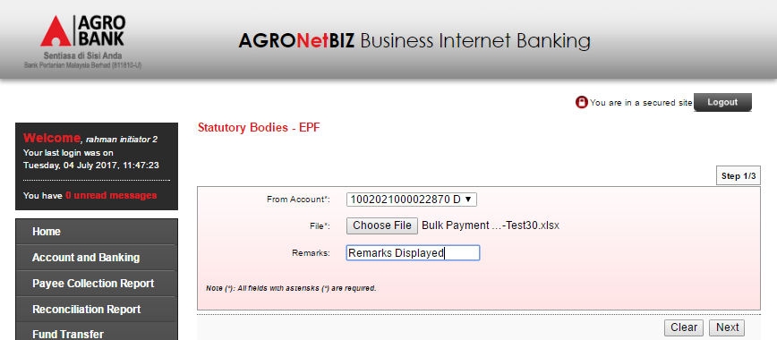

- Proceed to Next Page
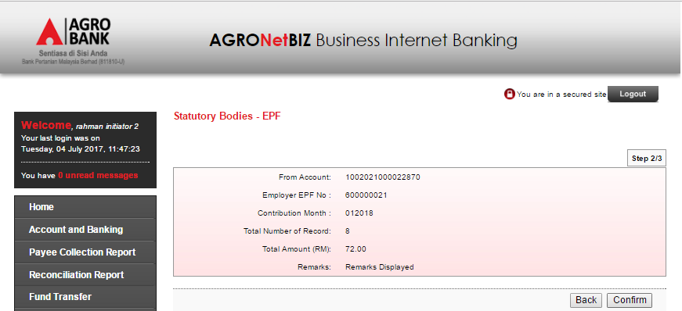
- Display Result Page.
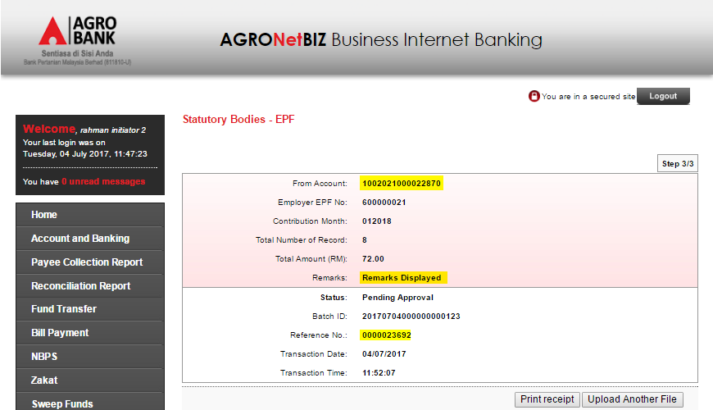

- Display AgronetBiz Transaction History.
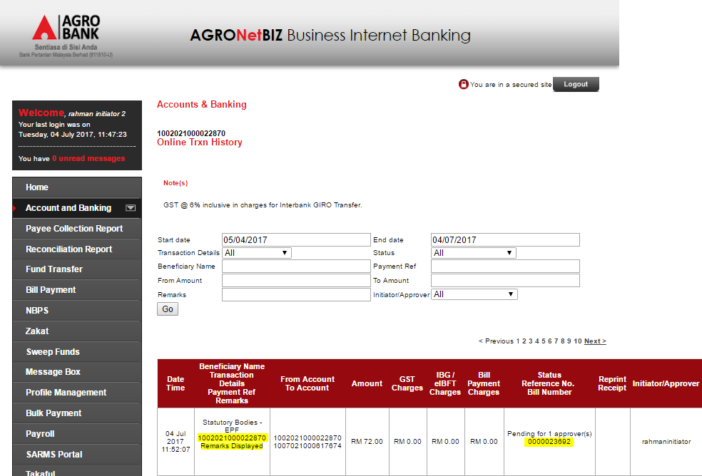
Reviewed By: (PMO)
 |  |  | Name/Position : Norhaidah Binti Md Dasuki / Senior Manager, Quality Assurance and Support  Date :

