Test Issue Log |  |  |  |  |  | SCP ID# : SIT_011
Project Name: | AGROBANK BUSINESS INTERNET BANKING
Test Stage: | Unit Functionality Integration System Interface  Performance Regression Acceptance Pilot
Test Case Number: | Support #7601 |  |  | Test Started Date: |  |  | 03/08/2017
Test Title: | [EPF_011] Transaction displayed successful when perform insufficient amount for Single User
Test Description: | To ensure status display unsuccessful at EPF Transfer History when unsuccessful transaction (Insufficient Amount)
Test Functionality: | BIB  - Payroll > Statutory Bodies > EPF Other Payment Submission  - Payroll > Statutory Bodies > EPF Transfer History
Test Procedure: | - Test upload EPF Other Payment Submission with insufficient amount
Test Result: | Pass: Fail: | Tested by: |  |  | Erni Suhaireen binti Zulkifli
Reason for Failure:
TEST DESCRIPTION
- Check current account balance.
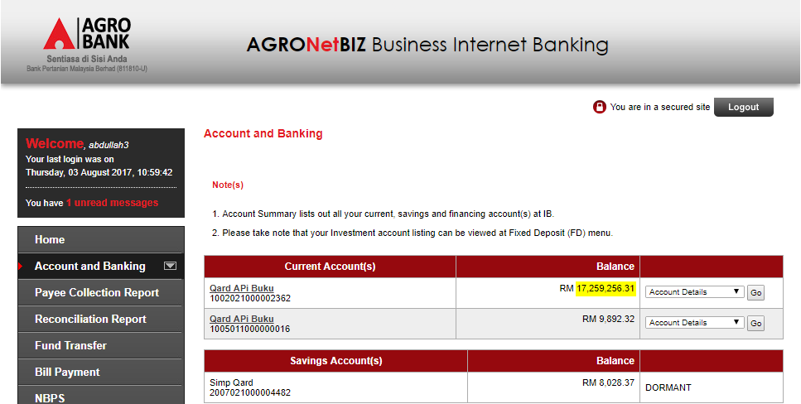

- Test uploads EPF Other Payment Submission with insufficient amount.
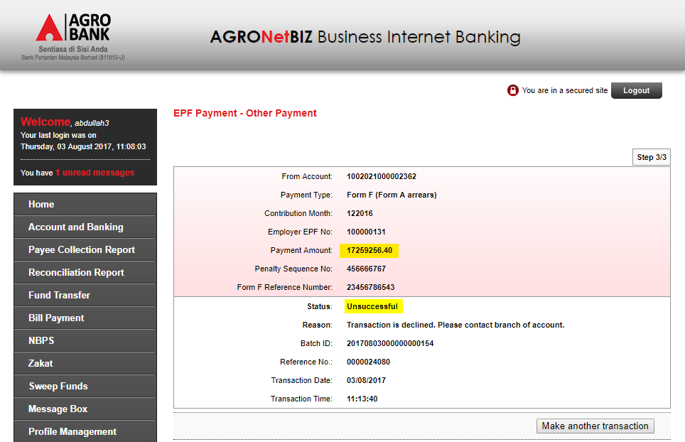

- Display EPF Transfer History status.
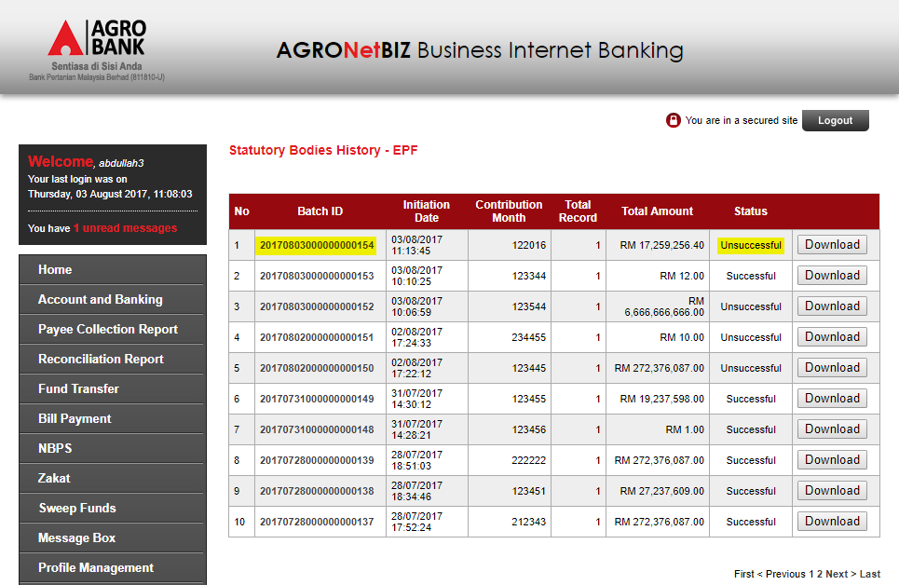
Reviewed By: (PMO)
 |  |  | Name/Position : Norhaidah Binti Md Dasuki / Senior Manager, Quality Assurance and Support  Date :

