Test Issue Log |  |  |  |  |  | SCP ID# : 3980
Project Name: | AGROBANK BUSINESS INTERNET BANKING
Test Stage: | Unit Functionality Integration System Interface  Performance Regression Acceptance Pilot
Test Case Number: | Support #7600 |  |  | Test Started Date: |  |  | 10/08/2017
Test Title: | Account & Banking at AgroNet
Test Description: | Currently BIB display account type at account & banking screen.  Need to change to display account no to avoid customer confusion because customer may have more than 1 account in the same account type.
Test Functionality: | BIB  Account & Banking
Test Procedure: | - Display Account & Banking for user:  - Initiator  - Approver  - Single User  - Viewer
Test Result: | Pass: Fail:  Conditional Pass: | Tested by: |  |  | Erni Suhaireen binti Zulkifli
Reason for Failure:
TEST DESCRIPTION
- Display Account & Banking for user:
  - Initiator
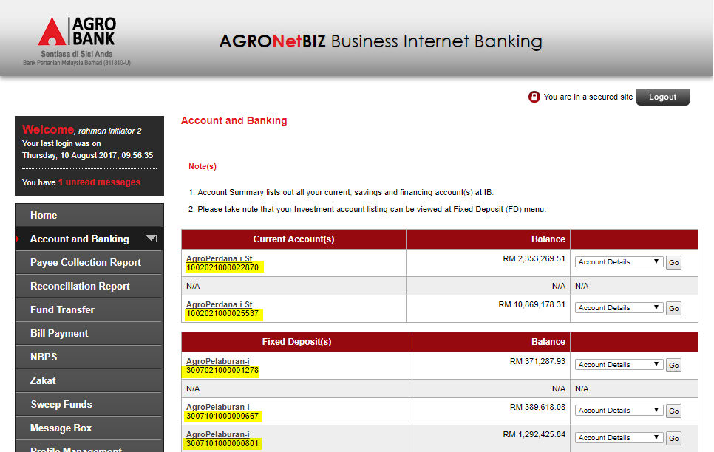
  - Approver
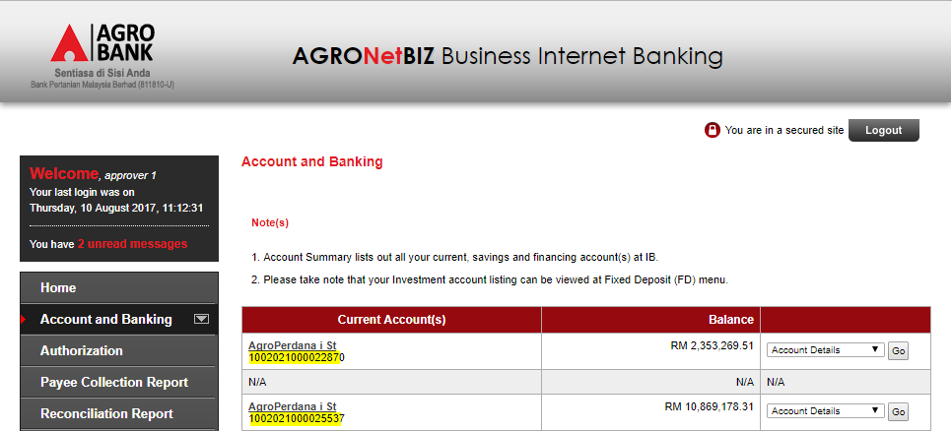

  - Single User
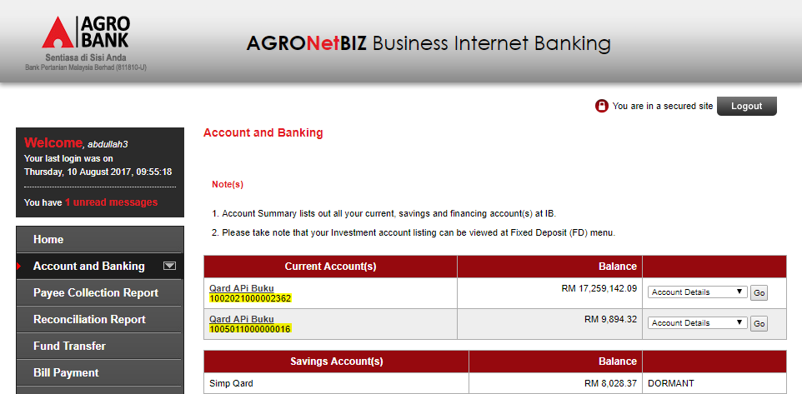
  - Viewer
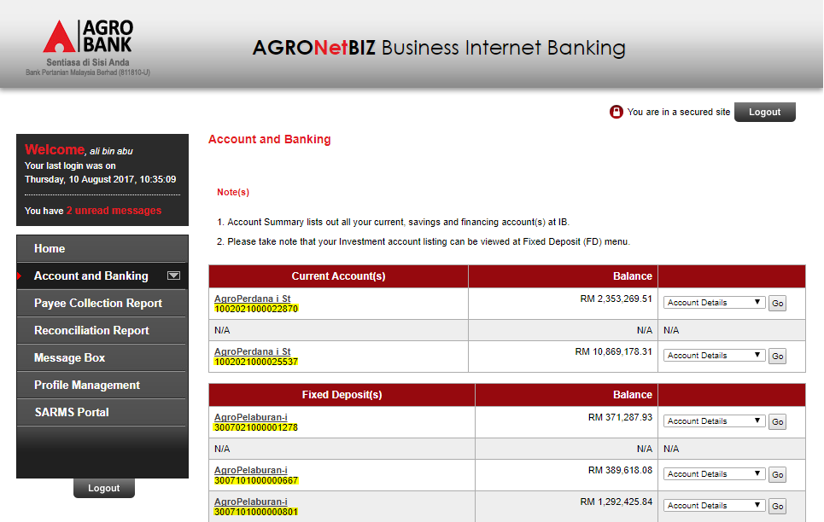

Reviewed By: (PMO)
 |  |  | Name/Position : Norhaidah Binti Md Dasuki / Senior Manager, Quality Assurance and Support  Date :

