Test Issue Log |  |  |  |  |  | SCP ID# : 4061
Project Name: | AGROBANK BUSINESS INTERNET BANKING
Test Stage: | Unit Functionality Integration System Interface  Performance Regression Acceptance Pilot
Test Case Number: | Support #7798 |  |  | Test Started Date: |  |  | 27/03/2017
Test Title: | Transaction not display in Transaction History
Test Description: | - To ensure Transaction History and Reconciliation Report for date 30/06/2017 at account number 10051271000056754 can be displayed.
Test Functionality: | BIB (Single User & Multiple User)  - Account and Banking > Transaction History  - Reconciliation Report
Test Procedure: | Before Fixes  - Login as Single User to view on Transaction History and Reconciliation Report for date 30/06/2017 at account number 10051271000056754.  - Transaction History  - Reconciliation Report  After Fixes  - Login as Single User to view on Transaction History and Reconciliation Report for date 30/06/2017 at account number 10051271000056754.  - Transaction History  - Reconciliation Report
Test Result: | Pass: Fail: | Tested by: |  |  | Erni Suhaireen binti Zulkifli
Reason for Failure:
TEST DESCRIPTION
Before Fixes
- Login as Single User to view on Transaction History and Reconciliation Report for date 30/06/2017 at account number 10051271000056754.
  - Transaction History
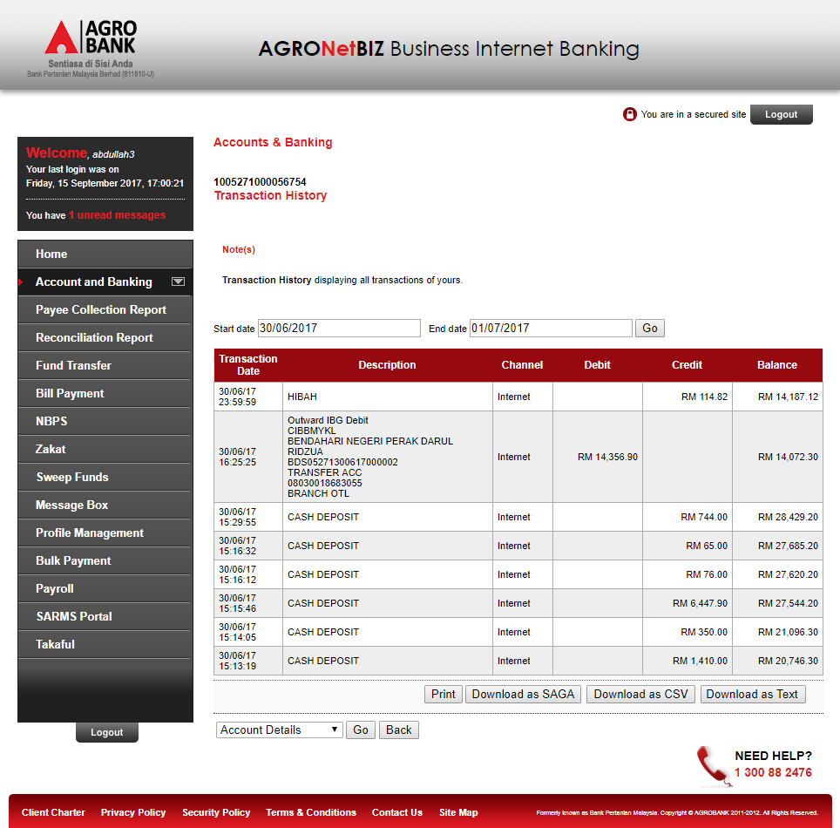

  - Reconciliation Report
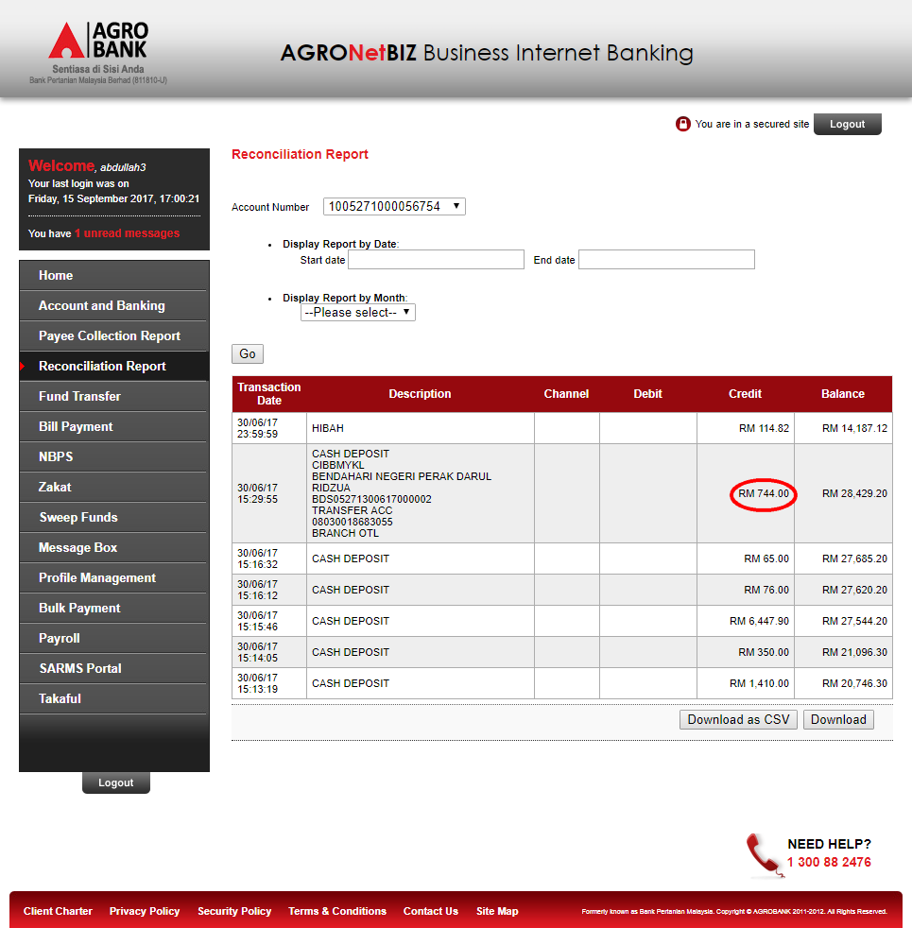

After Fixes
- Login as Single User to view on Transaction History and Reconciliation Report for date 30/06/2017 at account number 10051271000056754.
  - Transaction History
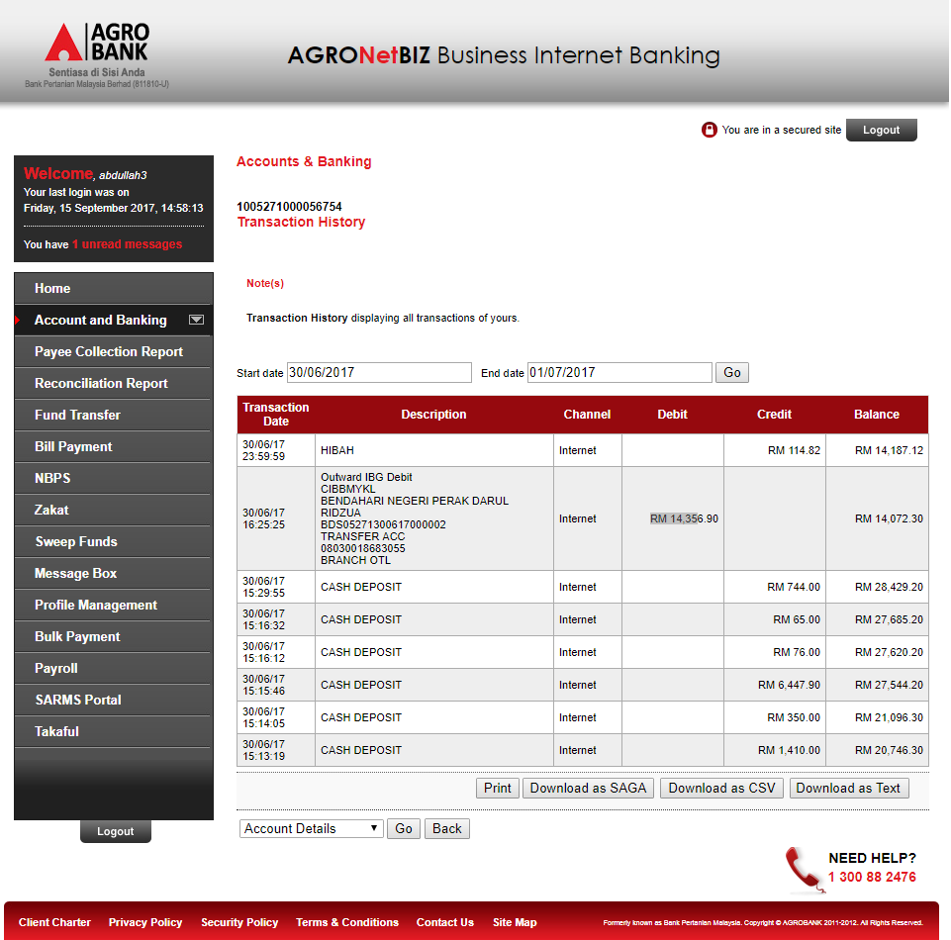

  - Reconciliation Report
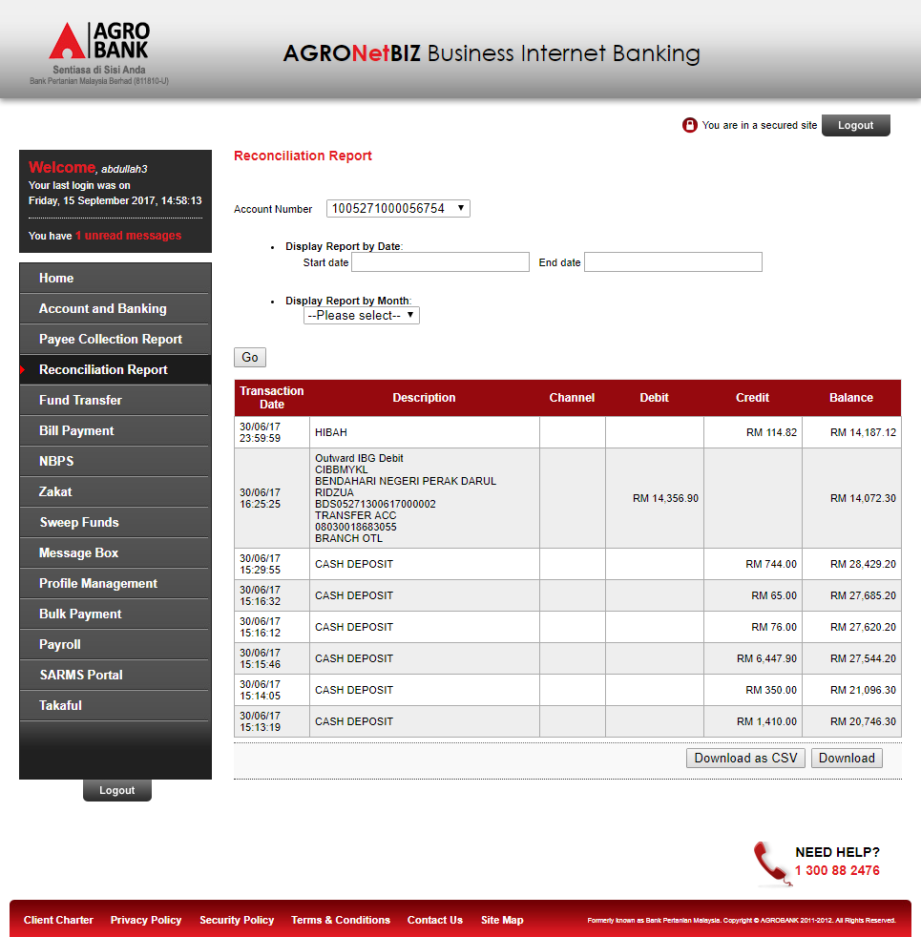
Reviewed By: (PMO)
 |  |  | Name/Position : Norhaidah Binti Md Dasuki / Senior Manager, Quality Assurance and Support  Date :

