CR#EB170059 – Change screen “e-Statement” on RIB

# Host Message

1. To update existing host message
   1. Account Summary e-Statement (1579) to get additional value, E-mail

# RIB

Update e-Statement display to display customer’s email address in listing table instead of display on the top of the page. There is no change to the existing flow.

## e-Statement Enrolment

### Steps

**Step 0**: e-Statement Listing (No Subscription)

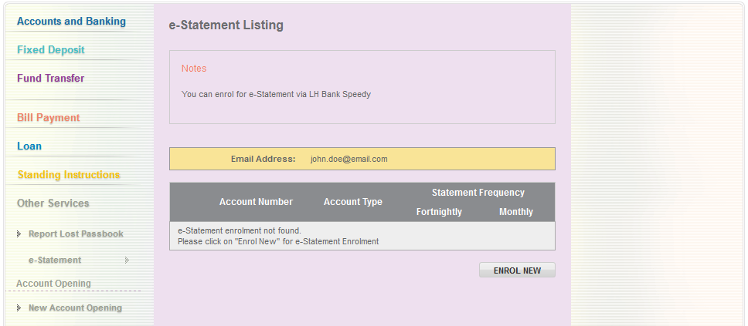

1. Click on “Enrol New” to start enrolment.

**Step 1:** Terms & Condition

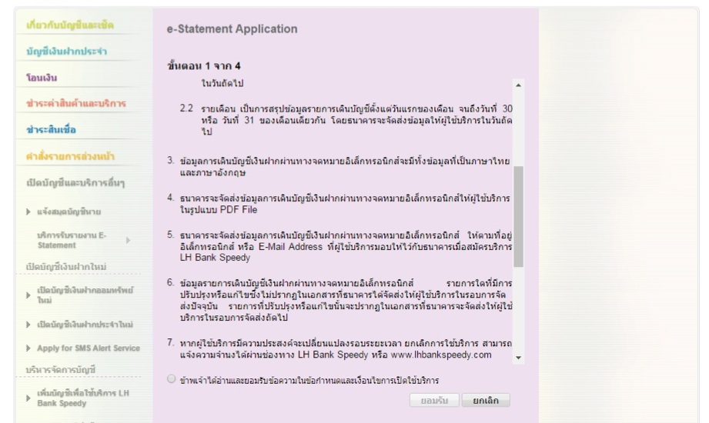

**Step 2:** Details

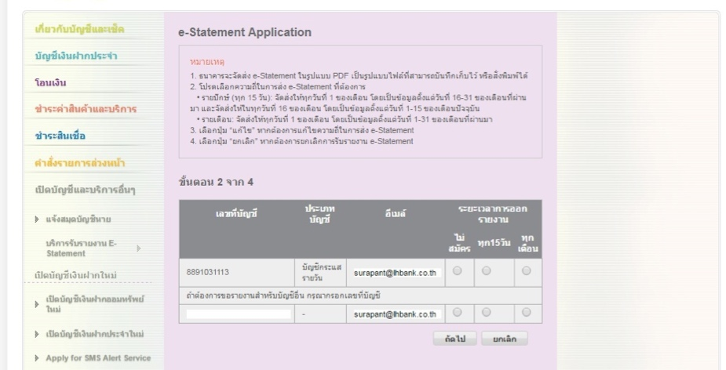

1. Customer allowed to enroll account (not link to IB) for e-Statement. Customer’s email address displayed in the listing table (display only, not editable).

**Step 3:** Confirmation

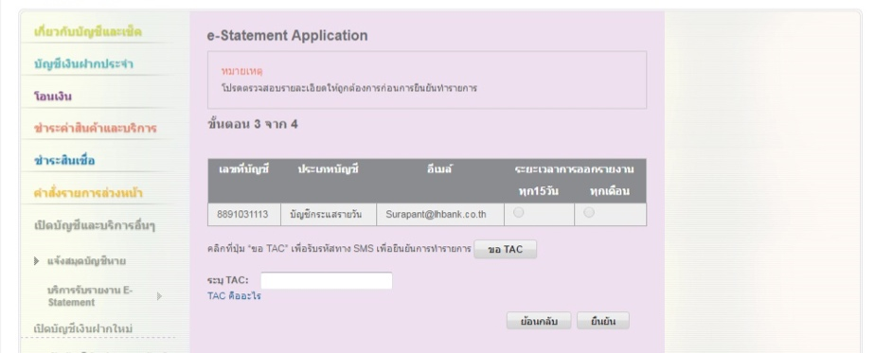

**Step 4:** Result

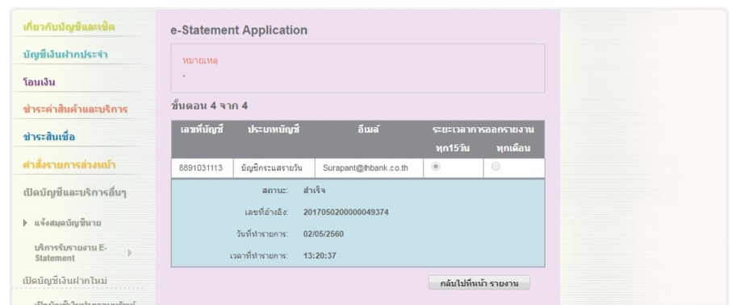

## Update e-Statement Enrolment

### Steps

**Step 1**: Select Account to modify [1]

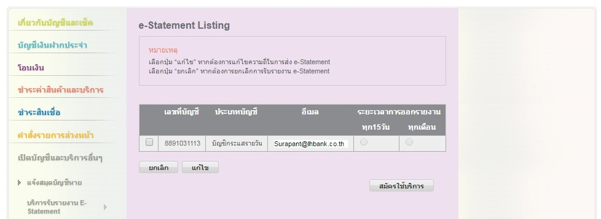

1. Customer select account(s) to modify e-Statement subscription and click “Update”

**Step 1:** Modify e-Statement Frequency

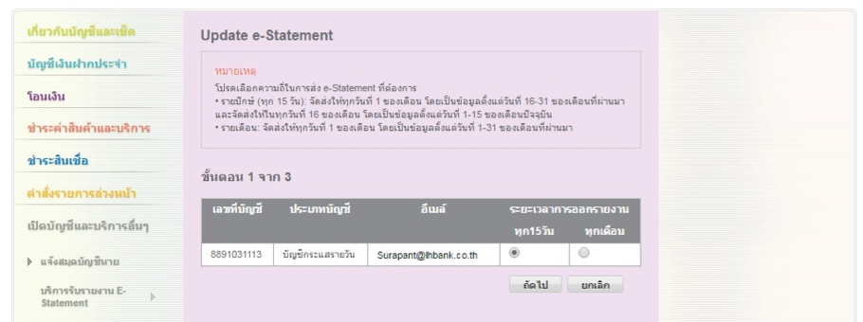

1. Based on the selection from Step 1, list the accounts and available options to modify.

**Step 2:** Confirm

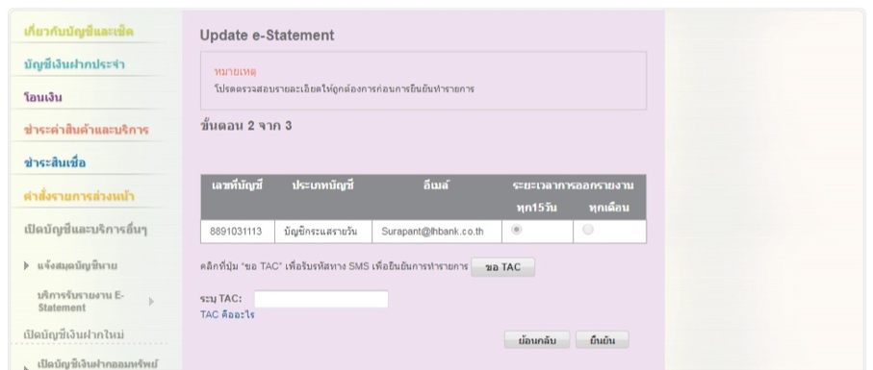

**Step 3:** Result

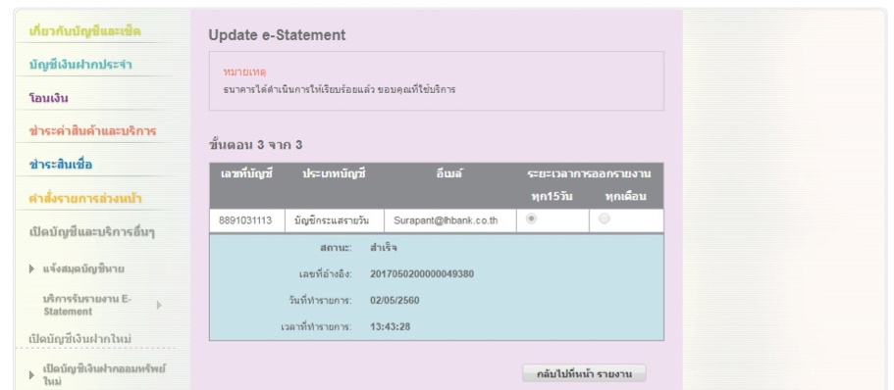

## Cancel e-Statement Subscription

### Steps

**Step 1:** Select account to cancel e-Statement Subscription

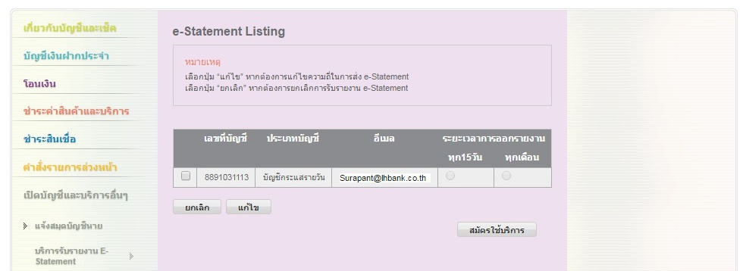

1. Customer select account(s) to modify e-Statement subscription and click “Un-scribe”

**Step 2:** Confirm

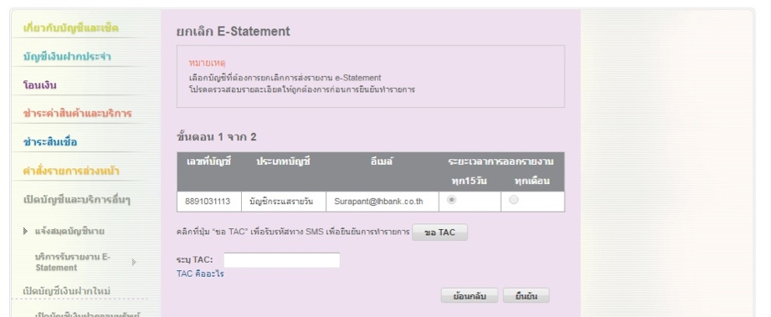

1. Based on the selection from Step 1, list the accounts to cancel the e-Statement subscription

**Step 3:** Result

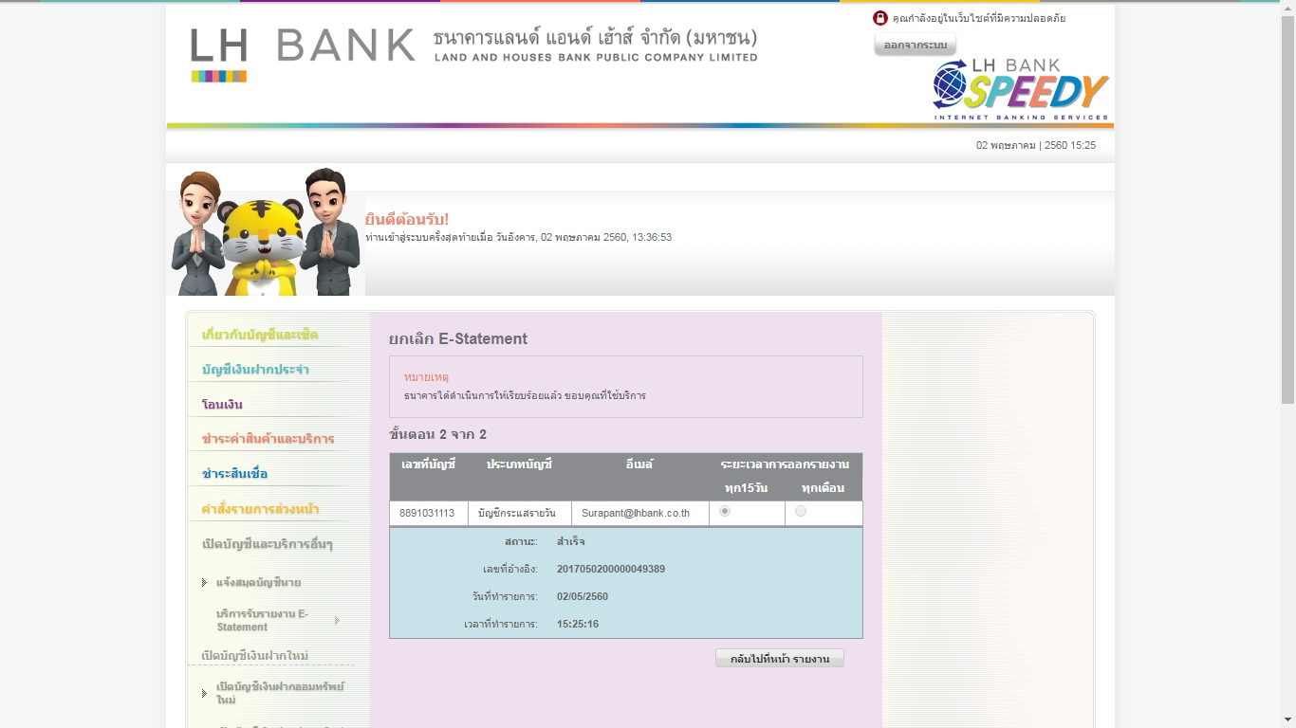

|  |  |
| --- | --- |
| Effort(man-days) | 3 |
| Affected Area | RIB  RIB Manual |

1. IB to get email address from Host for display