<http://www.kfh.com.my/kfhmb/v2/contentView.do?contentTypeId=3000&displayPage=%2Fver2%2Fcontent%2Fstandard.jsp&pageTypeId=12852&channelPath=%2Fver2%2Fv2_Navigation%2FConsumer+Banking%2FDeposits&programName=02_libshara&contentId=17828>

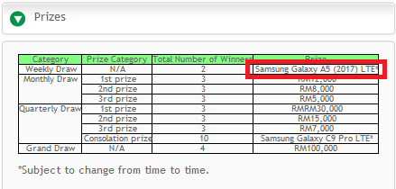

1. Update weekly draw phone model to Samsung Galaxy J7+

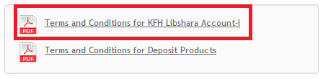

2. Change Terms & Conditions for KFH Libshara Account-i

<http://www.kfh.com.my/libshara/>

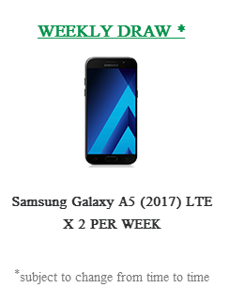

3. Change phone model to Samsung Galaxy J7+ (text & visual)



4. Update T&C