

**Issue Form (PROD)**

|  |  |  |
| --- | --- | --- |
| **Originator's Name:** Kamaruddin Damiri  **Project:** Internet Banking  **Project Manager:** Malarvili Muniandy  **Module : BIB SI**  **Date Raised: 09/02/11**  **Phase :** Business Internet Banking  **Functional Area :** | **Issue ID Number:** kd11-002  **Related Issue ID Number:**  **Classification:**  **Priority:** Critical/High/Medium/Low  **Assigned to: Vendor / IT / PMO SA / UPA**  **Actual Closed Date:** | |
| **Status:** Open/Assigned/Investigated/Resolved/Approved/Deferred/No Action  *(Circle one)* | | |
| 1. BIB SI on bill payment was failed to execute on 09/02/11. The scheduler run correctly.   SI Ref No : 0000000812  Amount : RM1.90  Account not debited.  Frequency : Half yearly  Account # : 001105013079  Customer Name : KFH Online | | **Impact:** |
| **Findings/Root Caused (Description):** | | **Resolution:** |
| **Estimated Impact :** | |  |
| **Recommendation:** | | |
| **Accepted :**  **(Vendor / IT / PMO SA / UPA)**  **Date:** | **Accepted (KFHMB Tester):**  **Date:** | |

Scheduler OK:

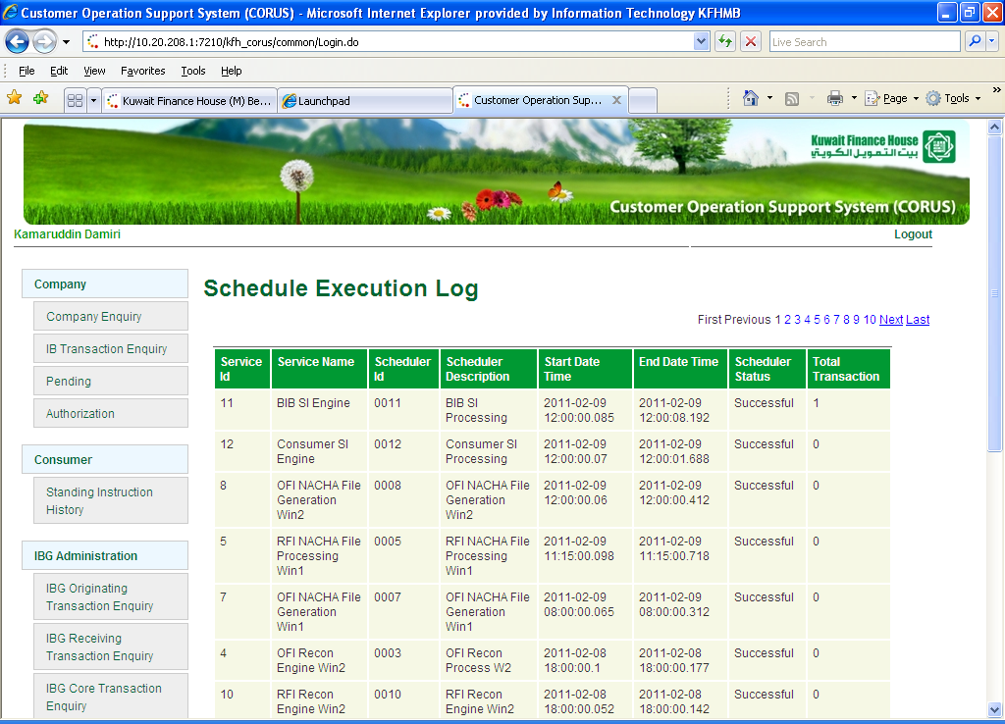

Email on Unsuccessful:

