
Issue Form (PROD)
Originator's Name: Sharon Lai  Project: Internet Banking  Project Manager: Malarvili  Module : BVMC  Date Raised:  Phase : IBG  Functional Area : | Issue ID Number: SL030  Related Issue ID Number:  Classification:  Priority: Critical/High/Medium/Low  Assigned to: Vendor / IT / PMO SA / UPA  Actual Closed Date:
Status: Open/Assigned/Investigated/Resolved/Approved/Deferred/No Action (Circle one)
Description :  1. Unable to re-create new branch using code 008 (Kota Bharu) under dropdown list for Corp Website’s application form in IB Branch Info (BVMC).  [Previously wrongly created and subsequently removed as offline function is not functioning]  Temporary solution: Create Kota Bharu under code 010  2. Unable to offline the Branch Info – will still be shown in the App Form |  | Impact:
Findings/Root Caused (Description): |  | Resolution:
Estimated Impact :

Recommendation:

Accepted :  (Vendor / IT / PMO SA / UPA)  Date: | Accepted (KFHMB Tester):  Date:

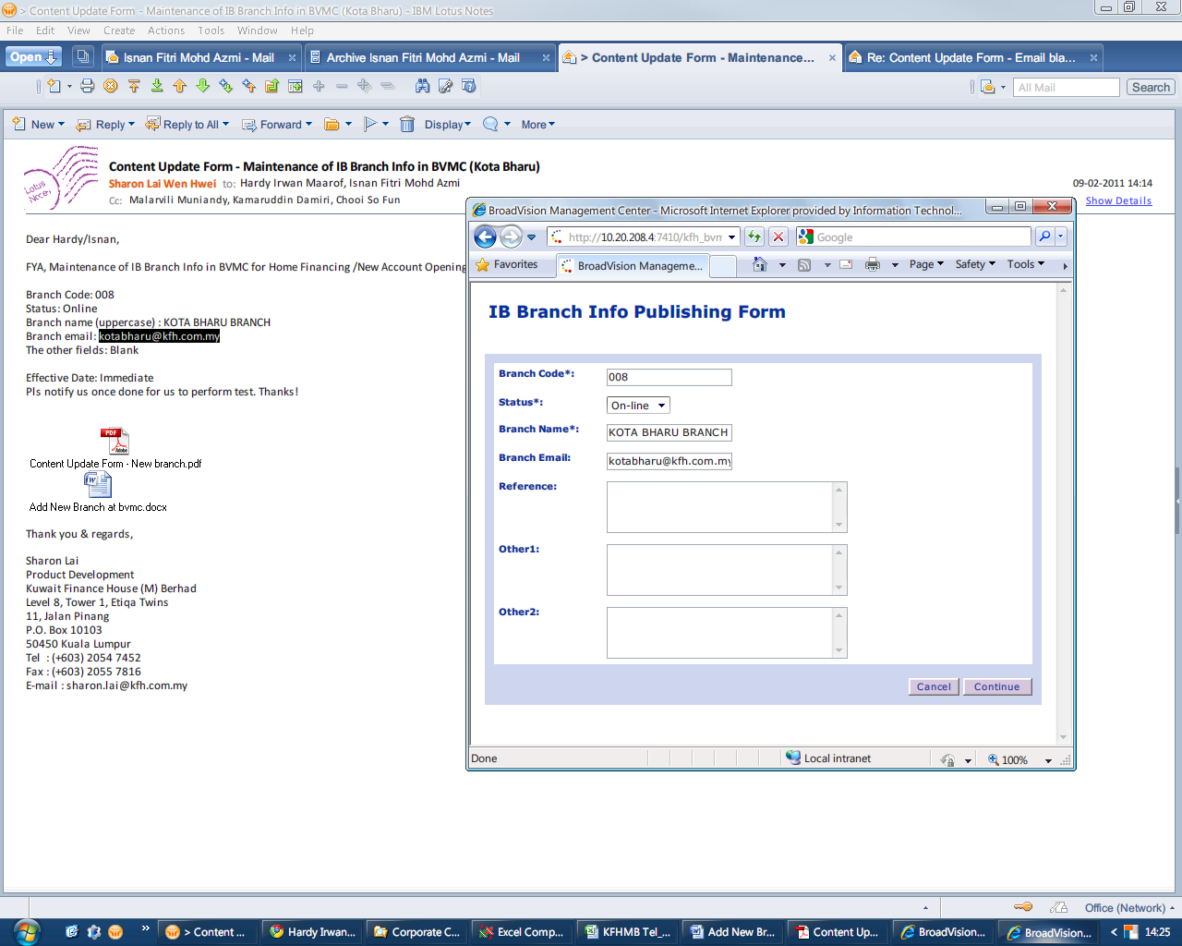
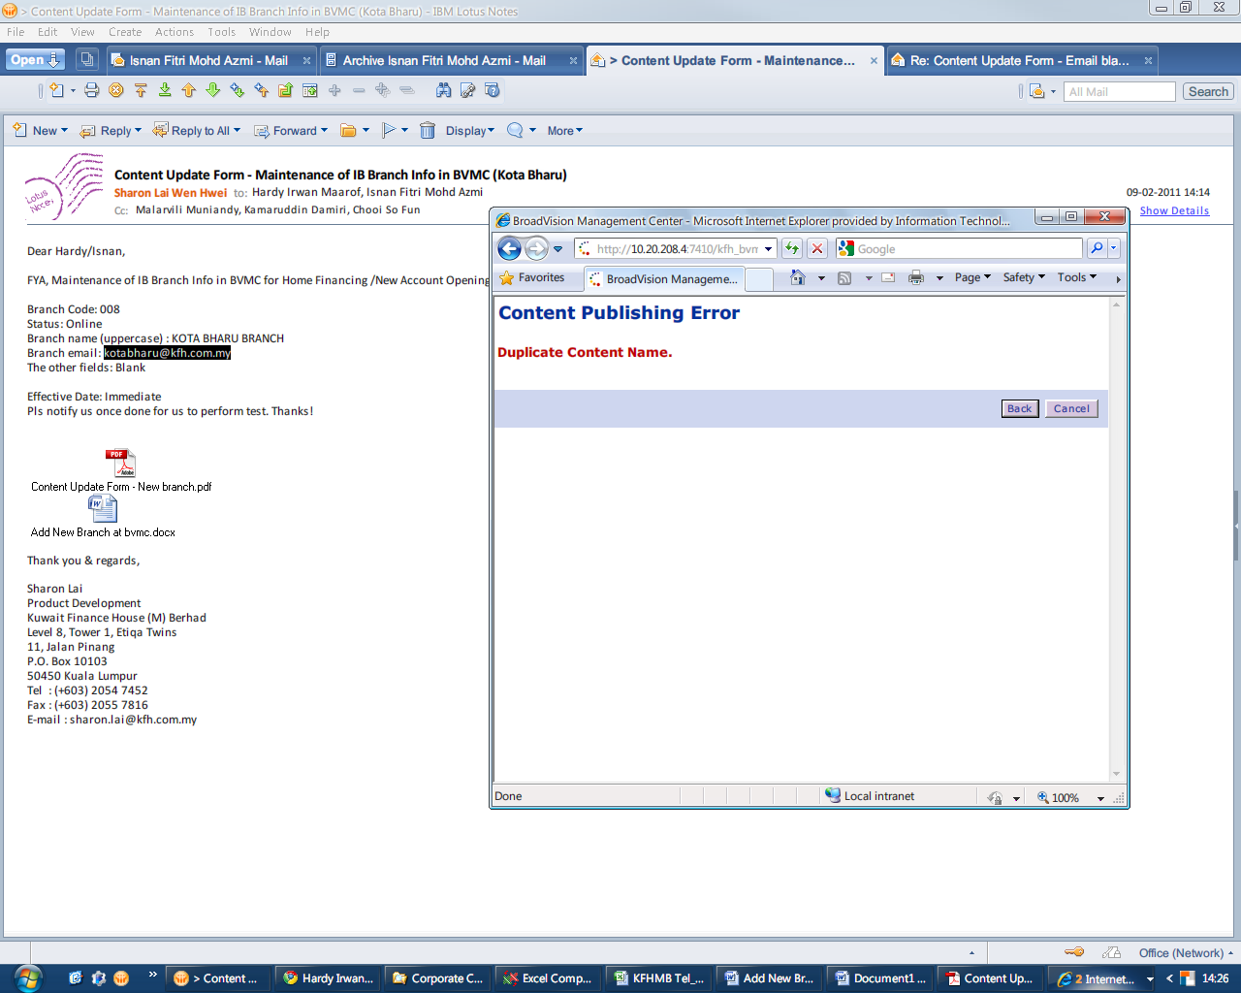
Create using code 010 - ok
