**LATEST NEWS UPDATES 30/11/17**

1 - CONGRATULATIONS KFH MALAYSIA

Date: 30/11/17



Dear Colleagues,

CONGRATULATIONS!

We are delighted to announce that KFH Malaysia has been recognised with three notable awards from Islamic Business Finance – South East Asia Awards 2017.

**Best Islamic Bank**

**Best Islamic Retail Banking Product**

**(KFH Libshara Account-i)**

**Most Innovative Islamic Banking Product**

**(International Commodity Murabahah Deposit-i)**

The awards are a testament to the Bank’s effort in building a formidable Islamic Institution in the country, in-line with our Parent Company’s aspiration. The recognition is the product of the hard work of the Bank’s most valuable assets, the people. Congratulations!

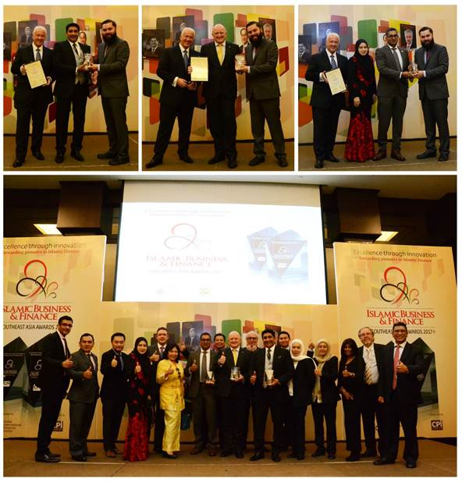

It has been our main goal since the beginning of the year to provide a SIMPLER - BETTER - FASTER experience to our stakeholders, our customers and our employees and therefore an outstanding service remains the cornerstone of success in every industry and at KFH Malaysia, it is no different. We strive to provide the best solutions to our customers and it is only possible with all of our active contribution as part of the KFH family.

Thank you.

**A message from Corporate Communication, Corporate Strategy**  
cid:image004.jpg@01D3201E.8E2D5680

4. KFH MALAYSIA RETAIL BANKING DASHBOARD & RETAIL BANKING BRANCH DASHBOARD - Deskmate

Date: 29/11/17



Dear Colleagues,

We are pleased to inform that Retail Banking Dashboard and Retail Banking Branch Dashboard are currently available at Deskmate. Simply click on the icon titled: Retail Banking Dashboard and Retail Banking Branch Dashboard to view the reports.

Please note that these dashboards are restricted to those with access only.

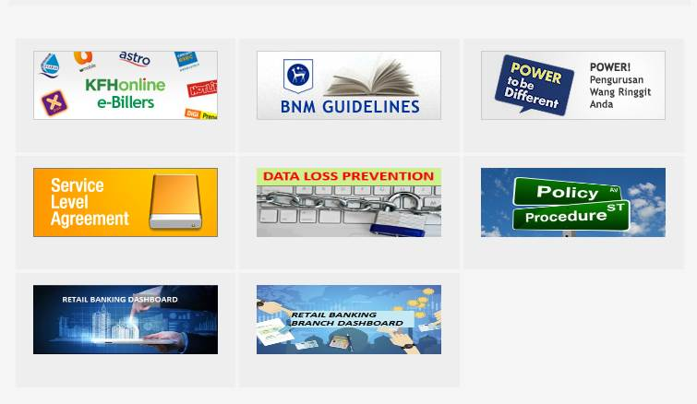

For further clarifications, please feel free to contact **Brother Vike (ext: 0695), Sister Hamidah (ext: 0696)** or **Sister Sumathi (ext: 0697)** from the Business Performance Analytics, Corporate Strategy.

Thank you.

**A message from Business Performance Analytics, Corporate Strategy**  
cid:image004.jpg@01D3201E.8E2D5680

5. SHARIAH AWARENESS (NO. 25/2017)

Date: 29/11/17



Dear Colleagues,

As part of the Shariah Awareness drive, we are pleased to share details on Kafalah (Guarantee).

For more information regarding the Kafalah (Guarantee), kindly contact Ustaz Nazrin (ext. 0320) and Ustaz Azmuddin (ext. 0319) or just stay tuned for the next series of Shariah Awareness.

If you have missed any of our previous communications on the Shariah Awareness series, please go to the link provided: X:\Shariah\1. Shariah Division\8. Shariah Awareness Series.

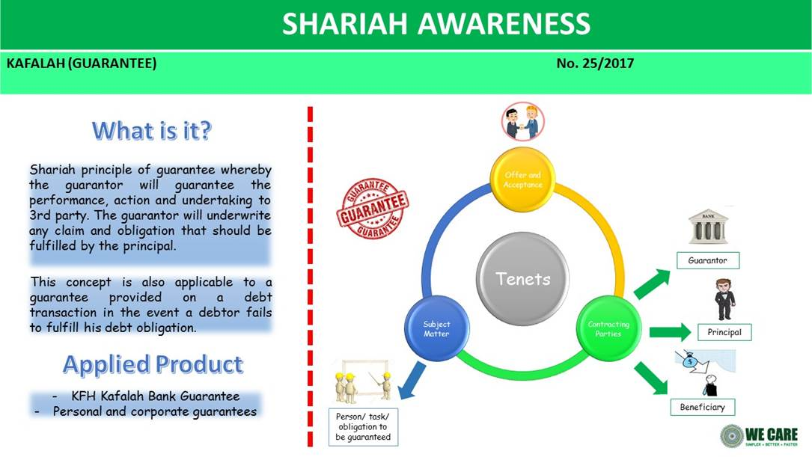

Thank you

**A message from Shariah**   
cid:image004.jpg@01D3201E.8E2D5680