**Agrobank**

|  |
| --- |
| **AGRONet Registration and Activation Process** |
| Business Requirement and System Specification |

**PENRIL/AGRO-BRS/CR00066)**

**Version 1.0**

**15 December 2017**

Prepared By:



**Penril Datability (SEA) Sdn Bhd (384556-U)**

Suite A-07-07 Plaza Mon’t Kiara

No. 2, Jalan Kiara, Mon’t Kiara

50480 Kuala Lumpur, Malaysia

Tel: (603) 6201 2622Fax: (603) 6201 7622

# 

# Document Amendment Log

| **Rev. No** | **Date Update** | **Description of Change** | **Update By**  **<Name, Dept>** | **Review By**  **<Name, dept>** | **Approved By**  **<Name, Dept>** |
| --- | --- | --- | --- | --- | --- |
| 1.0 | 15/12/2017 | Initial Release | Yap Kah Yan  (Software Engineer) |  | Tan Lee Yong |
|  |  |  |  |  |  |
|  |  |  |  |  |  |
|  |  |  |  |  |  |
|  |  |  |  |  |  |

# Table of Contents

Document Amendment Log 2

Table of Contents 3

Business Requirement Acceptance 4

Section A: Introduction 5

1.1 Objective 5

1.2 Scope of Delivery 6

Section B: Internet Banking 9

2. Retail Internet Banking (RIB) 9

2.1 BRS001 – Register New User to RIB 9

2.1.1 Process Flow 9

2.1.2 Screen Flows 9

2.2 BRS002 – Activate New RIB User with Valid Mobile Number 15

2.2.1 Process Flow 15

2.2.2 Screen Flow 16

2.3 BRS003 – Activate RIB User with Invalid Mobile Number 18

2.3.1 Process Flow 18

2.3.2 Screen Flows 19

2.4 BRS004 – First Time Login (FTL) for New RIB User with Valid Mobile Number 23

2.4.1 Process Flow 23

2.4.2 Screen Flow 23

2.5 BRS005 – First Time Login (FTL) for New RIB User without Valid Mobile Number 29

2.5.1 Process Flow 29

2.5.2 Screen Flow 29

# Business Requirement Acceptance

I/We hereby verify that this Business Requirement consist of all the requirements requested by AGROBANK. The implemented system will fulfil ONLY this requirement.

I/We also hereby AGREE that this satisfies our entire requirement for **AGRONet Registration and Activation Process**.

Any future changes to this agreed scope will be treated as an enhancement to the system. Any future changes to the project timeline will be subjected to the final approval of the project steering committee.

**AGROBANK:**

|  |  |  |  |
| --- | --- | --- | --- |
| **Approved by** | **Role** | **Signature** | **Date** |
|  |  |  |  |
|  |  |  |  |
|  |  |  |  |
|  |  |  |  |
|  |  |  |  |
|  |  |  |  |
|  |  |  |  |

**Penril Datability (SEA) Sdn. Bhd.:**

|  |  |  |  |
| --- | --- | --- | --- |
| **Approved by** | **Role** | **Signature** | **Date** |
| Norhaidah Bt Md Dasuki | Project Manager |  |  |
|  |  |  |  |
|  |  |  |  |

# Section A: Introduction

This document served as the business requirement and system specification which to enable the users to register and activate Retail Internet Banking (RIB) account through RIB.

All screen designs provided in this document are samples and only illustration purpose for easy understanding. The screen designs are not final.

## Objective

The objective of this document is to capture user requirements to enable the users to register and activate Retail Internet Banking (RIB) account through RIB.

The base line features description and screen designs will become a reference blueprint for the development team to develop the transactional and administration module. Hence, it is crucial that all stakeholders need to ensure the correctness and adequacy of the requirements captured in this document.

All stakeholders involved are expected to review and sign off this document before the development start. By signing off the document, the stakeholder has endorsed the correctness and accuracy and adequacy of the requirements documented in this document.

## Scope of Delivery

To enhance AGRONet Registration and Activation Process module.

| System | Modules | Features | Description | CF / DB | Effort (Days) |
| --- | --- | --- | --- | --- | --- |
| 1. Registration of AGRONet | | | | | 10 |
| RIB | Registration and Activation | * To simplify the registration process * New field to input Introducer info | Step 1:   * Terms & conditions   Step 2:   * Card number * Account number * Pin number * Captcha * To add new field of Introducer [Staff ID & Branch code]   + Staff ID – alphanumeric wit 10 characters   + Branch code – numeric with 10 characters   + Non-mandatory field   + Does not required validation from host   Step 3:   * Username * Password * Confirm password   ***Continue with online activation process***  Step 4: System will get and display mobile phone number from host. Customer require to select “Yes” or “No”   * If users choose “Yes” – TAC will be send to user. System will prompt insert TAC screen. After correct TAC, System will prompt message “Registration was successful”   + Once Login, customer require to perform steps below in order for them to proceed with Account viewing and transactions:     - Select Security Quotations     - Image & phrases * If users choose “No”, system will prompt message that require customer to call Contact Center to complete the activation process * They will be KYC process and Contact Center will enable Mobile Number updates once customer login to AGRONet,   + Once mobile number be keyed-in, it will follows by:     - Select Security Quotations     - Image & phrases | CF |
| IBAM | RIB Report | * Revised on Internet Banking Registration Report Daily | * To add new info on Introducer * Staff ID * Branch Code * Branch Name | CF |
| RIB User Activity Log | To allow checking on Successful/Unsuccessful Online Activation | * Add “Activation” to Activity dropdown list * To display list and details of Successful and Unsuccessful online activation activity | CF |
| Database |  | New Column | * To store Introducer information * To store activation information | DB |
| DEMO | RIB Demo | * Registration | * Update on AGRONet Registration Demo page |  | 1 |

# Section B: Internet Banking

## Retail Internet Banking (RIB)

## BRS001 – Register New User to RIB

This feature allows user to register account in RIB.

## Process Flow



Diagram 1: RIB Registration Process Flow

There are two participants involved in this process: RIB System and IB User. The process has the following steps:

## Screen Flow

***Step 1:***

1. User access Register an Account screen.
2. System display Terms and Condition screen.

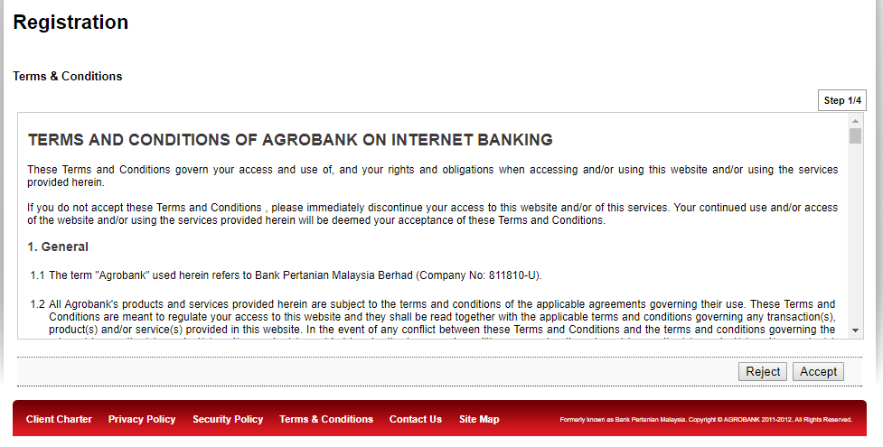

Figure 1: Registration: Terms and Condition Screen

Display Specification:

|  |  |  |  |
| --- | --- | --- | --- |
| No | Field | Format | Description |
|  | Terms and Condition | Text | Display the terms and condition |

Table 1: **Registration: Terms and Condition** Display Field

**Action:**

|  |  |  |  |
| --- | --- | --- | --- |
| No | Action | Type | Description |
|  | Accept | Button | Contain an action to next to screen |
|  | Reject | Button | Contain an action to landing screen |

Table 2: **Registration: Terms and Condition** Action

***Step 2:***

1. User click on “Accept”
2. System display Registration Details screen
3. User click on “Payment Reference” link to view on related Direct Debit Details

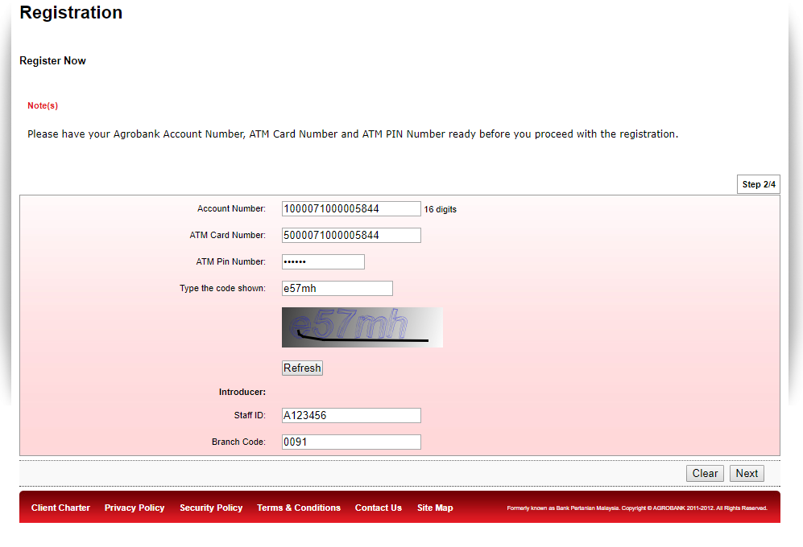

Figure 2: Registration: Registration Details Screen

**Display Specification:**

|  |  |  |  |
| --- | --- | --- | --- |
| No | Field | Format | Description |
|  | Captcha | Alphanumeric | Display the captcha for verification |

Table 3: **Registration: Registration Details** Display Fields

**Input Specification:**

|  |  |  |  |  |  |
| --- | --- | --- | --- | --- | --- |
| No | Field | Field Type | Validation Rule | Description | M/O |
|  | Account Number | Textbox | Numeric | Account Number | M |
|  | ATM Card Number | Textbox | Numeric | ATM Card Number | M |
|  | ATM Pin Number | Textbox | Numeric | ATM Pin Number | M |
|  | Type the code shown | Textbox | Match displayed captcha | Captcha verification | M |
|  | Introducer Staff ID | Textbox | Alphanumeric | Introducer Staff ID | O |
|  | Introducer Branch Code | Textbox | Numeric | Introducer Branch Code | O |

Table 4: **Registration: Registration Details** Input Specification

**Action:**

|  |  |  |  |
| --- | --- | --- | --- |
| No | Action | Type | Description |
|  | Refresh | Button | Contain an action to refresh captcha |
|  | Clear | Button | Contain an action to clear details |
|  | Next | Button | Contain an action to next screen |

Table 5: **Registration: Registration Details** Action

***Step 3:***

1. User click on “Next”
2. System display Username and Password screen

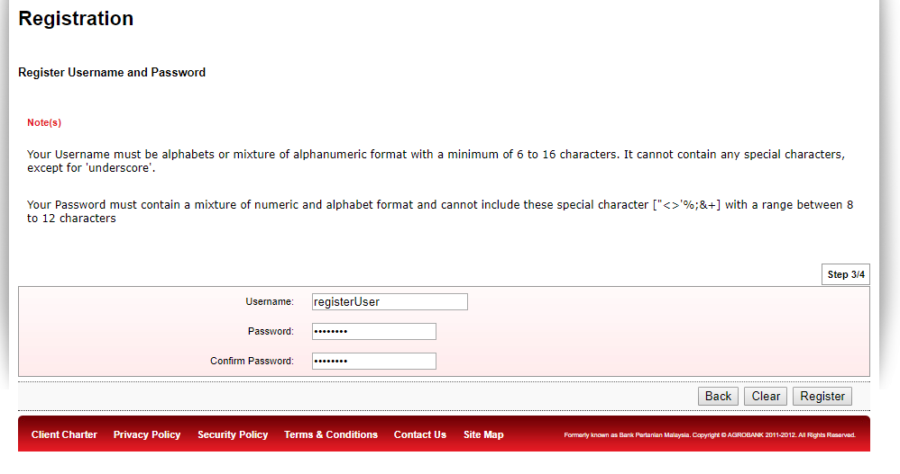

Figure 3: Registration: Register Username and Password Screen

**Input Specification:**

|  |  |  |  |  |  |
| --- | --- | --- | --- | --- | --- |
| No | Field | Field Type | Validation Rule | Description | M/O |
|  | Username | Textbox | Alphanumeric and underscore | Username | M |
|  | Password | Textbox | Alphanumeric and symbol.  Cannot contain \"<>'%;&+ | Password | M |
|  | Confirm Password | Textbox | Alphanumeric and symbol.  Cannot contain \"<>'%;&+ | Confirm Password | M |

Table 6: **Registration: Register Username and Password** Input Specification

**Action:**

|  |  |  |  |
| --- | --- | --- | --- |
| No | Action | Type | Description |
|  | Back | Button | Contain an action to go to previous page |
|  | Clear | Button | Contain an action to clear details |
|  | Register | Button | Contain an action to register user |

Table 7: **Registration: Register Username and Password** Action

***Step 4:***

1. User click on “Register”
2. System display Result Screen

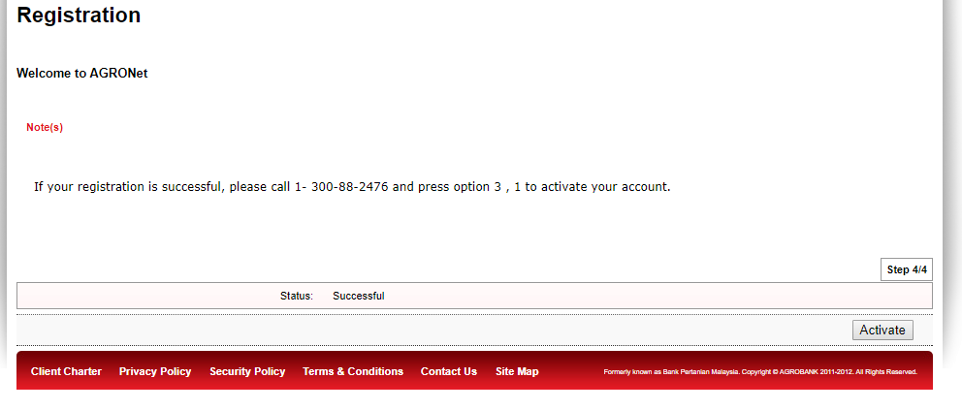

Figure 4: Registration: Result Screen

Display Specification:

|  |  |  |  |
| --- | --- | --- | --- |
| No | Field | Format | Description |
|  | Result Message | Text | Shows the result message |

Table 8: **Registration: Result** Specification

**Action:**

|  |  |  |  |
| --- | --- | --- | --- |
| No | Action | Type | Description |
|  | Activate | Button | Contain an action to activate user |

Table 9: **Registration: Result** Action

## BRS002 – Activate New RIB User with Valid Mobile Number

This feature allows user to activate RIB account with a valid mobile number.

## Process Flow



Diagram 2: Activation: Activate with Valid Mobile Number Flow Diagram

There are two participants involved in this process, RIB System and IB User. The process has the following steps:

## Screen Flow

***Step 1:***

1. User click on “Activate”
2. System display Mobile Number

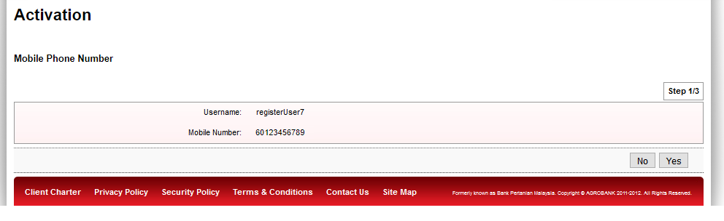

Figure : **Activation: Mobile Number Screen**

Display Specification:

|  |  |  |  |
| --- | --- | --- | --- |
| No | Field | Format | Description |
|  | Username | Text | Display the username |
|  | Mobile Number | Numeric | Display the mobile number from host |

Table 10: **Activation: Mobile Number** Display Field

**Action:**

|  |  |  |  |
| --- | --- | --- | --- |
| No | Action | Type | Description |
|  | No | Button | Contain an action result screen |
|  | Yes | Button | Contain an action to enter tac screen |

Table 11: **Activation: Mobile Number** Action

***Step 2:***

1. User verify mobile number is correct
2. User click “Yes”
3. System display Enter TAC screen

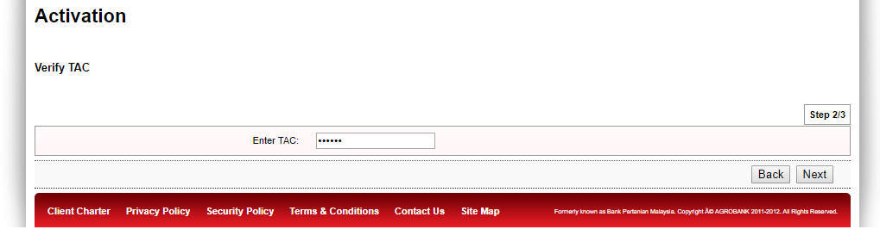

Figure : **Activation: Verify TAC** Screen

**Input Specification:**

|  |  |  |  |  |  |
| --- | --- | --- | --- | --- | --- |
| No | Field | Field Type | Validation Rule | Description | M/O |
|  | TAC Number | Textbox | Numeric | TAC Number | M |

Table 12: **Activation: Verify TAC** Input Specification

**Action:**

|  |  |  |  |
| --- | --- | --- | --- |
| No | Action | Type | Description |
|  | Back | Button | Contain an action to previous screen |
|  | Next | Button | Contain an action to landing screen |

Table 13: **Activation: Verify TAC** Action

***Step 3:***

1. User click “Next”
2. System display Result Screen

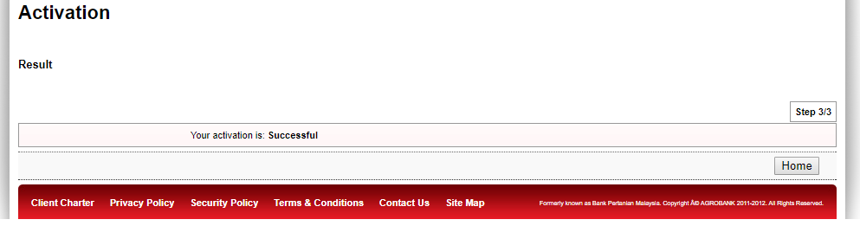

Figure : **Activation: Result Screen**

Display Specification:

|  |  |  |  |
| --- | --- | --- | --- |
| No | Field | Format | Description |
|  | Result Message | Text | Display the result message |

Table 14: **Activation: Result** Display Field

## BRS003 – Activate RIB User with Invalid Mobile Number

This feature allows user to activate RIB account without a valid mobile number.

## Process Flow



Diagram 3: Activation: Activate with Invalid Mobile Number Flow Diagram



Diagram 4: Print Direct Debit Details Flow Diagram

There are four participants, IB User, RIB System, Bank Admin and IBAM. The process has the following steps:

## Screen Flow

***Step 1:***

1. User click on “Activate”
2. System display Mobile Number



Figure : **Activation: Mobile Number Screen**

Display Specification:

|  |  |  |  |
| --- | --- | --- | --- |
| No | Field | Format | Description |
|  | Username | Text | Display the username |
|  | Mobile Number | Numeric | Display the mobile number from host |

Table 15: **Activation: Mobile Number** Display Field

**Action:**

|  |  |  |  |
| --- | --- | --- | --- |
| No | Action | Type | Description |
|  | No | Button | Contain an action to result screen |
|  | Yes | Button | Contain an action to enter tac screen |

Table 16: **Activation: Mobile Number** Action

***Step 2:***

1. User verify mobile number is incorrect
2. User click “No”
3. System display Result Screen

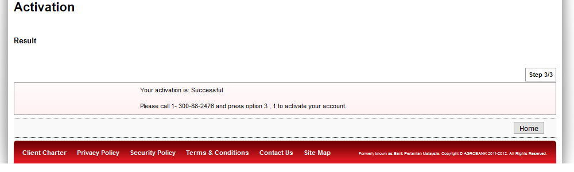

Figure : **Activation: Result Screen**

Display Specification:

|  |  |  |  |
| --- | --- | --- | --- |
| No | Field | Format | Description |
|  | Result Message | Text | Display the result message |

Table 17: **Activation: Result** Display Field

***Step 3: Current Standard Operating Procedure***

1. User call Agrobank’s Contact Center to activate
2. Agrobank’s Contact Center validate user through KYC process
3. Contact Center (Bank Admin) login to IBAM > RIB > RIB User Detail
4. System display User Detail Screen

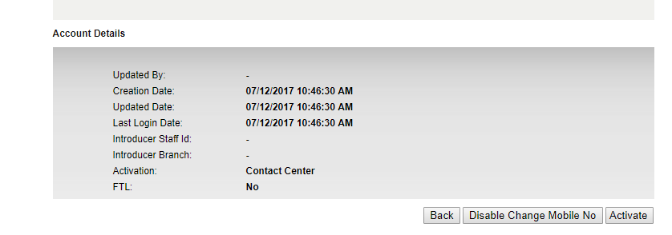

Figure : **Activation: IBAM – User Details Screen**

Display Specification:

|  |  |  |  |
| --- | --- | --- | --- |
| No | Field | Format | Description |
| Account Details | | | |
|  | Updated By | Text | Display the updater name |
|  | Creation Date | Date | Display the creation date |
|  | Updated Date | Date | Display the updated date |
|  | Last Login Date | Date | Display the last login date |
|  | Introducer Staff Id | Text | Display the introducer staff id |
|  | Introducer Branch | Text | Display the introducer branch name |
|  | Activation | Text | Display the activation channel   * Contact Center * Internet Banking |
|  | FTL | Text | Display the indicator of First Time Login (FTL) |

Table 18: **Activation: IBAM – User Details** Display Field

**Action:**

|  |  |  |  |
| --- | --- | --- | --- |
| No | Action | Type | Description |
|  | Back | Button | Contain an action to previous screen |
|  | Disable Change Mobile No | Button | Contain an action to disable change mobile number |
|  | Activate | Button | Contain an action to activate user |

Table 19: **Activation: IBAM – User Details** Action

***Step 4: Current Standard Operating Procedure***

1. User click on “Activate”
2. System display Result Screen

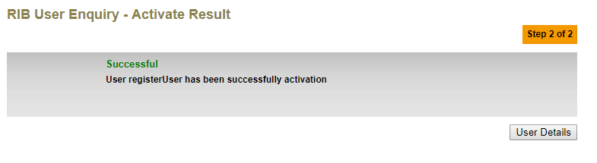

Figure : **Activation: IBAM – Result Screen**

Display Specification:

|  |  |  |  |
| --- | --- | --- | --- |
| No | Field | Format | Description |
|  | Result Message | Text | Display the result message |

Table 20: **Activation: IBAM – Result** Display Field

**Action:**

|  |  |  |  |
| --- | --- | --- | --- |
| No | Action | Type | Description |
|  | User Details | Button | Contain an action to user details screen |

Table 21: **Activation: IBAM – Result** Action

## BRS004 – First Time Login (FTL) for New RIB User with Valid Mobile Number

This feature allows user with valid mobile number to perform FTL.

## Process Flow



Diagram 5: FTL: User with Valid Mobile Number Flow Diagram

There are two participants involved in this process, RIB System and IB User. The process has the following steps:

## Screen Flow

***Step 1:***

1. User access to RIB
2. System display RIB Landing Screen

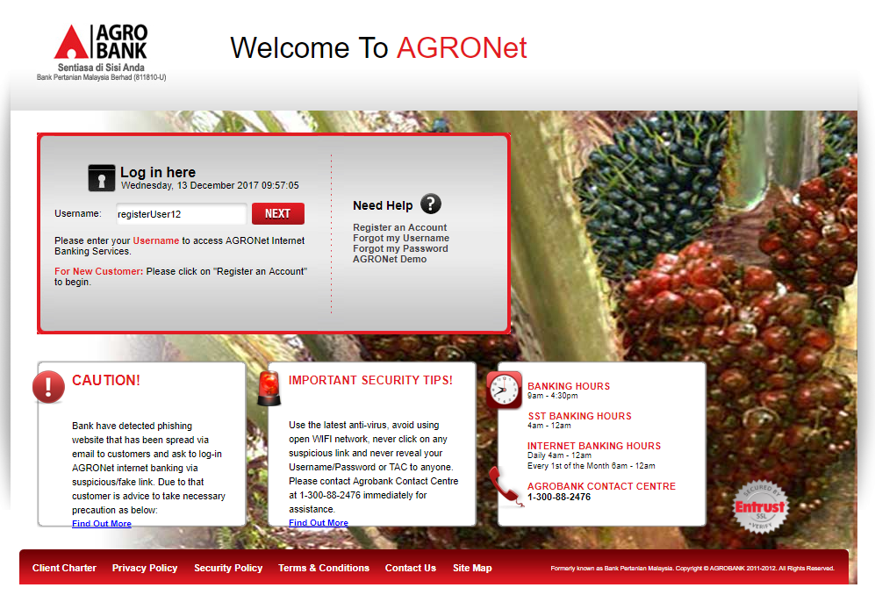

Figure : **RIB Landing Screen**

**Input Specification:**

|  |  |  |  |  |  |
| --- | --- | --- | --- | --- | --- |
| No | Field | Field Type | Validation Rule | Description | M/O |
|  | Username | Textbox | Alphanumeric and underscore | Username | M |

Table 22: **RIB Landing Screen** Input Specification

**Action:**

|  |  |  |  |
| --- | --- | --- | --- |
| No | Action | Type | Description |
|  | Next | Button | Contain an action to next screen |

Table 23: **RIB Landing Screen** Action

***Step 2:***

1. User input username
2. User click “Next”
3. System display Enter Password screen

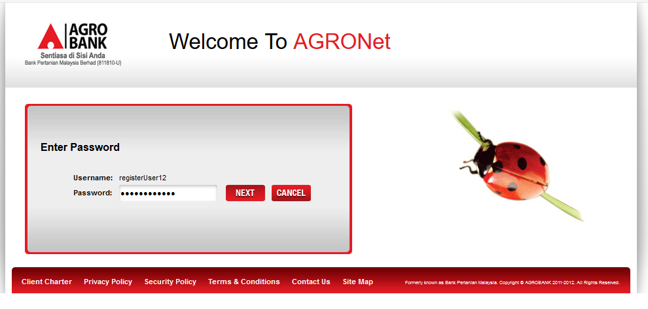

Figure : FTL: **Enter Password Screen**

Display Specification:

|  |  |  |  |
| --- | --- | --- | --- |
| No | Field | Format | Description |
|  | Username | Text | Display the username |

Table 24: FTL: **Enter Password** Display Field

**Input Specification:**

|  |  |  |  |  |  |
| --- | --- | --- | --- | --- | --- |
| No | Field | Field Type | Validation Rule | Description | M/O |
|  | Password | Textbox | Alphanumeric and symbol.  Cannot contain \"<>'%;&+ | Password | M |

Table 25: FTL: **Enter Password** Input Specification

**Action:**

|  |  |  |  |
| --- | --- | --- | --- |
| No | Action | Type | Description |
|  | Next | Button | Contain an action to next screen |
|  | Cancel | Button | Contain an action to RIB Landing Screen |

Table 26: FTL: **Enter Password** Action

***Step 3:***

1. User input Password
2. User click “Next”
3. System display Security Question screen

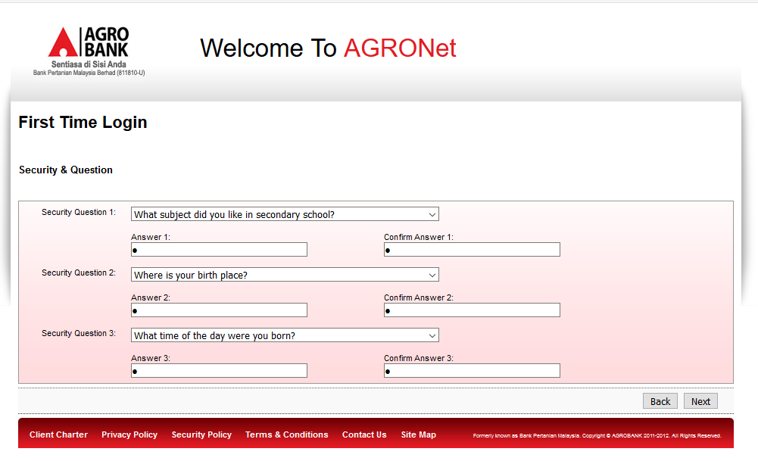

Figure : FTL: **Enter Security Question and Security Answer Screen**

**Input Specification:**

|  |  |  |  |  |  |
| --- | --- | --- | --- | --- | --- |
| No | Field | Field Type | Validation Rule | Description | M/O |
|  | Security Question 1 | Dropdown | N/A | Security Question | M |
|  | Answer 1 | Text | N/A | Security Answer | M |
|  | Confirm Answer 1 | Text | Match Answer 1 | Confirm Security Answer | M |
|  | Security Question 2 | Dropdown | N/A | Security Question | M |
|  | Answer 2 | Text | N/A | Security Answer | M |
|  | Confirm Answer 2 | Text | Match Answer 2 | Confirm Security Answer | M |
|  | Security Question 3 | Dropdown | N/A | Security Question | M |
|  | Answer 3 | Text | N/A | Security Answer | M |
|  | Confirm Answer 3 | Text | Match Answer 3 | Confirm Security Answer | M |

Table 27: FTL: **Enter Security Question and Security Answer** Input Specification

**Action:**

|  |  |  |  |
| --- | --- | --- | --- |
| No | Action | Type | Description |
|  | Back | Button | Contain an action to previous screen |
|  | Next | Button | Contain an action to next screen |

Table 28: FTL: **Enter Security Question and Security Answer** Action

***Step 4:***

1. User input Security Questions and Answers
2. User click “Next”
3. System display Security Image screen

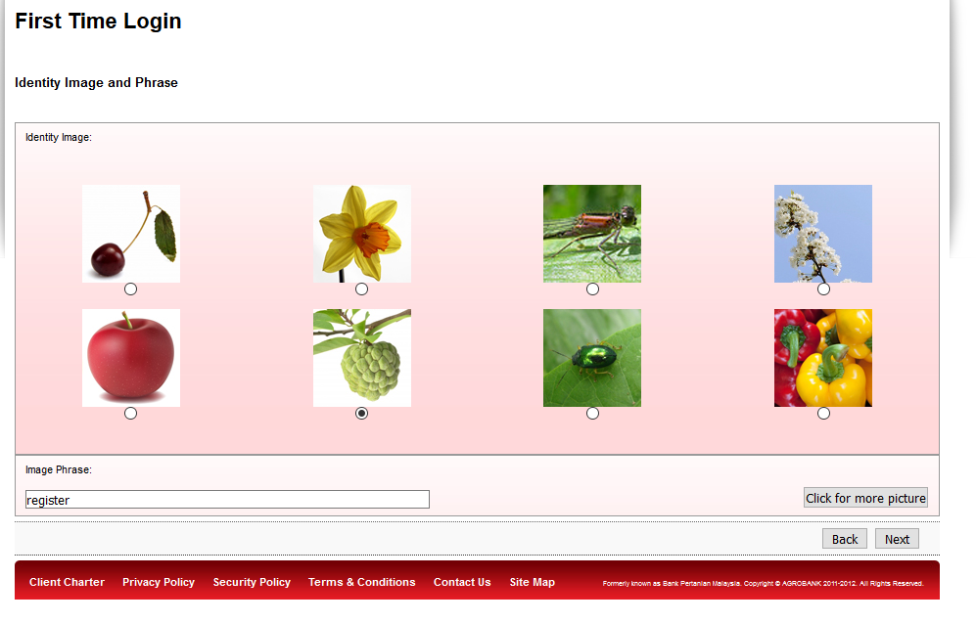

Figure : FTL: **Identity Image and Identity Phrase Screen**

**Input Specification:**

|  |  |  |  |  |  |
| --- | --- | --- | --- | --- | --- |
| No | Field | Field Type | Validation Rule | Description | M/O |
|  | Security Image | Radio Button | N/A | Security Image | M |
|  | Image Phrase | Textbox | N/A | Image Phrase | M |

Table 29: FTL: **Identity Image and Identity Phrase** Input Specification

**Action:**

|  |  |  |  |
| --- | --- | --- | --- |
| No | Action | Type | Description |
|  | Click for more picture | Button | Contain an action to load more images |
|  | Back | Button | Contain an action to previous screen |
|  | Next | Button | Contain an action to home screen (after login) |

Table 30: FTL: **Identity Image and Identity Phrase** Action

***Step 5:***

1. User select Security Image and input Image Phase
2. User click “Next”
3. System display Home screen

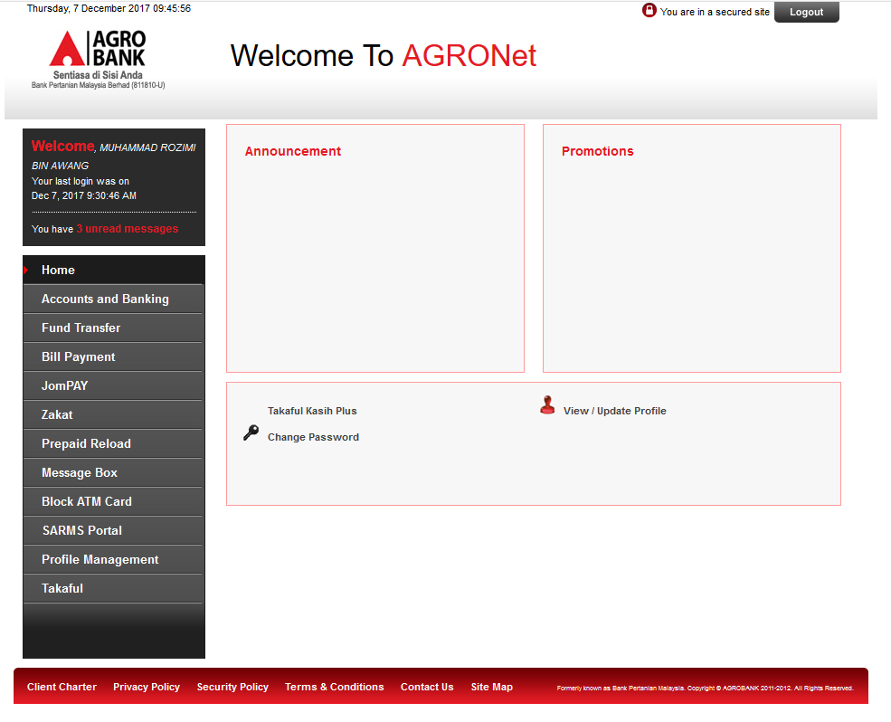

Figure : RIB Home **Screen**

## BRS005 – First Time Login (FTL) for New RIB User without Valid Mobile Number

This feature allows user without valid mobile number to perform FTL.

## Process Flow



Diagram 6: FTL: User with Valid Mobile Number Flow Diagram

There are two participants involved in this process, RIB System and IB User. The process has the following steps:

## Screen Flow

***Step 1:***

1. User access to RIB
2. System display RIB Landing Screen



Figure : **RIB Landing Screen**

**Input Specification:**

|  |  |  |  |  |  |
| --- | --- | --- | --- | --- | --- |
| No | Field | Field Type | Validation Rule | Description | M/O |
|  | Username | Textbox | Alphanumeric and underscore | Username | M |

Table 31: **RIB Landing Screen** Input Specification

**Action:**

|  |  |  |  |
| --- | --- | --- | --- |
| No | Action | Type | Description |
|  | Next | Button | Contain an action to next screen |

Table 32: **RIB Landing Screen** Action

***Step 2:***

1. User input username
2. User click “Next”
3. System display Enter Password screen



Figure : FTL: **Enter Password Screen**

Display Specification:

|  |  |  |  |
| --- | --- | --- | --- |
| No | Field | Format | Description |
|  | Username | Text | Display the username |

Table 33: FTL: **Enter Password** Display Field

**Input Specification:**

|  |  |  |  |  |  |
| --- | --- | --- | --- | --- | --- |
| No | Field | Field Type | Validation Rule | Description | M/O |
|  | Password | Textbox | Alphanumeric and symbol.  Cannot contain \"<>'%;&+ | Password | M |

Table 34: FTL: **Enter Password** Input Specification

**Action:**

|  |  |  |  |
| --- | --- | --- | --- |
| No | Action | Type | Description |
|  | Next | Button | Contain an action to next screen |
|  | Cancel | Button | Contain an action to RIB Landing Screen |

Table 35: FTL: **Enter Password** Action

***Step 3:***

1. User input Password
2. User click “Next”
3. System display Update Mobile Number screen

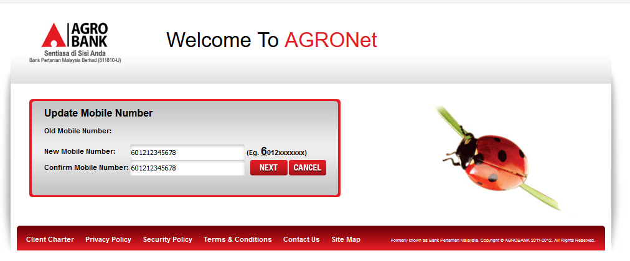

Figure : FTL: **Update Mobile Number Screen**

Display Specification:

|  |  |  |  |
| --- | --- | --- | --- |
| No | Field | Format | Description |
|  | Old Mobile Number | Text | Display old mobile number |

Table 36: FTL: **Update Mobile Number** Display Field

**Input Specification:**

|  |  |  |  |  |  |
| --- | --- | --- | --- | --- | --- |
| No | Field | Field Type | Validation Rule | Description | M/O |
|  | New Mobile Number | Textbox | N/A | New Mobile Number | M |
|  | Confirm Mobile Number | Textbox | N/A | Confirm Mobile Number | M |

Table 37: FTL: **Update Mobile Number** Input Specification

**Action:**

|  |  |  |  |
| --- | --- | --- | --- |
| No | Action | Type | Description |
|  | Next | Button | Contain an action to next screen |
|  | Cancel | Button | Contain an action to RIB Landing Screen |

Table 38: FTL: **Enter Password** Action

***Step 4:***

1. User input New Mobile Number and Confirm Mobile Number
2. User click “Next”
3. System display Verity TAC screen

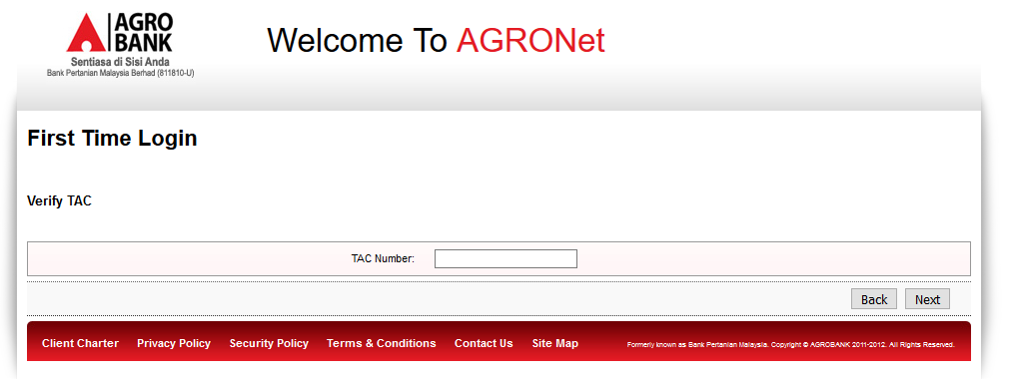

Figure : FTL: **Verify TAC Screen**

**Input Specification:**

|  |  |  |  |  |  |
| --- | --- | --- | --- | --- | --- |
| No | Field | Field Type | Validation Rule | Description | M/O |
|  | TAC Number | Textbox | Numeric | TAC Number | M |

Table 39: FTL: **Verify TAC** Input Specification

**Action:**

|  |  |  |  |
| --- | --- | --- | --- |
| No | Action | Type | Description |
|  | Back | Button | Contain an action to previous screen |
|  | Next | Button | Contain an action to next screen |

Table 40: FTL: **Verify TAC** Action

***Step 5:***

1. User input TAC Number
2. User click “Next”
3. System display Security Question Screen



Figure : FTL: **Enter Security Question and Security Answer Screen**

**Input Specification:**

|  |  |  |  |  |  |
| --- | --- | --- | --- | --- | --- |
| No | Field | Field Type | Validation Rule | Description | M/O |
|  | Security Question 1 | Dropdown | N/A | Security Question | M |
|  | Answer 1 | Text | N/A | Security Answer | M |
|  | Confirm Answer 1 | Text | Match Answer 1 | Confirm Security Answer | M |
|  | Security Question 2 | Dropdown | N/A | Security Question | M |
|  | Answer 2 | Text | N/A | Security Answer | M |
|  | Confirm Answer 2 | Text | Match Answer 2 | Confirm Security Answer | M |
|  | Security Question 3 | Dropdown | N/A | Security Question | M |
|  | Answer 3 | Text | N/A | Security Answer | M |
|  | Confirm Answer 3 | Text | Match Answer 3 | Confirm Security Answer | M |

Table 41: FTL: **Enter Security Question and Security Answer** Input Specification

**Action:**

|  |  |  |  |
| --- | --- | --- | --- |
| No | Action | Type | Description |
|  | Back | Button | Contain an action to previous screen |
|  | Next | Button | Contain an action to next screen |

Table 42: FTL: **Enter Security Question and Security Answer** Action

***Step 6:***

1. User input Security Questions and Answers
2. User click “Next”
3. System display Security Image screen



Figure : FTL: **Identity Image and Identity Phrase Screen**

**Input Specification:**

|  |  |  |  |  |  |
| --- | --- | --- | --- | --- | --- |
| No | Field | Field Type | Validation Rule | Description | M/O |
|  | Security Image | Radio Button | N/A | Security Image | M |
|  | Image Phrase | Textbox | N/A | Image Phrase | M |

Table 43: FTL: **Identity Image and Identity Phrase** Input Specification

**Action:**

|  |  |  |  |
| --- | --- | --- | --- |
| No | Action | Type | Description |
|  | Click for more picture | Button | Contain an action to load more images |
|  | Back | Button | Contain an action to previous screen |
|  | Next | Button | Contain an action to home screen (after login) |

Table 44: FTL: **Identity Image and Identity Phrase** Action

***Step 7:***

1. User select Security Image and input Image Phase
2. User click “Next”
3. System display Home screen



Figure : RIB Home **Screen**

## Internet Banking Application Management (IBAM)

## BRS006 – View Activated RIB User

## Screen Flow

There is no change on the process flow of view RIB user.

***Step 1:***

1. Bank Admin access IBAM
2. Bank Admin access IBAM > RIB User Activity Log
3. Bank Admin select Activity: “Activation”
4. Bank Admin click “Search”
5. System display Search Result Screen

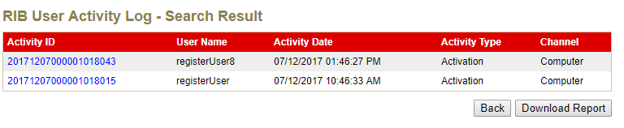

Figure : IBAM Search Result **Screen**

## BRS007 – View Registered RIB User Report

***Step 1:***

1. Bank Admin access IBAM
2. Bank Admin access IBAM > RIB Report
3. Bank Admin select “Internet Banking Registration Report”
4. Bank Admin click “Search”
5. System display Search Result Screen
6. User click “Save” to download report

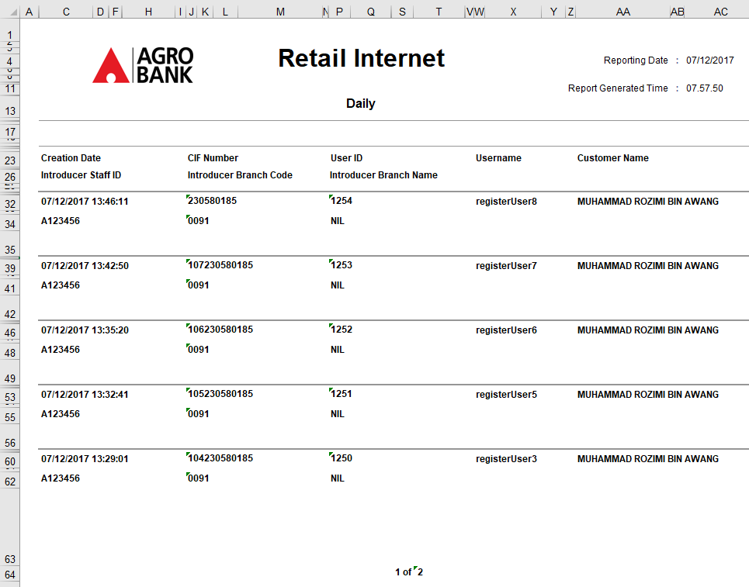

Figure : IBAM Internet Banking Registration Report (Excel)

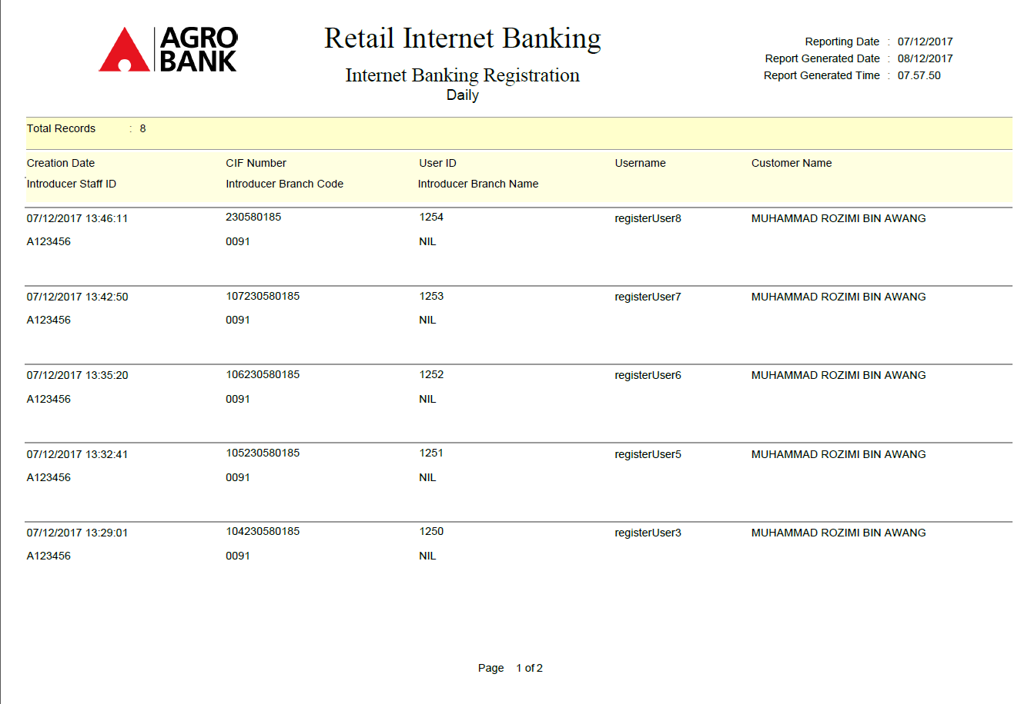

Figure 26: IBAM Internet Banking Registration Report (pdf)