Failed to Find Report drop down for “New Banker's Cheque Application" in BVMC - IB Report.
- Actual Result:
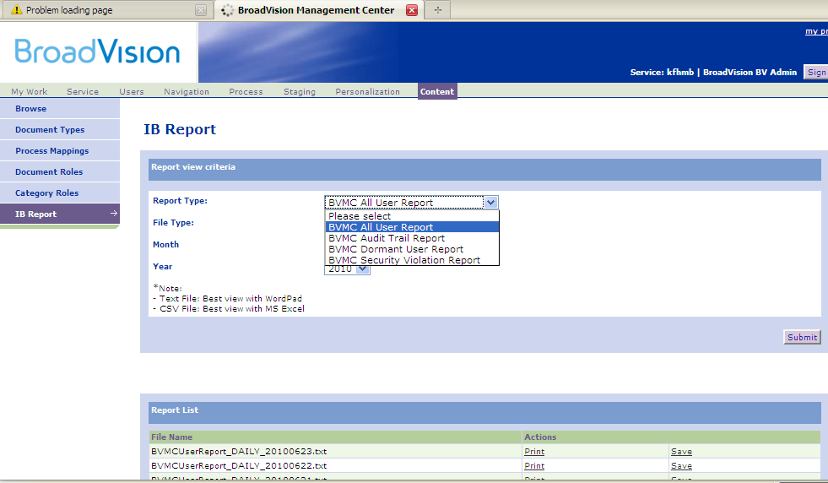

- Expected Result:
