Test Script |  |  |  |  |  | SCP ID# : 4344
Project Name: | BII – Maybank RIB
Test Stage: | Unit Functionality Integration System Interface  Performance Regression Acceptance Pilot
Redmine ID: | Support #8144 |  |  | Test Started Date: |  |  | 29/12/2017
Test Title: | Change Mobile Number Problem
Test Description: | Test Login On RIB
Test Functionality: | Login
Test Procedure:
Test Result: | Pass: Fail:  Conditional Pass: : |  | Tested by: |  | Tommy
Reason for Failure:
TEST DESCRIPTION
Username : ribuser

Login username and password
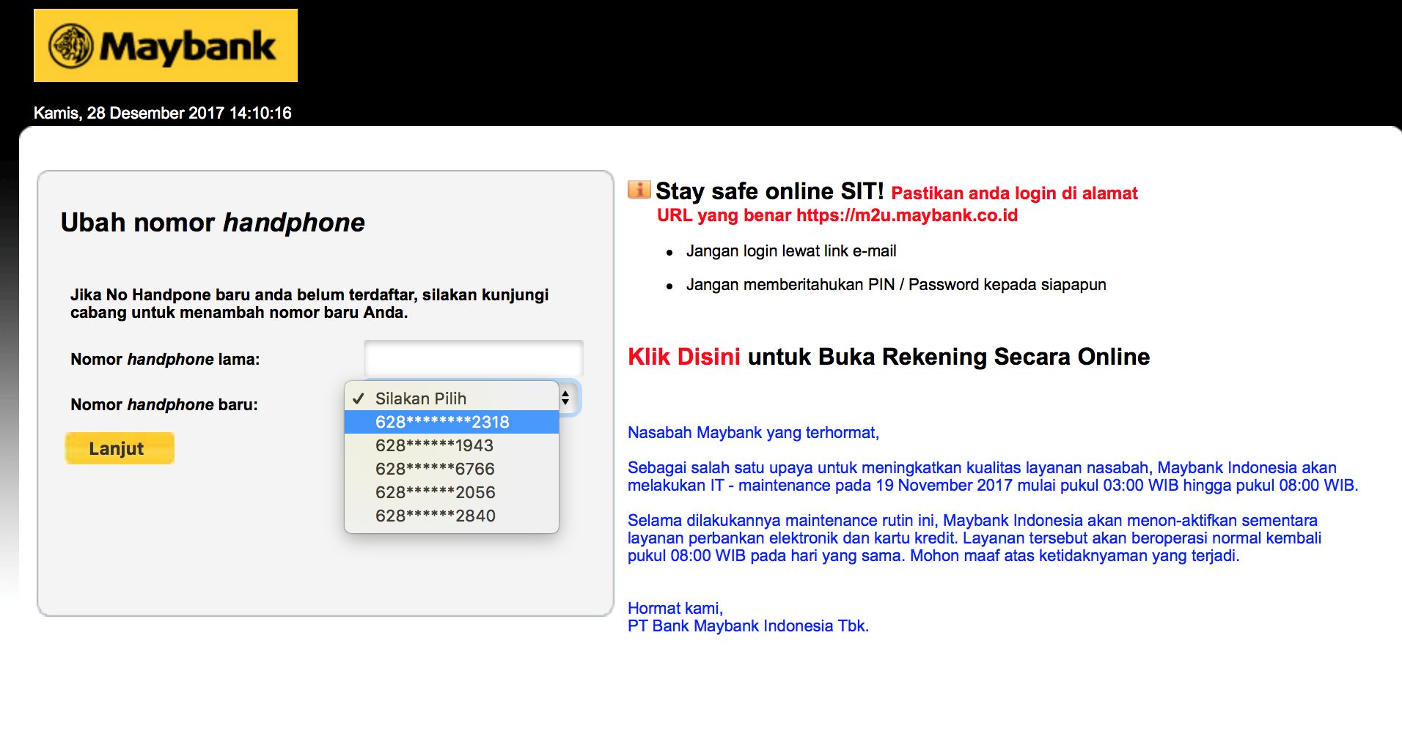
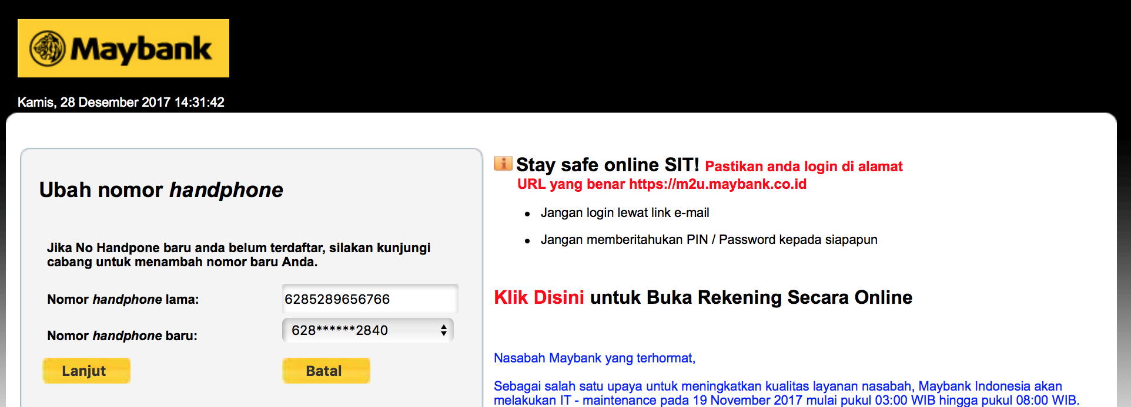

Before Changes

After update No
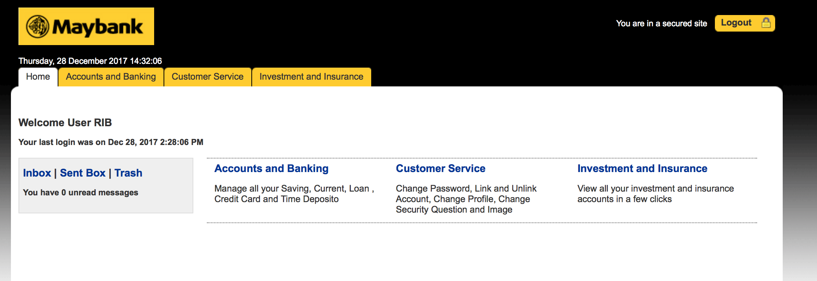

Logout
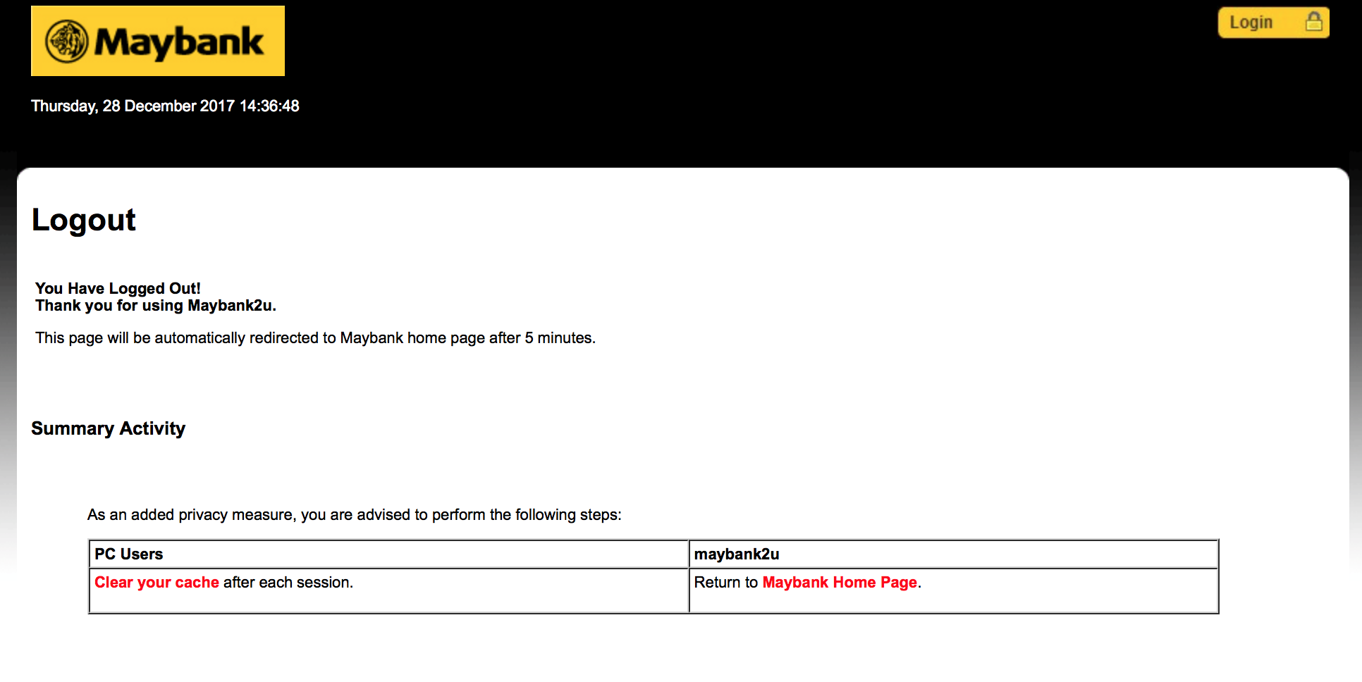
Try To Login Again
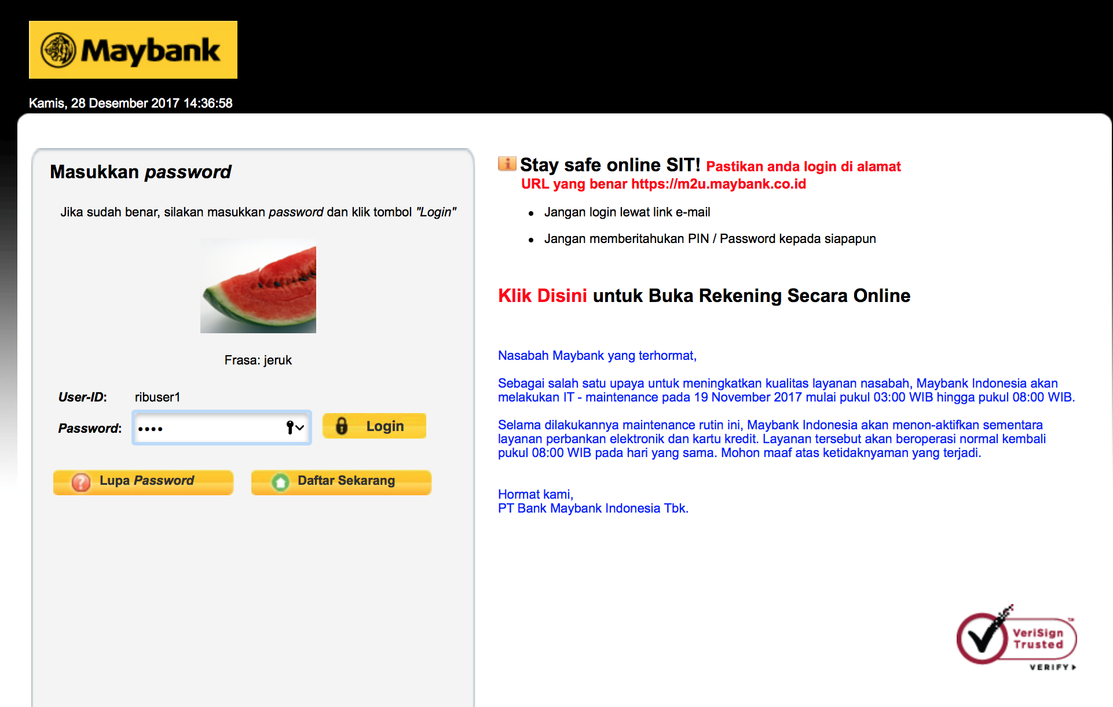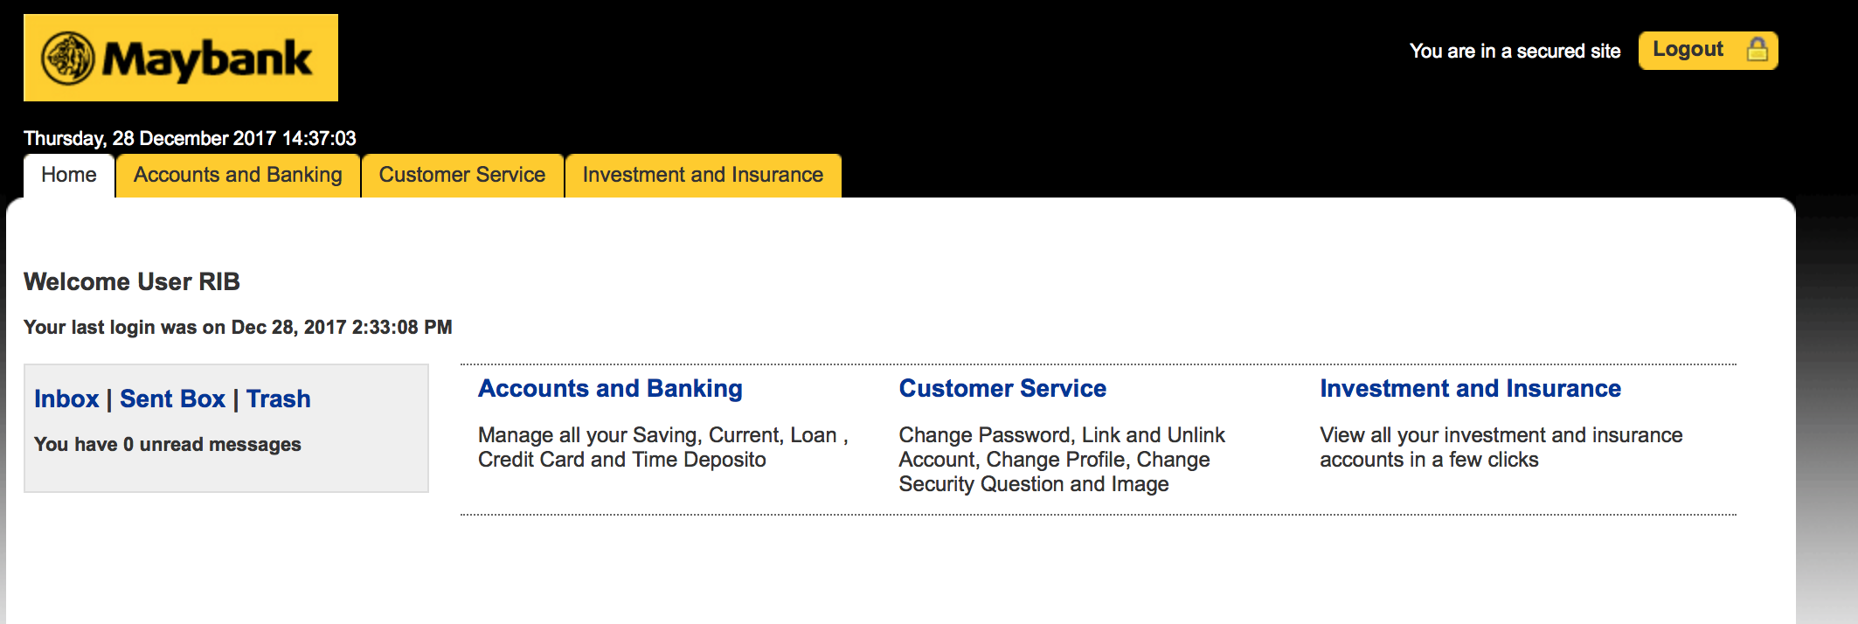

Reviewed By: (PMO)
Name/Position : Tommy
Date : 28 Dec 2017

