**Check the uncategorized content**

1. Go to ‘**Content**’ tab menu 🡪 then go to ‘**Uncategorized content**’

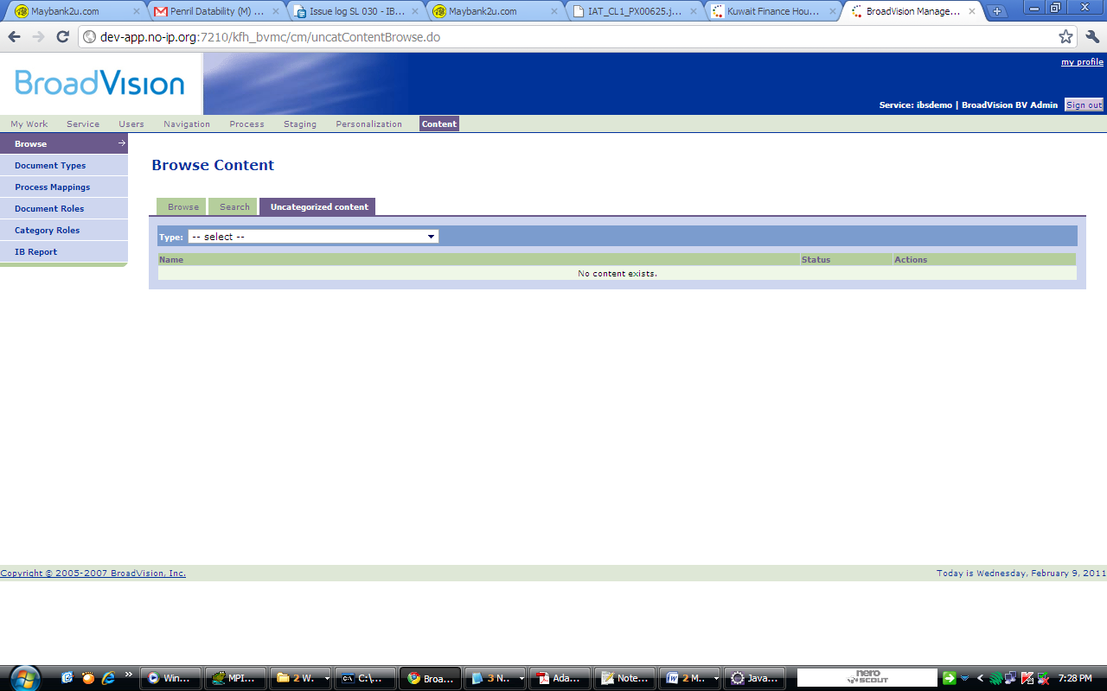

1. Then select type for ‘IB Branch Info’ and check whether the removed content is there.
2. If it is there, click button ‘Move’.

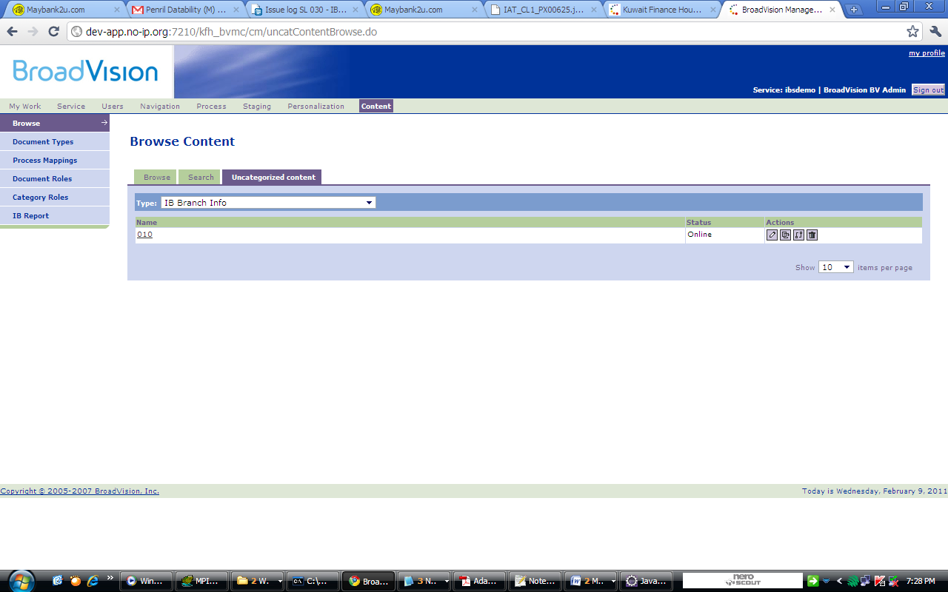

1. It would popup the new window to select the category. Thick for the category named ‘kfh’ and click button ‘Select’.

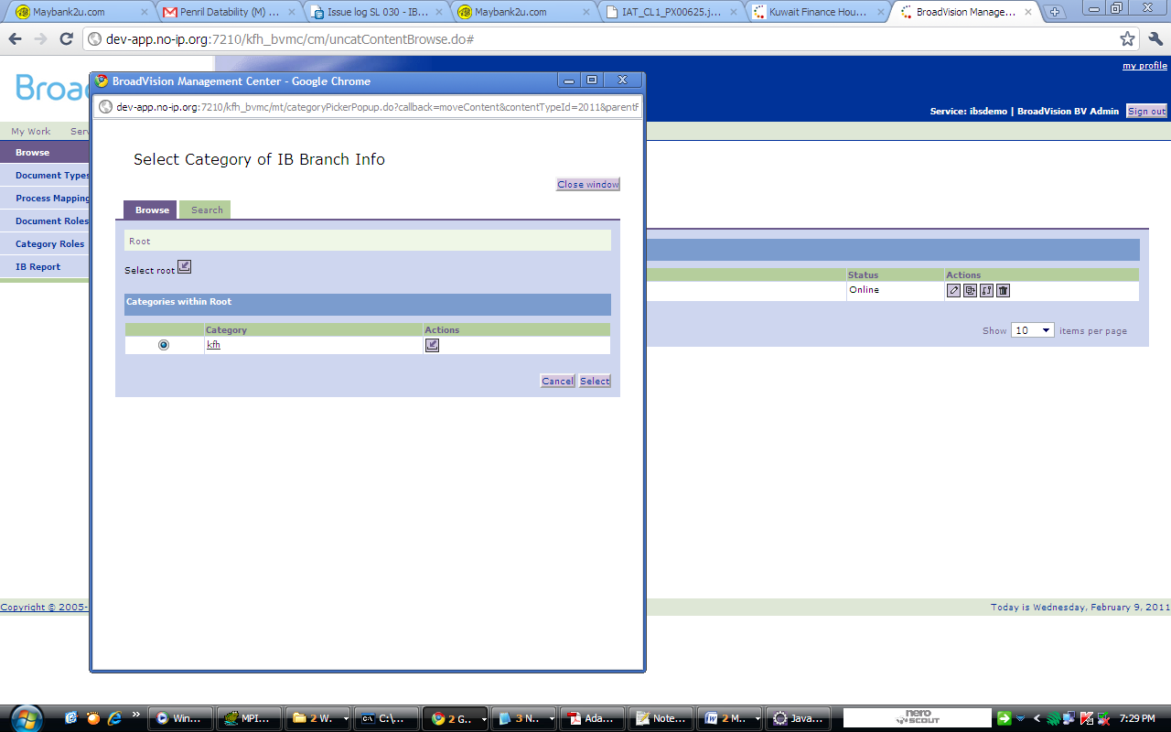

1. Then go to ‘Browse’

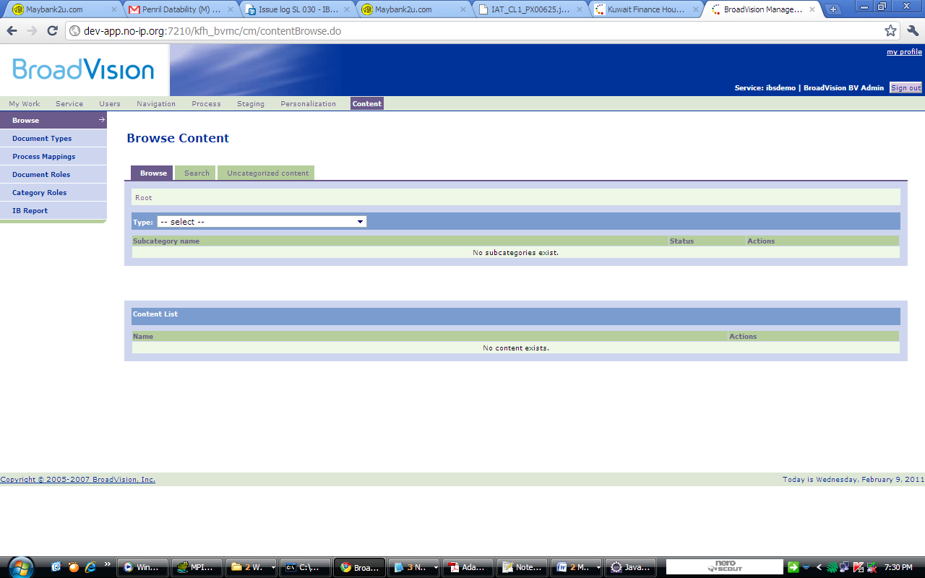

1. Then select Type for ‘IB Branch Info’ to check whether the content is there or not.

