**LATEST NEWS UPDATES 05 January 2018**

1 – SHOP ONLINE WITH YOUR KFH DEBIT CARD-i

Date: 19 December 2017



Dear Colleagues,

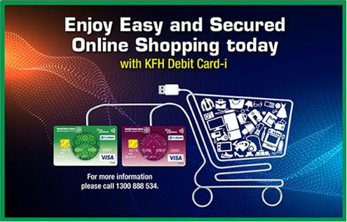

Shopping online is a breeze with KFH Debit Card-i via **One Time Password** (**OTP**) authentication.

You can now perform your online purchases at all **3D secured online merchants** (merchants with “Verified by VISA” logo) and enjoy a more secured online shopping experience both locally as well as overseas.

Upon completing your online shopping, please follow these simple steps:

**Step 1:**

At the checkout page, please enter your KFH Debit Card-i details

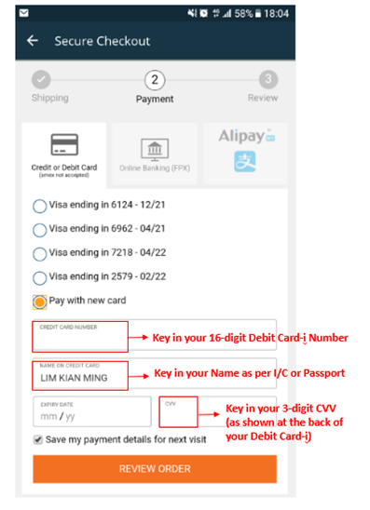

**Step 2:**

Once completed, an OTP will be sent to your mobile number registered with KFH Malaysia.

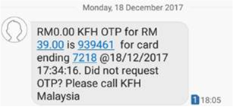

**Step 3:**

Enter the OTP into the space provided.

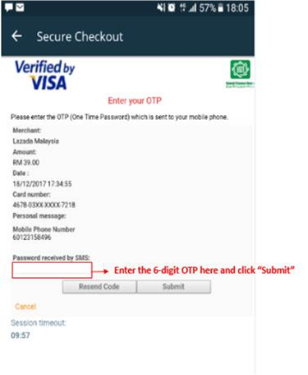

**Step 4:**

Once the OTP is authenticated, the online purchase transaction is now completed and a SMS notification will be sent to your mobile phone.

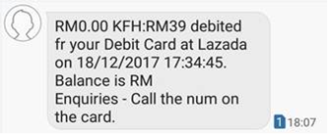

***Note:***

* *The OTP will only be sent to your mobile phone when you perform the online transactions at* ***3D secured online merchants****.*
* *For* ***non 3D secured online merchants*** *(not verified by VISA), the transaction will be declined due to security reason and no OTP will be sent.*

Thank you.



**A message from Retail Banking Division**cid:image004.jpg@01D3201E.8E2D5680

2. SHARIAH AWARENESS (NO.27/2017)

Date: 21/12/2017



Dear Colleagues,

As part of the Shariah Awareness drive, we are pleased to share details on Sukuk.

For more information regarding Sukuk, kindly contact Ustaz Nazrin (ext. 0320) and Ustaz Azmuddin (ext. 0319) or just stay tuned for the next series of Shariah Awareness.

If you have missed any of our previous communications on the Shariah Awareness series, please go to the link provided: X:\Shariah\1. Shariah Division\8. Shariah Awareness Series.

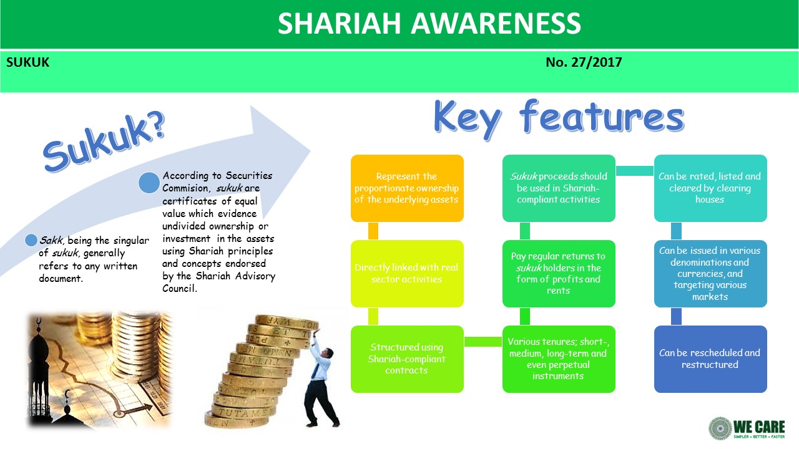

Thank you

**A message from Shariah Division**  
cid:image004.jpg@01D3201E.8E2D5680

3. SPARC PROJECT STATUS

Date: 28/12/2017

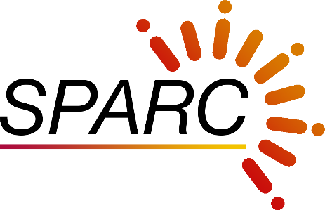

SYSTEM AS A PLATFORM TO ACCELERATE ROBUST CUSTOMERS’ EXPERIENCE

***SPARC PROJECT STATUS AND ITS BENEFITS FOR THE BANK.***

Expected to GO-LIVE tentatively on the 15 January 2018, SPARC is on its right track to improve the Bank’s processes and to facilitate new products for the Bank.

SPARC previously known as ICBS, aims to improve the Bank’s core banking system to be at par with competitors by improving the service delivery turnaround time with a much more user friendly system. Ultimately The project will provide better customer service experience by automating the process and making our customers’ banking experience SIMPLER-BETTER-FASTER.

We have planned to conduct 18 sessions of End Users Training before ‘Go Live’ date 15 January 2018.

Below are some pictures of the End Users in training:

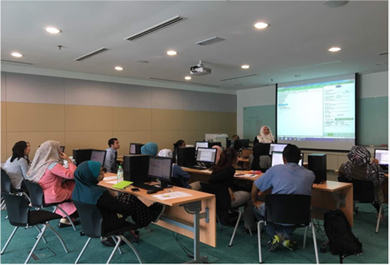

**Customer Service Executives**

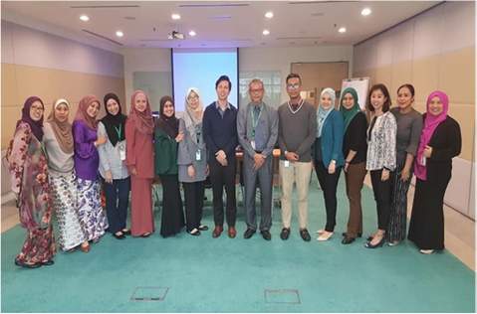

**Cash Officers**

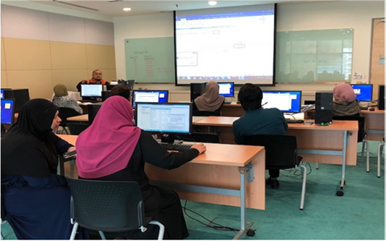

**COAD Users**

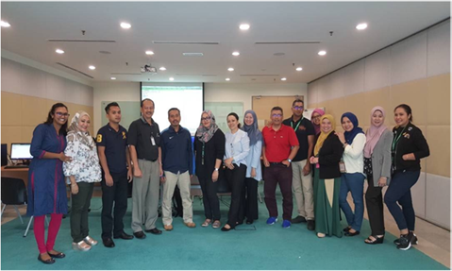

**Customer Service Managers**

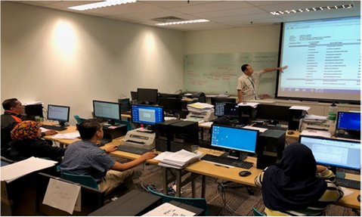

**Trade Operations Users**

We shall continue providing updates on the progress of SPARC. As a KFH Malaysia family we hope you will support this important endeavor as it marks an important milestone for the Bank’s development.

Thank you.

**A message from Technology & Innovation**   
cid:image004.jpg@01D3201E.8E2D5680

4. SPARC PROJECT STATUS

Date: 4/1/2018



SYSTEM AS A PLATFORM TO ACCELERATE ROBUST CUSTOMERS’ EXPERIENCE

***SPARC PROJECT STATUS AND ITS BENEFITS FOR THE BANK – Front Office Processes.***

**11**

**More days to Go Live.**

**SPARC EXPECTED GO-LIVE:**

**15 JANUARY 2018**

Key front office process improvements:

1. **Creation of New RIM and Opening of CASA Account:**

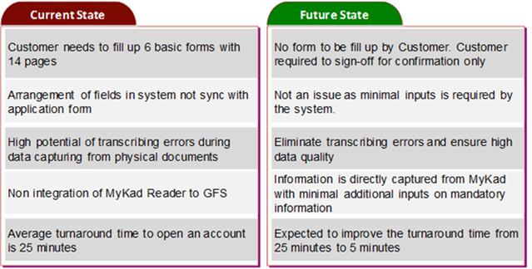

1. **Opening Holder Account for International Commodity Murabahah (ICM):**

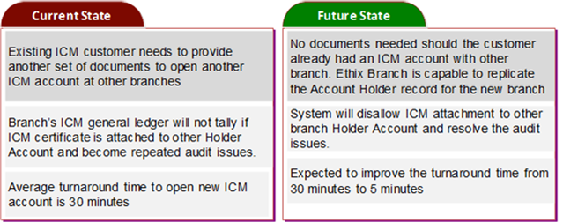

1. **System Integration with Signature Database (SDS):**

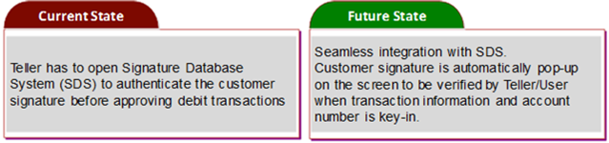

Stay tuned for more exciting news on SPARC.

**SIMPLER – BETTER - FASTER**

**A message from Technology & Innovation**   
cid:image004.jpg@01D3201E.8E2D5680