|  |
| --- |
|  |
| **Bill Payment**  **(Corporate Digital Banking)** |
| Business Requirement and System Specification |
|  |
| ***(PENRIL/BSN-CDB/BRS)***  ***Revision: 00*** |
| **11th August 2017**  Prepared By:    **Penril Datability (M) Sdn Bhd (816792-X)**  Suite A-07-07 Plaza Mon’t Kiara  No. 2, Jalan Kiara, Mon’t Kiara  50480 Kuala Lumpur, Malaysia  Tel: (603) 6201 2622Fax: (603) 6201 7622 |

# DOCUMENT AMENDMENT LOG

|  |  |  |  |  |  |
| --- | --- | --- | --- | --- | --- |
| Rev. No | Date Update | Description of Change | Update By  <Name, Dept> | Review By  <Name, dept> | Approved By  <Name, Dept> |
| 00 | 27/02/2018 | Update as per current system | Nurul Akmal binti Yusof (Software QA) | Siti Norahayu Md Desa (TL) |  |
|  |  |  |  |  |  |
|  |  |  |  |  |  |
|  |  |  |  |  |  |

Table of Contents

DOCUMENT AMENDMENT LOG 2

**Business Requirement Acceptance** 4

**Section A: Introduction** 5

1.1 Objective 6

Section 2: Corporate Digital Banking Functions 7

1 Bill Payment 7

1.1 New Bill Payment 7

1.1.1 Process Flows 7

1.1.2 Screen Flows 7

1.2 Favourite Bill Payment 17

1.2.1 Process Flows 17

1.2.2 Screen Flows 17

2 Bill Payments Payee Maintenance 24

2.1 View Registered Payee Corporation 24

2.1.1 Process Flows 24

2.1.2 Screen Flows 24

2.2 Add Payee to Favourite Payee List 26

2.2.1 Process Flows 26

2.2.2 Screen Flows 26

2.3 Delete Bill Payment Favourite Payee 34

2.3.1 Process Flows 34

2.3.2 Screen Flows 35

Appendix 1: System Security 39

Appendix 2: List Allowable Values 41

Appendix 3: Internet Banking “Text” Input Fields Specification 42

Appendix 4: Acceptable Characters for Validation 43

Appendix 5: Download Report 45

Appendix 6: Glossary 46

**Business Requirement Acceptance**

I/We hereby verify that this Business Requirement consist of all the requirements requested by AGROBANK. The implemented system will fulfill ONLY this requirement.

I/We also hereby AGREE that this satisfies our entire requirement for **[Bill Payment]**

Any future changes to this agreed scope will be treated as an enhancement to the system. Any future changes to the project timeline will be subjected to the final approval of the project steering committee.

**BSN:**

|  |  |  |  |
| --- | --- | --- | --- |
| **Approved by** | **Role** | **Signature** | **Date** |
|  |  |  |  |
|  |  |  |  |
|  |  |  |  |
|  |  |  |  |
|  |  |  |  |
|  |  |  |  |
|  |  |  |  |

**Penril Datability (M) Sdn. Bhd.:**

|  |  |  |  |
| --- | --- | --- | --- |
| **Approved by** | **Role** | **Signature** | **Date** |
|  | Project Manager |  |  |
|  | Team Lead |  |  |
|  | Senior Software Engineer |  |  |

**Section A: Introduction**

This document served as the business requirement and system specification of implementing Bill Payment transaction in BSN Interbank Banking system which is customer able to make Bill Payment via online.

This document shall explain all the features and functionalities, which is elaborating with screen captures, process flow, descriptions, input fields specifications and error messages. All screen designs provided in this document are samples and only illustration purpose for easy understanding. The screen designs are not final.

## Objective

The objective of this document is to capture user requirements of transactional and administration modules of implementing Bill Payment. This document will facilitate development and implementation of the mentioned modules of Internet Banking System for BSN.

The base line features description and screen designs will become a reference blueprint for the development team to develop the transactional and administration module. Hence, it is crucial that all stakeholders need to ensure the correctness and adequacy of the requirements captured in this document.

All stakeholders involved are expected to review and sign off this document before the development start. By signing off the document, the stakeholder has endorsed the correctness and accuracy and adequacy of the requirements documented in this document.



Section 2: Corporate Digital Banking Functions

# Bill Payment

This module allows user to make payment to a registered bill payee corporation or from an open list of payee corporations. As mentioned, there are 2 types bill payment method namely:

* New Bill Payment: Allow Single User to transfer fund to payee ad hoc.
* Favourite Bill Payment: Allow Single User to transfer fund to favourite payee.

## New Bill Payment

### Process Flows



Diagram 1: New Bill Payment Flow Diagram

### Screen Flows

**Step 1:**

1. Single User accesses the New Bill Payment screen and IBS displays New Bill Payment screen. Single User selects which category of Payee Corporation to be paid.
2. Single User clicks on the “Next” button to go to the next page.

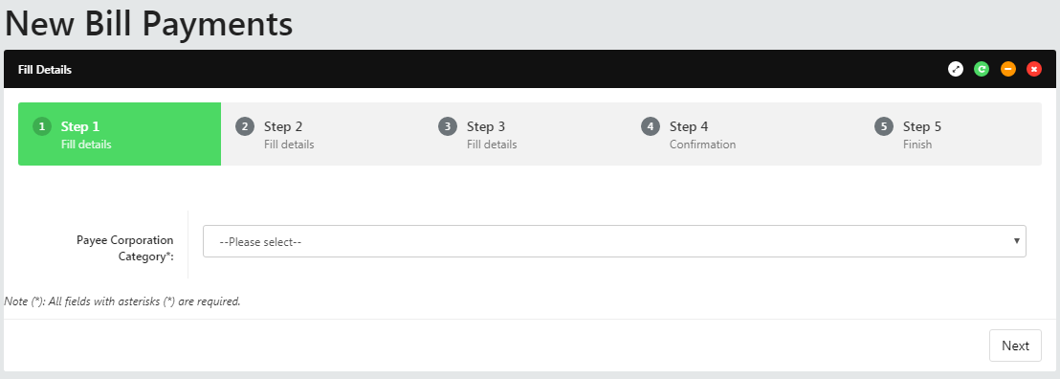

Figure 1: New Bill Payment payee corporation category screen

**Input Specification:**

|  |  |  |  |  |  |
| --- | --- | --- | --- | --- | --- |
| No | Field | Field Type | Validation Rule | Description | M/O |
|  | Payee Corporation Category | Dropdown List | Must be selected | Payee industry categories | M |

Table 1*:* New Bill Payment payee category Input Specification

**Action:**

|  |  |  |  |
| --- | --- | --- | --- |
| No | Action | Type | Description |
|  | Next | Button | Contain an action to continue to next page |

Table 2: New Bill Payment payee category List Action

**List of available messages for the screen:**

|  |  |  |
| --- | --- | --- |
| **No.** | **Event** | **Error Description in English** |
|  | Did not select Payee Corporation Category | Payee Corporation Category is required. |

Table 3: New Bill Payment payee category Error message list

**Step 2:**

1. Single User selects which Payee Corporation to be paid.
2. Single User clicks on the “Next” button to go the next page or clicks on the “Back” button to go back to the previous page.

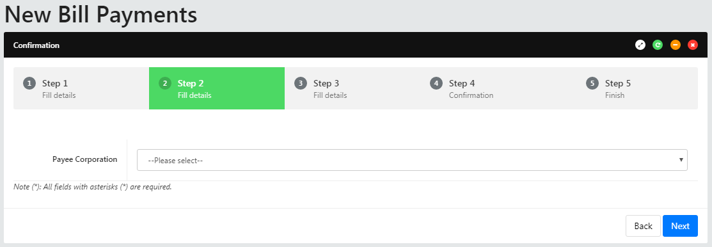

Figure 2: New Bill Payment payee corporation screen

**Input Specification:**

|  |  |  |  |  |  |
| --- | --- | --- | --- | --- | --- |
| No | Field | Field Type | Validation Rule | Description | M/O |
|  | Payee Corporation | Dropdown List | Must be selected | A pre-registered Payee | M |

Table 4: New Bill Payment payee Input Specification

**Action:**

|  |  |  |  |
| --- | --- | --- | --- |
| No | Action | Type | Description |
|  | Back | Button | Contains an action to go back to previous page |
|  | Next | Button | Contains an action to continue to next page |

Table 5: New Bill Payment payee List Action

**List of available messages for the screen:**

|  |  |  |
| --- | --- | --- |
| **No** | **Event** | **Error Description in English** |
|  | Did not select Payee Corporation | Payee Corporation is required. |

Table 6: New Bill Payment payee Error message list

**Step 3:**

1. Single User selects which account to pay the bills, if there’s more than one account in the bank. Single User keys in amount to transfer and Bill Account number.
2. Single User clicks on the “Next” button to go the next page or Single User can clicks on the “Back” button to go back to the previous page.

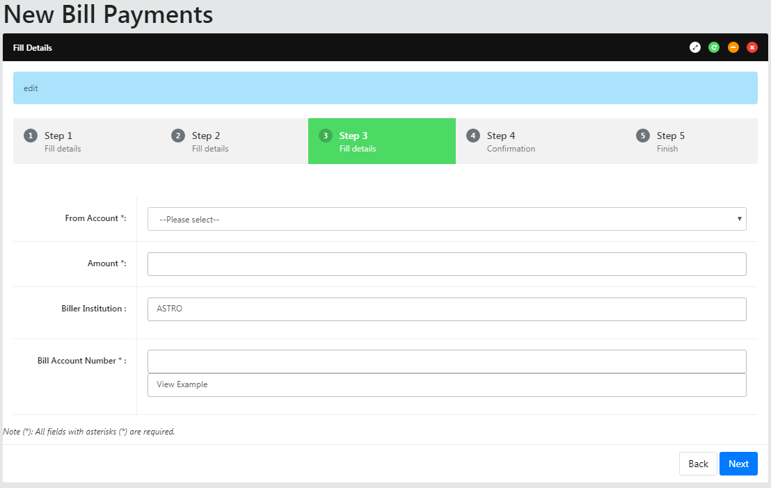

Figure 3: New Bill Payment detail screen

**Display Fields:**

|  |  |  |  |
| --- | --- | --- | --- |
| No | Field | Format | Description |
|  | Biller Institution | Text | Shows the name of payee corporation |

Table 7: New Bill Payment Display Fields

**Input Specification:**

|  |  |  |  |  |  |
| --- | --- | --- | --- | --- | --- |
| No | Field | Field Type | Validation Rule | Description | M/O |
|  | From Account | Dropdown List | Must be selected | From Account to put in Standing Instruction | M |
|  | Amount | Text Box | 15, 2 decimal | Transaction amount | M |
|  | Bill Account Number | Text Box | Max length: 30  Alphanumeric | Set bill Account no | M |

Table 8: New Bill Payment Input Specification

**Action:**

|  |  |  |  |
| --- | --- | --- | --- |
| No | Action | Type | Description |
|  | View Example | Hyperlink | Contains an action to display the sample of bill account number |
|  | Next | Button | Contains an action to continue to next page |
|  | Back | Button | Contains an action to go back to previous page |

Table 9: New Bill Payment List Action

**List of available messages for the screen:**

| **No.** | **Event** | **Error Description in English** |
| --- | --- | --- |
|  | Did not fill in or select mandatory field   * From Account * Amount * Bill Account No | From Account is required. |
| Amount is required. |
| Bill Account No is required |
|  | Fill in amount others than numeric | Amount is not valid currency format. |
|  | Fill in amount less than 0.01 or more than 999999999999.99 | Amount must be in the range of 0.01 to 999999999999.99 |

Table 10: New Bill Payment Error message list

**Step 4:**

1. IBS displays New Bill Payment confirmation screen.
2. Single User confirms the Bill Payment by clicking on the “Confirm” button or clicks on the “Back” button to go back to the previous page.

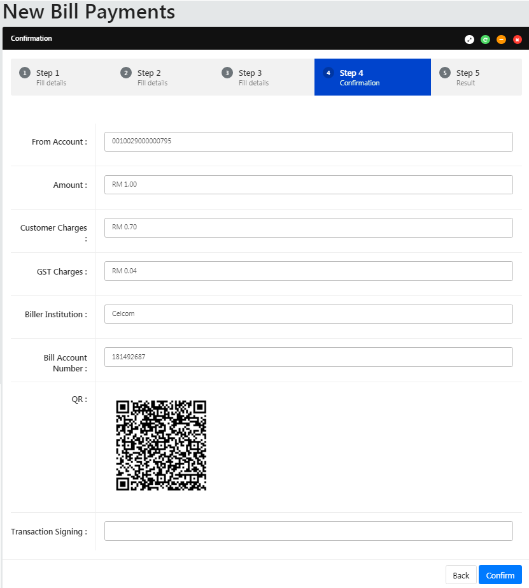

Figure 4: New Bill Payment Confirmation screen

**Display Fields:**

|  |  |  |  |
| --- | --- | --- | --- |
| No | Field | Format | Description |
|  | From Account | Text | Shows the name of payee corporation |
|  | Amount | Text | Shows the amount of the bill payment |
|  | Customer Charges | Text | Shows the customer charges |
|  | GST Charges | Text | Shows the GST charges |
|  | Biller Institution | Text | Shows the selected payee corporation |
|  | Bill Account Number | Text | Shows the reference number 2 of bill |
|  | QR | QR code | Shows the QR code image |

Table 11: New Bill Payment Confirmation Display Fields

**Input Specification:**

|  |  |  |  |  |  |
| --- | --- | --- | --- | --- | --- |
| No | Field | Field Type | Validation Rule | Description | M/O |
|  | Transaction Signing | Text Field | Must input 6 digits | To confirm the transaction is made by Single User | M |

Table 12: New Bill Payment Confirmation Input Specification

**Action:**

|  |  |  |  |
| --- | --- | --- | --- |
| No | Action | Type | Description |
|  | Back | Button | Contains an action to go back to previous page |
|  | Confirm | Button | Contains an action to continue to next page |

Table 13: New Bill Payment Confirmation List Action

**Step 5:**

1. IBS send Bill payment details to the Host System which processes the Bill payment and return result.
2. IBS display New Bill payment Result screen. And Single User is able to make another transaction by clicking on the “Make another transaction” button.

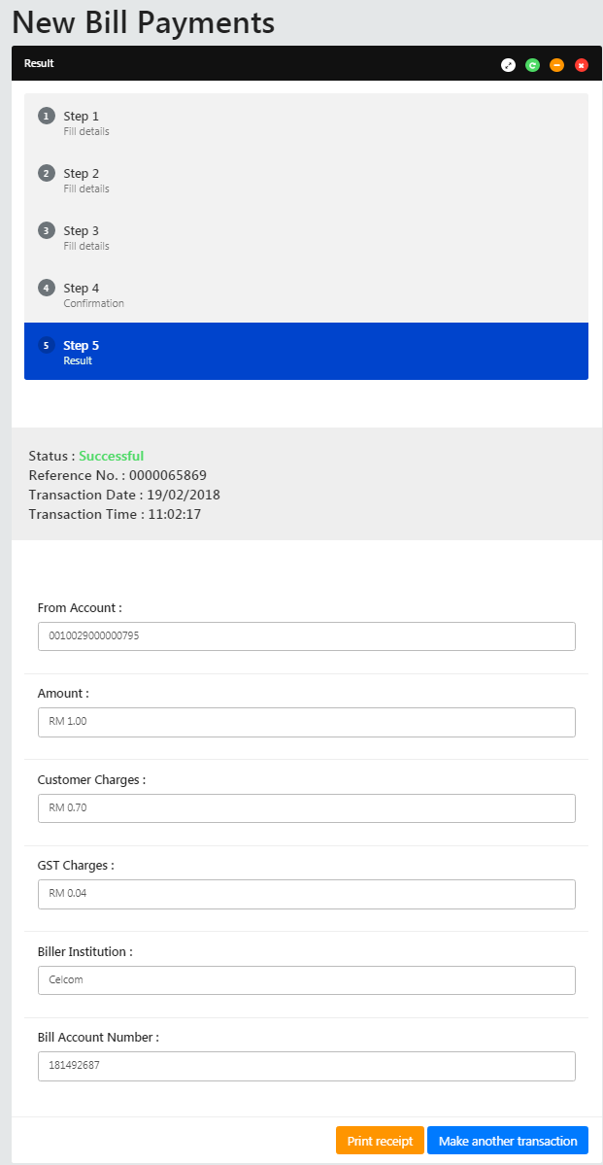

Figure 5: New Bill Payment result screen

Display Fields:

|  |  |  |  |
| --- | --- | --- | --- |
| No | Field | Format | Description |
|  | From Account | Text | Shows the name of payee corporation |
|  | Amount | Text | Shows the amount of the bill payment |
|  | Customer Charges | Text | Shows the customer charges |
|  | GST Charges | Text | Shows the GST charges |
|  | Biller Institution | Text | Shows the selected biller institution |
|  | Bill Account No | Text | Shows the reference number 2 of bill |
|  | Status | Text | Shows the status of the transaction |
|  | Reference No | Numeric | Shows the reference number of particular transaction |
|  | Transaction Date | DD/MM/YYYY | Shows the date of transaction |
|  | Transaction Time | HH:MM:SS | Shows the time of transaction |

Table 14: New Bill Payment Result Display Fields

**Action:**

|  |  |  |  |
| --- | --- | --- | --- |
| No | Action | Type | Description |
|  | Make Another Transaction | Button | Contains an action to go back to New Bill Payment page |
|  | Print Receipt | Button | Contains an action to generate receipt’s pop-up display |

Table 15: New Bill Payment result List Action

1. Single User is able to print out the receipt by clicking “Print Receipt” button. CDB system displays the print form of New Bill Payment Receipt.

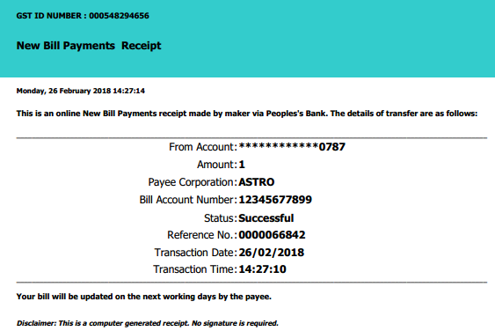

Figure 6: New Bill Payment Receipt Print Form screen

**Display Fields:**

|  |  |  |  |
| --- | --- | --- | --- |
| No | Field | Format | Description |
|  | From Account | Text | Shows the name of payee corporation |
|  | Amount | Text | Shows the amount of the bill payment |
|  | Payee Corporation | Text | Shows the selected payee corporation |
|  | Bill Account No | Text | Shows the reference number 2 of bill |
|  | Status | Text | Shows the status of the transaction |
|  | Reference No | Numeric | Shows the reference number of particular transaction |
|  | Transaction Date | DD/MM/YYYY | Shows the date of transaction |
|  | Transaction Time | HH:MM:SS | Shows the time of transaction |

Table 16: New Bill Payment Receipt Display Fields

**Action:**

|  |  |  |  |
| --- | --- | --- | --- |
| No | Action | Type | Description |
|  | Close the Window | Hyperlink | Contains an action to close the print receipt window. |

Table 17: Print New Bill Payment Receipt Action

## Favourite Bill Payment

### Process Flows

Diagram 2: Favourite Bill Payment Flow Diagram



### Screen Flows

**Step 1:**

1. Single User accesses the Favourite Bill Payment screen and IBS displays Favourite Bill Payment screen. Single User selects which Payee Corporation to pay. If only one registered Payee Corporation, it will be defaulted.
2. Single User clicks on the “Next” button to go to the next page.

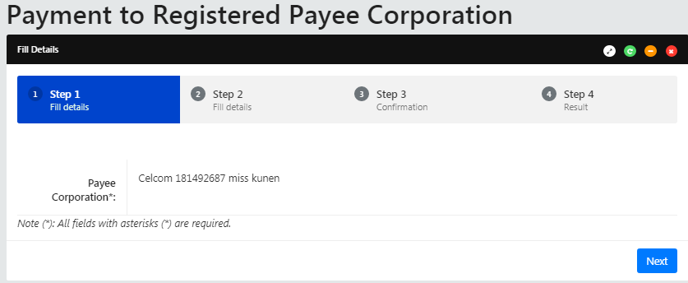

Figure 7: Favourite Bill Payment payee screen

**Input Specification:**

|  |  |  |  |  |  |
| --- | --- | --- | --- | --- | --- |
| No | Field | Field Type | Validation Rule | Description | M/O |
|  | Payee Corporation | Dropdown List | Must be selected | Registered Favourite Payee Corporation | M |

Table 18: Favourite Bill Payment Input Specification

**Action:**

|  |  |  |  |
| --- | --- | --- | --- |
| No | Action | Type | Description |
|  | Next | Button | Contains an action to continue to next page |

Table 19: Favourite Bill Payment List Action

**List of available messages for the screen:**

| **No.** | **Event** | **Error Description in English** |
| --- | --- | --- |
|  | Did not fill in Payee Corporation | Payee Corporation is required. |

Table : Favourite Bill Payment Error message list

**Step 2:**

1. Single User selects a debit account, if there’s more than one account in the dropdown list. And keys in the payment amount.
2. Single User clicks on the “Next” button to go the next page or user can clicks on the “Back” button to go back to the previous page.

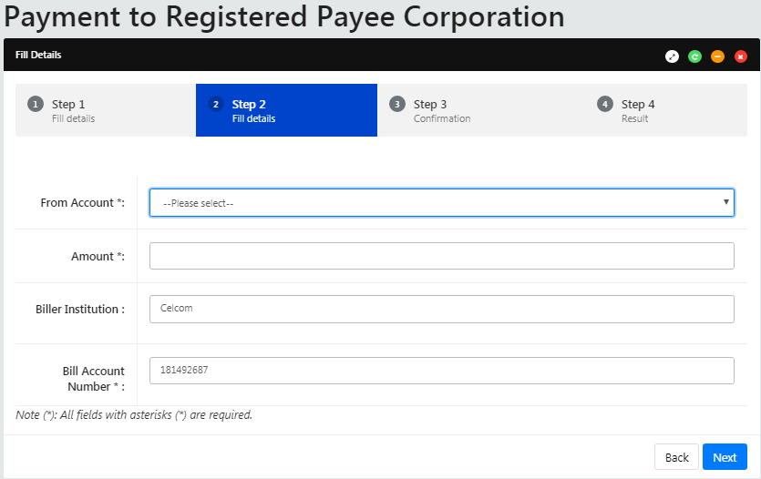

Figure 8: Favourite Bill Payment payee detail screen

Display Fields:

|  |  |  |  |
| --- | --- | --- | --- |
| No | Field | Format | Description |
|  | Biller Institution | Text | Shows the selected Favorite payee corporation |
|  | Bill Account No | Text | Shows the Account number of bill |

Table 21: Favourite Bill Payment payee detail Display Fields

**Input Specification:**

|  |  |  |  |  |  |
| --- | --- | --- | --- | --- | --- |
| No | Field | Field Type | Validation Rule | Description | M/O |
|  | From Account | Dropdown List | Must be selected | Account to debit the payment | M |
|  | Amount | Text Box | 15, 2 decimal  Numeric only | Transaction amount | M |

Table 22: Favourite Bill Payment payee detail Input Specification

**Action:**

|  |  |  |  |
| --- | --- | --- | --- |
| No | Action | Type | Description |
|  | Next | Button | Contains an action to continue to next page |
|  | Back | Button | Contains an action to go back to previous page |

Table 23: Favourite Bill Payment payee detail List Action

**List of available messages for the screen:**

|  |  |  |
| --- | --- | --- |
| **No.** | **Event** | **Error Description in English** |
|  | Did not fill in or select mandatory field   * From Account * Amount | From Account is required. |
| Amount is required. |
|  | Fill in amount others than numeric | Amount must be numeric. |
|  | Fill in amount less than 0.01 or more than 999999999999.99 | Amount must be in the range of 0.01 to 999999999999.99 |

Table 24: Favourite Bill Payment payee detail Error message list

**Step 3:**

1. IBS displays Favourite Bill Payment confirmation screen.
2. Single User confirms the Favourite Bill Payment by clicking on the “Confirm” button or clicks on the “Back” button to go back to the previous page.

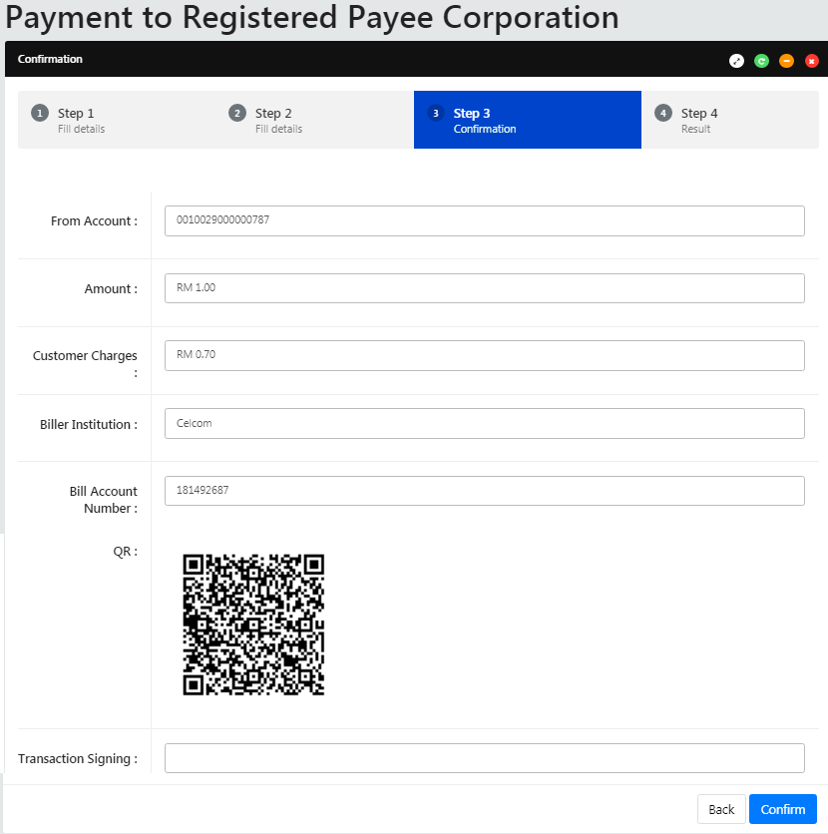

Figure 9: Favourite Bill Payment confirmation screen

**Display Fields:**

|  |  |  |  |
| --- | --- | --- | --- |
| No | Field | Format | Description |
|  | From Account | Numeric | Shows the account number to debit the payment |
|  | Amount | Text | Shows the amount of the bill payment |
|  | Customer Charges | Text | Shows the customer charges |
|  | Biller Institution | Text | Shows name of payee corporation |
|  | Bill Account Number | Text | Shows the account number of bill |
|  | QR | QR code | Shows the QR code image |

Table 25: Favourite Bill Payment payee Confirmation Display Fields

**Input Specification:**

|  |  |  |  |  |  |
| --- | --- | --- | --- | --- | --- |
| No | Field | Field Type | Validation Rule | Description | M/O |
|  | Transaction Signing | Text Field | Must input 6 digits | To confirm the transaction is made by Single User | M |

Table 26: Favourite Bill Payment payee Confirmation Input Specification

**Action:**

|  |  |  |  |
| --- | --- | --- | --- |
| No | Action | Type | Description |
|  | Confirm | Button | Contains an action to continue to next page |
|  | Back | Button | Contains an action to go back to previous page |

Table 27: Favourite Bill Payment payee Confirmation List Action

**Step 4:**

1. IBS send Bill payment details to database which processes the Bill payment and return result.
2. IBS display Bill payment Result screen. And user has the choice to make another transaction by clicking on the “Make another Registered Bill Payment” button or user can click “Print Receipt” button to generate a receipt of Favourite Bill Payment.

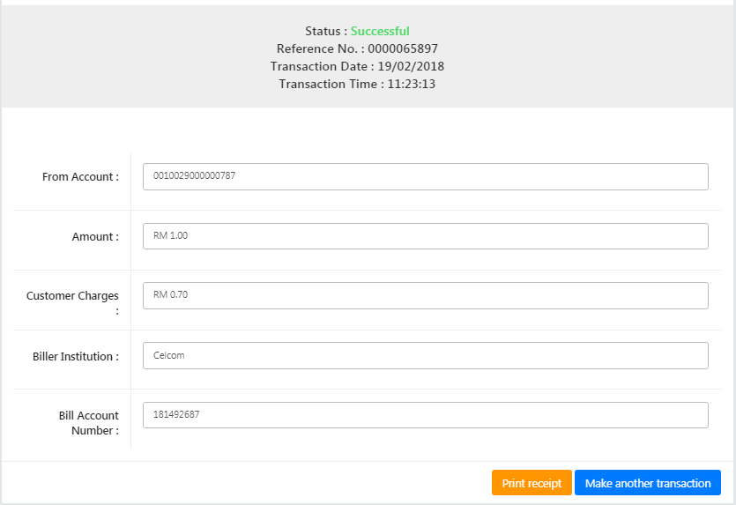

Figure 10: Favourite Bill Payment result screen

**Display Fields:**

|  |  |  |  |
| --- | --- | --- | --- |
| No | Field | Format | Description |
|  | From Account | Numeric | Shows the account number to debit the payment |
|  | Amount | Text | Shows the amount of the bill payment |
|  | Customer Charges | Text | Shows the customer charges |
|  | Biller Institution | Text | Shows name of payee corporation |
|  | Bill Account No | Text | Shows the account number of bill |
|  | Status | Text | Shows the status of the transaction |
|  | Reference No | Numeric | Shows the reference number of particular transaction |
|  | Transaction Date | DD/MM/YYYY | Shows the date of transaction |
|  | Transaction Time | HH:MM:SS | Shows the time of transaction |

Table 28: Favourite Bill Payment Result Display Fields

**Action:**

|  |  |  |  |
| --- | --- | --- | --- |
| No | Action | Type | Description |
|  | Make Another Registered Bill Payment | Button | Contains action to go back to Favourite Bill Payment page |
|  | Print Receipt | Button | Contains an action To generate receipt’s pop-up display |

Table 29: Favourite Bill Payment result List Action

1. User is able to generate a receipt of Favourite Bill Payment by clicking “Print Receipt” button CDB system display the print form of Payment to Favourite Receipt.

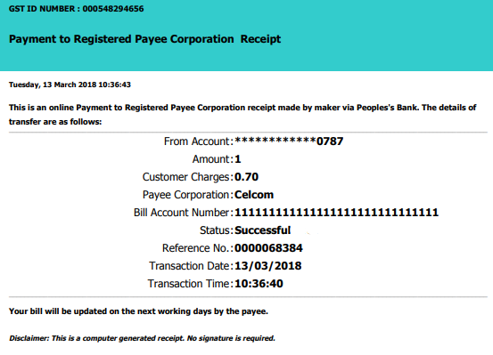

Figure 11: Favourite Bill Payment Receipt Print Form screen

**Display Fields:**

|  |  |  |  |
| --- | --- | --- | --- |
| No | Field | Format | Description |
|  | From Account | Numeric | Shows the account number to debit the payment |
|  | Amount | Text | Shows the amount of the bill payment |
|  | Payee Corporation | Text | Shows name of payee corporation |
|  | Bill Account No | Text | Shows the account number of bill |
|  | Status | Text | Shows the status of the transaction |
|  | Reference No | Numeric | Shows the reference number of particular transaction |
|  | Transaction Date | DD/MM/YYYY | Shows the date of transaction |
|  | Transaction Time | HH:MM:SS | Shows the time of transaction |

Table 30: Favourite Bill Payment Receipt Display Fields

**Action:**

|  |  |  |  |
| --- | --- | --- | --- |
| No | Action | Type | Description |
|  | Close the Window | Hyperlink | Contains an action to close the print receipt window. |

Table 31: Print Favourite Bill Payment Receipt Action

# Bill Payments Payee Maintenance

This function allows Single User to save regularly used Payee in CDB for later usage. The registered payee(s) are tied to the user’s profile, and cannot be shared between other users in the same company.

## View Registered Payee Corporation

Single User can view their registered Payee Account under the Registered Payee Maintenance page.

### Process Flows



Diagram 3: View Registered Payee Flow

### Screen Flows

**Step 1:**

1. Single User clicks on the Registered Payee Maintenance and views the display.

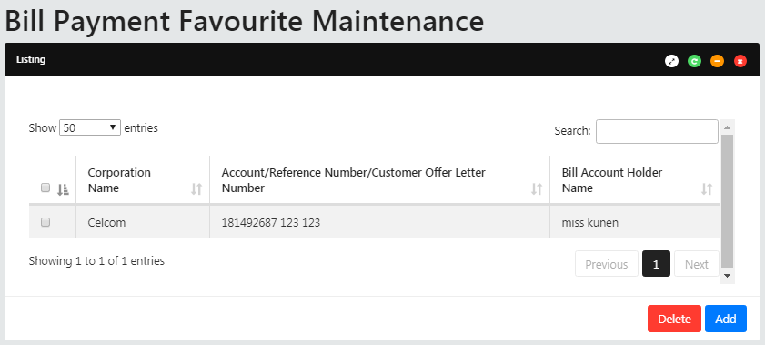

Figure 12: Favourite Payee Maintenance screen

**Display Fields:**

|  |  |  |  |
| --- | --- | --- | --- |
| No | Field | Format | Description |
|  | Payee Corporation | Text | Shows the name of payee corporation |
|  | Account/Reference Number/Customer Offer Letter Number | Text | Shows the reference number of bill |
|  | Bill Account Holder Name | Text | Shows the name of bill account |

Table 32: Registered Payee Maintenance Display Fields

**Input Specification:**

|  |  |  |  |  |  |
| --- | --- | --- | --- | --- | --- |
| No | Field | Field Type | Validation Rule | Description | M/O |
|  | N/A | Check Box | Must link at least one account | The available account number that will be linked | M |

Table 33: Registered Payee Maintenance Input Specification

**Action:**

|  |  |  |  |
| --- | --- | --- | --- |
| No | Action | Type | Description |
|  | Delete | Button | Contains an action to continue to delete confirmation of Payee |
|  | Add | Button | Contains an action to add another Payee |

Table 34: Registered Payee Maintenance List Action

**List of available messages for the screen:**

|  |  |  |
| --- | --- | --- |
| **No.** | **Event** | **Error Description in English** |
|  | Favourite Payee is not selected | Checkbox selection is required. |

Table 35: Registered Payee Maintenance Error message list

## Add Payee to Favourite Payee List

Single User requires adding the registered Payee Account before they can view it at the View Favourite Payee Account Maintenance module.

### Process Flows



Diagram 4: Create Favourite Payee Flow

### Screen Flows

1. Single User can add favorite payee corporation by clicking on the “Add” button on the registered Payee Maintenance page.

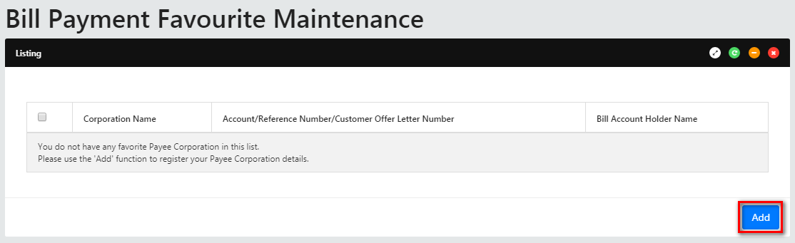

Figure 13: Favourite Payee Maintenance screen

**Display Fields:**

|  |  |  |  |
| --- | --- | --- | --- |
| No | Field | Format | Description |
|  | Corporation Name | Text | Shows the name of payee corporation |
|  | Account/Reference Number | Text | Shows the reference number of bill |
|  | Bill Account Holder Name | Text | Shows the name of bill account |

Table 36: Registered Payee Maintenance Display Fields

**Input Specification:**

|  |  |  |  |  |  |
| --- | --- | --- | --- | --- | --- |
| No | Field | Field Type | Validation Rule | Description | M/O |
|  | N/A | Check Box | Must link at least one account | The available account number that will be linked | M |

Table 37: Registered Payee Maintenance Input Specification

**Action:**

|  |  |  |  |
| --- | --- | --- | --- |
| No | Action | Type | Description |
|  | Delete | Button | Contains an action to continue to delete confirmation of Payee |
|  | Add | Button | Contains an action to add another Payee |

Table 38: Registered Payee Maintenance List Action

**List of available messages for the screen:**

|  |  |  |
| --- | --- | --- |
| **No.** | **Event** | **Error Description in English** |
|  | Favourite Payee is not selected | Checkbox selection is required. |

Table 39: Registered Payee Maintenance Error message list

**Step 1:**

1. Single User selects the Payee Corporation Category.
2. Single User clicks on the “Next” button to go the next page.

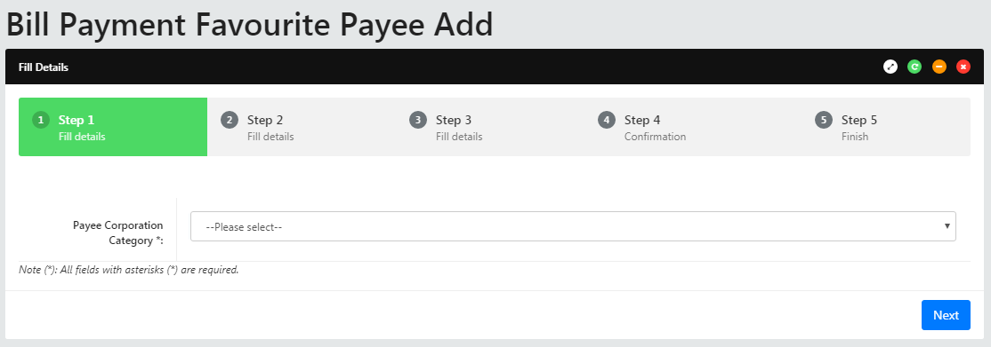

Figure 14: Add Favourite Payee Maintenance category screen

**Input Specification:**

|  |  |  |  |  |  |
| --- | --- | --- | --- | --- | --- |
| No | Field | Field Type | Validation Rule | Description | M/O |
|  | Payee Corporation Category | Dropdown List | Must select a category | Payee industry categories | M |

Table 40: Add Favourite Payee Maintenance List Input Specification

**Action:**

|  |  |  |  |
| --- | --- | --- | --- |
| No | Action | Type | Description |
|  | Next | Button | Contains an action to continue to next page |

Table 41: Add Favourite Payee Maintenance List Action

**List of available messages for the screen:**

|  |  |  |
| --- | --- | --- |
| **No.** | **Event** | **Error Description in English** |
|  | Did not select Payee Corporation Category | Payee Corporation Category is required. |

Table 42: Add Favourite Payee Maintenance List Available Messages

**Step 2:**

1. Single User selects the registered Payee Corporation.
2. Single User clicks on the “Next” button to go the next page or user can click on the “Back” button to go back to previous page.

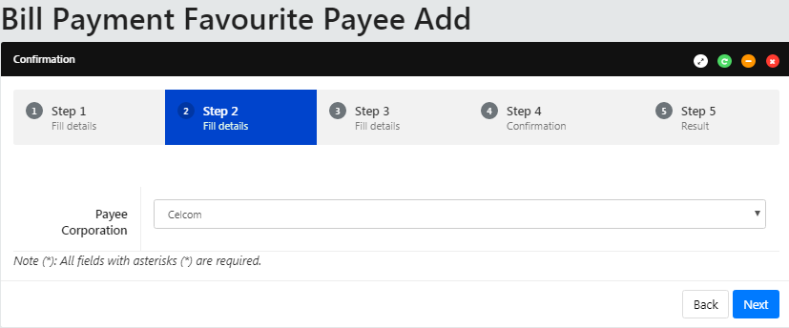

Figure 15: Add Favourite Payee Maintenance screen

**Input Specification:**

|  |  |  |  |  |  |
| --- | --- | --- | --- | --- | --- |
| No | Field | Field Type | Validation Rule | Description | M/O |
|  | Payee Corporation | Dropdown List | Must select a Payee Corporation | A pre-registered Payee | M |

Table 43: Add Favourite Payee Maintenance Specification

**Action:**

|  |  |  |  |
| --- | --- | --- | --- |
| No | Action | Type | Description |
|  | Back | Button | Contains an action to go back to previous page |
|  | Next | Button | Contains an action to continue to next page |

Table 44: Add Favourite Payee Maintenance List Action

**List of available messages for the screen:**

|  |  |  |
| --- | --- | --- |
| **No** | **Event** | **Error Description in English** |
|  | Payee Corporation is not selected | Payee Corporation is required. |

Table 45: Add Favourite Payee Maintenance Error message list

**Step 3:**

1. Single User keys in the Bill Account number and Bill Account Holder name.
2. Single User clicks on the “Continue” button to go to the next page or user can clicks on the “Go Back” button to go back to previous page.

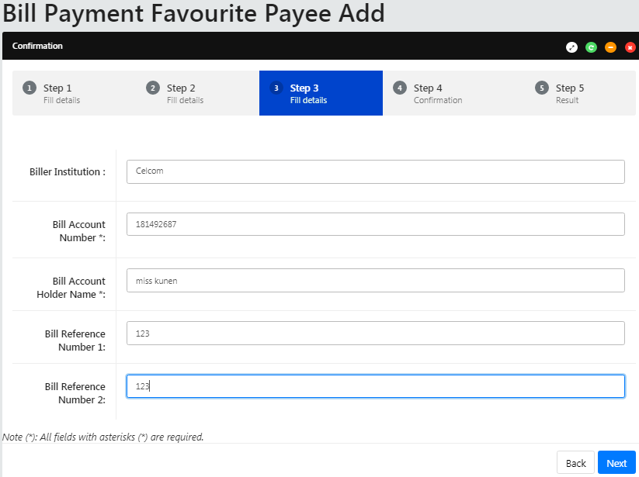

Figure 16: Add Favourite Payee Maintenance detail screen

**Display Fields:**

|  |  |  |  |
| --- | --- | --- | --- |
| No | Field | Format | Description |
|  | Payee Corporation | Text | Shows the corporation name of registered payee |

Table 46: Add Favourite Payee Maintenance Display Fields

**Input Specification:**

|  |  |  |  |  |  |
| --- | --- | --- | --- | --- | --- |
| No | Field | Field Type | Validation Rule | Description | M/O |
|  | Bill Account Number | Text Box | Max length: 30  Alphanumeric | Account number of Bill | M (Depends on the Payee) |
|  | Bill Account Holder Name | Text Box | Max length 60  Alphanumeric with Space, Dot & Dash | Name for bill account | M (Depends on the Payee) |
|  | Bill Reference Number 1 | Text Box | Max length: 30  Alphanumeric | 1st Reference no for bill | M (Depends on the Payee) |
|  | Bill Reference Number 2 | Text Box | Max length: 30  Alphanumeric | 2nd Reference no for bill | M (Depends on the Payee) |

Table 47: Add Favourite Payee Maintenance Input Specification

**Action:**

|  |  |  |  |
| --- | --- | --- | --- |
| No | Action | Type | Description |
|  | Back | Button | Contains an action to go back to previous page |
|  | Continue | Button | Contains an action to continue to next page |

Table 48: Add Favourite Payee Maintenance List Action

**List of available messages for the screen:**

|  |  |  |
| --- | --- | --- |
| **No** | **Event** | **Error Description in English** |
|  | Bill Account No is not inserted | Bill Account No is required |
|  | Bill Account Holder Name is not inserted | Subscriber's Name is required. |
|  | Fill in Invalid information | Bill Account Holder Name is not valid. |
| Bill Account Number is not valid. |

Table 49: Add Favourite Payee Maintenance Error message list

**Step 4:**

1. IBS displays add favourite payee confirmation screen.
2. Single User confirms add favourite payee by clicking on the “Confirm” button or clicks on the “Go Back” button to go back to the previous page.

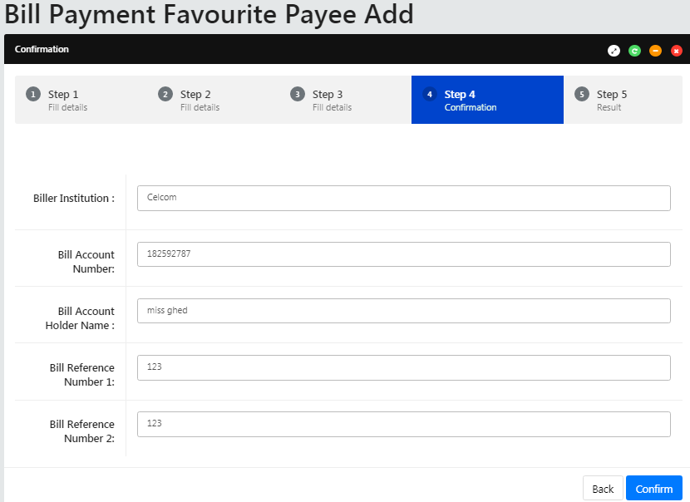

Figure 17: Add Favorite Payee Maintenance confirmation screen

**Display Fields:**

|  |  |  |  |
| --- | --- | --- | --- |
| No | Field | Format | Description |
|  | Biller Institution | Text | Shows the corporation name of biller. |
|  | Bill Account No | Text | Shows the account number of bill |
|  | Bill Account Holder Name | Text | Show the name of bill account |
|  | Bill Reference Number 1 | Text Box | Show 1st Reference no for bill |
|  | Bill Reference Number 2 | Text Box | Show 2nd Reference no for bill |

Table 50: Add Favourite Payee Maintenance Confirmation Display Fields

**Action:**

|  |  |  |  |
| --- | --- | --- | --- |
| No | Action | Type | Description |
|  | Back | Button | Contains an action to go back to previous page |
|  | Confirm | Button | Contains an action to continue to next page |

Table 51: Add Favorite Payee Maintenance Confirmation List Action

**Step 5:**

1. IBS send add new payee details to database which processes new payee and return result.
2. IBS display Add Favourite Payee Result screen. And user clicks on the “Back to Favorite Payee List” button to go back to Registered Payee Maintenance page.

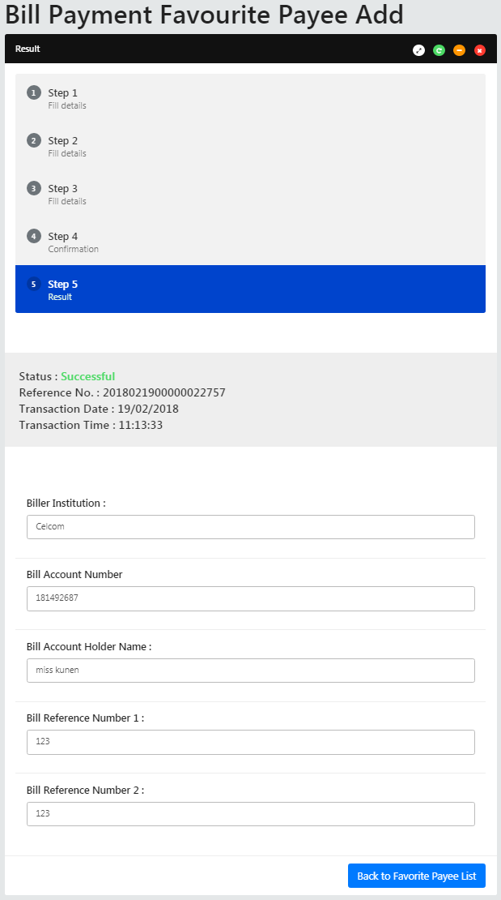

Figure 18: Add Favourite Payee Maintenance result screen

**Display Fields:**

|  |  |  |  |
| --- | --- | --- | --- |
| No | Field | Format | Description |
|  | Biller Institution | Text | Shows the corporation name of biller. |
|  | Bill Account Number | Text | Shows the account number of bill |
|  | Bill Account Holder Name | Text | Show the name of bill account |
|  | Bill Reference Number 1 | Text Box | Show 1st Reference no for bill |
|  | Bill Reference Number 2 | Text Box | Show 2nd Reference no for bill |
|  | Status | Text | Shows the status of the transaction |
|  | Reference No | Numeric | Shows the reference number of particular transaction |
|  | Transaction Date | DD/MM/YYYY | Shows the date of transaction |
|  | Transaction Time | HH:MM:SS | Shows the time of transaction |

Table 52: Add Favourite Payee Maintenance Result Display Fields

**Action:**

|  |  |  |  |
| --- | --- | --- | --- |
| No | Action | Type | Description |
|  | Back to Favorite Payee List | Button | Contains an action to go back to Registered Payee Maintenance page |

Table 53: Add Favourite Payee Maintenance Result List Action

## Delete Bill Payment Favourite Payee

Single User is allowed to delete registered favourite payee.

### Process Flows



Diagram 5: Delete Favourite Payee Flow

### Screen Flows

1. Single User can delete Favourite Payee Corporation by checking the check box and clicking on the “Delete” button on the Registered Payee Maintenance page.

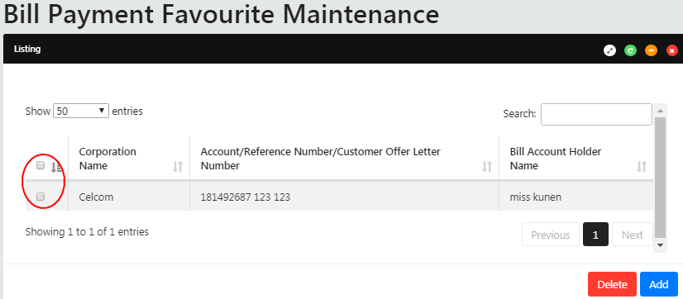

Figure 19: Favourite Payee Maintenance screen

**Display Fields:**

|  |  |  |  |
| --- | --- | --- | --- |
| No | Field | Format | Description |
|  | Corporation Name | Text | Shows the name of payee corporation |
|  | Account/Reference Number/Customer Offer Letter Number | Text | Shows the reference number of bill |
|  | Bill Account Holder Name | Text | Shows the name of bill account |

Table 54: Registered Payee Maintenance Display Fields

**Input Specification:**

|  |  |  |  |  |  |
| --- | --- | --- | --- | --- | --- |
| No | Field | Field Type | Validation Rule | Description | M/O |
|  | N/A | Check Box | Must link at least one account | The available account number that will be linked | M |

Table 55: Registered Payee Maintenance Input Specification

**Action:**

|  |  |  |  |
| --- | --- | --- | --- |
| No | Action | Type | Description |
|  | Delete | Button | Contains an action to continue to delete confirmation of Payee |
|  | Add | Button | Contains an action to add another Payee |

Table 56: Registered Payee Maintenance List Action

**List of available messages for the screen:**

| **No.** | **Event** | **Error Description in English** |
| --- | --- | --- |
|  | Favourite Payee is not selected | Favourite Payee is required. |

Table 57: Registered Payee Maintenance Error message list

**Step 1:**

1. IBS displays Bill Payment Favourite Payee Delete confirmation screen.
2. Single User confirms delete registered payee by clicking on the “Confirm” button or clicks on the “Back” button to go back to the previous page.

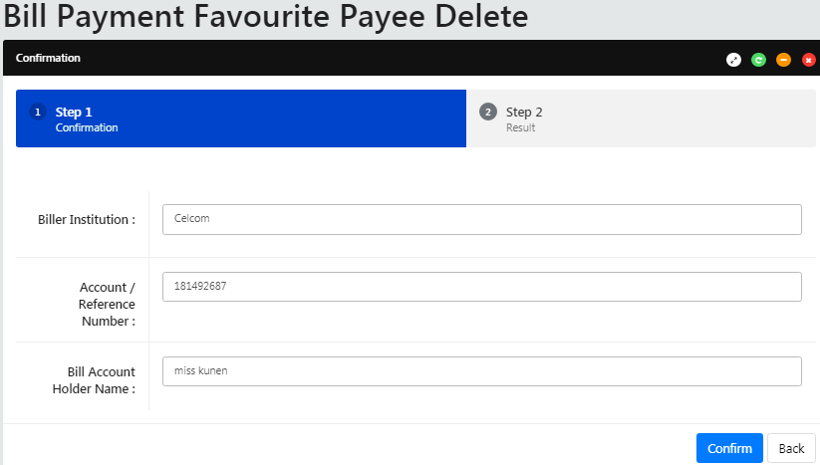

Figure 20: Bill Payment Favourite Payee Delete confirmation screen

**Display Fields:**

|  |  |  |  |
| --- | --- | --- | --- |
| No | Field | Format | Description |
|  | Biller Institution | Text | Shows the corporation name of biller. |
|  | Account/ Reference No | Text | Shows the account number of bill |
|  | Bill Account Holder Name | Text | Show the name of bill account |

Table 58: Bill Payment Favourite Payee Delete Confirmation Display Fields

**Action:**

|  |  |  |  |
| --- | --- | --- | --- |
| No | Action | Type | Description |
|  | Go Back | Button | Contains an action to go back to previous page |
|  | Confirm | Button | Contains an action to continue to next page |

Table 59: Bill Payment Favourite Payee Delete confirmation List Action

**Step 2:**

1. IBS send deleted favourite payee details to Host System which processes deleted registered payee and return result.
2. IBS display deleted registered payee Result screen. And user clicks on the “Back to favorite payee list” button to go back to Registered Payee Maintenance page.

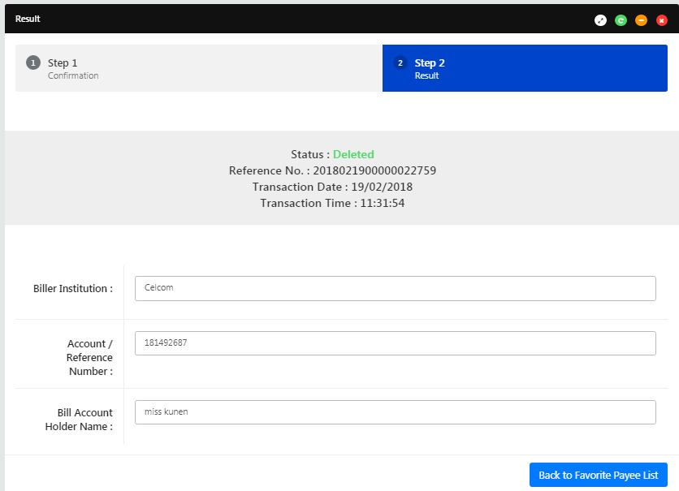

Figure 21: Bill Payment Favourite Payee Delete result screen

**Display Fields:**

|  |  |  |  |
| --- | --- | --- | --- |
| No | Field | Format | Description |
|  | Biller Institution | Text | Shows the corporation name of biller. |
|  | Account/ Reference No | Text | Shows the account number of bill |
|  | Bill Account Holder Name | Text | Show the name of bill account |
|  | Status | Text | Shows the status of the transaction |
|  | Reference No | Numeric | Shows the reference number of particular transaction |
|  | Transaction Date | DD/MM/YYYY | Shows the date of transaction |
|  | Transaction Time | HH:MM:SS | Shows the time of transaction |

Table 60: Bill Payment Favourite Payee Delete Result Display Fields

**Action:**

|  |  |  |  |
| --- | --- | --- | --- |
| No | Action | Type | Description |
|  | Back to Favorite Payee List | Button | Contains an action go back to Registered Payee Maintenance page |

Table 61: Bill Payment Favourite Payee Delete result List Action

# Appendix 1: System Security

|  |  |  |  |
| --- | --- | --- | --- |
| No | Single User ID and Password Control | Requirements | Remark |
|  | Single User ID | Single or combination of numeric, alphabet or alphanumeric. Underscore is accepted. **6 – 16** characters. | The rule is not parameterized. |
|  | Maximum password expiration | **No expiration** | System wide support and can be parameterized via the system configuration file |
|  | Password | Password must contain a mixture of numeric and alphabet format and cannot include these special character ["<>'%;&+].>  Permitted Password length are **8 - 12** characters |  |
|  | Maximum failed log-in attempts | **3 times.** (The Single User ID will subsequently be locked (disabled)) | The maximum number of attempts can be parameterized via the system configuration file. If the Single User ID is locked, the user must send a request to the administrator to reset the password. The application will force the user to change their password upon login. |
|  | Inactive/Dormant ID | Single User ID is automatically disabled by the system after **90** days of inactivity. | The number of days can be parameterized via the system configuration file. |
|  | Duplicate password control | For a minimum of **12** generations, the same passwords cannot be reused. | The number of generations can be parameterized via the system configuration file. |
|  | Last sign on information displayed | The last signed on details will be displayed to the user upon logging into the system | This is a standard feature. |
|  | Changing of passwords by user | Single User may change their passwords anytime they wish | This is standard feature. |
|  | No deletion of Single User IDs from application | Single User IDs that are obsolete must be able to be deleted (instead of just suspended) from the application | The same Single User ID cannot be reused even if restored. The deleted user will not show up on the user enquiry screen, but the record will still be stored in the database. |
|  | Password storage | Password is hashed using SHA-256 hashing algorithm | Combination of nonce and Password is encrypted using SHA-256 before being stored into Database. The hashed value will be used for authentication |

Table 62: Single User Authentication Rules

# Appendix 2: List Allowable Values

|  |  |  |
| --- | --- | --- |
| Field | Type | Values |
| Login as | Dropdown list | * Initiator * Approver |
| Status | Text field | * Successful * Pending * Unsuccessful |
| Action (Account details) / Quick Link | Dropdown list | * Account Details * Transaction History * Agronet Online Trxn History |
| Action Status / Approver Status | Text field | * Approve * Reject |
| Batch Status | Text field | * Pending * Accepted |
| User Role | Dropdown list | * Initiator * Approver |
| User Status | Dropdown list | * New * Active * Suspended * Locked * Unlocked * Dormant |
| Secure Pass Status | Dropdown list | * Not assigned * Assigned * Faulty |

Table 63: List Allowable Values

# Appendix 3: Internet Banking “Text” Input Fields Specification

| No. | Item/Field | Data Type | Format & Length |
| --- | --- | --- | --- |
|  | Username (IB login ID) | Alphanumeric | * Min Length: 6 * Max Length: 16 |
|  | Password | Alphanumeric | * Min Length: 8 * Max Length: 12 * Minimum 1 numeric * Minimum 1 alphabet |
|  | Token Serial | Numeric | * Length: 13 |
|  | Token Pin | Numeric | * Length: 6 |
|  | Date | Date | * Format: DD/MM/YYYY |
|  | Transaction Amount | Decimal | * Max Length: 15 * Format: Decimal 15,2 |
|  | Transaction Remarks | Alphanumeric | * Max Length: 30 |
|  | Transaction Reference No | Alphanumeric | * Max Length: 20 |
|  | Transaction Details | Alphanumeric | * Max Length: 20 |
|  | Email | Email | * Max Length: 60 * Format: <email>@<emailhost>.<extension> |
|  | Beneficiary Nickname | Alphanumeric | * Max Length: 60 |
|  | Interbank Beneficiary Account Number | Numeric | * Max Length: 20 |
|  | Interbank Holder Name | Alphanumeric | * Max Length: 40 |
|  | Bill Account Number | Alphanumeric | * Max Length: 30 |
|  | Favourite Payee Nickname | Alphanumeric | * Max Length: 60 |
|  | Approval Remark | Alphanumeric | * Max Length: 30 |
|  | Name | Alphabet | * Max Length: 100 |
|  | Telephone Number | Alphanumeric | * Max Length: 32 |
|  | Mobile Number[1] | Alphanumeric | * Max Length: 32 |
|  | Address | Alphanumeric | * Max Length: 256 |
|  | Approval Matrix | Numeric | * Length: 1 |

Table 64: Text Input Field Specifications

# Appendix 4: Acceptable Characters for Validation

|  |  |
| --- | --- |
| Validation Name | Acceptable characters |
| Text | No limitations |
| Alphanumeric with Dot & Slash | a-z, A-Z  0-9  Dot / Period (.)  Slash (/) |
| Alphanumeric with Space | a-z, A-Z  0-9  Space |
| Alphanumeric with spaces and underscore | a-z, A-Z  0-9  Space  Underscore (_) |
| Alphanumeric with Space & Symbols | a-z, A-Z  0-9  Space  Ampersand (&)  Apostrophe (', `)  Left Bracket (()  Right Bracket ())  Comma (,)  Alias (@)  Question Mark (?) |
| Email | a-z, A-Z  0-9  Dot / Period (.)  Minus/Hypen (-)  Underscore (_)  Minus/Hypen (-)  Must have one alias (@)  Format: <value>@<value>.<value> |
| Character(s) acceptable for URL path  URL Path | a-z, A-Z  0-9  Dot / Period (.)  Space  Ampersand (&  Plus (+)  Minus/Hypen (-)  Slash (/)  Equal (=)  Question Mark (?)  Underscore (_) |

Table 65: Acceptable Characters for Validations

# Appendix 5: Download Report

Depending on the user’s browser settings and software availability,

* 1. the report can be automatically opened using default software for .xls file type, such as Microsoft Excel or OpenOffice.org Calc
  2. a dialog box will pop-up, asking further action from administrator whether to open the report using with software such as Microsoft Excel or OpenOffice.org Calc or to save the file

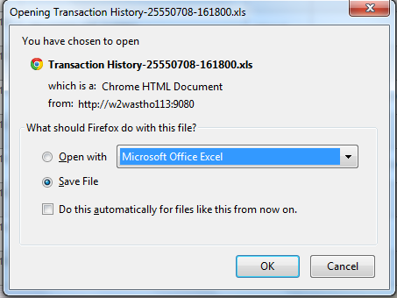

Figure 22: Example dialog box for Download Report

# Appendix 6: Glossary

| **Term** | **Definition** |
| --- | --- |
| RIB | **R**etail **I**nternet **B**anking System |
| CDB | **B**usiness **I**nternet **B**anking System |
| IB | **I**nternet **B**anking |
| IBS | **I**nternet **B**anking **S**ystem |
| IBAM | **I**nternet **B**anking **A**dministration **M**anager (the administration module) |
| SME | **S**mall & **M**edium **E**nterprise |
| TAC | **T**ransaction **A**uthorization **C**ode  TAC is a temporary random six digits security code generated by the authentication server and sent to user by SMS using a SMS gateway. TAC is required as the second level security authentication before committing any bank transactions and user profile updates. |
| OTP | **O**ne **T**ime **P**assword, in this document it meant for the Secure Pass or Token 6 digit PIN from VASCO. |
| BNM | **B**ank **N**egara **M**alaysia |
| CASA | Current & Savings Account |
| FD | Fixed Deposit |

Table 66: Glossary

--- END ---

1. *Mobile Number format subject to change according to SMS Gateway specification*