**[TC 3.11.1.1]**  
Issue:  
No validation for entering Group ID field with alpha and/or special character  
Expected Result:  
Throw error message: "Group ID is not numeric."   
**Actual Result: "Please enter a valid number"**

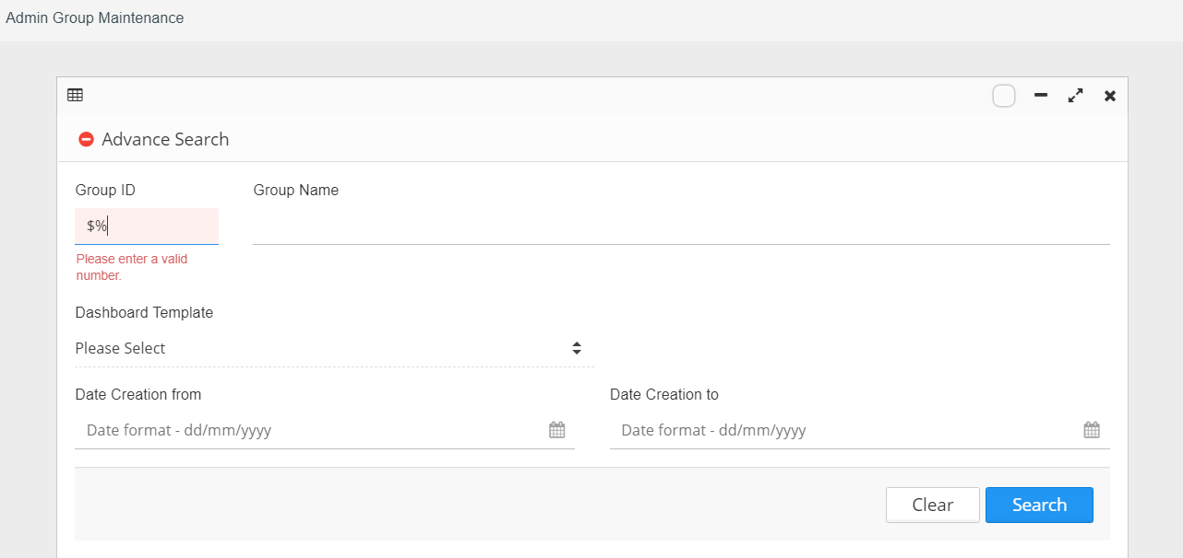

**[TC 3.11.1.4]**  
Issue:  
Entering future date at "Date Creation From"   
Expected Result:  
To disable Date Picker dated greater than today’s date  
***Passed. System disables date greater than today's date***

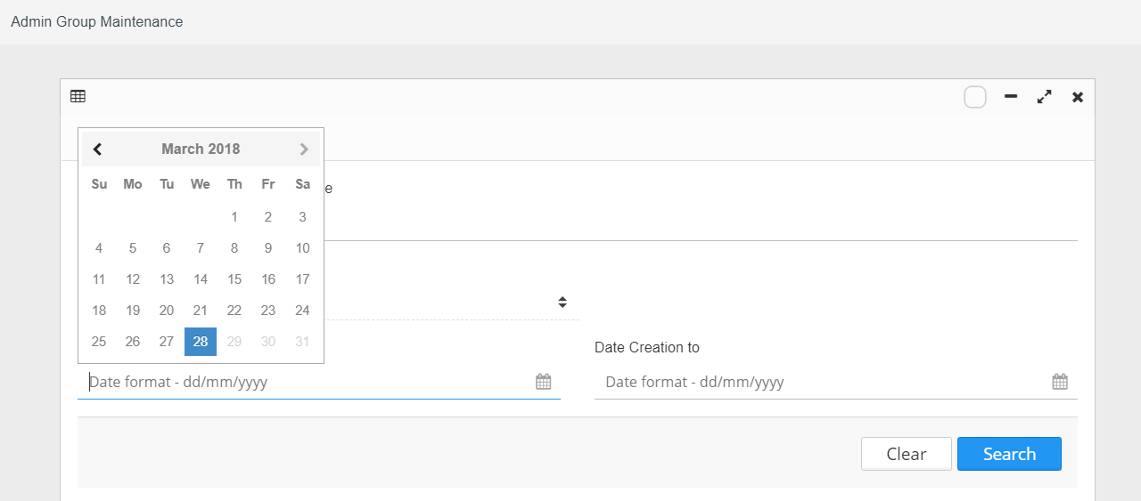

**[TC 3.11.1.5]**  
Issue:  
No validation for entering “Date Creation From” fields with date that more than “Date Creation To” (> “Date Creation To”) value.  
Expected Result:  
Throw error message: "Date Creation From cannot be greater than Date Creation To"   
***Passed. System disables date less than Date Creation From***

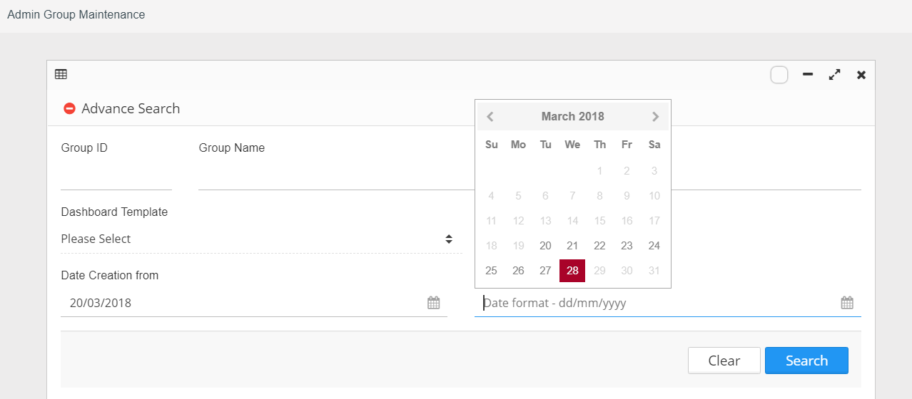

**[TC 3.11.1.6]**  
Issue:  
No validation for entering “Date Creation To” fields with date that less than “Date Creation From” (<”Date Creation From”) value.  
Expected Result:  
Throw error message: "Date Creation To cannot be less than Date Creation From"   
***Passed. System disables date greater than Date Creation To***

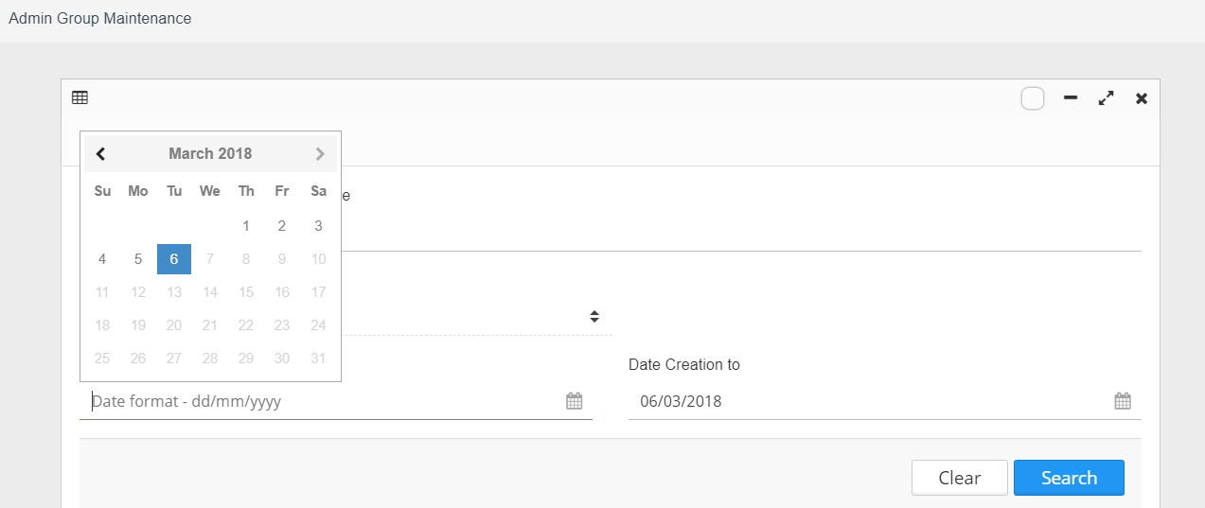

**[TC 3.11.1.7]**  
Issue:  
No validation for entering future dated at "Date Creation To"   
Expected Result:  
To disable Date Picker dated greater than today's date  
***Passed. System disables future date in calendar***

