|  |
| --- |
|  |
| **Bulk Payment**  **(Corporate Digital Banking)** |
| Business Requirement and System Specification |
|  |
| ***(PENRIL/BSN-CDB/BRS)***  ***Revision: 00*** |
| **11th August 2017**  Prepared By:    **Penril Datability (M) Sdn Bhd (816792-X)**  Suite A-07-07 Plaza Mon’t Kiara  No. 2, Jalan Kiara, Mon’t Kiara  50480 Kuala Lumpur, Malaysia  Tel: (603) 6201 2622Fax: (603) 6201 7622 |

# DOCUMENT AMENDMENT LOG

|  |  |  |  |  |  |
| --- | --- | --- | --- | --- | --- |
| Rev. No | Date Update | Description of Change | Update By  <Name, Dept> | Review By  <Name, dept> | Approved By  <Name, Dept> |
| 00 | 28/02/2018 | Update as per current system | Nurul Akmal binti Yusof (Software QA) | Siti Norahayu Md Desa (TL) |  |
|  |  |  |  |  |  |
|  |  |  |  |  |  |
|  |  |  |  |  |  |

Table of Contents

DOCUMENT AMENDMENT LOG 2

**Business Requirement Acceptance** 4

**Section A: Introduction** 5

1.1 Objective 6

Section 2: Corporate Digital Banking Functions 7

1 Bill Payment 7

1.1 New Bill Payment 7

1.1.1 Process Flows 7

1.1.2 Screen Flows 7

1.2 Favourite Bill Payment 17

1.2.1 Process Flows 17

1.2.2 Screen Flows 17

2 Bill Payments Payee Maintenance 24

2.1 View Registered Payee Corporation 24

2.1.1 Process Flows 24

2.1.2 Screen Flows 24

2.2 Add Payee to Favourite Payee List 26

2.2.1 Process Flows 26

2.2.2 Screen Flows 26

2.3 Delete Bill Payment Favourite Payee 34

2.3.1 Process Flows 34

2.3.2 Screen Flows 35

Appendix 1: System Security 39

Appendix 2: List Allowable Values 41

Appendix 3: Internet Banking “Text” Input Fields Specification 42

Appendix 4: Acceptable Characters for Validation 43

Appendix 5: Download Report 45

Appendix 6: Glossary 46

**Business Requirement Acceptance**

I/We hereby verify that this Business Requirement consist of all the requirements requested by BSN. The implemented system will fulfill ONLY this requirement.

I/We also hereby AGREE that this satisfies our entire requirement for **[Bulk Payment]**

Any future changes to this agreed scope will be treated as an enhancement to the system. Any future changes to the project timeline will be subjected to the final approval of the project steering committee.

**BSN:**

|  |  |  |  |
| --- | --- | --- | --- |
| **Approved by** | **Role** | **Signature** | **Date** |
|  |  |  |  |
|  |  |  |  |
|  |  |  |  |
|  |  |  |  |
|  |  |  |  |
|  |  |  |  |
|  |  |  |  |

**Penril Datability (M) Sdn. Bhd.:**

|  |  |  |  |
| --- | --- | --- | --- |
| **Approved by** | **Role** | **Signature** | **Date** |
|  | Project Manager |  |  |
|  | Team Lead |  |  |
|  | Senior Software Engineer |  |  |

**Section A: Introduction**

This document served as the business requirement and system specification of implementing Bulk Payment transaction in BSN Interbank Banking system which is customer able to view Account Summary via online.

This document shall explain all the features and functionalities, which is elaborating with screen captures, process flow, descriptions, input fields specifications and error messages. All screen designs provided in this document are samples and only illustration purpose for easy understanding. The screen designs are not final.

## Objective

The objective of this document is to capture user requirements of transactional and administration modules of implementing Bulk Payment. This document will facilitate development and implementation of the mentioned modules of Internet Banking System for BSN.

The base line features description and screen designs will become a reference blueprint for the development team to develop the transactional and administration module. Hence, it is crucial that all stakeholders need to ensure the correctness and adequacy of the requirements captured in this document.

All stakeholders involved are expected to review and sign off this document before the development start. By signing off the document, the stakeholder has endorsed the correctness and accuracy and adequacy of the requirements documented in this document.

## Business Internet Banking (BIB)

Business Internet Banking solution is the Web interface channel to Core Banking application that serves Corporate Banking customer online via Internet Web Browser. BIB user is different than Retail Internet Banking (RIB) as each user has a role described below:-

| **Role** | **Description** |
| --- | --- |
| Corporate Admin | Act as the corporation administrator to manage the below modules: -  IB Service Management   * User Management * Secure Pass Management * Approval Matrix Management |
| Initiator | Allow to initiate/make transaction, based on access rights.  Not allowed to access to Authorization Module & IB Service Management. |
| Approver | Allow to approve and reject initiated / made transaction.  Allow to access to Authorization Module.  Not allow to access to all transactional modules. |
| Approver All/Single User | Allow to perform straight through transaction without Maker/Checker concept. This is normally used for SME that has only one person or do not has the role of Maker/Checker.  Allow to access to all modules. |

## Scope of Delivery

1. Add new Bulk Payment/Payroll modules in the BIB that enable customer make payment/payroll by upload file format or manually key in.
2. Allow file format upload by the customer via BIB and send to the Bulk Payment/Payroll System for checking, processing and crediting.
3. Bulk Payment/Payroll System to debit Saving/Current Account of the customer and credit the fund to beneficiary accounts based on crediting date has been assigned.
4. BIB (BIB>Bulk Payment Module> Bulk Payment History) to display Bulk Payment History status for customer reference.
5. BIB (BIB>Payroll Module> Payroll History) to display Payroll History status for customer reference.
6. (BIB>Account & Banking) to display status of the customer account in the AGRONet Transaction History and Transaction History once the account has been credited for bulk payment transaction
7. IBAM (IBAM>Company Enquiry>Company Details) to display status online/offline of Bulk Payment and Payroll for company and VB is able to edit online/offline of Bulk Payment and Payroll for company.
8. IBAM (IBAM>Company Enquiry>Charges) to display charges of Bulk Payment and Payroll for company and VB is able to set charges of Bulk Payment and Payroll for each company.
9. IBAM (IBAM>BIB Report) to generate new reports related that to Bulk/Payroll transactions for VB reference i.e. Bulk Payment Report Daily and Payroll Report Daily
10. IBAM (IBAM>BIB Report) to extract Bulk Payment/Payroll transactions has been executed on crediting date into Interbank Fund Transfer Report, Consolidated Transaction IB Report Monthly and BNM Financial Transactions Corporate Report Monthly.
11. IBAM (IBAM>BIB Transaction Enquiry) to display two inquiries i.e. Bulk Payment transaction and Payroll transaction.
12. Demo Page
13. Distribute payment for Statutory Bodies (IRB/EPF/SOCSO/Zakat/Tabung Haji) using Payroll menu

Section 2: Corporate Digital Banking Functions



# Enhancement at Internet Banking Application Manager (IBAM)

## IBAM> BIB> Company Enquiry

This feature allows administrator to set the Bulk Payment module either to online or offline in the BIB navigation and also can set the charges for each company.

### Process Flow



Diagram 1: Edit Company Details Process Flow

There are 2 participants involved in this process which is User and IBAM. The following are the steps to set the flag for Bulk Payment status and to update the charges at Company Details:

### Screen Flow

***Step 1:***

1. Admin search the company’s name by key in into the Company Name field and click on Search button
2. The result will display as per keyed in
3. Click on the Company Name link to view the details of company

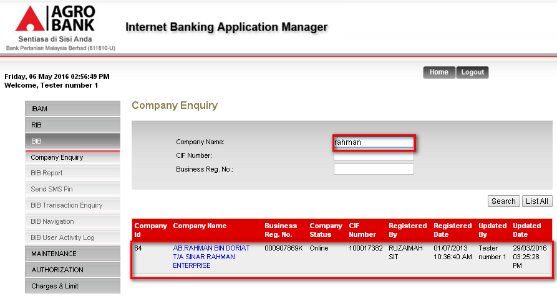

Figure 1: Content List Screen

**Action:**

| **No** | **Action** | **Type** | **Description** |
| --- | --- | --- | --- |
| 1 | Search | Button | Contains the action to search the desired details |
| 2 | List | Button | Contains an action to list all companies |
| 3 | Company Name | Link | Contains an action to display the details of the company |

Table 1: Content List Action

***Step 2:***

1. IBAM System shows the specific company details.
2. Admin User clicks on ‘Edit’ button.

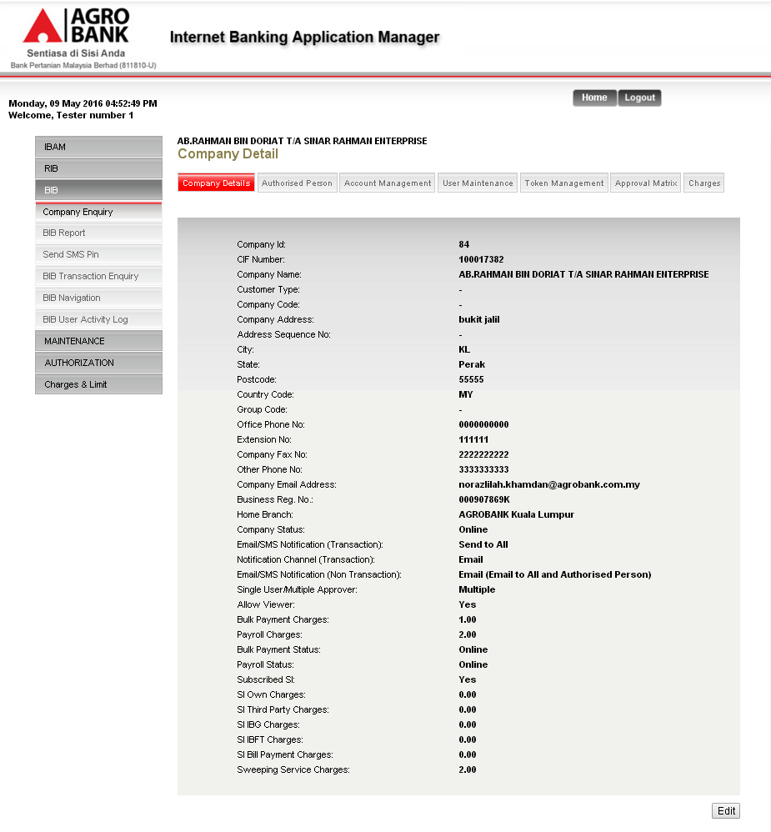

Figure 2: Company Details Screen

**Display Fields:**

| **No** | **Field** | **Format** | **Description** |
| --- | --- | --- | --- |
|  | Company ID | Text | Shows the company ID |
|  | CIF Number | Text | Shows the company CIF |
|  | Company Name | Text | Shows the company name |
|  | Customer Type | Text | Shows the customer type |
|  | Company Code | Text | Shows the company code |
|  | Company Address | Text | Shows the company address |
|  | Address Sequence No | Text | Shows the sequence number of address |
|  | City | Text | Shows the city |
|  | State | Text | Shows the state |
|  | Postcode | Text | Shows the postcode |
|  | Country Code | Text | Shows the country code |
|  | Office Phone No | Text | Shows the office phone number |
|  | Extension No | Text | Shows the extension number |
|  | Company Fax No | Text | Shows the company fax number |
|  | Other Phone No | Text | Shows the other phone number |
|  | Company Email Address | Text | Shows the email address of company |
|  | Business Reg No. | Text | Shows the registration number of company |
|  | Home Branch | Text | Shows the branch of account |
|  | Company Status | Text | Shows the status of company |
|  | Email/SMS Notification (Transaction) | Text | Shows the recipient of Email/SMS Notification for transaction |
|  | Notification Channel (Transaction) | Text | Shows the channel for notification |
|  | Email/SMS Notification (Non Transaction) | Text | Shows the recipient of Email/SMS Notification for Non Transaction |
|  | Single User/Multiple Approver | Text | Shows the type of user |
|  | Allow Viewer | Text | Flagged |
|  | Bulk Payment Charges | Text | Shows the charges of bulk payment |
|  | Payroll Charges | Text | Shows the charges of Payroll |
|  | Subscribed SI | Text | Shows the flagged for SI subscribing |
|  | SI Own Charges | Text | Shows the charges of SI Own |
|  | SI Third Party Charges | Text | Shows the charges of SI Third Party |
|  | SI IBG Charges | Text | Shows the charges of SI IBG |
|  | SI IBFT Charges | Text | Shows the charges of SI IBFT |
|  | SI Bill Payment Charges | Text | Shows the charges of SI Bill Payment |
|  | Sweeping Service Charges | Text | Shows the charges of Sweeping Service |

**Action:**

| **No** | **Action** | **Type** | **Description** |
| --- | --- | --- | --- |
| 1 | Edit | Button | Contains an action to edit the company information. |

Table 2: Company Details Action

***Step 3:***

1. IBAM System shows the edit company details page.

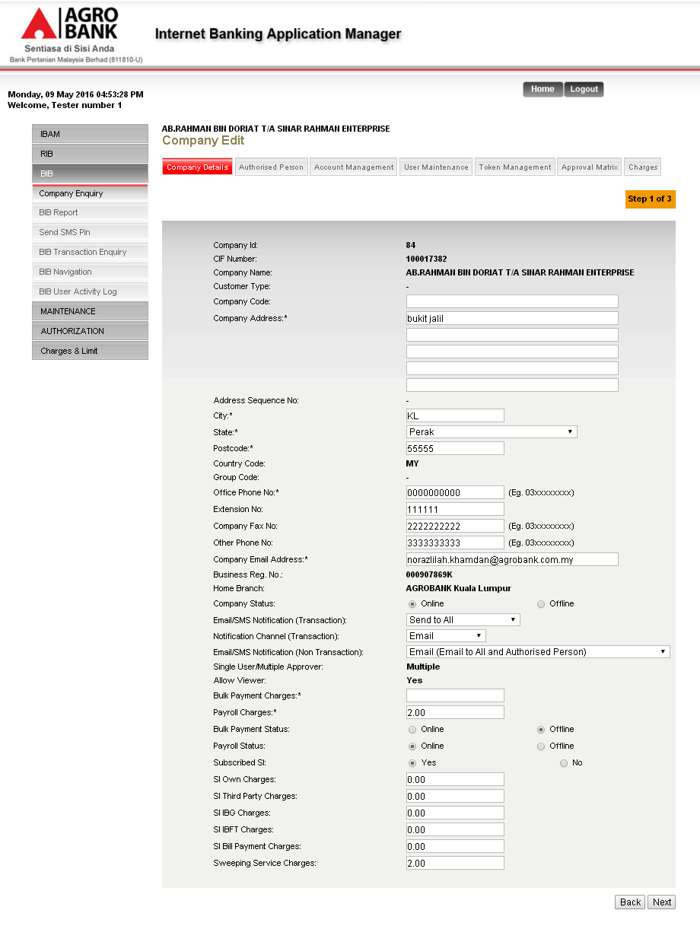

Figure 3: Edit Content Details Screen

**Input Specification:**

| **No** | **Field** | **Field Type** | **Validation Rule** | **Description** | **Compulsory** |
| --- | --- | --- | --- | --- | --- |
|  | Company Code | Text | Alphanumeric.  Max length: 10 char | Code of company | O |
|  | Company Address | Text | Alphanumeric | Address of company | M |
|  | Address Sequence No | Text | Alphanumeric |  | O |
|  | City | Text | Alphanumeric | City of company | M |
|  | State | Dropdown List | Alphanumeric | State of company | M |
|  | Postcode | Text | Numeric | Mailing postcode | M |
|  | Country Code | Text | Numeric | Code of country | O |
|  | Office Phone No | Text | Numeric | Telephone number of office | M |
|  | Extension No | Text | Numeric | Extension of office phone number | O |
|  | Company Fax No | Text | Numeric | Fax number of company | O |
|  | Other Phone No | Text | Numeric | Alternative telephone number | O |
|  | Company Email Address | Text | Alphanumeric | Email address of company | M |
|  | Company Status | Radio button | Selected one of the option | Status of company | O |
|  | Email/SMS Notification (Transaction) | Dropdown List | Selected one of the option | Email/SMS Notification for Transaction | O |
|  | Notification Channel (Transaction) | Dropdown List | Selected one of the option | Notification Channel for Transaction | O |
|  | Email/SMS Notification (Non Transaction) | Dropdown List | Selected one of the option | Email/SMS Notification for Non Transaction | O |
|  | Bulk Payment Charges | Radio button | Selected one of the option | Charges for Bulk Payment Transaction | M |
|  | Payroll Charges | Radio button | Selected one of the option | Charges for Payroll Transaction | M |
|  | Subscribed SI | Radio button | Selected one of the option | Flagged | O |
|  | SI Own Charges | Text | Numeric | Charges for SI Own transaction | O |
|  | SI Third Party Charges | Text | Numeric | Charges for SI Third Party Transaction | O |
|  | SI IBG Charges | Text | Numeric | Charges for SI IBG Transaction | O |
|  | SI IBFT Charges | Text | Numeric | Charges for SI IBFT Transaction | O |
|  | SI Bill Payment Charges | Text | Numeric | Charges for SI Bill Payment Transaction | O |
|  | Sweeping Service Charges | Text | Numeric | Charges for Sweeping Service | O |

Table 3: Edit Company Details Input Specification

**Action:**

| **No** | **Action** | **Type** | **Description** |
| --- | --- | --- | --- |
| 1 | Back | Button | Goes back to ‘content list’ page. |
| 2 | Next | Button | Forward the action to validate and display the confirm page for confirmation |

Table 4: Edit Company Details Action

***Step 4:***

1. IBAM validate and go to confirm page
2. IBAM shows successful message and pending for Authorization approval process.
3. Once approved IBAM will shows the update details under the content type content list.

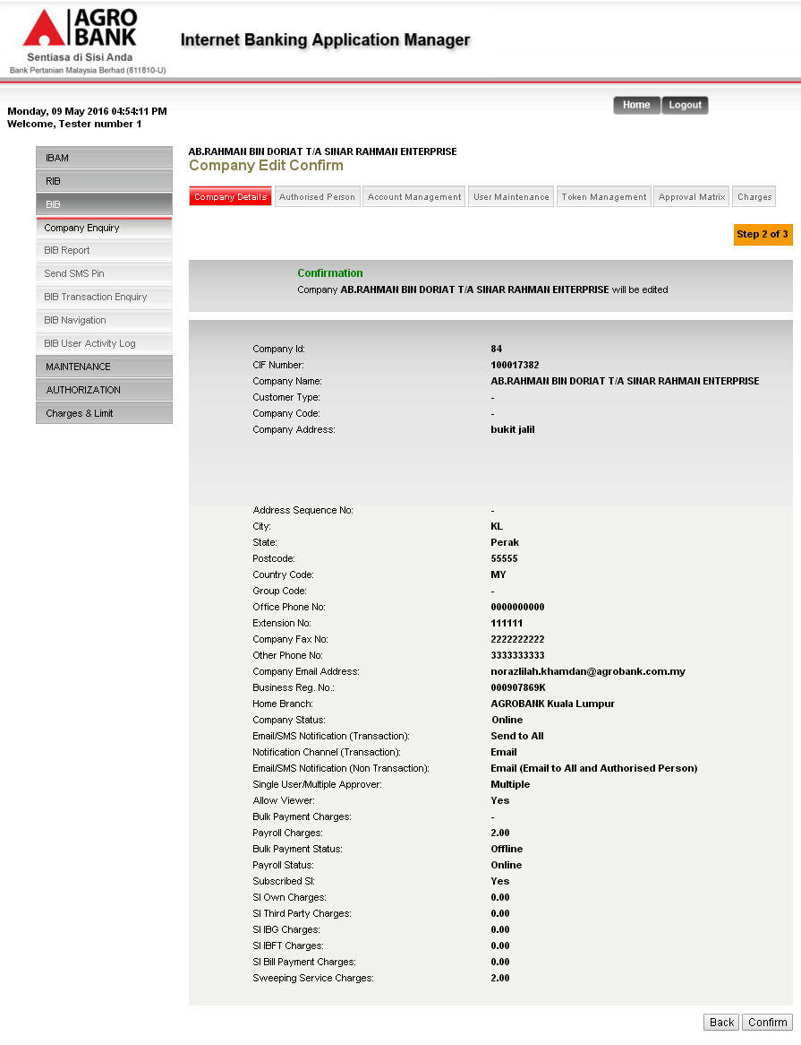

Figure 4: Edit Company Confirm

**Display Fields:**

| **No** | **Field** | **Format** | **Description** |
| --- | --- | --- | --- |
|  | Company ID | Text | Shows the company ID |
|  | CIF Number | Text | Shows the company CIF |
|  | Company Name | Text | Shows the company name |
|  | Customer Type | Text | Shows the customer type |
|  | Company Code | Text | Shows the company code |
|  | Company Address | Text | Shows the company address |
|  | Address Sequence No | Text | Shows the sequence number of address |
|  | City | Text | Shows the city |
|  | State | Text | Shows the state |
|  | Postcode | Text | Shows the postcode |
|  | Country Code | Text | Shows the country code |
|  | Office Phone No | Text | Shows the office phone number |
|  | Extension No | Text | Shows the extension number |
|  | Company Fax No | Text | Shows the company fax number |
|  | Other Phone No | Text | Shows the other phone number |
|  | Company Email Address | Text | Shows the email address of company |
|  | Business Reg No. | Text | Shows the registration number of company |
|  | Home Branch | Text | Shows the branch of account |
|  | Company Status | Text | Shows the status of company |
|  | Email/SMS Notification (Transaction) | Text | Shows the recipient of Email/SMS Notification for transaction |
|  | Notification Channel (Transaction) | Text | Shows the channel for notification |
|  | Email/SMS Notification (Non Transaction) | Text | Shows the recipient of Email/SMS Notification for Non Transaction |
|  | Single User/Multiple Approver | Text | Shows the type of user |
|  | Allow Viewer | Text | Flagged |
|  | Bulk Payment Charges | Text | Shows the charges of bulk payment |
|  | Payroll Charges | Text | Shows the charges of Payroll |
|  | Subscribed SI | Text |  |
|  | SI Own Charges | Text | Shows the charges of SI Own |
|  | SI Third Party Charges | Text | Shows the charges of SI Third Party |
|  | SI IBG Charges | Text | Shows the charges of SI IBG |
|  | SI IBFT Charges | Text | Shows the charges of SI IBFT |
|  | SI Bill Payment Charges | Text | Shows the charges of SI Bill Payment |
|  | Sweeping Service Charges | Text | Shows the charges of Sweeping Service |

**Action:**

| **No** | **Action** | **Type** | **Description** |
| --- | --- | --- | --- |
| 1 | Back | Button | Contains an action to go back edit the company information. |
| 2 | Confirm | Button | Contains an action to confirm the changes |

Table 5: Company Confirm Action

Content Maker Checker Permission set as ‘Disable’

1. IBAM updates the details to IB Database and display the result to the IBAM user
2. IBAM shows successful message and shows the updated content details under the content type without Authorization.

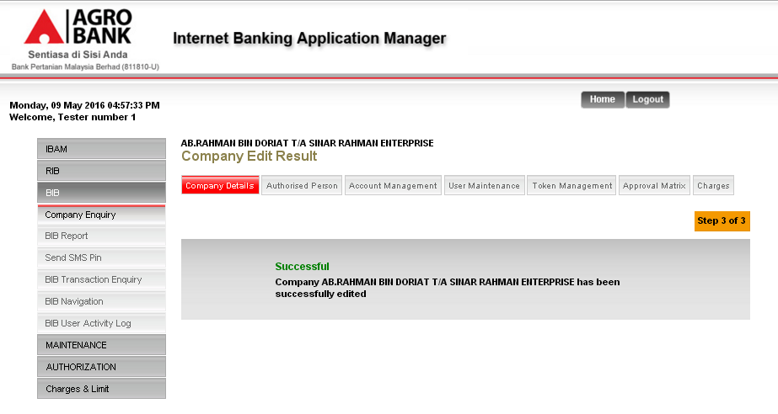

Figure 5: Edit Content Result Screen without Authorization Process

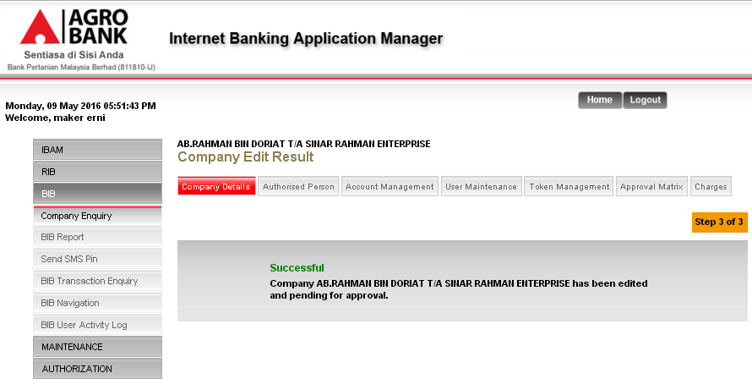

**Figure 6: Edit Content Result Screen with Authorization Process**

Display Specification:

| **No** | **Field** | **Format** | **Description** |
| --- | --- | --- | --- |
| 1. | Result Status | Text | Edit Content Result status |
| 2. | Result Status Notes | Text | Edit Content Result status message |

Table 6: Edit Company Result Display Fields

## **Report**

IBAM Admin User can access to reports under IB (BIB) Report module of IBAM, the user just need to select the appropriate report type, File Type as PDF (*.pdf) or Excel (*.xls), Month and Year to download the report in CSV or Text format.

The following are reports related to Bulk Payment

* + BIB Bulk Payment Report Daily

Below attached sample reports:

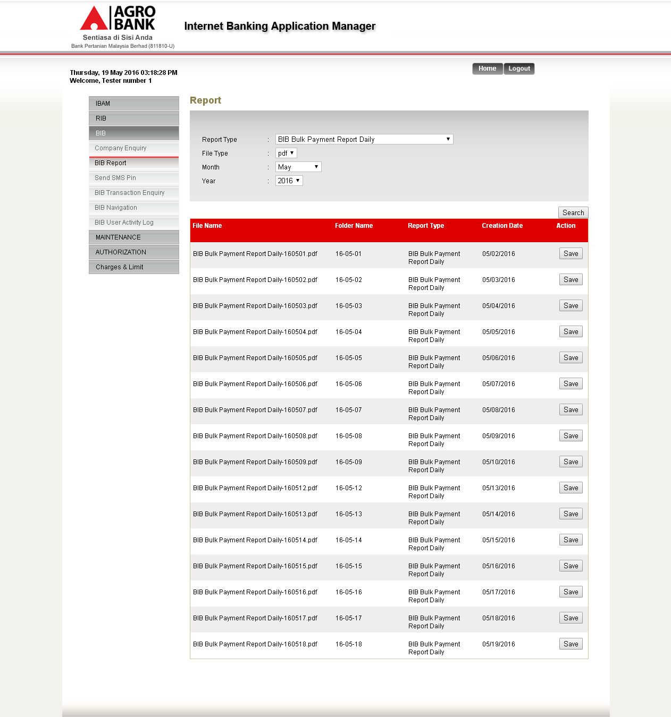

Figure 7: BIB – Report (BIB Bulk Payment Report Daily)

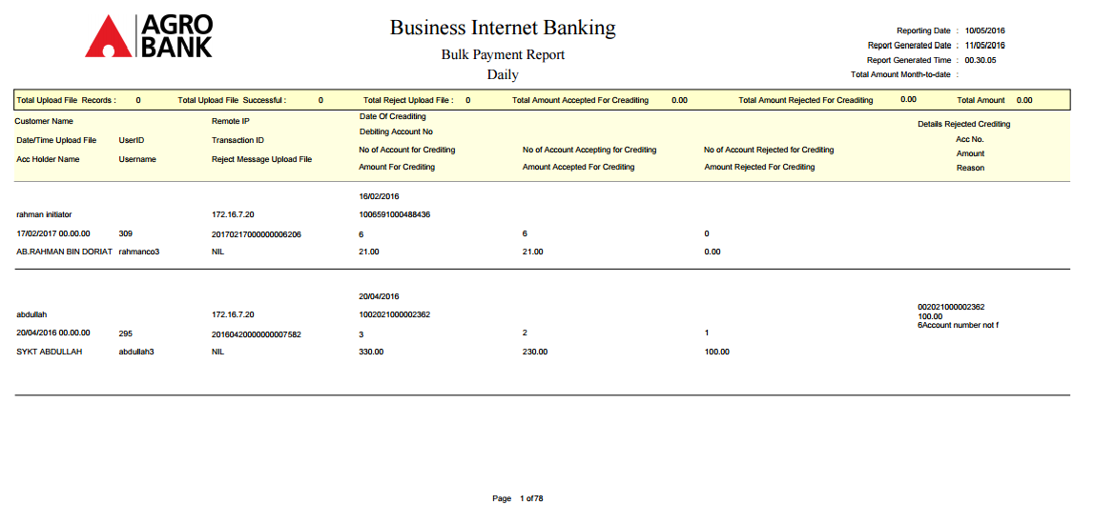

Figure 8: BIB – Bulk Payment Report Daily

# Enhancement at Business Internet Banking (BIB)

## Bulk Payment – Single User/Initiator

### Bulk Payment - File Upload

User uses this feature to make bulk payment to all the beneficiary or payee defined in uploaded payment file.

There are consists with 3 type of file format which are SAGA format, Excel format, MACS format with Single Debit Account and Multiple Debit Account.

### Process Flow



Diagram 2: File Upload Process Flow

##### Bulk Payment – File Upload – SAGA format with Single/Multiple Debit Account

There will have 2 job types when submit a transaction for SAGA format.

1. Single Debit Account: there only has one debit account in the upload file or select it from CMS. If the upload file did not have Debit account, it will take the debit account from CMS.

2. Multiple Debit Account: there have multiple debit accounts in the upload file or select it from CMS. If the upload file did not have debit account, it will take the debit account from CMS. CMS only will show one debit account.

There are 2 participants involved in bulk payment process which is User, CMS System. The process has the following steps:

###### Screen Flow

***Step 1:***

1. User accesses to Bulk Payment screen, and select File Upload.
2. User selects File Type.
3. User clicks Next.
4. User selects Job Type, From Account, key in Total Number of Transaction, Total Amount, Crediting Date, Remarks
5. User keys in Security Token PIN number
6. User clicks Confirm
7. User views Bulk Payment Result screen page.

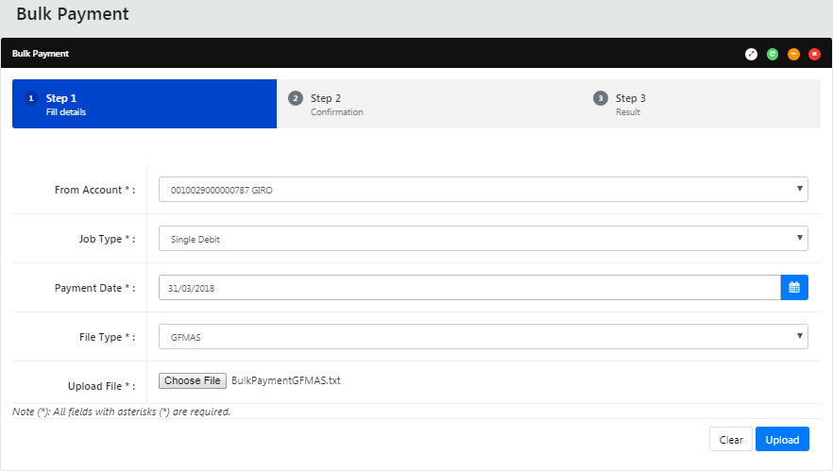

**Input Specification:**

| **No** | **Field name** | **Field Type** | **Validation Rule** | **Description** | **M/O** |
| --- | --- | --- | --- | --- | --- |
|  | From Account | Dropdown list | Selected one of the option | User account number | M |
|  | Job Type | Dropdown list | Selected one of the option | Type of payment | M |
|  | Payment Date | Date Picker |  | Date of payment | M |
|  | File Type | Dropdown list | Selected one of the option | Upload File format:  SAGA  Excel  MACS | M |
|  | Upload File | (Textbox) File Browser | String (File path) | Path to the Bulk Transfer file | M |

**Action:**

| **No** | **Field name** | **Field Type** | **Validation Rule** | **Description** | **M/O** |
| --- | --- | --- | --- | --- | --- |
|  | From Account | Dropdown list | Selected one of the option | User account number | M |
|  | Job Type | Dropdown list | Selected one of the option | Type of payment | M |
|  | Payment Date | Date Picker |  | Date of payment | M |
|  | File Type | Dropdown list | Selected one of the option | Upload File format:  SAGA  Excel  MACS | M |
|  | Upload File | (Textbox) File Browser | String (File path) | Path to the Bulk Transfer file | M |

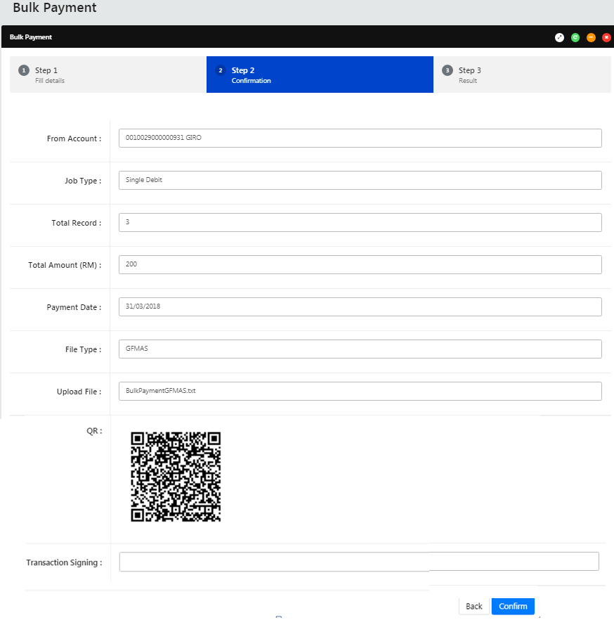

**Display Fields:**

| **No** | **Field** | **Format** | **Description** |
| --- | --- | --- | --- |
|  | Job Type | Dropdown List | Single or Multiple Debit Account |
|  | From Account | Dropdown List | Account number |
|  | Job Type | Dropdown List | Single or Multiple Debit Account |
|  | Total Record | Text Box | Total Transaction of the file upload |
|  | Total Amount | Text Box | Total Amount of this file transaction |
|  | Payment date | Dropdown list | Select the date for crediting |
|  | File Type | Text Box | Customer Remarks or Message |
|  | QR Code | Image | Scan using mobile |

**Input Specification**

| **No** | **Field name** | **Field Type** | **Validation Rule** | **Description** | **M/O** |
| --- | --- | --- | --- | --- | --- |
|  | Transaction Signing | Text Box | * Match Length: 6 * Numeric | A random, temporary generated number sent to mobile phone for transaction verification | M |

**Action:**

| **No** | **Action** | **Type** | **Description** |
| --- | --- | --- | --- |
|  | Back | Button | Contains an action to go back to previous page |
|  | Confirm | Button | Contains an action to continue to next page |

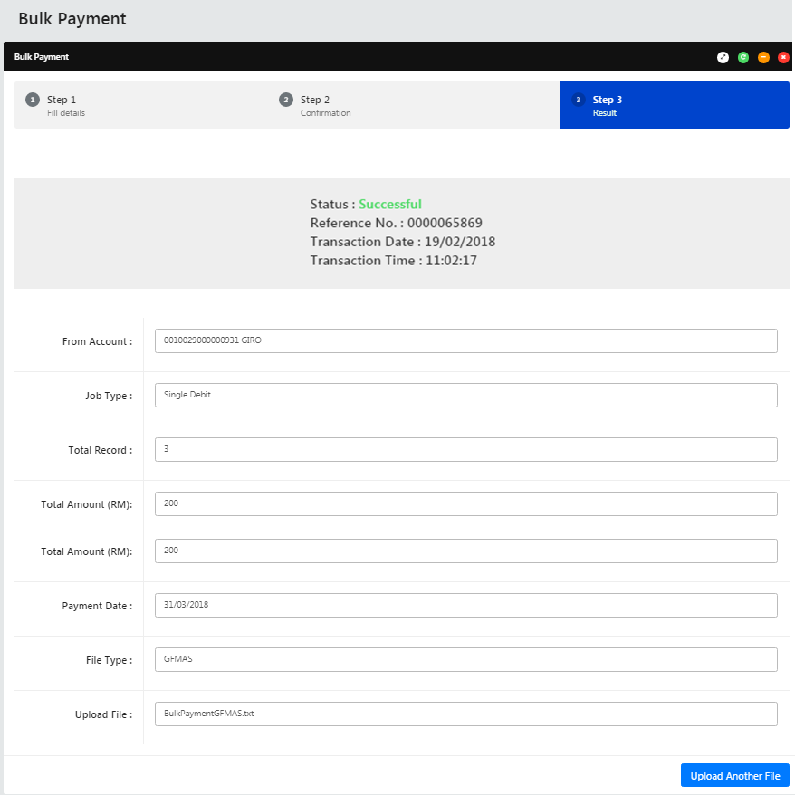

**Display Fields:**

| **No** | **Field** | **Format** | **Description** |
| --- | --- | --- | --- |
|  | From Account | Numeric | Shows the account number of sender |
| 1. J | Job Type | Text | Shows the payment type |
|  | Total Record | Numeric | Shows Total Transaction of the file upload |
|  | Total Amount | Text | Shows Total Amount of this file transaction |
|  | Payment Date | Text | Shows crediting date of this transaction |
|  | File Type | Text | Shows type of file uploaded |
|  | Upload File | Text | Shows uploaded file name |
|  | Status | Text | Show the transaction status  Single user = Accepted  Initiator = Pending Approval |
|  | Reference No | Numeric | Show the transaction reference no |
|  | Transaction Date | Date format | Show the transaction date |
|  | Transaction Time | Time format | Show the transaction time |

**Action:**

| **No** | **Action** | **Type** | **Description** |
| --- | --- | --- | --- |
|  | Upload Another File | Button | Contains an action to go back to bulk payment page |

### Bulk Payment- Multiple Payment – Single User/Initiator

This allows the customer to do manual entry to initiate the bulk payment for Excel file format only.

#### Create New record

User uses this feature to make payroll to the entire beneficiary or payee manually updates in CMS instead of upload a file.

There are 2 participants involved in bulk payment process which is User, BIB System. The process has the following steps:

***Step 1:***

1. User accesses to Bulk Payment screen, and select Multiple Payment.
2. User clicks on Create New button.
3. User selects Job Types and key in Crediting Date.
4. User click Add button
5. User key in Payment Type, Beneficiary Name, IC/ID No, Beneficiary/Account No, Amount, Payment Reference, Payment Detail.
6. User click Next
7. User verifies the information and click on Confirm.
8. User can see the result page for confirm the record added in CMS.
9. Once User adds all the record and click on Submit.
10. User clicks Confirm if the information is accurate.
11. User can see the result page. The result page, user can view the record based on Date, can select the date to view and added record.

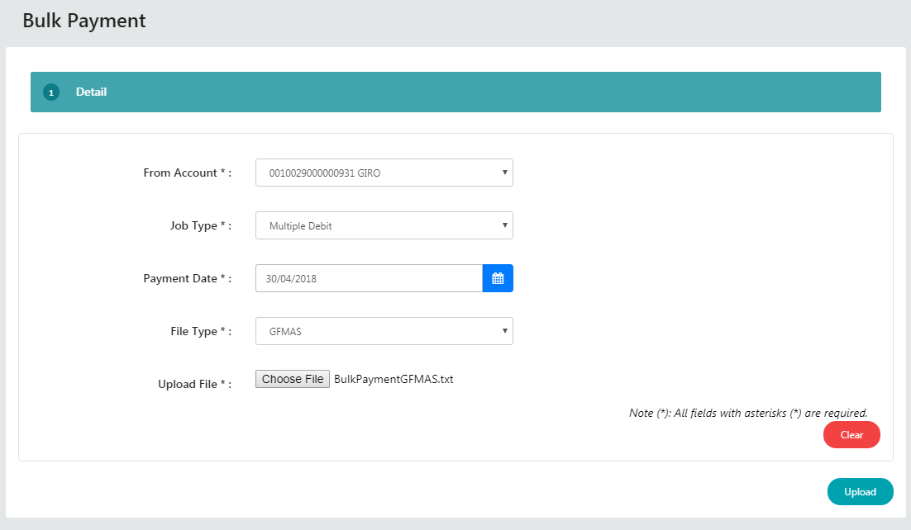

**Input Specification:**

| **No** | **Field name** | **Field Type** | **Validation Rule** | **Description** | **M/O** |
| --- | --- | --- | --- | --- | --- |
|  | From Account | Dropdown List | Selected one of the option | Displays the account number of user | M |
|  | Job Type | Dropdown List | Selected one of the option | Single or Multiple Debit Account | M |
|  | Payment Date | Calendar | Date format | Shows crediting date of this transaction | M |
|  | File Type | Dropdown List | Dropdown List | Display files type of user. | M |
|  | Upload File | (Textbox) File Browser | String (File path) | Path to the Bulk Transfer file | M |

**Action:**

| **No** | **Action** | **Type** | Description |
| --- | --- | --- | --- |
|  | Clear | Button | Contains an action to clear the record |
|  | Upload | Button | Contains an action to upload new record |

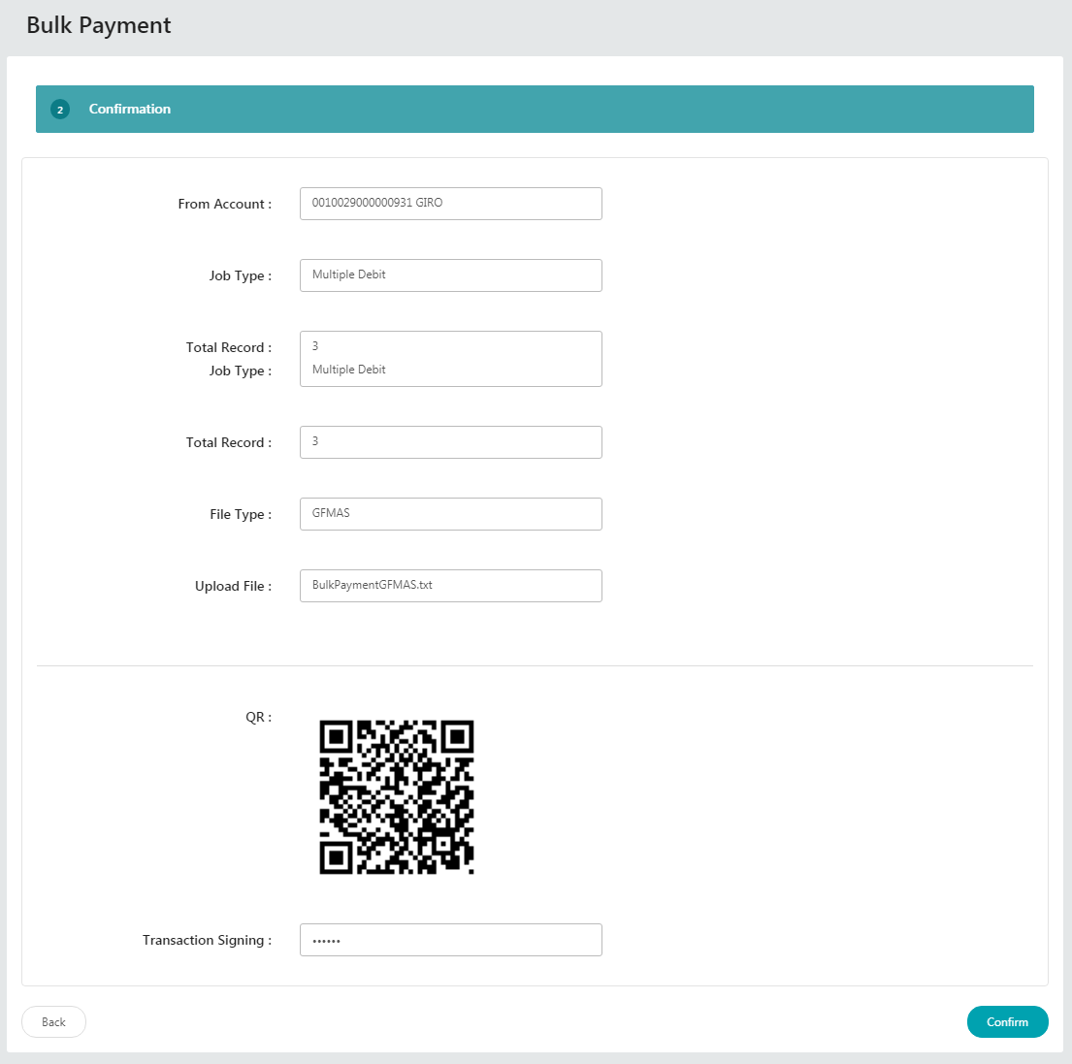

**Input Specification:**

| **No** | **Field name** | **Field Type** | **Validation Rule** | **Description** | **M/O** |
| --- | --- | --- | --- | --- | --- |
|  | Transaction Signing | Text Box | * Match Length: 6 * Numeric | A random, temporary generated number sent to mobile phone for transaction verification | M |

**Display Fields:**

| **No** | **Field** | **Format** | **Description** |
| --- | --- | --- | --- |
|  | From Account | Dropdown List | Displays the account number of user |
|  | Job Type | Dropdown List | Single or Multiple Debit Account |
|  | Payment Date | Calendar | Shows crediting date of this transaction |
|  | File Type | Dropdown List | Display files type of user. |
|  | Upload File | (Textbox) File Browser | Path to the Bulk Transfer file |

**Action:**

| **No** | **Action** | **Type** | **Description** |
| --- | --- | --- | --- |
|  | Back | Button | Contains an action to go back to previous page |
|  | Confirm | Button | Contains an action go to Next page. |

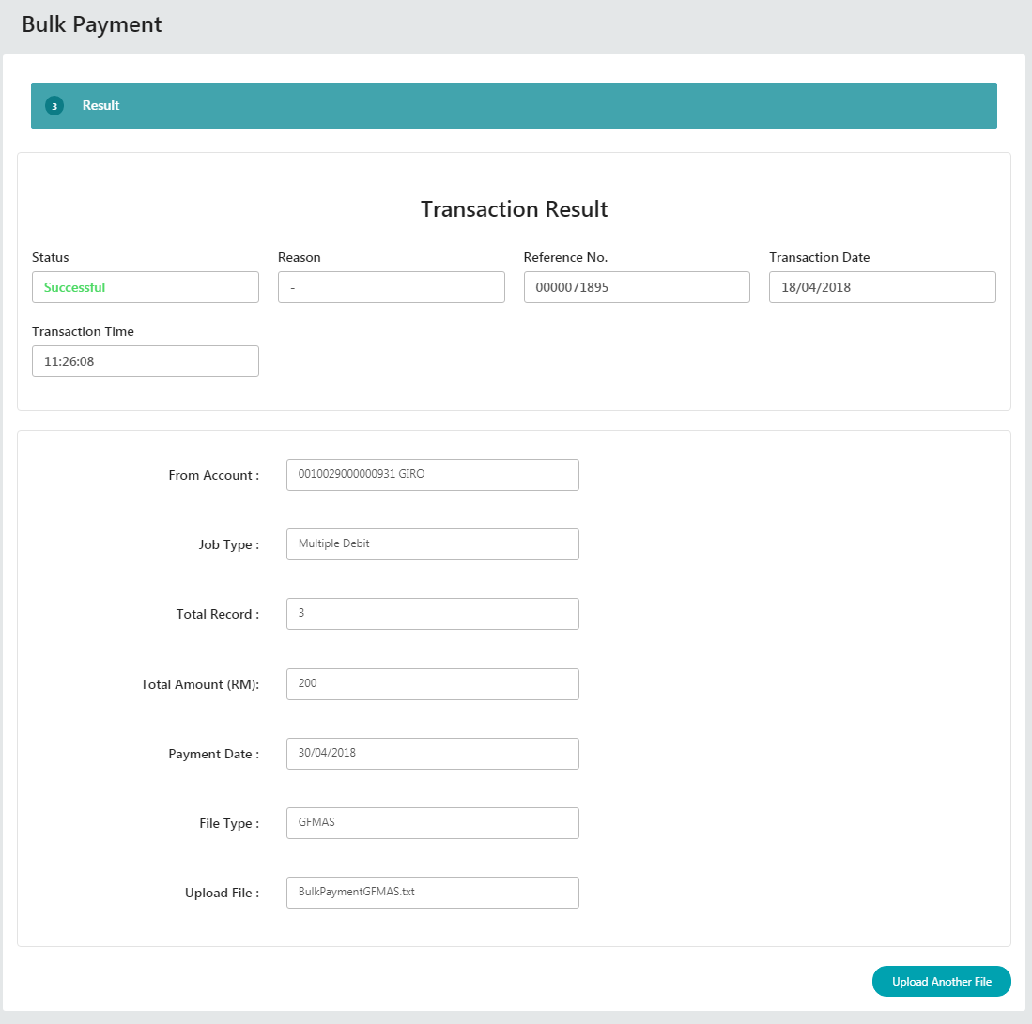

**Display Fields:**

| **No** | **Field** | **Format** | **Description** |
| --- | --- | --- | --- |
|  | From Account | Textbox | Displays the account number of user |
|  | Job Type | Textbox | Single or Multiple Debit Account |
|  | Total Record | Textbox | Total payment record |
|  | Total Amount(RM) | Textbox | Total of multiple bulk payment |
|  | Payment Date | Textbox | Shows crediting date of this transaction |
|  | File Type | Textbox | Display files type of user. |
|  | Upload File | Textbox | Path to the Bulk Transfer file |
|  | Status | Textbox | Transaction Status |
|  | Reason | Textbox | Server error reason |
|  | Reference No. | Textbox | Transaction No |
|  | Transaction Date | Textbox | Transaction Date |
|  | Transaction Time | Textbox | Transaction Timestamp |

**Action:**

| **No** | **Action** | **Type** | **Description** |
| --- | --- | --- | --- |
|  | Upload Another File | Button | Contains an action to go back to Bulk Payment page |

#### Submit added record

User is requiring submitting record added in order the transaction take effective.

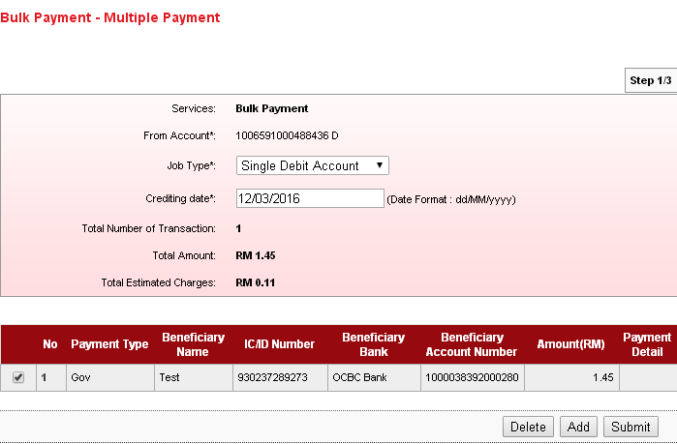

**Action:**

| **No** | **Action** | **Type** | **Description** |
| --- | --- | --- | --- |
|  | Delete | Button | Contains an action to delete a record |
|  | Add | Button | Contains an action to add a record |
|  | Submit | Button | Contains an action to continue to next page |

**Display Fields:**

| **No** | **Field** | **Format** | **Description** |
| --- | --- | --- | --- |
|  | From Account | Numeric | Displays the account number of user |
|  | Crediting Date | dd/mm/yyyy | Shows crediting date of this transaction |
|  | Total Number of Transaction | Text | Shows total number of transaction |
|  | Total Amount | Numeric | Shows Total Amount |
|  | Total Estimated Charges | Text | Shows Estimated Charges |

**Action:**

| **No** | **Action** | **Type** | **Description** |
| --- | --- | --- | --- |
|  | Back | Button | Contains an action to go back to previous page |
|  | Confirm | Button | Contains an action to go to next page. |

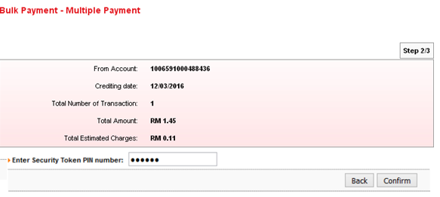

Single User screen view

**Display Fields:**

| **No** | **Field** | **Format** | **Description** |
| --- | --- | --- | --- |
|  | From Account | Numeric | Displays the account number of user |
|  | Crediting Date | dd/mm/yyyy | Shows crediting date of this transaction |
|  | Total Number of Transaction | Text | Shows total number of transaction |
|  | Total Amount | Numeric | Shows Total Amount |
|  | Total Estimated Charges | Text | Shows Estimated Charges |

**Input Specification:**

|  |  |  |  |  |  |
| --- | --- | --- | --- | --- | --- |
| No | Field | Field Type | Rule | Description | M/O |
|  | Enter Secure Pass PIN Number | Text Box | Match Length: 6  Numeric | Secondary pin that are generated through by Secure Pass. | Yes |

**Action:**

| **No** | **Action** | **Type** | **Description** |
| --- | --- | --- | --- |
|  | Back | Button | Contains an action to go back to previous page |
|  | Confirm | Button | Contains an action to go to next page. |

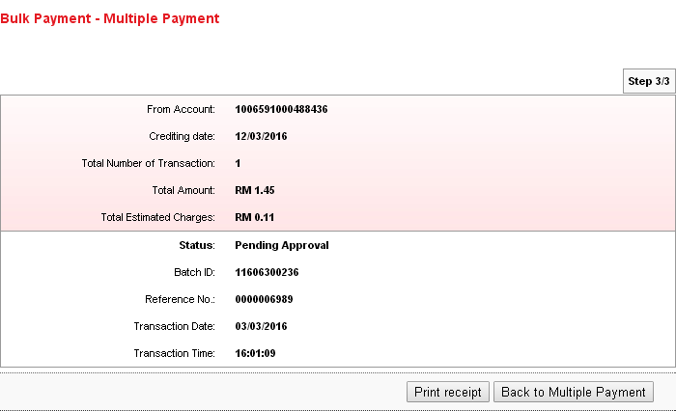

**Display Fields:**

| **No** | **Field** | **Format** | **Description** |
| --- | --- | --- | --- |
|  | From Account | Numeric | Shows the account number of user |
|  | Crediting Date | dd/mm/yyyy | Shows crediting date of this transaction |
|  | Total Number of Transaction | Text | Shows total number of transaction |
|  | Total Amount | Numeric | Shows Total Amount |
|  | Total Estimated Charges | Text | Shows Estimated Charges |
|  | Status | Text | Show the transaction status |
|  | Batch ID | Numeric | Show ID as reference # of the batch |
|  | Reference No | Numeric | Show the transaction reference no |
|  | Transaction Date | Date format | Show the transaction date |
|  | Transaction Time | Time format | Show the transaction time |

**Action:**

| **No** | **Action** | **Type** | **Description** |
| --- | --- | --- | --- |
|  | Print Receipt | Button | Contains an action to generate receipt’s pop-up display |
|  | Back to Multiple Payment | Button | Contains an action to go back to bulk payment page |

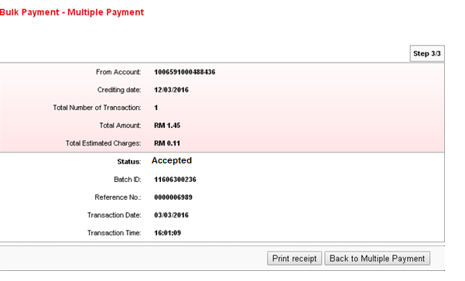

Single User view

**Display Fields:**

| **No** | **Field** | **Format** | **Description** |
| --- | --- | --- | --- |
|  | From Account | Numeric | Shows the account number of user |
|  | Crediting Date | dd/mm/yyyy | Shows crediting date of this transaction |
|  | Total Number of Transaction | Text | Shows total number of transaction |
|  | Total Amount | Numeric | Shows Total Amount |
|  | Total Estimated Charges | Text | Shows Estimated Charges |
|  | Status | Text | Show the transaction status |
|  | Batch ID | Numeric | Show ID as reference # of the batch |
|  | Reference No | Numeric | Show the transaction reference no |
|  | Transaction Date | Date format | Show the transaction date |
|  | Transaction Time | Time format | Show the transaction time |

**Action:**

| **No** | **Action** | **Type** | **Description** |
| --- | --- | --- | --- |
|  | Print Receipt | Button | Contains an action to generate receipt’s pop-up display |
|  | Back to Multiple Payment | Button | Contains an action to go back to bulk payment page |

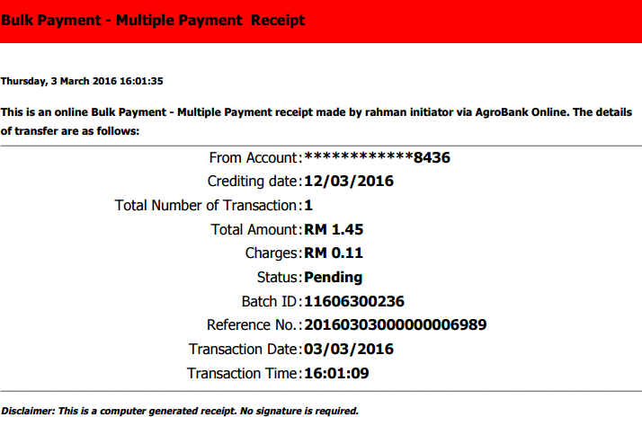

#### Delete payment record before submitting

User uses this feature to delete un-submit payment record. Once the payment record submitted for transaction, it will not allow for deleting.

***Step 1:***

1. User accesses to Bulk Payment screen, and select Multiple Payment.
2. User clicks on Create New button.
3. User adds on record needed.
4. User click on the box of the record want to delete
5. User click Delete button
6. User verifies the information and click on Confirm.
7. User can see the result page.

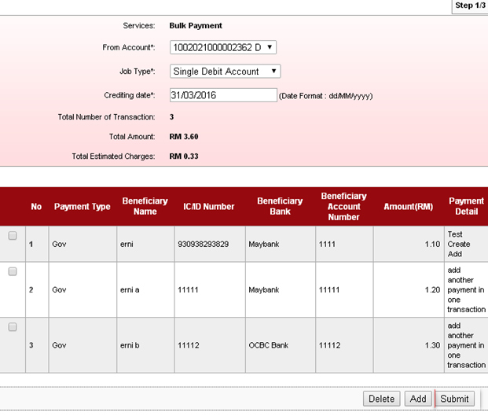

**Input Specification:**

|  |  |  |  |  |  |
| --- | --- | --- | --- | --- | --- |
| No | Field | Field Type | Rule | Description | M/O |
|  | Black Field | Text Box | NA | It require to tick for needed for deletion | NA |

**Action:**

| **No** | **Action** | **Type** | **Description** |
| --- | --- | --- | --- |
|  | Delete | Button | Contains an action to delete the record |
|  | Add | Button | Contains an action to add new record |
|  | Submit | Button | Contains an action to submit new record |

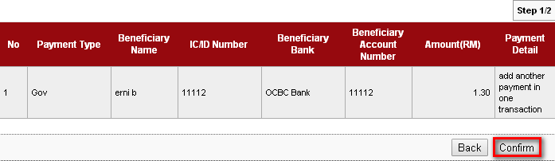

**Action:**

| **No** | **Action** | **Type** | **Description** |
| --- | --- | --- | --- |
|  | Back | Button | Contains an action to go back to previous page |
|  | Confirm | Button | Contains an action to go to next page. |

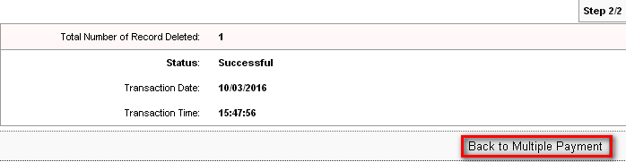

**Display Fields:**

| **No** | **Field** | **Format** | **Description** |
| --- | --- | --- | --- |
|  | Total Number of Record Deleted | Numeric | Shows the number record deletion. |
|  | Status | Text | Show the status of the record deletion. |
|  | Transaction Date | Date format | Show the transaction date |
|  | Transaction Time | Time format | Show the transaction time |

**Action:**

| **No** | **Action** | **Type** | **Description** |
| --- | --- | --- | --- |
|  | Back to Multiple Payment | Button | Contains an action to go back to bulk payment page |

#### Edit payment record before submitting

User uses this feature to edit the added record before submit for processing.

***Step 1:***

1. User accesses to Bulk Payment screen, and select Multiple Payment.
2. User added record needed.
3. User clicks No for the record need to amend.
4. User amends the necessary field: Payment Type, Beneficiary Name, IC/ID No, Beneficiary/Account No, Amount, Payment Reference, and Payment Detail.
5. User click Next
6. User verifies the information and click on Confirm.
7. User can see the result page for confirm the record amended in CMS.

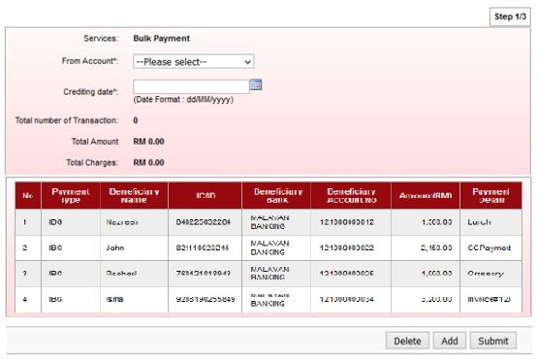

**Action:**

| **No** | **Action** | **Type** | **Description** |
| --- | --- | --- | --- |
|  | No | Button | Contains an action go to detail page. |
|  | Delete | Button | Contains an action to delete a record |
|  | Add | Button | Contains an action to add a record |
|  | Submit | Button | Contains an action to continue to next page |

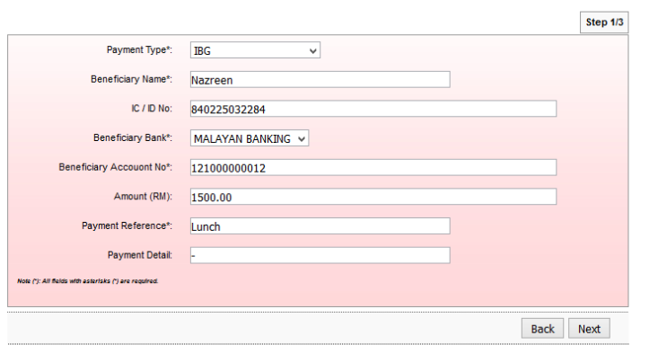

**Input Specification:**

| **No** | **Field name** | **Field Type** | **Validation Rule** | **Description** | **M/O** |
| --- | --- | --- | --- | --- | --- |
|  | Payment Type | Dropdown List | Selected one of the option | Transaction Type. Eg: Fund Transfer/Credit Card | M |
|  | Beneficiary Name | Text Box | Numeric. Max length 50 | Recipient Name | M |
|  | ID/ID No | Text Box | Numeric. Max length 50 | Recipient IC/ID | O |
|  | Beneficiary Bank | Dropdown List | Selected one of the option | Recipient Bank | M |
|  | Beneficiary Account No | Dropdown list | Selected one of the option | Recipient Account No | M |
|  | Amount | Text Box | Alphanumeric. Max length 50 | Transfer Amount | O |
|  | Payment Reference | Text Box | Numeric. Max length 20 | Any reference value | M |
|  | Payment Detail | Text Box | Numeric. Max length 50 | Any payment detail | O |

**Action:**

| **No** | **Action** | **Type** | **Description** |
| --- | --- | --- | --- |
|  | Back | Button | Contains an action to go back to previous page |
|  | Next | Button | Contains an action to continue to next page |

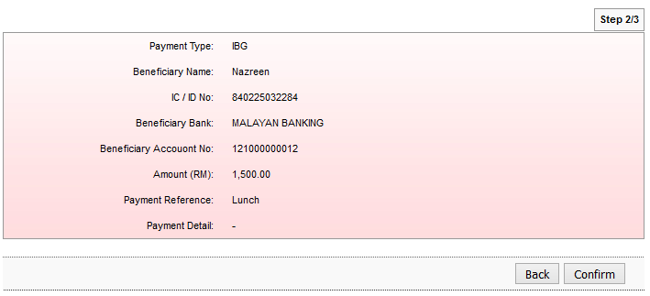

**Display Fields:**

| **No** | **Field** | **Format** | **Description** |
| --- | --- | --- | --- |
|  | Payment Type | Numeric | Shows Transaction Type. Eg: Fund Transfer/Credit Card |
|  | Beneficiary Name | Numeric | Shows Recipient Name |
|  | ID/ID No | Text | Shows Recipient IC/ID |
|  | Beneficiary Bank | Text | Shows Recipient Bank |
|  | Beneficiary Account No | Text | Shows Recipient Account No |
|  | Amount | Text | Shows Transfer Amount |
|  | Payment Reference | Text | Show reference value |
|  | Payment Detail | Text | Show payment detail |

**Action:**

| **No** | **Action** | **Type** | **Description** |
| --- | --- | --- | --- |
|  | Back | Button | Contains an action to go back to previous page |
|  | Confirm | Button | Contains an action to go to next page. |

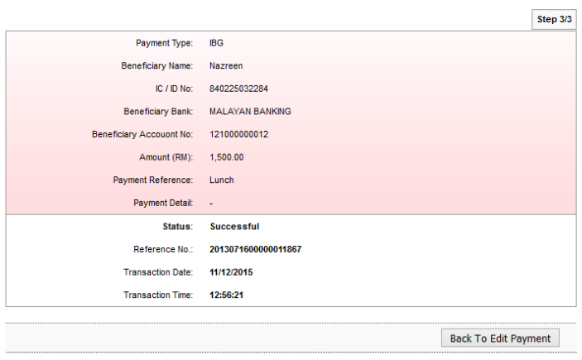

**Display Fields:**

| **No** | **Field** | **Format** | **Description** |
| --- | --- | --- | --- |
|  | Payment Type | Numeric | Shows Transaction Type. Eg: Fund Transfer/Credit Card |
|  | Beneficiary Name | Numeric | Shows Recipient Name |
|  | ID/ID No | Text | Shows Recipient IC/ID |
|  | Beneficiary Bank | Text | Shows Recipient Bank |
|  | Beneficiary Account No | Text | Shows Recipient Account No |
|  | Amount | Text | Shows Transfer Amount |
|  | Payment Reference | Text | Show reference value |
|  | Payment Detail | Text | Show payment detail |
|  | Status | Text | Show the transaction status |
|  | Reference No | Numeric | Show the transaction reference no |
|  | Transaction Date | Date format | Show the transaction date |
|  | Transaction Time | Time format | Show the transaction time |

**Action:**

| **No** | **Action** | **Type** | **Description** |
| --- | --- | --- | --- |
|  | Back to Edit Payment | Button | Contains an action to go back to Multiple Payment page |

#### Duplicate record

User uses this feature to duplicate the record and amend the necessary information instead of totally create new record which help to speed up the process. One of the unique information requires changing which is Payment Reference Number in order to proceed to duplicate the record.

***Steps:***

1. User accesses to Bulk Payment screen, and select Multiple Payment.
2. User selects the record/transaction need to duplicate.
3. User clicks Go for the record need to duplicate.
4. User clicks Duplicate button.
5. User click on the No to amend the necessary information.
6. User amends the necessary field: From Account, Job Type, Crediting Date, Payment Type, Beneficiary Name, IC/ID No, Beneficiary/Account No, Amount, Payment Reference, and Payment Detail. Payment Reference number is a unique number and is a must to change before proceeds to next step.
7. User also can Add new record or Delete the existing record.
8. User click on Next once amendment is done.
9. User click on Confirm button
10. User click on Back to Multiple Payment button
11. User verify and click Submit button
12. User click Confirm
13. User will see the result page.

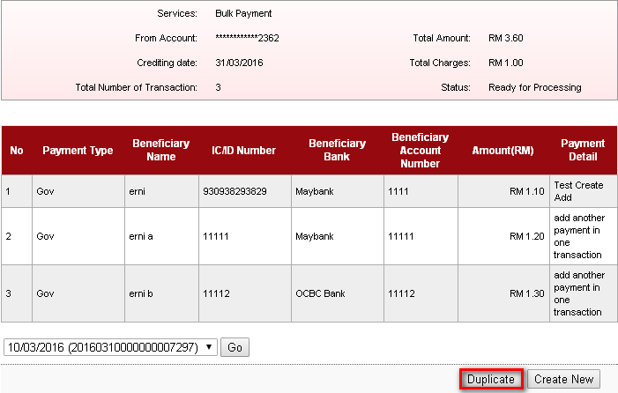

**Input Specification:**

| **No** | **Field name** | **Field Type** | **Validation Rule** | **Description** | **M/O** |
| --- | --- | --- | --- | --- | --- |
|  | Date with Reference Number of transaction | Dropdown List | Selected one of the option | History of submitted record | M |

**Action:**

| **No** | **Action** | **Type** | **Description** |
| --- | --- | --- | --- |
|  | Duplicate | Button | Contains an action to duplicate a record |

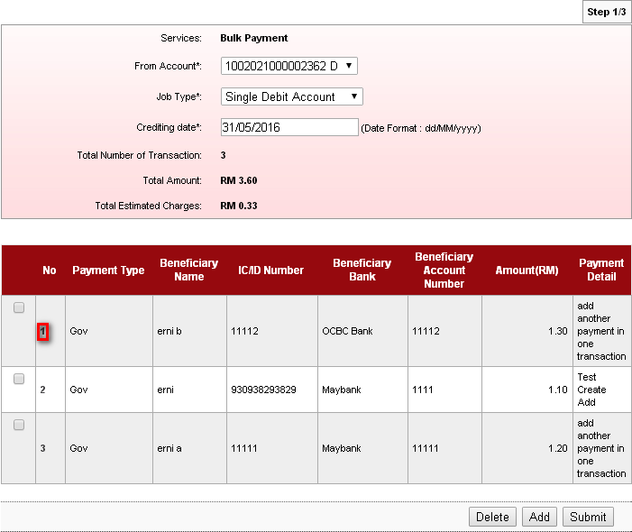

**Action:**

| **No** | **Action** | **Type** | **Description** |
| --- | --- | --- | --- |
|  | No | Button | Contains an action go to detail page. |
|  | Delete | Button | Contains an action to delete a record |
|  | Add | Button | Contains an action to add a record |
|  | Submit | Button | Contains an action to continue to next page |

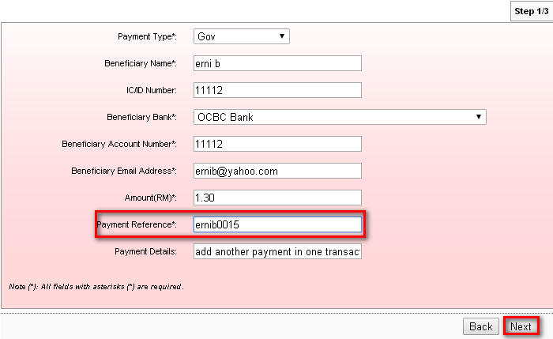

**Input Specification:**

| **No** | **Field name** | **Field Type** | **Validation Rule** | **Description** | **M/O** |
| --- | --- | --- | --- | --- | --- |
|  | Payment Type | Dropdown List | Selected one of the option | Payment Type | M |
|  | Beneficiary Name | Numeric | Numeric | Recipient Name | M |
|  | IC/ID Number | Alphanumeric | Alphanumeric | Recipient IC/ID | O |
|  | Beneficiary Bank | Dropdown List | Selected one of the option | Recipient Bank | M |
|  | Beneficiary Account Number | Dropdown List | Selected one of the option | Recipient Account number | M |
|  | Beneficiary Email Address | Text Box | Alphanumeric | Recipient Email Address | M |
|  | Amount | Text Box | Numeric | Total Amount of this file transaction | M |
|  | Payment Reference | Text Box | Alphanumeric | Select the date for crediting | M |
|  | Payment Detail | Text Box | Alphanumeric. | Customer Remarks or Message | O |

**Action:**

| **No** | **Action** | **Type** | **Description** |
| --- | --- | --- | --- |
|  | Back | Button | Contains an action to go back to previous page |
|  | Next | Button | Contains an action to go to next page. |

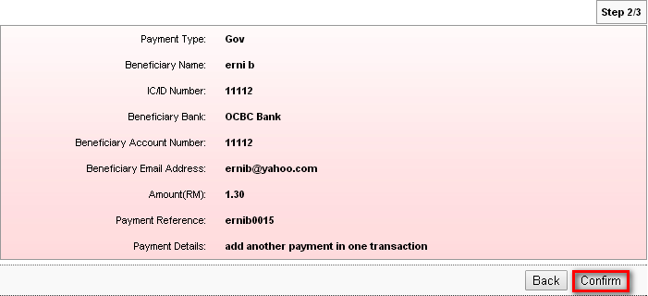

**Display Fields:**

| **No** | **Field** | **Format** | **Description** |
| --- | --- | --- | --- |
|  | Payment Type | Numeric | Shows Transaction Type |
|  | Beneficiary Name | Numeric | Shows Recipient Name |
|  | ID/ID No | Text | Shows Recipient IC/ID |
|  | Beneficiary Bank | Text | Shows Recipient Bank |
|  | Beneficiary Account No | Text | Shows Recipient Account No |
|  | Amount | Text | Shows Transfer Amount |
|  | Payment Reference | Text | Show Reference Number |
|  | Payment Detail | Text | Show Payment Detail information. |

**Action:**

| **No** | **Action** | **Type** | **Description** |
| --- | --- | --- | --- |
|  | Back | Button | Contains an action to go back to previous page |
|  | Confirm | Button | Contains an action go to Next page. |

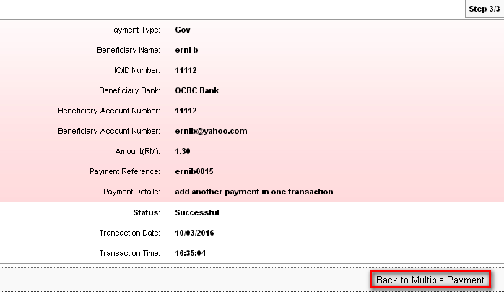

**Display Fields:**

| **No** | **Field** | **Format** | **Description** |
| --- | --- | --- | --- |
|  | Payment Type | Numeric | Shows Transaction Type. Eg: Fund Transfer/Credit Card |
|  | Beneficiary Name | Numeric | Shows Recipient Name |
|  | ID/ID No | Text | Shows Recipient IC/ID |
|  | Beneficiary Bank | Text | Shows Recipient Bank |
|  | Beneficiary Account No | Text | Shows Recipient Account No |
|  | Amount | Text | Shows Transfer Amount |
|  | Payment Reference | Text | Show Reference number |
|  | Payment Detail | Text | Show Payment Detail information. |
|  | Status | Text | Show the Transaction Status |
|  | Transaction Date | Date format | Show the transaction date |
|  | Transaction Time | Time format | Show the transaction time |

**Action:**

| **No** | **Action** | **Type** | **Description** |
| --- | --- | --- | --- |
|  | Back | Button | Contains an action to go back to Multiple Payment page |

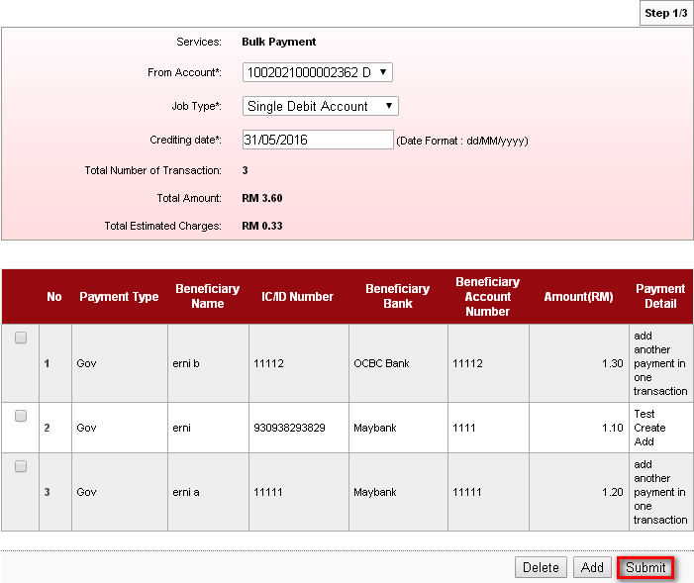

**Action:**

| **No** | **Action** | **Type** | **Description** |
| --- | --- | --- | --- |
|  | Delete | Button | Contains an action to delete a record |
|  | Add | Button | Contains an action to add a record |
|  | Submit | Button | Contains an action to continue to next page |

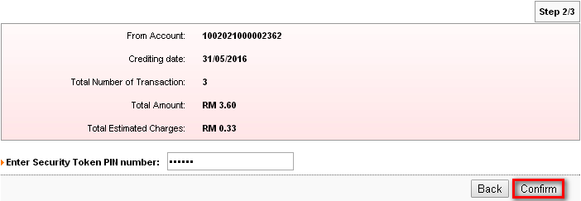

Single user screen view

**Display Fields:**

| **No** | **Field** | **Format** | **Description** |
| --- | --- | --- | --- |
|  | From Account | Numeric | Displays the account number of user |
|  | Crediting Date | dd/mm/yyyy | Shows crediting date of this transaction |
|  | Total Number of Transaction | Text | Shows total number of transaction |
|  | Total Amount | Numeric | Shows Total Amount |
|  | Total Estimated Charges | Text | Shows Estimated Charges |

**Input Specification:**

|  |  |  |  |  |  |
| --- | --- | --- | --- | --- | --- |
| No | Field | Field Type | Rule | Description | M/O |
|  | Enter Secure Pass PIN Number | Text Box | Match Length: 6  Numeric | Secondary pin that are generated through by Secure Pass. | Yes |

**Action:**

| **No** | **Action** | **Type** | **Description** |
| --- | --- | --- | --- |
|  | Back | Button | Contains an action to go back to previous page |
|  | Confirm | Button | Contains an action to go to next page. |

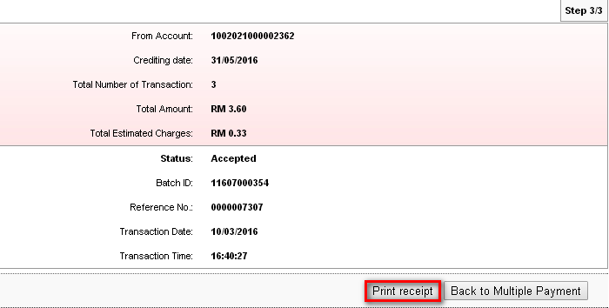

**Display Fields:**

| **No** | **Field** | **Format** | **Description** |
| --- | --- | --- | --- |
|  | From Account | Numeric | Shows the account number of user |
|  | Crediting Date | dd/mm/yyyy | Shows crediting date of this transaction |
|  | Total Number of Transaction | Text | Shows total number of transaction |
|  | Total Amount | Numeric | Shows Total Amount |
|  | Total Estimated Charges | Text | Shows Estimated Charges |
|  | Status | Text | Show the transaction status |
|  | Batch ID | Numeric | Show ID as reference # of the batch |
|  | Reference No | Numeric | Show the transaction reference no |
|  | Transaction Date | Date format | Show the transaction date |
|  | Transaction Time | Time format | Show the transaction time |

**Action:**

| **No** | **Action** | **Type** | **Description** |
| --- | --- | --- | --- |
|  | Print Receipt | Button | Contains an action to generate receipt’s pop-up display |
|  | Back to Multiple Payment | Button | Contains an action to go back to bulk payment page |

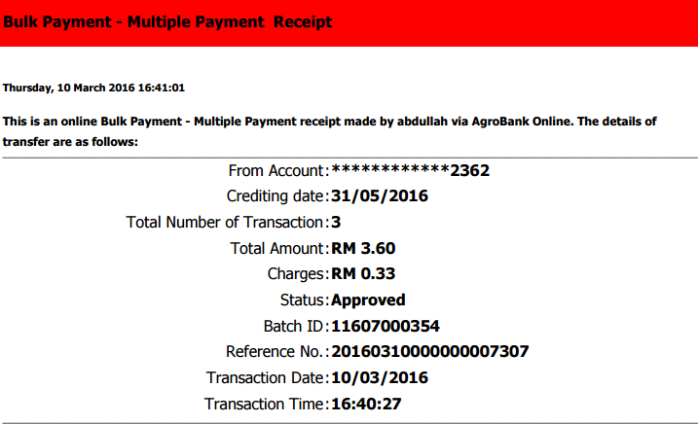

### Bulk Payment History

Bulk Payment History is to capture the submitted bulk payment. User can view the Payment transaction history.

***Steps:***

1. User accesses to Bulk Payment screen, and select Bulk Payment History.
2. User can view the summary of the Bulk Payment History.

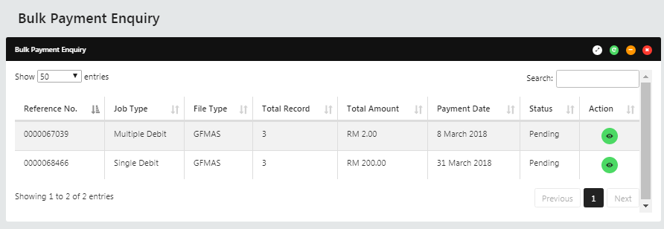

**Display Fields:**

| **No** | **Field** | **Format** | **Description** |
| --- | --- | --- | --- |
|  | Reference No | Numeric | Show ID as reference # of the batch |
|  | Job Type | Text | Shows type of payment |
|  | File Type | Numeric | Shows type of file |
|  | Total Record | Numeric | Shows total record |
|  | Total Amount | Text | Shows Total amount |
|  | Payment Date | Numeric | Shows date of payment |
|  | Status | Text | Single user and Multiple User status:  Pending  Validate (Pending Approval)  Rejected  Ready for Processing  In Progress  Success  Failed  Partial Failed  Cancelled |
|  | Action | Eye Icon | To display Transaction details |

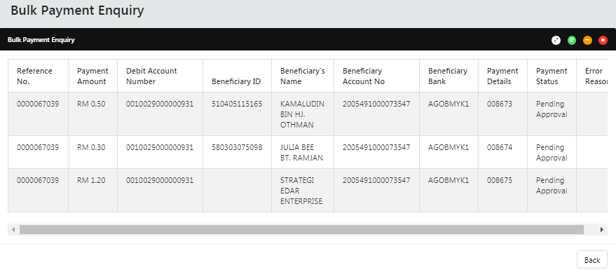

**Display Fields:**

| **No** | **Field** | **Format** | **Description** |
| --- | --- | --- | --- |
|  | Reference No | Numeric | Show ID as reference # of the batch |
|  | Payment Amount | Text | Shows amount of transaction |
|  | Debit Account Number | Numeric | Shows account number of transaction |
|  | Beneficiary ID | Numeric | Shows Recipient’s ID |
|  | Beneficiary’s Name | Text | Shows Recipient’s Name |
|  | Beneficiary Account Number | Numeric | Shows Recipient’s Account Number |
|  | Beneficiary Bank | Text | Shows Recipient’s Bank |
|  | Payment Details | Text | Shows Details of payment |
| 1. Payme | Payment Status | Text | Single user and Multiple User status:  Pending  Validate (Pending Approval)  Rejected  Ready for Processing  In Progress  Success  Failed  Partial Failed  Cancelled |
|  | Error Reason | Text | Shows reason for failed transaction |

**Action:**

| **No** | **Action** | **Type** | **Description** |
| --- | --- | --- | --- |
|  | Previous Page | Button | Contains an action to go back to previous page |
|  | Next | Button | Contains an action to go to next page. |

### Bulk Payment - Failed Bulk Payment Transaction Record (done)

User uses this feature to view only failed bulk payment.

***Steps:***

1. User accesses to Bulk Payment screen, and select Failed Bulk Payment Transaction Record.
2. User can view the summary of the Failed Payment records.
3. User clicks Batch ID to view detail of the history.
4. User can click on Download button to download the fail items.

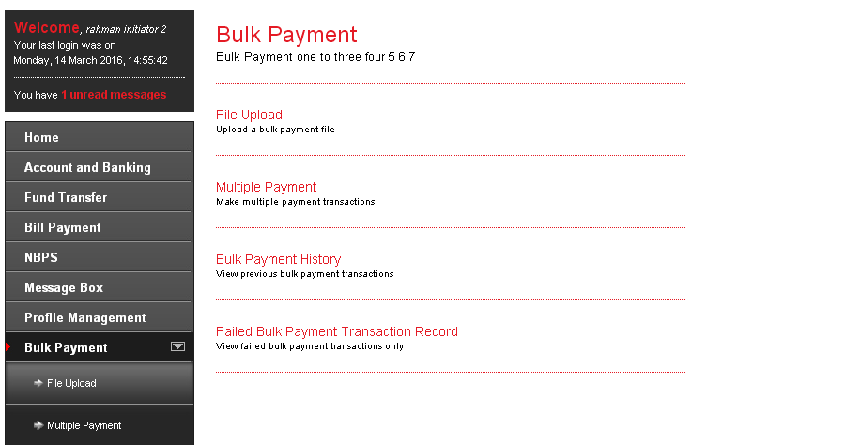

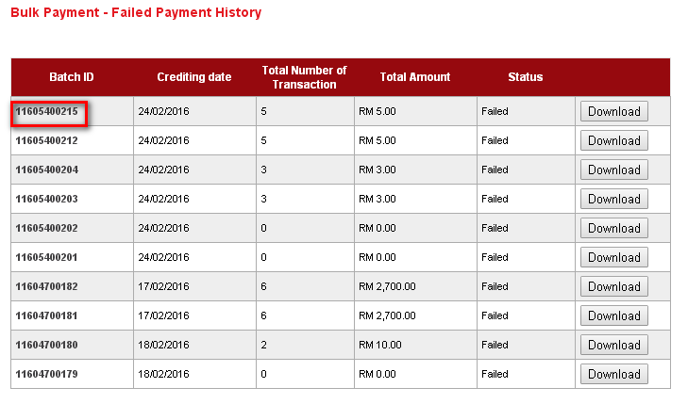

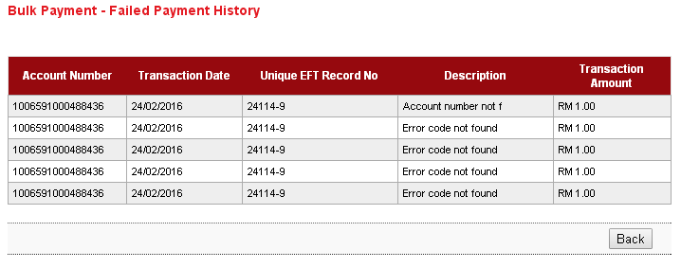

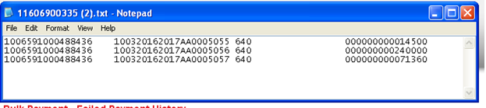

**Display Fields:**

| **No** | **Field** | **Format** | **Description** |
| --- | --- | --- | --- |
|  | Batch ID | Numeric | Show ID as reference # of the batch |
|  | Crediting Date | Numeric | Shows crediting date of this transaction |
|  | Total number of Transaction | Text | Shows Estimated Charges |
|  | Total Amount | Text | Shows crediting date of this transaction |
|  | Status | Text | Show the transaction status |

**Action:**

| **No** | **Action** | **Type** | **Description** |
| --- | --- | --- | --- |
|  | Batch ID link | Button | Contains an action to go detail list. |
|  | Download | Button | Contains an action to download the information |
|  | Back | Button | Contains an action to go back to Failed Payment page |

Sample of Download format:

It included for Excel or Text format depend on the file uploaded format.

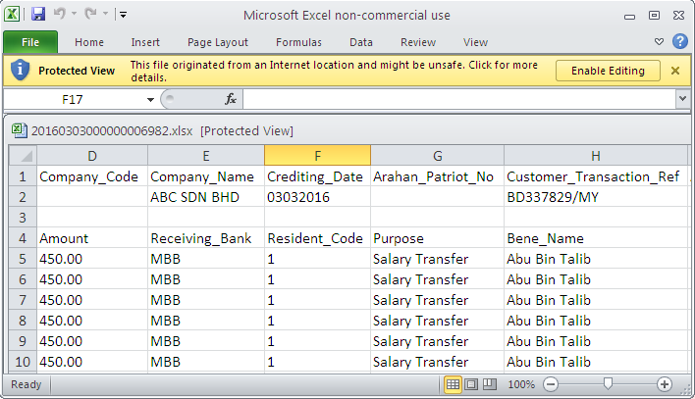

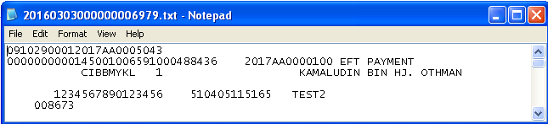

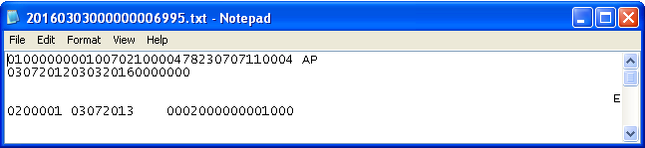

# Appendix 1: List Allowable Values

| **Field** | **Type** | **Values** |
| --- | --- | --- |
| Status | Text field | * Successful * Pending * Unsuccessful * Accepted |
| Action Status / Approver Status | Text field | * Approve * Reject |

Table : List Allowable Values

# Appendix 1: System Security

|  |  |  |  |
| --- | --- | --- | --- |
| No | Single User ID and Password Control | Requirements | Remark |
|  | Single User ID | Single or combination of numeric, alphabet or alphanumeric. Underscore is accepted. **6 – 16** characters. | The rule is not parameterized. |
|  | Maximum password expiration | **No expiration** | System wide support and can be parameterized via the system configuration file |
|  | Password | Password must contain a mixture of numeric and alphabet format and cannot include these special character ["<>'%;&+].>  Permitted Password length are **8 - 12** characters |  |
|  | Maximum failed log-in attempts | **3 times.** (The Single User ID will subsequently be locked (disabled)) | The maximum number of attempts can be parameterized via the system configuration file. If the Single User ID is locked, the user must send a request to the administrator to reset the password. The application will force the user to change their password upon login. |
|  | Inactive/Dormant ID | Single User ID is automatically disabled by the system after **90** days of inactivity. | The number of days can be parameterized via the system configuration file. |
|  | Duplicate password control | For a minimum of **12** generations, the same passwords cannot be reused. | The number of generations can be parameterized via the system configuration file. |
|  | Last sign on information displayed | The last signed on details will be displayed to the user upon logging into the system | This is a standard feature. |
|  | Changing of passwords by user | Single User may change their passwords anytime they wish | This is standard feature. |
|  | No deletion of Single User IDs from application | Single User IDs that are obsolete must be able to be deleted (instead of just suspended) from the application | The same Single User ID cannot be reused even if restored. The deleted user will not show up on the user enquiry screen, but the record will still be stored in the database. |
|  | Password storage | Password is hashed using SHA-256 hashing algorithm | Combination of nonce and Password is encrypted using SHA-256 before being stored into Database. The hashed value will be used for authentication |

Table 62: Single User Authentication Rules

# Appendix 2: List Allowable Values

|  |  |  |
| --- | --- | --- |
| Field | Type | Values |
| Login as | Dropdown list | * Initiator * Approver |
| Status | Text field | * Successful * Pending * Unsuccessful |
| Action (Account details) / Quick Link | Dropdown list | * Account Details * Transaction History * Agronet Online Trxn History |
| Action Status / Approver Status | Text field | * Approve * Reject |
| Batch Status | Text field | * Pending * Accepted |
| User Role | Dropdown list | * Initiator * Approver |
| User Status | Dropdown list | * New * Active * Suspended * Locked * Unlocked * Dormant |
| Secure Pass Status | Dropdown list | * Not assigned * Assigned * Faulty |

Table 63: List Allowable Values

# Appendix 3: Internet Banking “Text” Input Fields Specification

| No. | Item/Field | Data Type | Format & Length |
| --- | --- | --- | --- |
|  | Username (IB login ID) | Alphanumeric | * Min Length: 6 * Max Length: 16 |
|  | Password | Alphanumeric | * Min Length: 8 * Max Length: 12 * Minimum 1 numeric * Minimum 1 alphabet |
|  | Token Serial | Numeric | * Length: 13 |
|  | Token Pin | Numeric | * Length: 6 |
|  | Date | Date | * Format: DD/MM/YYYY |
|  | Transaction Amount | Decimal | * Max Length: 15 * Format: Decimal 15,2 |
|  | Transaction Remarks | Alphanumeric | * Max Length: 30 |
|  | Transaction Reference No | Alphanumeric | * Max Length: 20 |
|  | Transaction Details | Alphanumeric | * Max Length: 20 |
|  | Email | Email | * Max Length: 60 * Format: <email>@<emailhost>.<extension> |
|  | Beneficiary Nickname | Alphanumeric | * Max Length: 60 |
|  | Interbank Beneficiary Account Number | Numeric | * Max Length: 20 |
|  | Interbank Holder Name | Alphanumeric | * Max Length: 40 |
|  | Bill Account Number | Alphanumeric | * Max Length: 30 |
|  | Favourite Payee Nickname | Alphanumeric | * Max Length: 60 |
|  | Approval Remark | Alphanumeric | * Max Length: 30 |
|  | Name | Alphabet | * Max Length: 100 |
|  | Telephone Number | Alphanumeric | * Max Length: 32 |
|  | Mobile Number[1] | Alphanumeric | * Max Length: 32 |
|  | Address | Alphanumeric | * Max Length: 256 |
|  | Approval Matrix | Numeric | * Length: 1 |

Table 64: Text Input Field Specifications

# Appendix 4: Acceptable Characters for Validation

|  |  |
| --- | --- |
| Validation Name | Acceptable characters |
| Text | No limitations |
| Alphanumeric with Dot & Slash | a-z, A-Z  0-9  Dot / Period (.)  Slash (/) |
| Alphanumeric with Space | a-z, A-Z  0-9  Space |
| Alphanumeric with spaces and underscore | a-z, A-Z  0-9  Space  Underscore (_) |
| Alphanumeric with Space & Symbols | a-z, A-Z  0-9  Space  Ampersand (&)  Apostrophe (', `)  Left Bracket (()  Right Bracket ())  Comma (,)  Alias (@)  Question Mark (?) |
| Email | a-z, A-Z  0-9  Dot / Period (.)  Minus/Hypen (-)  Underscore (_)  Minus/Hypen (-)  Must have one alias (@)  Format: <value>@<value>.<value> |
| Character(s) acceptable for URL path  URL Path | a-z, A-Z  0-9  Dot / Period (.)  Space  Ampersand (&  Plus (+)  Minus/Hypen (-)  Slash (/)  Equal (=)  Question Mark (?)  Underscore (_) |

Table 65: Acceptable Characters for Validations

# Appendix 5: Download Report

Depending on the user’s browser settings and software availability,

* 1. the report can be automatically opened using default software for .xls file type, such as Microsoft Excel or OpenOffice.org Calc
  2. a dialog box will pop-up, asking further action from administrator whether to open the report using with software such as Microsoft Excel or OpenOffice.org Calc or to save the file

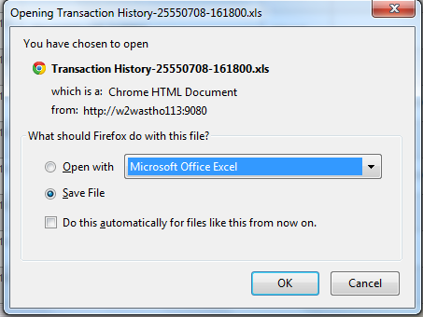

Figure 23: Example dialog box for Download Report

# Appendix 6: Glossary

| **Term** | **Definition** |
| --- | --- |
| RIB | **R**etail **I**nternet **B**anking System |
| CDB | **B**usiness **I**nternet **B**anking System |
| IB | **I**nternet **B**anking |
| IBS | **I**nternet **B**anking **S**ystem |
| IBAM | **I**nternet **B**anking **A**dministration **M**anager (the administration module) |
| SME | **S**mall & **M**edium **E**nterprise |
| TAC | **T**ransaction **A**uthorization **C**ode  TAC is a temporary random six digits security code generated by the authentication server and sent to user by SMS using a SMS gateway. TAC is required as the second level security authentication before committing any bank transactions and user profile updates. |
| OTP | **O**ne **T**ime **P**assword, in this document it meant for the Secure Pass or Token 6 digit PIN from VASCO. |
| BNM | **B**ank **N**egara **M**alaysia |
| CASA | Current & Savings Account |
| FD | Fixed Deposit |

Table 66: Glossary

--- END ---

1. *Mobile Number format subject to change according to SMS Gateway specification*