
Statutory Bodies
(SOCSO, EPF, LHDN)
(Cash Management System)
Business Requirement and System Specification
(PENRIL/BSN-CDB/BRS)
Revision: 00

11th August 2017

Prepared By:

Penril Datability (M) Sdn Bhd (816792-X)
Suite A-07-07 Plaza Mon’t Kiara
No. 2, Jalan Kiara, Mon’t Kiara
50480 Kuala Lumpur, Malaysia
Tel: (603) 6201 2622Fax: (603) 6201 7622

DOCUMENT AMENDMENT LOG
Rev. No | Date Update | Description of Change | Update By  <Name, Dept> | Review By  <Name, dept> | Approved By  <Name, Dept>
00 | 31-Jul-26 | Update as per current system | Nurul Akmal binti Yusof (Software QA) | Siti Norahayu Md Desa (TL)

Table of Contents
DOCUMENT AMENDMENT LOG 2
Business Requirement Acceptance 4
Section A: Introduction 5
1.1 Objective 5
1.2 Business Internet Banking (BIB) 6
1.3 Scope of Delivery 6
• (BIB>BIB Transaction Enquiry) to display Statutory Bodies transaction. 7
Section 2: Statutory Bodies for CMS 8
2 Statutory Bodies Process Flow via Maybank 8
2.2 Single User Process Flow 8
2.3 Multiple User Process Flow 9
2.4 Folder Structure at IB File Server 11
2.5 Folder Structure at BSN FTP Server 11
2.6 Folder Mapping among Servers 12
Section 3: Enhancement at Internet Banking Application Manager (IBAM) 13
3 Setting in IBAM 13
3.1 Edit Statutory Bodies Flag and Charges 13
3.1.1 Process Flow 13
3.1.2 Screen Flow 14
3.2 BIB Report 25
i. Process Flow 25
ii. Sample Reports 26
Section 4: Enhancement at Business Internet Banking (BIB) 28
4 Enhancement at Business Internet Banking (BIB) 28
4.1 Statutory Bodies – Single User/Initiator 28
4.1.1 Statutory Bodies - File Upload 28
4.1.2 Statutory Bodies Enquiry 35
4.2 Statutory Bodies – Approver 37
Appendix 1: List Allowable Values 41
Appendix 1: System Security 42
Appendix 2: List Allowable Values 44
Appendix 3: Internet Banking “Text” Input Fields Specification 45
Appendix 4: Acceptable Characters for Validation 46
Appendix 5: Download Report 48
Appendix 6: Glossary 49

Business Requirement Acceptance

I/We hereby verify that this Business Requirement consist of all the requirements requested by BSN. The implemented system will fulfill ONLY this requirement.

I/We also hereby AGREE that this satisfies our entire requirement for [Bulk Payment]

Any future changes to this agreed scope will be treated as an enhancement to the system. Any future changes to the project timeline will be subjected to the final approval of the project steering committee.

BSN:

Approved by | Role | Signature | Date

Penril Datability (M) Sdn. Bhd.:

Approved by | Role | Signature | Date
 | Project Manager
 | Team Lead
 | Senior Software Engineer

Section A: Introduction
This document served as the business requirement and system specification of implementing Statutory Bodies module consisting of Socso, EPF, and LHDN via BIB to enable payment to individual statutory body via BSN payment channel.

A Statutory Bodies module will be developed in existing Cash Management System.
Statutory Bodies module consists of File Upload, Statutory Bodies History, and Failed Statutory Bodies Transaction Record.

This document shall explain all the features and functionalities, which is elaborating with screen captures, process flow, descriptions, input fields specifications and error messages. All screen designs provided in this document are samples and only illustration purpose for easy understanding. The screen designs are not final.

Objective

The objective of this document is to capture user requirements of transactional and administration modules of implementing Statutory Bodies. This document will facilitate development and implementation of the mentioned modules of Internet Banking System for BSN.

The base line features description and screen designs will become a reference blueprint for the development team to develop the transactional and administration module. Hence, it is crucial that all stakeholders need to ensure the correctness and adequacy of the requirements captured in this document.

All stakeholders involved are expected to review and sign off this document before the development start. By signing off the document, the stakeholder has endorsed the correctness and accuracy and adequacy of the requirements documented in this document.

Business Internet Banking (BIB)
Business Internet Banking solution is the Web interface channel to Core Banking application that serves Corporate Banking customer online via Internet Web Browser. BIB user is different than Retail Internet Banking (RIB) as each user has a role described below:-
Role | Description
Corporate Admin | Act as the corporation administrator to manage the below modules: -  IB Service Management  - User Management  - Secure Pass Management  - Approval Matrix Management
Initiator | Allow to initiate/make transaction, based on access rights.  Not allowed to access to Authorization Module & IB Service Management.
Approver | Allow to approve and reject initiated / made transaction.  Allow to access to Authorization Module.  Not allow to access to all transactional modules.
Approver All/Single User | Allow to perform straight through transaction without Maker/Checker concept. This is normally used for SME that has only one person or do not has the role of Maker/Checker.  Allow to access to all modules.

Scope of Delivery

Work Package | Description
BIB | - New modules for Statutory Bodies to upload file and enquire status of uploaded file.  - (Account & Banking) to display transaction of the customer account in the Transaction History and Transaction History once the account has been credited for Statutory Bodies payment.  - CA to allow service for Statutory Bodies.
IBAM | - (IBAM>Content>Service Info) to create Service Info for Statutory Bodies.  - (BIB>Company Enquiry>Company Details) to set online/offline for Statutory Bodies, to set charges for each company and each Statutory Bodies.  - (BIB>Company Enquiry>User Maintenance) to allow service for Statutory Bodies.  - (BIB>BIB Report) to add new report for Statutory Bodies (Daily and Monthly).  - (BIB>Transaction History) to view Statutory Bodies transactions.  - (BIB>BIB Transaction Enquiry) to display Statutory Bodies transaction.
Batch Program | - Copy Uploaded File from IB File Server to BSN FTP Server  - Send Uploaded File from BSN FTP Server to Maybank FTP Server  - Grab ACK File from Maybank FTP Server to Agrobank FTP Server  - Read ACK File  - Update Status in DB  - Trigger IBG transaction from BSN GL/temp account to BSN account in Maybank  - Grab RTN File from Maybank FTP Server to BSN FTP Server  - Read RTN File  - Update Status in DB
Demo

Section 2: Statutory Bodies for CMS

Statutory Bodies Process Flow via Maybank

Single User Process Flow

Diagram 1: Single User Process Flow
Process:
Upload File
- Single User upload file (Socso/EPF/LHDN) and key in total amount of uploaded file.
- IB will deduct amount based on user key in and transfer the amount to GL/temp account (Third Party Transfer).
- Store Transaction in DB. Status of transaction is “Accepted”.
- Uploaded file is stored in Statutory File Folder in IB File Server.
- Batch program (IB File Server) grab uploaded file from Statutory File Folder in IB File Server.
- Batch program (IB File Server) copy to Statutory File Folder in BSN FTP Server.
- Batch program (BSN FTP Server) get uploaded file from Statutory File Folder in Agrobank FTP Server.
- Batch program (BSN FTP Server) send uploaded file to Statutory File Folder in Maybank FTP Server.
ACK File
- Batch program (BSN FTP Server) grab ACK file from Maybank FTP Server.
- Batch program (BSN FTP Server) store ACK file ACK File Folder in BSN FTP Server.
- Batch program (IB File Server) read from ACK file. If status from ACK file is success, batch program (IB File Server) will trigger IBG transaction to BSN account in Maybank and update status in DB. If status is successful, status of transaction from “Accepted” to “Processing”.
- If ACK file status is fail, will perform manual reversal of Third Party Transfer
RTN File
- Batch program (BSN FTP Server) grab RTN file from Maybank FTP Server.
- Batch program (BSN FTP Server) store RTN file RTN File Folder in BSN FTP Server.
- Batch program (IB File Server) read from RTN file and update status in DB. If status is successful, status of transaction is updated from “Processing” to “Successful” or “Unsuccessful”.
- If RTN file status is fail, will do manual reversal of IBG.
Enquiry
- Single User can enquire status from Enquiry Module.

Multiple User Process Flow

Diagram 2: Multiple User Process Flow
Process:
Upload File
- Initiator uploads file (Socso/EPF/LHDN) and key in total amount of uploaded file.
- IB will store the uploaded file to Temp Statutory File Folder in IB File Server.
- Status of transaction is “Pending for Approval”.
- Approver approves transaction.
- IB deduct amount based on user key in and transfer the amount to GL/temp account.
- IB grab uploaded file from Temp Statutory File Folder and store to Statutory File Folder in IB File Server.
- Batch program (IB File Server) grab uploaded file from Statutory File Folder in IB File Server.
- Batch program (IB File Server) copy to Statutory File Folder in BSN FTP Server.
- Batch program (BSN FTP Server) get uploaded file from Statutory File Folder in BSN FTP Server.
- Batch program (BSN FTP Server) send uploaded file to Statutory File Folder in Maybank FTP Server.
ACK File
- Batch program (BSN FTP Server) grab ACK file from Maybank FTP Server.
- Batch program (BSN FTP Server) store ACK file ACK File Folder in BSN FTP Server.
- Batch program (IB File Server) read from ACK file. If status from ACK file is success, batch program (IB File Server) will trigger IBG transaction to BSN account in Maybank and update status in DB. If status is successful, status of transaction from “Accepted” to “Processing”.
- If ACK file status is fail, will perform manual reversal of Third Party Transfer
RTN File
- Batch program (BSN FTP Server) grab RTN file from Maybank FTP Server.
- Batch program (BSN FTP Server) store RTN file RTN File Folder in BSN FTP Server.
- Batch program (IB File Server) read from RTN file and update status in DB. Status of transaction from “Processing” to “Successful” or “Unsuccessful”.
- If RTN file status is fail, will do manual reversal of IBG.
Enquiry
- Initiator can enquire status from Enquiry Module.

Folder Structure at IB File Server

Folder Structure at BSN FTP Server

Folder Mapping among Servers

Section 3: Enhancement at Internet Banking Application Manager (IBAM)

Setting in IBAM

Edit Statutory Bodies Flag and Charges
This feature allows administrator to set the Statutory Bodies module either to online or offline in the BIB navigation and also can set the charges for each company and each Statutory Body.

Process Flow

Diagram 3: Edit Company Details Process Flow

There are 2 participants involved in this process which is IBAM Admin and IBAM. The following are the steps to set the flag for Statutory Bodies status and to update the charges at Company Details:

Screen Flow
Step 1:
- Admin search the company’s name by key in into the Company Name field and click on Search button
- The result will display as per keyed in
- Click on the Company Name link to view the details of company

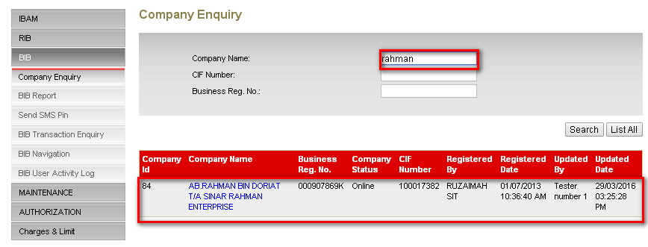
Diagram 4: Content List Screen

Action:
No | Action | Type | Description
1 | Search | Button | Contains the action to search the desired details
2 | List | Button | Contains an action to list all companies
3 | Company Name | Link | Contains an action to display the details of the company
Table 1: Content List Action
Step 2:
- IBAM System shows the specific company details.
- Admin User clicks on ‘Edit’ button.
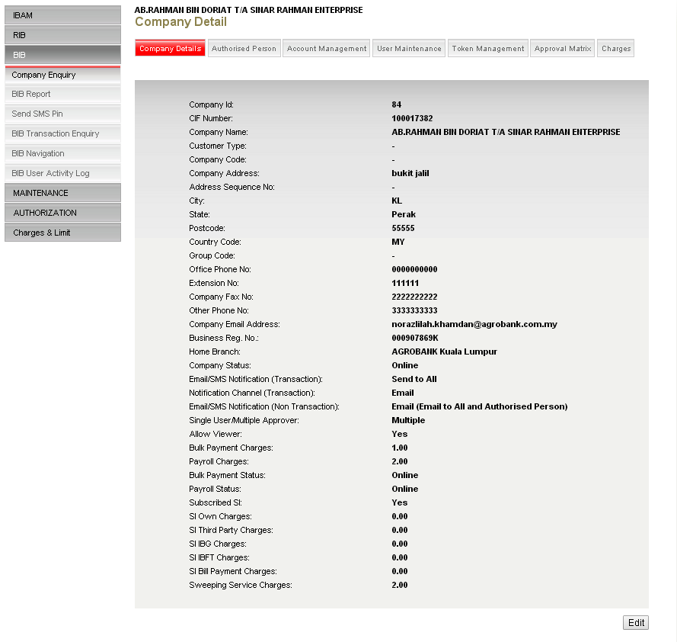
Diagram 5: Company Details Screen
Display Fields:
No | Field | Format | Description
 | Company ID | Text | Shows the company ID
 | CIF Number | Text | Shows the company CIF
 | Company Name | Text | Shows the company name
 | Customer Type | Text | Shows the customer type
 | Company Code | Text | Shows the company code
 | Company Address | Text | Shows the company address
 | Address Sequence No | Text | Shows the sequence number of address
 | City | Text | Shows the city
 | State | Text | Shows the state
 | Postcode | Text | Shows the postcode
 | Country Code | Text | Shows the country code
 | Office Phone No | Text | Shows the office phone number
 | Extension No | Text | Shows the extension number
 | Company Fax No | Text | Shows the company fax number
 | Other Phone No | Text | Shows the other phone number
 | Company Email Address | Text | Shows the email address of company
 | Business Reg No. | Text | Shows the registration number of company
 | Home Branch | Text | Shows the branch of account
 | Company Status | Text | Shows the status of company
 | Email/SMS Notification (Transaction) | Text | Shows the recipient of Email/SMS Notification for transaction
 | Notification Channel (Transaction) | Text | Shows the channel for notification
 | Email/SMS Notification (Non Transaction) | Text | Shows the recipient of Email/SMS Notification for Non Transaction
 | Single User/Multiple Approver | Text | Shows the type of user
 | Allow Viewer | Text | Shows the flag for Viewer
 | Bulk Payment Charges | Text | Shows the charges of bulk payment
 | Payroll Charges | Text | Shows the charges of Payroll
 | Subscribed SI | Text | Shows the flag for SI
 | SI Own Charges | Text | Shows the charges of SI Own
 | SI Third Party Charges | Text | Shows the charges of SI Third Party
 | SI IBG Charges | Text | Shows the charges of SI IBG
 | SI IBFT Charges | Text | Shows the charges of SI IBFT
 | SI Bill Payment Charges | Text | Shows the charges of SI Bill Payment
 | Sweeping Service Charges | Text | Shows the charges of Sweeping Service
 | Subscribed Statutory Bodies | Text | Shows the flag for Statutory Bodies
 | Statutory Bodies Charges | Text | Shows the charges for Statutory Bodies

Action:
No | Action | Type | Description
1 | Edit | Button | Contains an action to edit the company information.
Table 2: Company Details Action

Step 3:
- IBAM System shows the edit company details page.
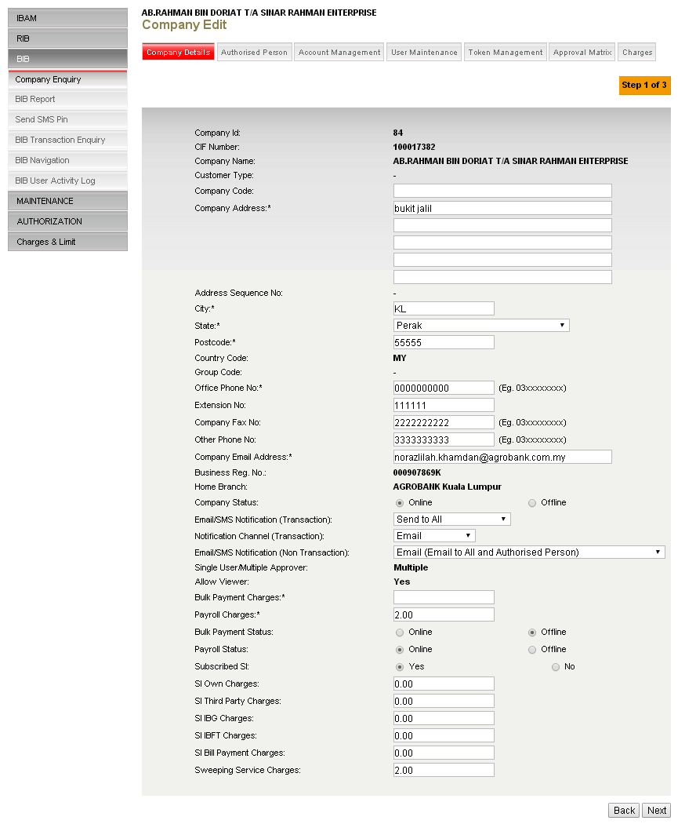
Diagram 6: Edit Content Details Screen

Input Specification:
No | Field | Field Type | Validation Rule | Description | Compulsory
 | Company Code | Text | Alphanumeric.  Max length: 10 char | Code of company | O
 | Company Address | Text | Alphanumeric | Address of company | M
 | Address Sequence No | Text | Alphanumeric |  | O
 | City | Text | Alphanumeric | City of company | M
 | State | Dropdown List | Alphanumeric | State of company | M
 | Postcode | Text | Numeric | Mailing postcode | M
 | Country Code | Text | Numeric | Code of country | O
 | Office Phone No | Text | Numeric | Telephone number of office | M
 | Extension No | Text | Numeric | Extension of office phone number | O
 | Company Fax No | Text | Numeric | Fax number of company | O
 | Other Phone No | Text | Numeric | Alternative telephone number | O
 | Company Email Address | Text | Alphanumeric | Email address of company | M
 | Company Status | Radio button | Selected one of the option | Status of company | O
 | Email/SMS Notification (Transaction) | Dropdown List | Selected one of the option | Email/SMS Notification for Transaction | O
 | Notification Channel (Transaction) | Dropdown List | Selected one of the option | Notification Channel for Transaction | O
 | Email/SMS Notification (Non Transaction) | Dropdown List | Selected one of the option | Email/SMS Notification for Non Transaction | O
 | Bulk Payment Status | Radio button | Selected one of the option | Flag for Bulk Payment | O
 | Payroll Status | Radio button | Selected one of the option | Flag for Payroll | O
 | Bulk Payment Charges | Text | Numeric | Charges for Bulk Payment Transaction | M
 | Payroll Charges | Text | Numeric | Charges for Payroll Transaction | M
 | Subscribed SI | Radio button | Selected one of the option | Flag | O
 | SI Own Charges | Text | Numeric | Charges for SI Own transaction | O
 | SI Third Party Charges | Text | Numeric | Charges for SI Third Party Transaction | O
 | SI IBG Charges | Text | Numeric | Charges for SI IBG Transaction | O
 | SI IBFT Charges | Text | Numeric | Charges for SI IBFT Transaction | O
 | SI Bill Payment Charges | Text | Numeric | Charges for SI Bill Payment Transaction | O
 | Sweeping Service Charges | Text | Numeric | Charges for Sweeping Service | O
 | Subscribed Statutory Bodies | Radio button | Selected one of the option | Flag for Statutory Bodies | O
 | Statutory Bodies Charges | Text | Numeric | Charges for Statutory Bodies | O
Table 3: Edit Company Details Input Specification

Action:
No | Action | Type | Description
1 | Back | Button | Goes back to ‘content list’ page.
2 | Next | Button | Forward the action to validate and display the confirm page for confirmation
Table 4: Edit Company Details Action
Step 4:
- IBAM validate and go to confirm page
- IBAM shows successful message and pending for Authorization approval process.
- Once approved IBAM will shows the update details under the content type content list.

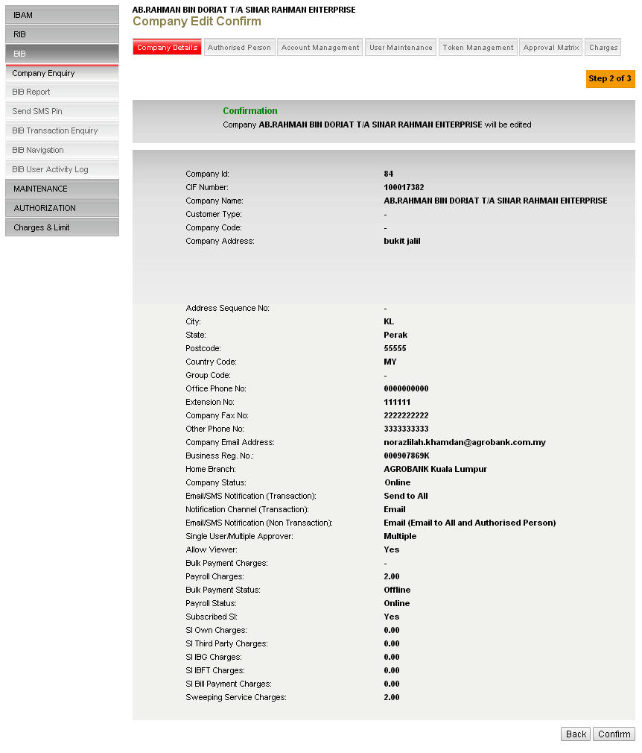
Diagram 7: Edit Company Confirm
Display Fields:
No | Field |  | Format | Description
 | Company ID |  | Text | Shows the company ID
 | CIF Number |  | Text | Shows the company CIF
 | Company Name |  | Text | Shows the company name
 | Customer Type |  | Text | Shows the customer type
 | Company Code |  | Text | Shows the company code
 | Company Address |  | Text | Shows the company address
 | Address Sequence No |  | Text | Shows the sequence number of address
 | City |  | Text | Shows the city
 | State |  | Text | Shows the state
 | Postcode |  | Text | Shows the postcode
 | Country Code |  | Text | Shows the country code
 | Office Phone No |  | Text | Shows the office phone number
 | Extension No |  | Text | Shows the extension number
 | Company Fax No |  | Text | Shows the company fax number
 | Other Phone No |  | Text | Shows the other phone number
 | Company Email Address |  | Text | Shows the email address of company
 | Business Reg No. |  | Text | Shows the registration number of company
 | Home Branch |  | Text | Shows the branch of account
 | Company Status |  | Text | Shows the status of company
 | Email/SMS Notification (Transaction) |  | Text | Shows the recipient of Email/SMS Notification for transaction
 | Notification Channel (Transaction) |  | Text | Shows the channel for notification
 | Email/SMS Notification (Non Transaction) |  | Text | Shows the recipient of Email/SMS Notification for Non Transaction
 | Single User/Multiple Approver |  | Text | Shows the type of user
 | Allow Viewer |  | Text | Flag
 | Bulk Payment Charges |  | Text | Shows the charges of bulk payment
 | Payroll Charges |  | Text | Shows the charges of Payroll
 | Subscribed SI |  | Text
 | SI Own Charges |  | Text | Shows the charges of SI Own
 | SI Third Party Charges |  | Text | Shows the charges of SI Third Party
 | SI IBG Charges |  | Text | Shows the charges of SI IBG
 | SI IBFT Charges |  | Text | Shows the charges of SI IBFT
 | SI Bill Payment Charges |  | Text | Shows the charges of SI Bill Payment
 | Sweeping Service Charges |  | Text | Shows the charges of Sweeping Service
 |  | Subscribed Statutory Bodies | Text | Flag for Statutory Bodies
 |  | Statutory Bodies Charges | Text | Charges for Statutory Bodies

Action:
No | Action | Type | Description
1 | Back | Button | Contains an action to go back edit the company information.
2 | Confirm | Button | Contains an action to confirm the changes
Table 5: Company Confirm Action

Content Maker Checker Permission set as ‘Disable’
- IBAM updates the details to IB Database and display the result to the IBAM user
- IBAM shows successful message and shows the updated content details under the content type without Authorization.

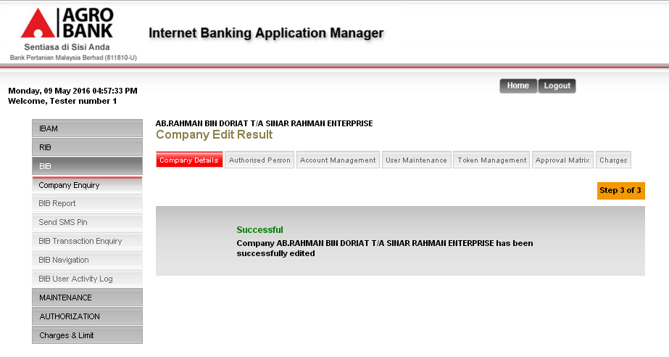
Diagram 8: Edit Content Result Screen without Authorization Process

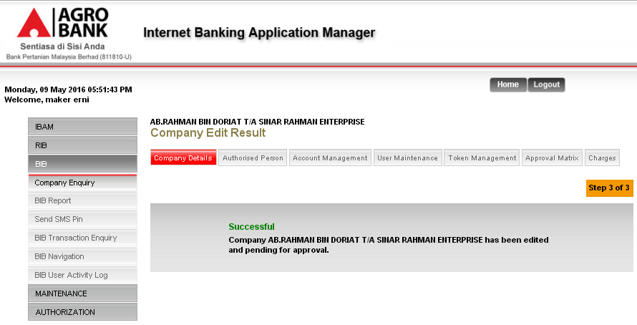
Diagram 9: Edit Content Result Screen with Authorization Process

Display Specification:
No | Field | Format | Description
1. | Result Status | Text | Edit Content Result status
2. | Result Status Notes | Text | Edit Content Result status message
Table 6: Edit Company Result Display Fields

BIB Report
IBAM Admin User can access to reports under IB (BIB) Report module of IBAM, the user just need to select the appropriate report type, File Type as PDF (*.pdf) or Excel (*.xls), Month and Year to download the report in CSV or Text format.

Process Flow
Diagram 10: BIB Report Process Flow

The following are reports related to Statutory Bodies
  - BIB Statutory Bodies Report Daily
  - BIB Statutory Bodies Report Monthly

Sample Reports
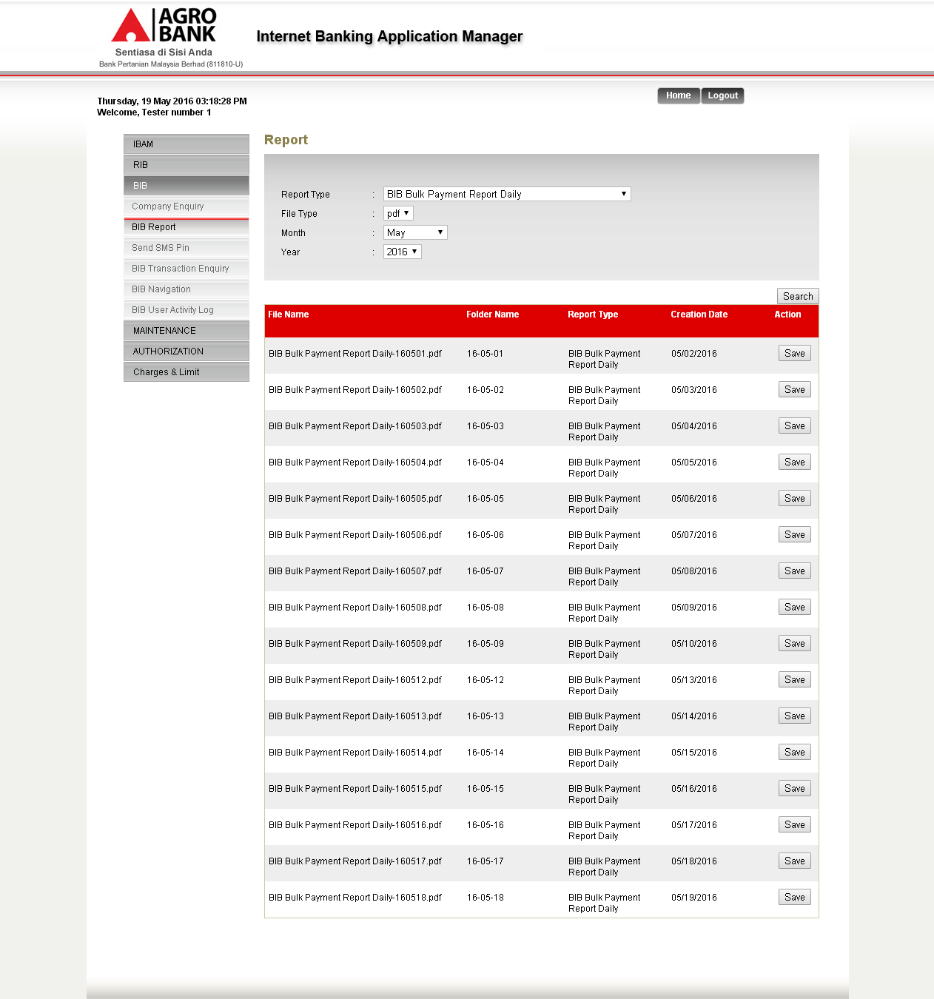
Diagram 11: BIB – Report (BIB Statutory Bodies Report Daily)
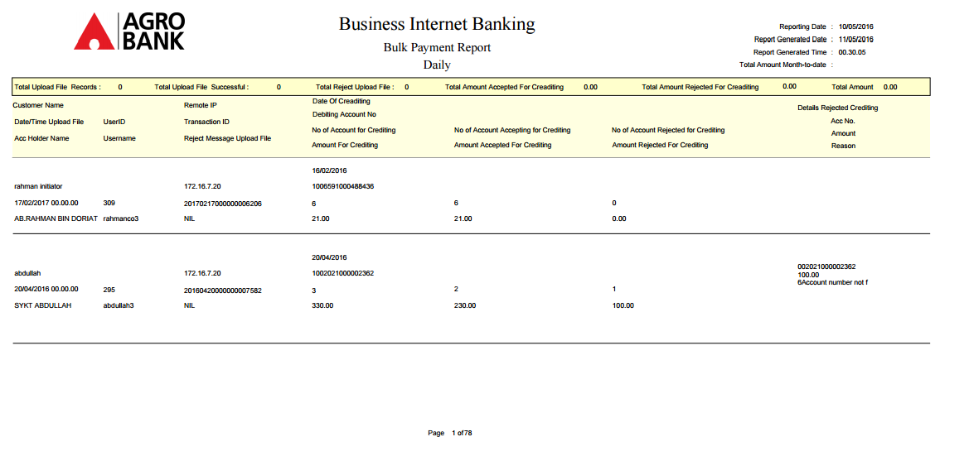
Diagram 12: BIB – Statutory Bodies Report Daily

Diagram 13: BIB – Statutory Bodies Report Monthly

Section 4: Enhancement at Business Internet Banking (BIB)

Enhancement at Business Internet Banking (BIB)

Statutory Bodies – Single User/Initiator

Statutory Bodies - File Upload

User uses this feature to make payment to all the Statutory Bodies defined in uploaded payment file.
There are 4 types of file format which are Socso, EPF Registration, EPF Payment, and LHDN.

Process Flow

Diagram 14: File Upload Process Flow

There are 2 participants involved in bulk payment process which is IB User and CMS System. The process has the following steps:

Screen Flow
Step 1:
- User accesses to Statutory Bodies screens, and select File Upload.
- User selects From Account.
- User selects Services and File Path of file to upload.
- User clicks Upload.
- User selects From Account, key in Total Number of Transaction, Total Amount, Crediting Date, Remarks.
- User keys in Security Token PIN number.
- User clicks Confirm.
- User views Statutory Bodies Result screen page.
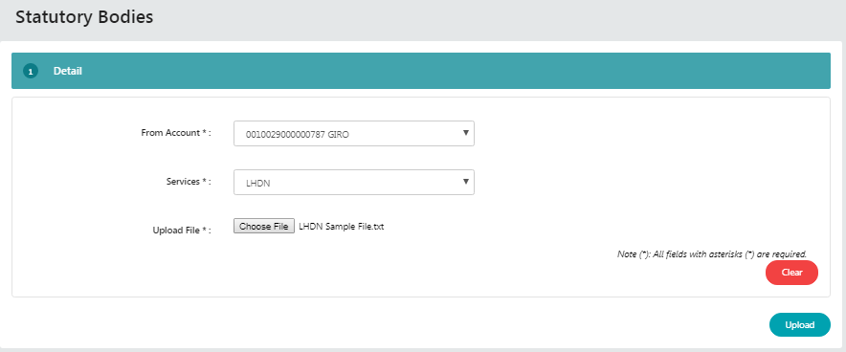

Input Specification:
No | Field name | Field Type | Validation Rule | Description | M/O
 | From Account | Dropdown list | Selected one of the option | User account number | M
 | Services | Dropdown list | Selected one of the option | Upload File format:  SOCSO  EPF Registration  EPF Payment  LHDN | M
 | Upload File | (Textbox) File Browser | String (File path) | Path of file to upload | M
Action:
No | Action | Type | Description
 | Upload | Button | Contains an action to continue to next page
 | Clear | Button | Contains an action to clear root or directory of payment file that has been chosen
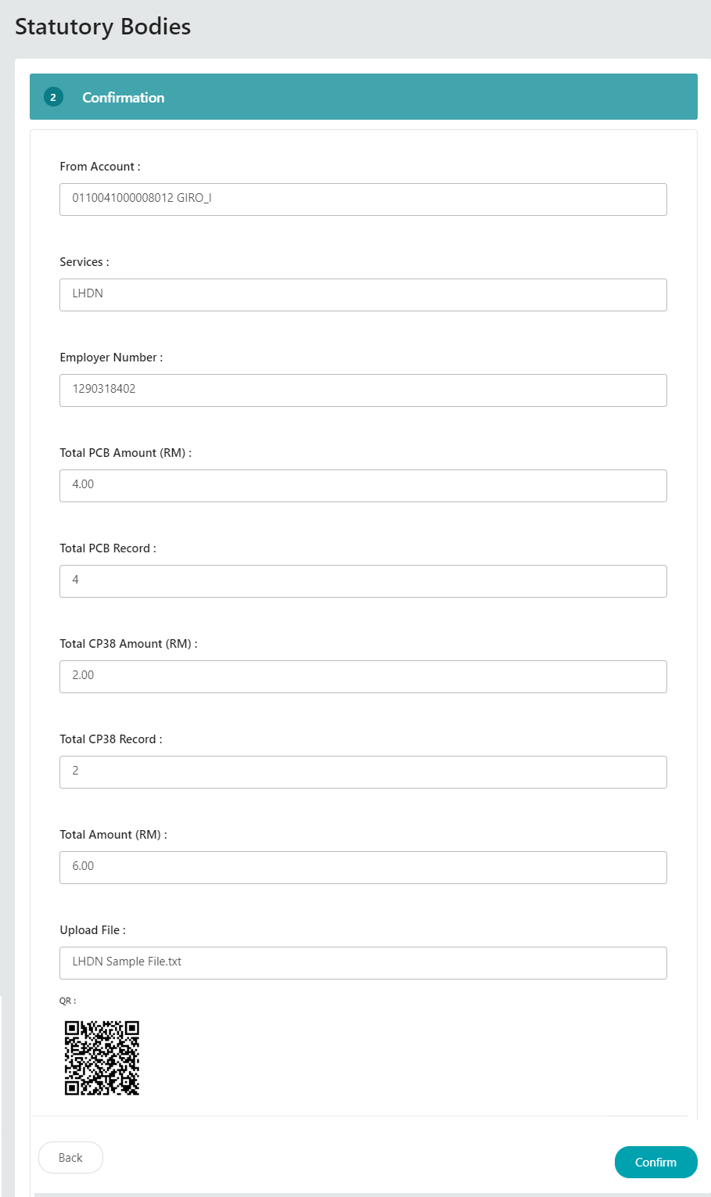
Figure 1: Single User – Confirmation screen
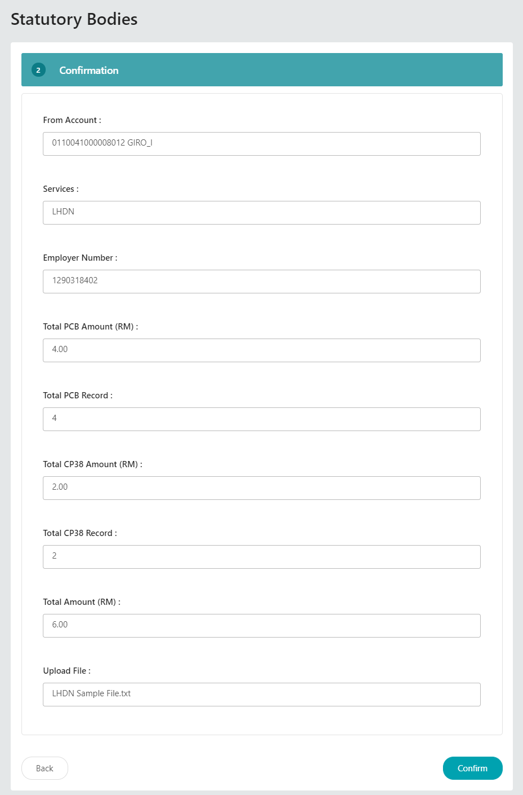
Figure 2: Initiator – Confirmation screen
Input Specification:

No | Field name | Field Type | Validation Rule | Description | M/O
 | From Account | Dropdown List | Selected one of the option | Account number | M
 | Total Number of Transaction | Text Box | Numeric. Max length 50 | Total Transaction of the file upload | M
 | Total Amount | Text Box | Numeric. Max length 50 | Total Amount of this file transaction | M
 | Crediting date | Dropdown list | Selected one of the option | Select the date for crediting | M
 | Remarks | Text Box | Alphanumeric. Max length 50 | Customer Remarks or Message | M
 | Secure PIN Number | Text Box, Masked | - Match Length: 6  - Numeric | A random, temporary generated number from secure token | M

Action:
No | Action | Type | Description
 | Back | Button | Contains an action to go back to previous page
 | Confirm | Button | Contains an action to continue to next page

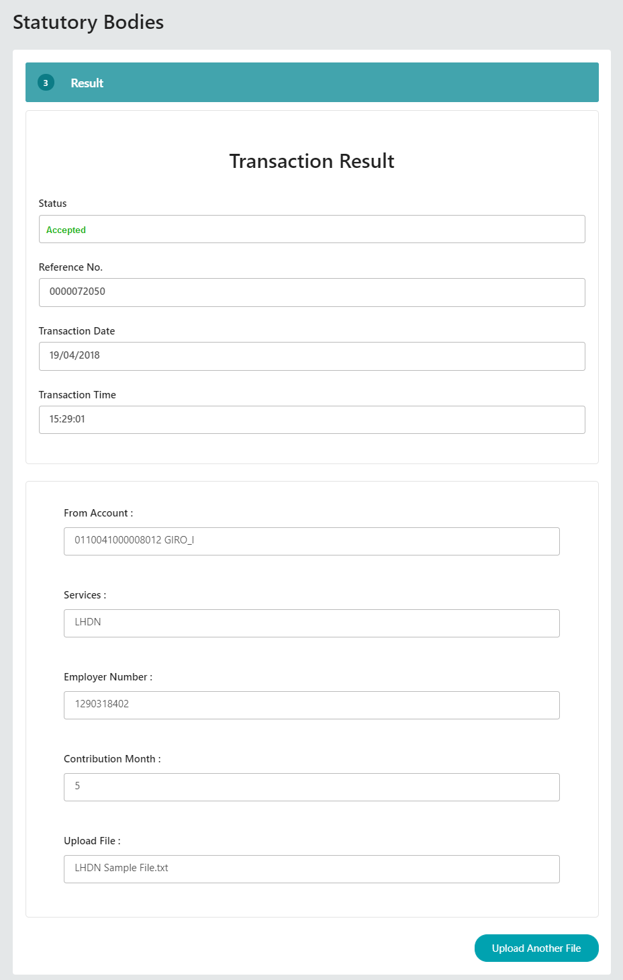
Figure 3: Result screen
Display Fields:
No | Field | Format | Description
 | From Account | Numeric | Shows the account number of sender
 | Total Number of Transaction | Numeric | Shows Total Transaction of the file upload
 | Total Amount | Text | Shows Total Amount of this file transaction
 | Crediting Date | Text | Shows crediting date of this transaction
 | Remarks | Text | Shows the remarks input by sender
 | Status | Text | Show the transaction status  Single user = Accepted  Initiator = Pending Approval
 | Batch ID | Numeric | Show ID as reference # of the batch
 | Reference No | Numeric | Show the transaction reference no
 | Transaction Date | Date format | Show the transaction date
 | Transaction Time | Time format | Show the transaction time

Action:
No | Action | Type | Description
 | Print Receipt | Button | Contains an action to generate receipt’s pop-up display
 | Upload Another File | Button | Contains an action to go back to Statutory Bodies page
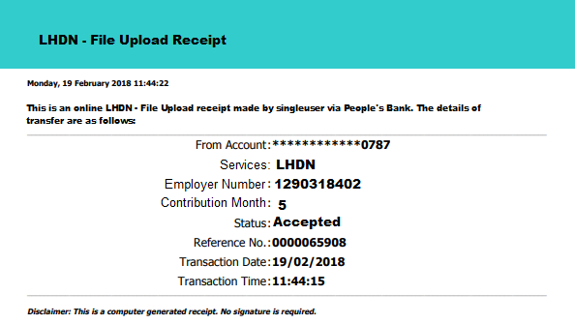

Statutory Bodies Enquiry
Statutory Bodies Enquiry is to capture the status of submitted Statutory Bodies files. User can view the payment transaction history.

Process Flow

Diagram 15: Enquiry Process Flow

Screen Flow
Steps:
- User accesses to Statutory Bodies screen, and select Statutory Bodies Enquiry.
- User can view the summary of summited Statutory Bodies files.
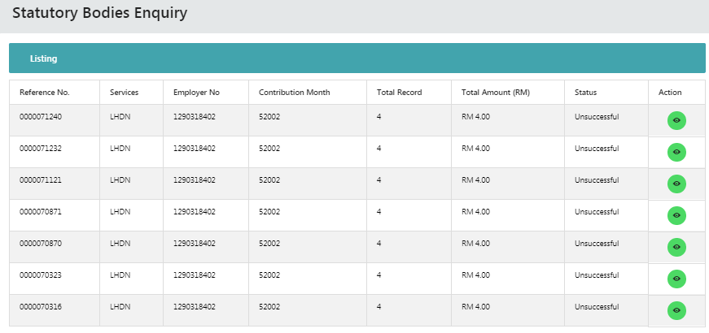
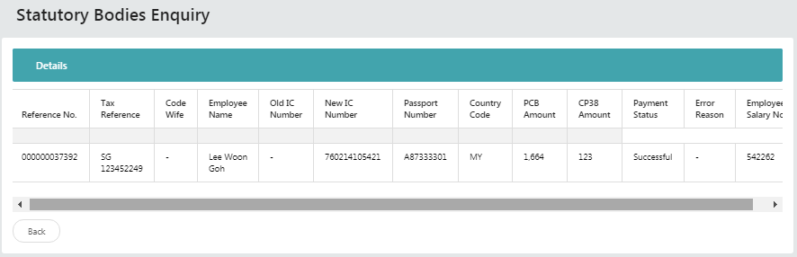
Display Fields:
No | Field | Format | Description
 | Batch ID | Numeric | Show ID as reference # of the batch
 | Crediting Date | Numeric | Shows Recipient Name
 | Total Number of Transaction | Text | Shows Recipient IC/ID
 | Total Amount | Text | Shows Recipient Bank
 | Status | Text | Single User and Multiple User status:  Pending  Validate (Pending Approval)  Rejected  Ready for Processing  In Progress  Success  Failed  Partial Failed  Cancelled

Action:
No | Action | Type | Description
 | Previous Page | Button | Contains an action to go back to previous page
 | Next | Button | Contains an action to go to next page.

Statutory Bodies – Approver
Approver role will be to determine approve or reject the Statutory Bodies file submitted by Initiator.

Process Flow

Screen Flow
Steps:
- User access to Authorization screen
- User clicks on IB Reference No to Approve or Reject the transaction
- User can clicks on Approve or Reject, key in Remark and Secure Token PIN number
- User can clicks Download button to view the file upload also
- User clicks Confirm.

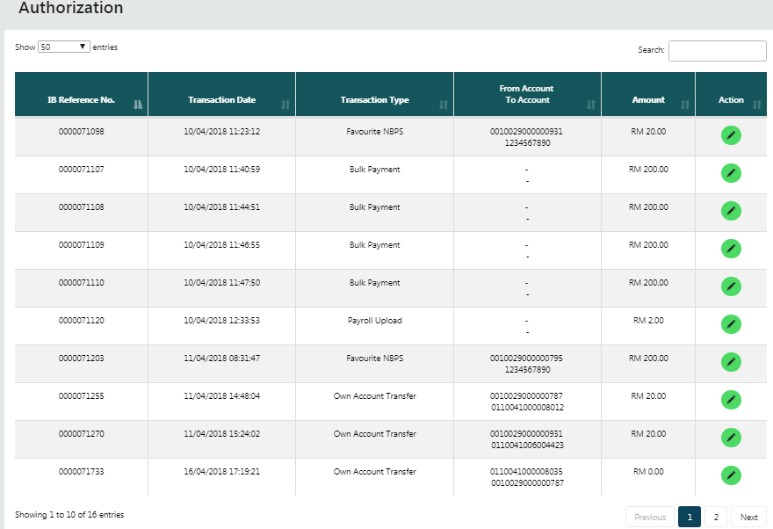
Figure 4: Authorization List
Display Fields:
No | Field | Format | Description
 | IB Reference No | Numeric and Hyperlink | Show Payment reference number
 | Transaction Date | DD/MM/YYYY HH:MM:SS | Show the date and time of transaction
 | Transaction Type | Text | The details of transaction
 | From Account | Numeric | The payment from account
 | To Account | Numeric | The payment to account
 | Amount | Numeric | The transactions amount
 | Action | Icon | Contain an action to display transaction

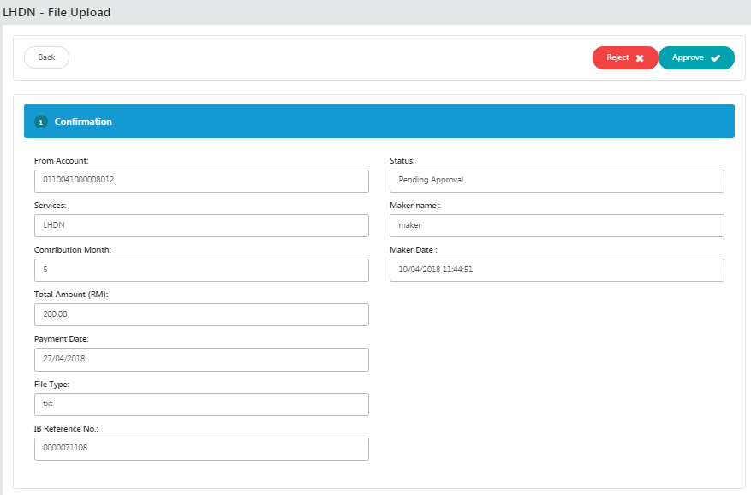
Display Fields:
No | Field | Format | Description
 | From Account | Numeric | Displays the account number of user
 | Services | Text | Display services of statutory body
 | Contribution Month | Numeric | Display Month of contribution
 | Total Amount | Numeric | Displays amount of funds that will be transferred
 | Payment Date | DD/MM/YYYY HH:MM:SS | Show the date and time of transaction
 | File Type | Text | Displays the type of file uploaded
 | IB Reference No | Numeric | Displays the IB Reference Number
 | Status | Text | Displays the transfer status
 | Maker Name | Text | Displays the Initiator name
 | Maker Date | DD/MM/YYYY HH:MM:SS | Displays the Initiator initiate date.

Action:
No | Action | Type | Description
 | Reject | Button | Contains an action to reject transaction
 | Approve | Button | Contains an action to approve transaction

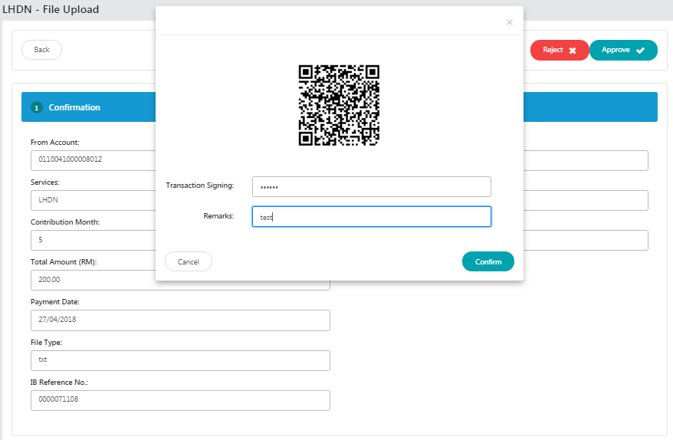
Figure 5: Confirm screen by scanning QR image
Display Fields:
No | Field | Format | Description
 | QR Image | QR Code | Show QR code of transaction

Input Specification:
No | Field | Field Type | Rule | Description | M/O
 | Transaction Signing | Text Box | Match Length: 6  Numeric | Security pin that generated through QR code scanning. | M
 | Remarks | Text Box | Alphanumeric and spaces only. Up to 30 characters | Allow user to make a remark for this transfer | O

Action:
No | Action | Type | Description
 | Confirm | Button | Contains an action to confirm the pending approval

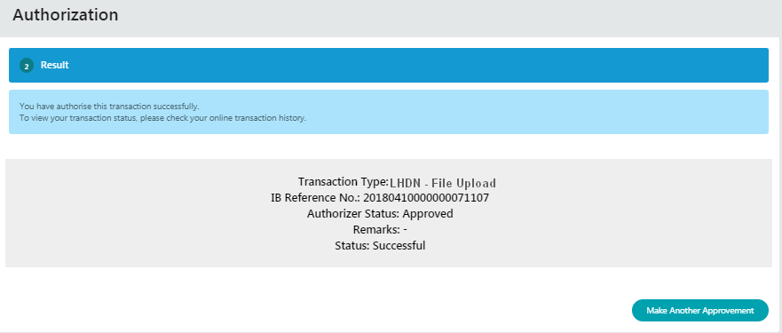
Figure 6: Result screen

Display Fields:
No | Field | Format | Description
 | Transaction Type | Text | Displays the transaction type
 | IB Reference No | Numeric | Displays the IB reference number
 | Authorizer Status | Text | Displays the approver status
 | Remarks | Text | Displays the Remarks (if any)
 | Status | Text | Displays the transaction status

Appendix 1: List Allowable Values
Field | Type | Values
Status | Text field | - Successful  - Pending  - Unsuccessful  - Accepted
Action Status / Approver Status | Text field | - Approve  - Reject
Table 7: List Allowable Values

Appendix 1: System Security
No | Single User ID and Password Control | Requirements | Remark
 | Single User ID | Single or combination of numeric, alphabet or alphanumeric. Underscore is accepted. 6 – 16 characters. | The rule is not parameterized.
 | Maximum password expiration | No expiration | System wide support and can be parameterized via the system configuration file
 | Password | Password must contain a mixture of numeric and alphabet format and cannot include these special character ["<>'%;&+].>  Permitted Password length are 8 - 12 characters
 | Maximum failed log-in attempts | 3 times. (The Single User ID will subsequently be locked (disabled)) | The maximum number of attempts can be parameterized via the system configuration file. If the Single User ID is locked, the user must send a request to the administrator to reset the password. The application will force the user to change their password upon login.
 | Inactive/Dormant ID | Single User ID is automatically disabled by the system after 90 days of inactivity. | The number of days can be parameterized via the system configuration file.
 | Duplicate password control | For a minimum of 12 generations, the same passwords cannot be reused. | The number of generations can be parameterized via the system configuration file.
 | Last sign on information displayed | The last signed on details will be displayed to the user upon logging into the system | This is a standard feature.
 | Changing of passwords by user | Single User may change their passwords anytime they wish | This is standard feature.
 | No deletion of Single User IDs from application | Single User IDs that are obsolete must be able to be deleted (instead of just suspended) from the application | The same Single User ID cannot be reused even if restored. The deleted user will not show up on the user enquiry screen, but the record will still be stored in the database.
 | Password storage | Password is hashed using SHA-256 hashing algorithm | Combination of nonce and Password is encrypted using SHA-256 before being stored into Database. The hashed value will be used for authentication
Table 8: Single User Authentication Rules

Appendix 2: List Allowable Values
Field | Type | Values
Login as | Dropdown list | - Initiator  - Approver
Status | Text field | - Successful  - Pending  - Unsuccessful
Action (Account details) / Quick Link | Dropdown list | - Account Details  - Transaction History  - Agronet Online Trxn History
Action Status / Approver Status | Text field | - Approve  - Reject
Batch Status | Text field | - Pending  - Accepted
User Role | Dropdown list | - Initiator  - Approver
User Status | Dropdown list | - New  - Active  - Suspended  - Locked  - Unlocked  - Dormant
Secure Pass Status | Dropdown list | - Not assigned  - Assigned  - Faulty
Table 9: List Allowable Values

Appendix 3: Internet Banking “Text” Input Fields Specification
No. | Item/Field | Data Type | Format & Length
 | Username (IB login ID) | Alphanumeric | - Min Length: 6  - Max Length: 16
 | Password | Alphanumeric | - Min Length: 8  - Max Length: 12  - Minimum 1 numeric  - Minimum 1 alphabet
 | Token Serial | Numeric | - Length: 13
 | Token Pin | Numeric | - Length: 6
 | Date | Date | - Format: DD/MM/YYYY
 | Transaction Amount | Decimal | - Max Length: 15  - Format: Decimal 15,2
 | Transaction Remarks | Alphanumeric | - Max Length: 30
 | Transaction Reference No | Alphanumeric | - Max Length: 20
 | Transaction Details | Alphanumeric | - Max Length: 20
 | Email | Email | - Max Length: 60  - Format: <email>@<emailhost>.<extension>
 | Beneficiary Nickname | Alphanumeric | - Max Length: 60
 | Interbank Beneficiary Account Number | Numeric | - Max Length: 20
 | Interbank Holder Name | Alphanumeric | - Max Length: 40
 | Bill Account Number | Alphanumeric | - Max Length: 30
 | Favourite Payee Nickname | Alphanumeric | - Max Length: 60
 | Approval Remark | Alphanumeric | - Max Length: 30
 | Name | Alphabet | - Max Length: 100
 | Telephone Number | Alphanumeric | - Max Length: 32
 | Mobile Number | Alphanumeric | - Max Length: 32
 | Address | Alphanumeric | - Max Length: 256
 | Approval Matrix | Numeric | - Length: 1
Table 10: Text Input Field Specifications

Appendix 4: Acceptable Characters for Validation
Validation Name | Acceptable characters
Text | No limitations
Alphanumeric with Dot & Slash | a-z, A-Z  0-9  Dot / Period (.)  Slash (/)
Alphanumeric with Space | a-z, A-Z  0-9  Space
Alphanumeric with spaces and underscore | a-z, A-Z  0-9  Space  Underscore (_)
Alphanumeric with Space & Symbols | a-z, A-Z  0-9  Space  Ampersand (&)  Apostrophe (', `)  Left Bracket (()  Right Bracket ())  Comma (,)  Alias (@)  Question Mark (?)
Email | a-z, A-Z  0-9  Dot / Period (.)  Minus/Hypen (-)  Underscore (_)  Minus/Hypen (-)  Must have one alias (@)  Format: <value>@<value>.<value>
Character(s) acceptable for URL path  URL Path | a-z, A-Z  0-9  Dot / Period (.)  Space  Ampersand (&  Plus (+)  Minus/Hypen (-)  Slash (/)  Equal (=)  Question Mark (?)  Underscore (_)
Table 11: Acceptable Characters for Validations

Appendix 5: Download Report
Depending on the user’s browser settings and software availability,
  - the report can be automatically opened using default software for .xls file type, such as Microsoft Excel or OpenOffice.org Calc
  - a dialog box will pop-up, asking further action from administrator whether to open the report using with software such as Microsoft Excel or OpenOffice.org Calc or to save the file
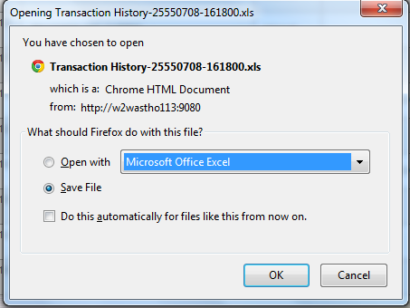
Figure 7: Example dialog box for Download Report

Appendix 6: Glossary

Term | Definition
RIB | Retail Internet Banking System
CDB | Business Internet Banking System
IB | Internet Banking
IBS | Internet Banking System
IBAM | Internet Banking Administration Manager (the administration module)
SME | Small & Medium Enterprise
TAC | Transaction Authorization Code  TAC is a temporary random six digits security code generated by the authentication server and sent to user by SMS using a SMS gateway. TAC is required as the second level security authentication before committing any bank transactions and user profile updates.
OTP | One Time Password, in this document it meant for the Secure Pass or Token 6 digit PIN from VASCO.
BNM | Bank Negara Malaysia
CASA | Current & Savings Account
FD | Fixed Deposit
Table 12: Glossary
--- END ---

Mobile Number format subject to change according to SMS Gateway specification

