Appendix A: Scope of Work

|  |  |
| --- | --- |
| **CR No:** | **CR-00085** |
| **CR Title:** | **Change Request: Real-Time Payments Platform for Internet Banking** |

| System | Affected Modules | Change Description | CF / DB | Effort (Days) |
| --- | --- | --- | --- | --- |
| CR-00085 Enhancement | | | | |
| RIB | * Fund Transfer * AgroNet Transaction History | * Develop new sub-modules under Fund Transfer:   1. RPP Instant Transfer (Credit Transfer)   2. DuitNow   3. Favorite DuitNow   4. DuitNow Favorite Maintenance   5. DuitNow ID Registration   6. DuitNow ID Maintenance * Add RPP Instant Transfer & DuitNow to AGRONet Transaction History filtering | DEV | 18 |
| BIB | * Fund Transfer * AGRONetBiz Transaction History * IB Service Maintenance > User Maintenance   Notes*: For all Role   * Single User * Multiple User | * Develop new sub-modules under Fund Transfer:   + RPP Instant Transfer (Credit Transfer)   + DuitNow   + Favorite DuitNow   + DuitNow Favorite Maintenance   + DuitNow ID Registration   + DuitNow ID Maintenance * Add RPP Instant Transfer & DuitNow to AGRONetBiz Transaction History filtering * Update User Maintenance (CA access) to include service access for DuitNow modules * Update Maker/Checker - Authorization to include DuitNow modules | DEV | 20 |
| IBAM | * RIB Transaction Enquiry * RIB Reports * BIB Transaction Enquiry * Company Maintenance * BIB Reports | * Include RPP Instant Transfer & DuitNow transactions into RIB & BIB Transaction Enquiry * Add new access for DuitNow report for RIB & CMS * Allow new service by bank admin (Company > User > Allowed Service) * Navigation & Service Info Creation for RIB and CMS * Changes in other related IBAM module/services which required | DEV | 2 |
| Report | Report Generator | * Develop new reports for RPP Instant Transfer & DuitNow transactions for RIB & CMS * Add RPP transaction into RIB & CMS Transaction Summary Report:   + BIB_Consolidated_Transaction_IB_Report   + Consolidated_Transaction_IB | DEV | 8 |
| Integration | New integration message | Integrate with Middle Service on   * Credit Transfer transaction * DuitNow transaction * DuitNow ID Look Up * DuitNow ID Registration * DuitNow ID Maintenance (Status Inquiry, Activation/De-activation, Delete) | DEV | 25 |
| SI Cron | New module SI DuitNow | Add new SI processing for DuitNow transactions | DEV | 3 |
| Database | New tables | * IB_RPP_PAY_TRANSACTION * BIB_ RPP_PAY_TRANSACTION * IB_RPP_ PAY_FAV_MAINTENANCE * BIB_RPP_ PAY_FAV_MAINTENANCE | DB | - |
| DEMO | RIB & BIB Demo | * New RPP Instant Transfer modules * New DuitNow modules * New DuitNow ID modules | Dev | 4 |

**Assumptions:**

1. Reconciliation Batch Files (14 reports/files) not included, to be purchased separately.
2. Thematic Screen Design function not included, to be purchased separately.

| System | Affected Modules | Change Description | CF / DB | Effort (Days) |
| --- | --- | --- | --- | --- |
| RPP Middle Service (Optional) | | | | |
| Integration |  | 1. Integration with Bank Host / Silverlake 2. Integration with RPP Connector |  | 45 |
| RPP Admin Module |  | RPP Admin Module allows Bank Admin to maintain services available for RPP. Bank Admin also able to view RPP Transactions and Reports |  | 35 |
| Reporting | Reporting Engine | To download reports from PayNet via SFTP   1. MEPS Reconciliation File 2. Participant Settlement Report (PSR01) 3. Participant Fee Monthly Report (PFMR01) 4. Transaction Daily Report (TAR01) 5. Transaction Daily File (TAR02) 6. Transaction Settlement Cycle Report (TAR03) 7. Transaction Settlement Cycle File (TAR04) 8. SAF Rejected Transactions Report (SRTR01) 9. SAF Rejected Transactions File (SRTR02) 10. NAD Maintenance Report (NADM01) 11. NAD Maintenance File (NADM02) 12. NAD Usage Statistics Report (NUSR01) 13. SAF Exception Report (SER01) 14. SAF Exception File (SER02)   To generate report to submit to PayNet:   1. NAD Mobile Number Maintenance (NADM03) |  | 10 |
|  | Reconciliation Engine | To process file and reconcile transactions     1. Transaction Daily File (TAR02) / Transaction Settlement Cycle File (TAR04) 2. SAF Rejected Transaction File (SRTR02) 3. MEPS Reconciliation File |  | 10 |

| System | Affected Modules | Change Description | CF / DB | Effort (Days) |
| --- | --- | --- | --- | --- |
| Thematic Screen Design Function (Optional) | | | | |
| RIB | DuitNow | To create new template for DuitNow module to allow change of background image at pre-defined location | DEV | 10 |

Appendix B: RPP Middle Service

**Current**

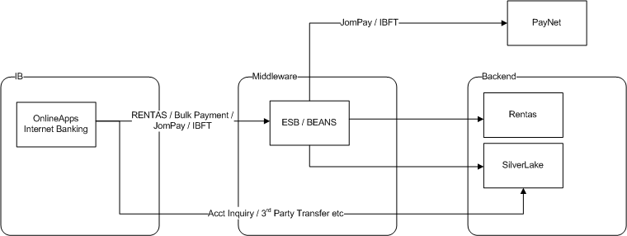

1. IB integrate direct to Silverlake for Account Inquiry, 3rd Party Transfer, etc (initial implementation in 2011-12)
2. IB integrate to ESB/BEANS for new type of transactions (post-2015) introduced by AgroBank i.e. Rentas, JomPay & IBFT

**Proposed**

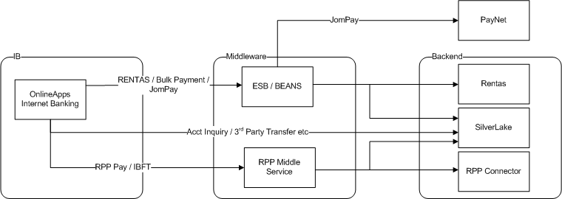

1. RPP Middle Service to be added into the Middleware and integrate with RPP Connector
2. IB integrate to RPP Middle Service for RPP related services, RPP Pay, NAD & IBFT.
3. Middle Service to post RPP transactions(OFI) via RPP Connector and also process transactions received (RFI) from RPP Connected
4. All existing transactions remains “as-is” except IBFT