
Term Deposit
(Corporate Digital Banking)

Business Requirement and System Specification
(PENRIL/BSN-CDB/BRS)
Revision: 00

31 July 2026

Prepared By:

Penril Datability (M) Sdn Bhd (816792-X)
Suite A-07-07 Plaza Mon’t Kiara
No. 2, Jalan Kiara, Mon’t Kiara
50480 Kuala Lumpur, Malaysia
Tel: (603) 6201 2622Fax: (603) 6201 7622

DOCUMENT AMENDMENT LOG
Rev. No | Date Update | Description of Change | Update By  <Name, Dept> | Review By  <Name, dept> | Approved By  <Name, Dept>
00 | 31-Jul-26 | Update as per current system | Nurul Akmal binti Yusof (Software QA) | Siti Norahayu Md Desa (TL)

Table of Contents
DOCUMENT AMENDMENT LOG 1
Section A: Introduction 5
1.1 Objective 6
Section 2: Corporate Digital Banking Functions 7
Term Deposit 7
2.1 Term Deposit Enquiry 7
2.2 Term Deposit Placement 10
2.3 Term Deposit Withdrawal 16
Appendix 1: System Security 23
Appendix 2: List Allowable Values 25
Appendix 3: Internet Banking “Text” Input Fields Specification 26
Appendix 4: Acceptable Characters for Validation 28
Appendix 5: Download Report 30
Appendix 6: Glossary 31

Business Requirement Acceptance

I/We hereby verify that this Business Requirement consist of all the requirements requested by AGROBANK. The implemented system will fulfill ONLY this requirement.

I/We also hereby AGREE that this satisfies our entire requirement for [Term Deposit]

Any future changes to this agreed scope will be treated as an enhancement to the system. Any future changes to the project timeline will be subjected to the final approval of the project steering committee.

BSN:

Approved by | Role | Signature | Date

Penril Datability (M) Sdn. Bhd.:

Approved by | Role | Signature | Date
 | Project Manager
 | Team Lead
 | Senior Software Engineer

Section A: Introduction
This document served as the business requirement and system specification of implementing Bill Payment transaction in BSN Interbank Banking system which is customer able to view and make Term Deposit via online.

This document shall explain all the features and functionalities, which is elaborating with screen captures, process flow, descriptions, input fields specifications and error messages. All screen designs provided in this document are samples and only illustration purpose for easy understanding. The screen designs are not final.

Objective

The objective of this document is to capture user requirements of transactional and administration modules of implementing Term Deposit. This document will facilitate development and implementation of the mentioned modules of Internet Banking System for BSN.

The base line features description and screen designs will become a reference blueprint for the development team to develop the transactional and administration module. Hence, it is crucial that all stakeholders need to ensure the correctness and adequacy of the requirements captured in this document.

All stakeholders involved are expected to review and sign off this document before the development start. By signing off the document, the stakeholder has endorsed the correctness and accuracy and adequacy of the requirements documented in this document.

Section 2: Corporate Digital Banking Functions

Term Deposit
This product earns you interest at an agreed rate depending on tenure or term which can range from short term to a longer term time frame. Rates can fluctuate depending on various factors including monetary policy by the Portal Rasmi Bank Negara Malaysia (bnm.gov.my). Local deposits are denominated in the national currency, the Malaysian ringgit RM (MYR).

Term Deposit Enquiry
Term Deposit Enquiry feature shall provide a list of summary of account which can be retrieved from the BSN backend host.
Flow Diagram:
Sample Screen Design:
Term Deposit Enquiry Page
The page shall display a list of available deposit account. User can use an eye icon to view account details.
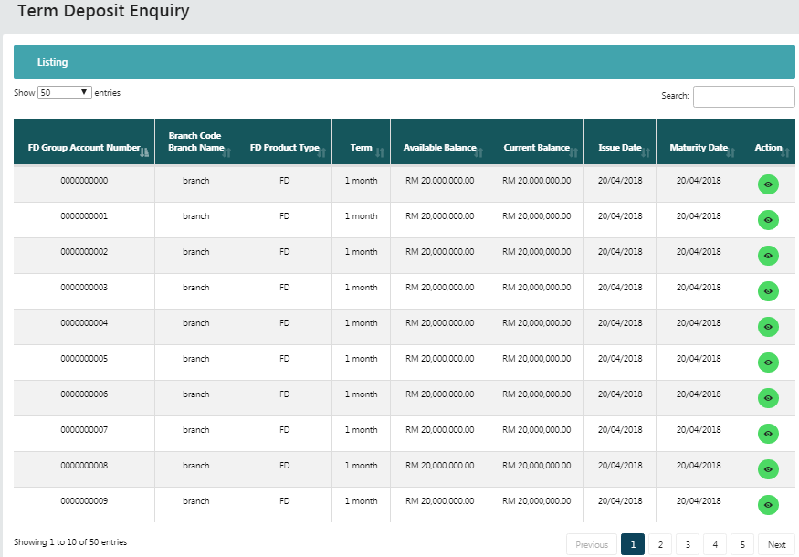
Figure 1: Term Deposit Listing
Display Fields:
No | Field | Format | Description
 | FD Group Account Number | Numeric | Shows the Term Deposit account number
 | Branch Code  Branch Name | Numeric  Text | Shows the Code of branch of deposit  Shows the name of branch of deposit
 | FD Product Type | Text | Shows the type of FD
 | Term | Alphanumeric | Shows the period of deposit
 | Available Balance | Numeric | Shows the available balance
 | Current Balance | Numeric | Shows the current balance
 | Issue Date | dd/mm/yyyy | Shows the date of issued the deposit
 | Maturity Date | dd/mm/yyyy | Shows the date of maturity for the deposit
 | Action | Icon | Shows an eye icon that contain an action to view deposit details
Table 1: Term Deposit Enquiry display field
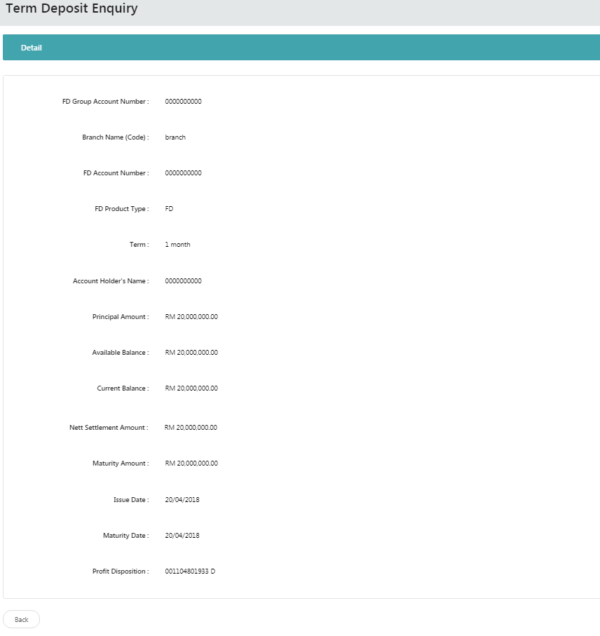
Figure 2: Term Deposit Details
Display Fields:
No | Field | Format | Description
 | FD Group Account Number | Numeric | Shows the Fixed Deposit Group account number
 | Branch Name (Code) | Text | Shows the Code/name of branch of deposit
 | FD Account Number | Numeric | Shows the Term Deposit account number
 | FD Product Type | Text | Shows the type of FD
 | Term | Alphanumeric | Shows the period of deposit
 | Account Holder's Name | Text | Shows the name of account holder
 | Principal Amount | Numeric | Shows the Principal Amount
 | Available Balance | Numeric | Shows the available balance
 | Current Balance | Numeric | Shows the current balance
 | Nett Settlement Amount | Numeric | Shows the Nett Settlement Amount
 | Maturity Amount | Numeric | Shows the Maturity Amount
 | Issue Date | dd/mm/yyyy | Shows the date of issued the deposit
 | Maturity Date | dd/mm/yyyy | Shows the date of maturity for the deposit
 | Profit Disposition | Numeric | Shows the Profit Disposition
Table 2: Term Deposit Details display field
Action:
No | Action | Type | Description
 | Back | Button | Contain an action to go to previous page
Table 3: Term Deposit Details action

Term Deposit Placement

User may make deposit placement by clicking on Term Deposit Placement navigation.

Step 1:
- Select FD Group Account.
- Click on “Next” button.

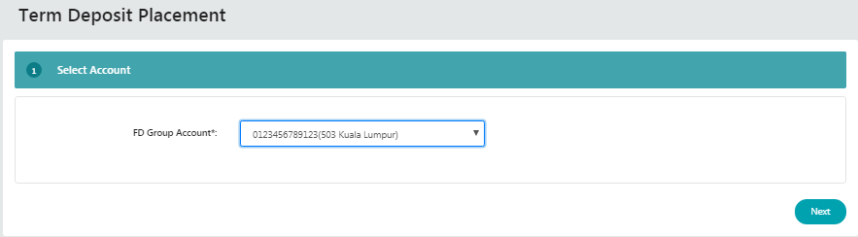
Figure 3: Term Deposit Placement Account selection
Input Specification:
No | Field | Field Type | Validation Rule | Description | M/O
 | FD Group Account | Dropdown List | Must be selected | FD Group Account No | M
Table 4: Term Deposit Input Specification
Action:
No | Action | Type | Description
 | Next | Button | Contain an action to continue to next page
Table 5: Term Deposit Action

List of available messages for the screen:
No. | Event | Error Description in English
 | Did not select “FD Group Account” field | FD Group Account is required.
Table 6: Select FD Group Account message list
Step 2:
- Select FD Product Type.
- Select Term which is up to 60 months.
- Select From Account.
- Select Profit Disposition Account.
- Enter Principal Amount.
- Click on “Next” button.
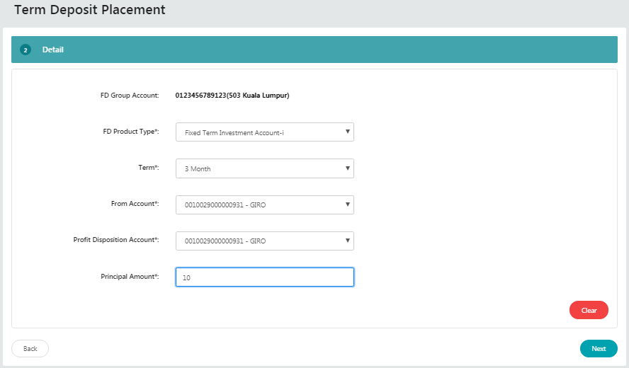
Figure 4: Term Deposit Placement details screen
Display Fields:
No | Field | Format | Description
 | FD Group Account | Numeric | Shows the Fixed Deposit Group account number

Input Specification:
No | Field | Field Type | Validation Rule | Description | M/O
 | FD Product Type | Dropdown List | Must be selected | FD Product Type | M
 | Term | Dropdown List | Must be selected | The period of deposit | M
 | From Account | Dropdown List | Must be selected | Customer account no. | M
 | Profit Disposition Account | Dropdown List | Must be selected | Customer account number for profit disposition | M
 | Principal Amount | Text | Must be numeric | Amount for fixed deposit | M
Table 7: Term Deposit Input Specification
Action:
No | Action | Type | Description
 | Next | Button | Contain an action to continue to next page
 | Clear | Button | Contain an action to clear fields
 | Back | Button | Contain an action to go to previous page
Table 8: Term Deposit Action
List of available messages for the screen:
No. | Event | Error Description in English
 | Did not fill/select required field:  - FD Product Type  - Term  - From Account  - Profit Disposition Account  - Principal Amount | FD Product Type is required.
 |  | Term is required.
 |  | From Account is required.
 |  | Profit Disposition Account is required.
 |  | Principal Amount is required.
 | Enter other than numeric (“Rm100” or “!@@” or “one hundred”) for Principal Amount | Principal Amount is not valid currency format.
 | Enter other amount less than 0.01 or more than 999999999999.99 for Principal Amount | Principal Amount must be in the range of 0.01 to 999999999999.99
Table 9: Fill Details Error message list
Step 3:
- View Bank Term and Conditions.
- Click on “Agree” button to proceed or “Reject” if disagree.
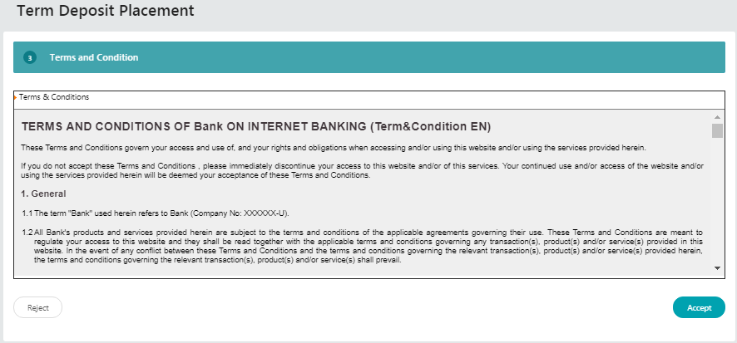
Figure 5: Bank Term and Condition screen
Action:
No | Action | Type | Description
 | Reject | Button | Contain an action to go to previous page
 | Accept | Button | Contain an action to proceed to next page
Table 10: Bank Term and Condition action
Step 4:
- View Term and Conditions of Term Deposit Placement.
- Click on “Accept” button to proceed or “Reject” if disagree.

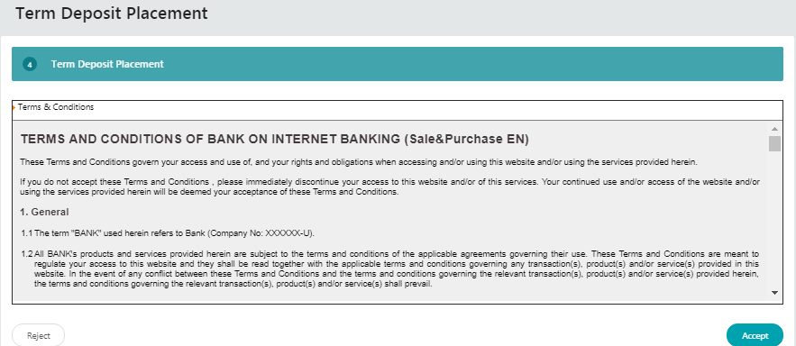
Figure 6: Term Deposit Placement Term and Condition screen
Action:
No | Action | Type | Description
 | Reject | Button | Contain an action to go to previous page
 | Accept | Button | Contain an action to proceed to next page
Table 11: Term Deposit Placement Term and Condition action
Step 5:
- View Term Deposit Placement confirm page.
- Click on “Confirm” button
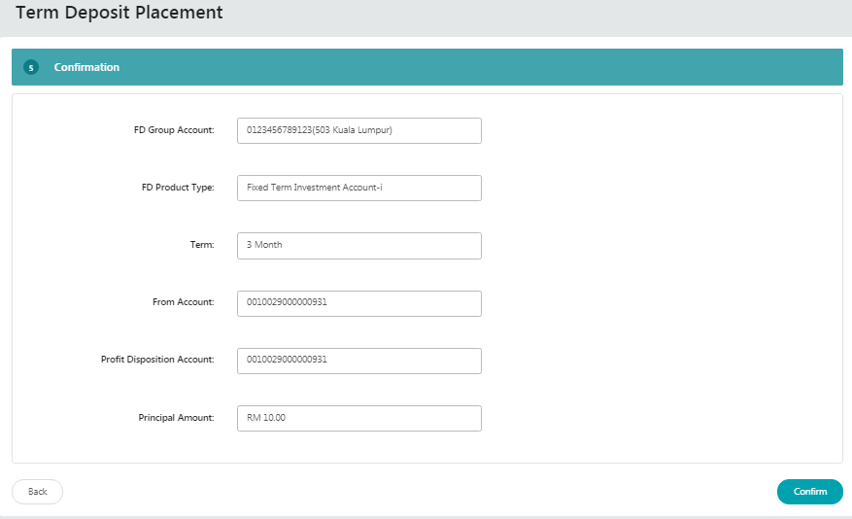
Figure 7: Term Deposit Placement Confirm page
Display Fields:
No | Field | Format | Description
 | FD Group Account | Numeric | Shows the Fixed Deposit Group account number
 | FD Product Type | Text | Shows the type of FD
 | Term | Alphanumeric | Shows the period of deposit
 | From Account | Numeric | Shows the customer account number
 | Profit Disposition Account | Numeric | Shows the customer account number for profit disposition
 | Principal Amount | Numeric | Shows the Principal Amount
Table 12: Term Deposit Placement Confirm display fields
Action:
No | Action | Type | Description
 | Back | Button | Contain an action to go to previous page
 | Confirm | Button | Contain an action to confirm the transaction and go to next page
Table 13: Term Deposit Placement Term and Condition confirm action
Step 6:
- View Term Deposit Placement Result page with Status of placement.

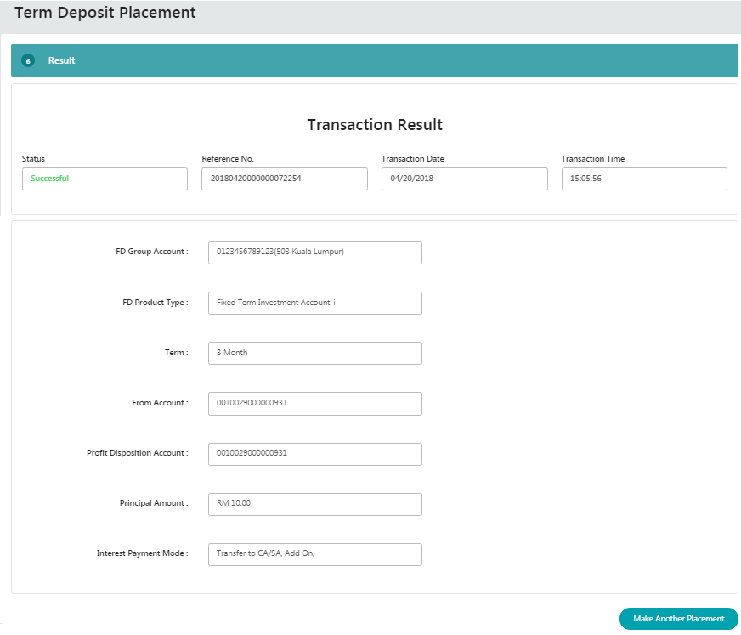
Figure 8: Term Deposit Placement Result page
Display Fields:
No | Field | Format | Description
 | FD Group Account | Numeric | Shows the Fixed Deposit Group account no
 | FD Product Type | Text | Shows the type of FD
 | Term | Alphanumeric | Shows the period of deposit
 | From Account | Numeric | Shows the customer account number
 | Profit Disposition Account | Numeric | Shows the customer account number for profit disposition
 | Principal Amount | Numeric | Shows the Principal Amount
 | Interest Payment Mode | Text | Shows the Mode of payment of interest
 | Status | Text | Shows the Status of placement
 | Reference No. | Numeric | Shows the Reference number for placement
 | Transaction Date | dd/mm/yyyy | Shows the Transaction Date
 | Transaction Time | hh:mm:ss | Shows the Transaction Time
Table 14: Term Deposit Placement result display fields
Action:
No | Action | Type | Description
 | Make Another Placement | Button | Contain an action to go to 1st step of Term Deposit Placement
Table 15: Term Deposit Placement Term and Condition result action

Term Deposit Withdrawal
User may do withdrawal upon maturity. To perform online withdrawal steps as below:

Step 1:
- Select “To Account Number”.
- Click on “Next” button.
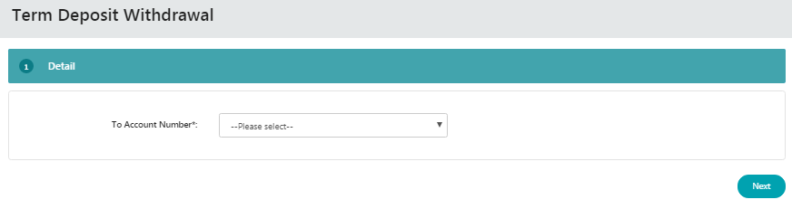
Figure 9: Term Deposit Withdrawal details
Input Specification:
No | Field | Field Type | Validation Rule | Description | M/O
 | To Account Number | Dropdown List | Must be selected | Customer own Account Number | M
Table 16: Term Deposit Withdrawal Input Specification
Action:
No | Action | Type | Description
 | Next | Button | Contain an action to continue to next page
Table 17: Term Deposit Withdrawal Action
List of available messages for the screen:
No. | Event | Error Description in English
 | Did not select To Account Number | Credit To Account is required.
Table 18: Select To Account message list

Step 2:
- Select which FD Group Account Number to be withdrawn
- Click on Action button.
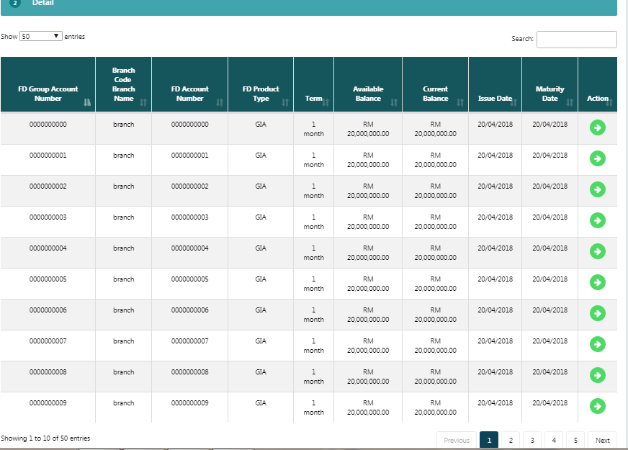
Figure 10: Term Deposit Withdrawal list of account
Display Fields:
No | Field | Format | Description
 | FD Group Account Number | Numeric | Shows the Term Deposit account number
 | Branch Code  Branch Name | Numeric  Text | Shows the Code of branch of deposit  Shows the name of branch of deposit
 | FD Product Type | Text | Shows the type of FD
 | Term | Alphanumeric | Shows the period of deposit
 | Available Balance | Numeric | Shows the available balance
 | Current Balance | Numeric | Shows the current balance
 | Issue Date | dd/mm/yyyy | Shows the date of issued the deposit
 | Maturity Date | dd/mm/yyyy | Shows the date of maturity for the deposit
 | Action | Icon | Shows an eye icon that contain an action to go to confirm page for withdrawal
Table 19: Term Deposit Withdrawal display field
Step 3:
- At confirm page, view details and click Submit to proceed.
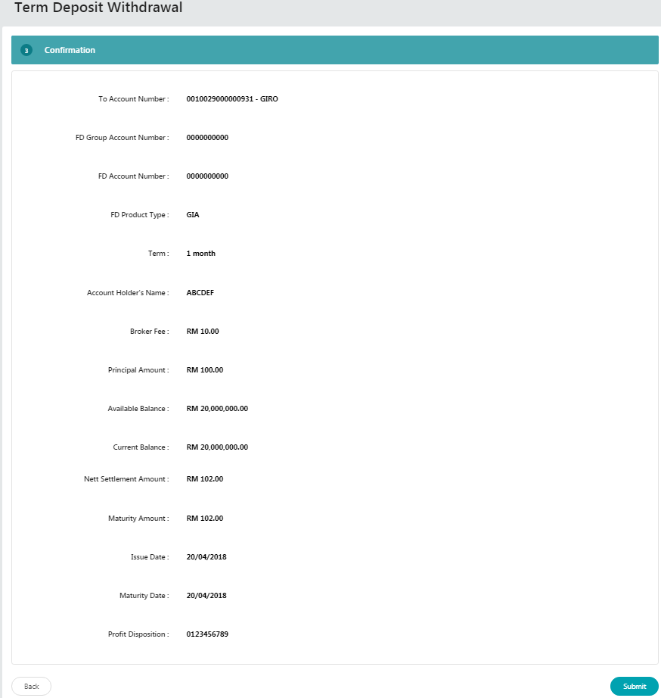
Figure 11: Term Deposit Withdrawal confirm page
Display Fields:
No | Field | Format | Description
 | To Account Number | Numeric | Shows the account number to transfer the deposit withdrawal
 | FD Group Account Number | Numeric | Shows the Term Deposit Group account number
 | FD Account Number | Numeric | Shows the Term Deposit account number
 | FD Product Type | Text | Shows the type of FD
 | Term | Alphanumeric | Shows the period of deposit
 | Account Holder Name | Text | Shows the name of account holder
 | Broker fee | Numeric | Shows the fee of broker
 | Principal Amount | Numeric | Shows the principal amount
 | Available Balance | Numeric | Shows the available balance
 | Current Balance | Numeric | Shows the current balance
 | Nett Settlement Amount | Numeric | Shows the Nett Settlement amount
 | Maturity Amount | Numeric | Shows the Maturity amount
 | Issue Date | dd/mm/yyyy | Shows the date of issued the deposit
 | Maturity Date | dd/mm/yyyy | Shows the date of maturity for the deposit
 | Profit Disposition | Numeric | Shows the account number for profit disposition
Table 20: Term Deposit Withdrawal confirm display field
Action:
No | Action | Type | Description
 | Submit | Button | Contain an action to continue to next page
 | Back | Button | Contain an action to go to previous page
Table 21: Term Deposit Withdrawal confirm Action
Step 4:
- User may print receipt by clicking on “Print Receipt” button.

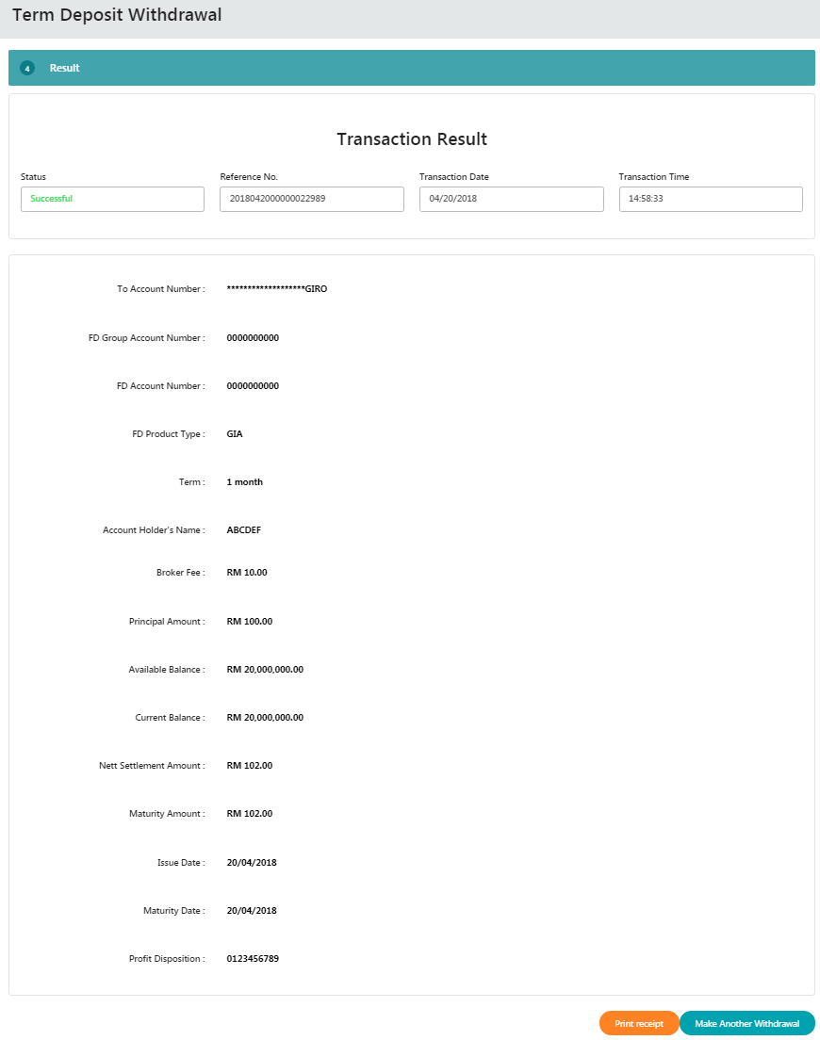
Figure 12: Term Deposit Withdrawal result page
Display Fields:
No | Field | Format | Description
 | To Account Number | Numeric | Shows the account number to transfer the deposit withdrawal
 | FD Group Account Number | Numeric | Shows the Term Deposit Group account number
 | FD Account Number | Numeric | Shows the Term Deposit account number
 | FD Product Type | Text | Shows the type of FD
 | Term | Alphanumeric | Shows the period of deposit
 | Account Holder Name | Text | Shows the name of account holder
 | Broker fee | Numeric | Shows the fee of broker
 | Principal Amount | Numeric | Shows the principal amount
 | Available Balance | Numeric | Shows the available balance
 | Current Balance | Numeric | Shows the current balance
 | Nett Settlement Amount | Numeric | Shows the Nett Settlement amount
 | Maturity Amount | Numeric | Shows the Maturity amount
 | Issue Date | dd/mm/yyyy | Shows the date of issued the deposit
 | Maturity Date | dd/mm/yyyy | Shows the date of maturity for the deposit
 | Profit Disposition | Numeric | Shows the account number for profit disposition
 | Status | Text | Shows the Status of deposit withdrawal
 | Reference No. | Numeric | Shows the Reference number for placement
 | Transaction Date | dd/mm/yyyy | Shows the Transaction Date
 | Transaction Time | hh:mm:ss | Shows the Transaction Time
Table 22: Term Deposit Withdrawal result display field
Action:
No | Action | Type | Description
 | Print Receipt | Button | Contain an action to receipt of deposit withdrawal
 | Make Another Withdrawal | Button | Contain an action to go to 1st step of Term Deposit Withdrawal
Table 23: Term Deposit Placement Term and Condition result action

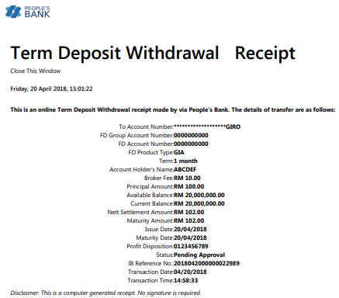
Figure 13: Term Deposit Withdrawal receipt

Appendix 1: System Security
No | Single User ID and Password Control | Requirements | Remark
 | Single User ID | Single or combination of numeric, alphabet or alphanumeric. Underscore is accepted. 6 – 16 characters. | The rule is not parameterized.
 | Maximum password expiration | No expiration | System wide support and can be parameterized via the system configuration file
 | Password | Password must contain a mixture of numeric and alphabet format and cannot include these special character ["<>'%;&+].>  Permitted Password length are 8 - 12 characters
 | Maximum failed log-in attempts | 3 times. (The Single User ID will subsequently be locked (disabled)) | The maximum number of attempts can be parameterized via the system configuration file. If the Single User ID is locked, the user must send a request to the administrator to reset the password. The application will force the user to change their password upon login.
 | Inactive/Dormant ID | Single User ID is automatically disabled by the system after 90 days of inactivity. | The number of days can be parameterized via the system configuration file.
 | Duplicate password control | For a minimum of 12 generations, the same passwords cannot be reused. | The number of generations can be parameterized via the system configuration file.
 | Last sign on information displayed | The last signed on details will be displayed to the user upon logging into the system | This is a standard feature.
 | Changing of passwords by user | Single User may change their passwords anytime they wish | This is standard feature.
 | No deletion of Single User IDs from application | Single User IDs that are obsolete must be able to be deleted (instead of just suspended) from the application | The same Single User ID cannot be reused even if restored. The deleted user will not show up on the user enquiry screen, but the record will still be stored in the database.
 | Password storage | Password is hashed using SHA-256 hashing algorithm | Combination of nonce and Password is encrypted using SHA-256 before being stored into Database. The hashed value will be used for authentication
Table 24: Single User Authentication Rules

Appendix 2: List Allowable Values
Field | Type | Values
Login as | Dropdown list | - Initiator  - Approver
Status | Text field | - Successful  - Pending  - Unsuccessful
Action (Account details) / Quick Link | Dropdown list | - Account Details  - Transaction History  - Agronet Online Trxn History
Action Status / Approver Status | Text field | - Approve  - Reject
Batch Status | Text field | - Pending  - Accepted
User Role | Dropdown list | - Initiator  - Approver
User Status | Dropdown list | - New  - Active  - Suspended  - Locked  - Unlocked  - Dormant
Secure Pass Status | Dropdown list | - Not assigned  - Assigned  - Faulty
Table 25: List Allowable Values

Appendix 3: Internet Banking “Text” Input Fields Specification
No. | Item/Field | Data Type | Format & Length
 | Username (IB login ID) | Alphanumeric | - Min Length: 6  - Max Length: 16
 | Password | Alphanumeric | - Min Length: 8  - Max Length: 12  - Minimum 1 numeric  - Minimum 1 alphabet
 | Token Serial | Numeric | - Length: 13
 | Token Pin | Numeric | - Length: 6
 | Date | Date | - Format: DD/MM/YYYY
 | Transaction Amount | Decimal | - Max Length: 15  - Format: Decimal 15,2
 | Transaction Remarks | Alphanumeric | - Max Length: 30
 | Transaction Reference No | Alphanumeric | - Max Length: 20
 | Transaction Details | Alphanumeric | - Max Length: 20
 | Email | Email | - Max Length: 60  - Format: <email>@<emailhost>.<extension>
 | Beneficiary Nickname | Alphanumeric | - Max Length: 60
 | Interbank Beneficiary Account Number | Numeric | - Max Length: 20
 | Interbank Holder Name | Alphanumeric | - Max Length: 40
 | Bill Account Number | Alphanumeric | - Max Length: 30
 | Favourite Payee Nickname | Alphanumeric | - Max Length: 60
 | Approval Remark | Alphanumeric | - Max Length: 30
 | Name | Alphabet | - Max Length: 100
 | Telephone Number | Alphanumeric | - Max Length: 32
 | Mobile Number | Alphanumeric | - Max Length: 32
 | Address | Alphanumeric | - Max Length: 256
 | Approval Matrix | Numeric | - Length: 1
Table 26: Text Input Field Specifications

Appendix 4: Acceptable Characters for Validation
Validation Name | Acceptable characters
Text | No limitations
Alphanumeric with Dot & Slash | a-z, A-Z  0-9  Dot / Period (.)  Slash (/)
Alphanumeric with Space | a-z, A-Z  0-9  Space
Alphanumeric with spaces and underscore | a-z, A-Z  0-9  Space  Underscore (_)
Alphanumeric with Space & Symbols | a-z, A-Z  0-9  Space  Ampersand (&)  Apostrophe (', `)  Left Bracket (()  Right Bracket ())  Comma (,)  Alias (@)  Question Mark (?)
Email | a-z, A-Z  0-9  Dot / Period (.)  Minus/Hypen (-)  Underscore (_)  Minus/Hypen (-)  Must have one alias (@)  Format: <value>@<value>.<value>
Character(s) acceptable for URL path  URL Path | a-z, A-Z  0-9  Dot / Period (.)  Space  Ampersand (&  Plus (+)  Minus/Hypen (-)  Slash (/)  Equal (=)  Question Mark (?)  Underscore (_)
Table 27: Acceptable Characters for Validations

Appendix 5: Download Report
Depending on the user’s browser settings and software availability,
  - the report can be automatically opened using default software for .xls file type, such as Microsoft Excel or OpenOffice.org Calc
  - a dialog box will pop-up, asking further action from administrator whether to open the report using with software such as Microsoft Excel or OpenOffice.org Calc or to save the file
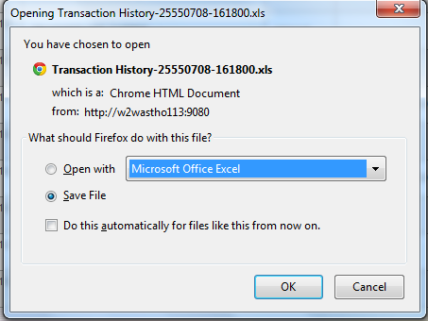
Figure 14: Example dialog box for Download Report

Appendix 6: Glossary

Term | Definition
RIB | Retail Internet Banking System
CDB | Business Internet Banking System
IB | Internet Banking
IBS | Internet Banking System
IBAM | Internet Banking Administration Manager (the administration module)
SME | Small & Medium Enterprise
TAC | Transaction Authorization Code  TAC is a temporary random six digits security code generated by the authentication server and sent to user by SMS using a SMS gateway. TAC is required as the second level security authentication before committing any bank transactions and user profile updates.
OTP | One Time Password, in this document it meant for the Secure Pass or Token 6 digit PIN from VASCO.
BNM | Bank Negara Malaysia
CASA | Current & Savings Account
FD | Fixed Deposit
Table 28: Glossary
--- END ---

Mobile Number format subject to change according to SMS Gateway specification

