**Participants Authorization:**

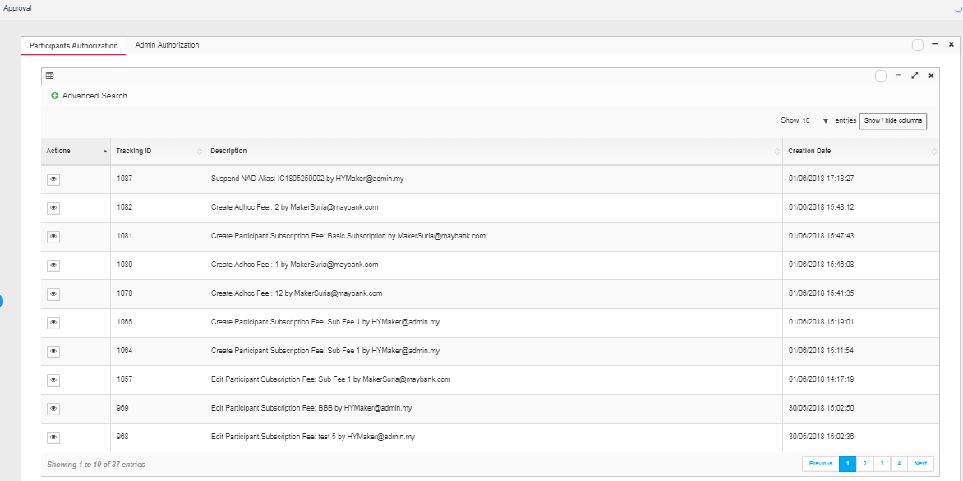

**Approval Details – Participant – Suspend NAD Alias – Approve:**

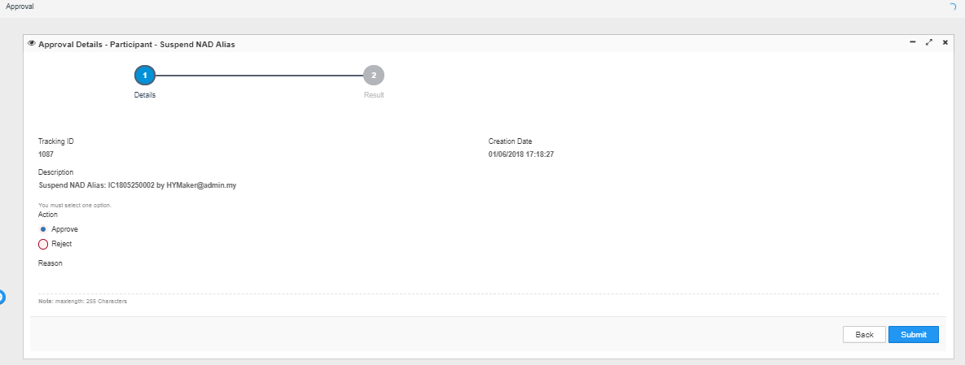

**Approval Details – Participant – Suspend NAD Alias – Approved successfully by checker id:**

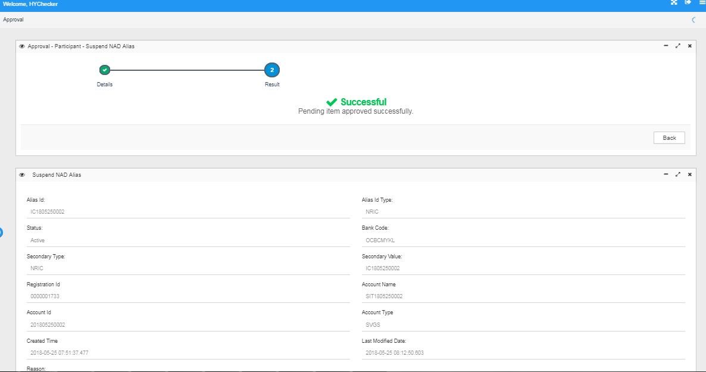

**NAD Enquiry – Still active:**

