**NAD Enquiry – Activate – Reason allowed to key in more than 250 characters**

1. Issue Description

Able to key in value more than 250 characters at field of Reason in NAD Enquiry – Activate.

2. Expected Results

Should have similar handling when to suspend NAD enquiry (please refer to attached screenshot)

3. Risk / Impact

Medium impact.

4. Steps To Reproduce:

* Go to NAD MAINTENANCE > NAD Enquiry > Activate > Enter reason more than 250 characters.

**Screenshot:**

1. **To activate:**

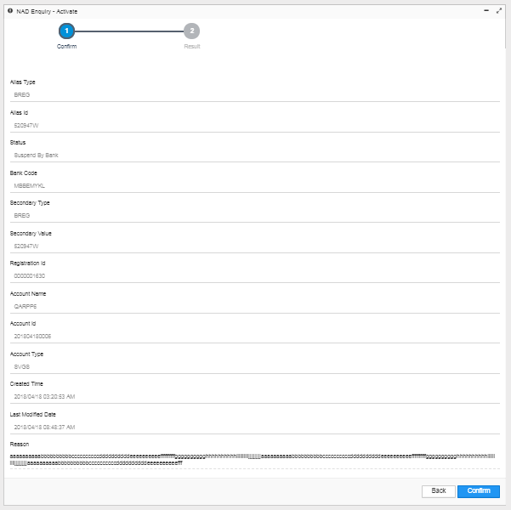

1. **To suspend**

